Dynamic arterial elastance as a predictor of arterial pressure changes after volume administration: a validation study
Manuel Ignacio Monge García^{1,2}, Manuel Gracia Romero¹, Anselmo Gil Cano¹, Hollmann D. Aya², Andrew Rhodes², Robert Michael Grounds², Maurizio Cecconi²
¹Servicio de Cuidados Intensivos y Urgencias, Hospital SAS de Jerez, C/ Circunvalación s/n, 11407 Jerez de la Frontera, Spain
²Department of Intensive Care Medicine, St. George’s Healthcare NHS Trust and St George’s University of London, Tooting, London SW17 0QT, UK

ELECTRONIC SUPLEMENTARY FILE (ESM)

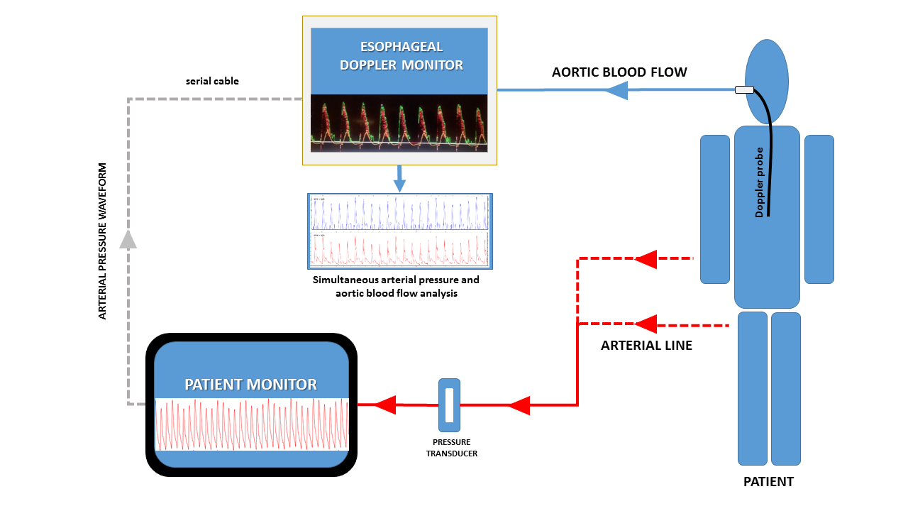
Figure S1. Schematic representation of the monitoring procedures.

Figure S2. Weighted least-squares regression analysis between preinfusion dynamic arterial elastance and arterial pressure increases after volume expansion, considering relative changes in cardiac output.
Relationship between preinfusion dynamic arterial elastance (Ea_{dyn}) and systolic arterial pressure (SAP), diastolic arterial pressure (DAP), mean arterial pressure (MAP) and arterial pulse pressure changes after volume expansion (VE), adjusted for VE-induced cardiac output changes. Dashed lines represent 95% confidence intervals for the regression line (solid line).

Figure S3. Relationship between cardiac output and arterial pressure changes after volume expansion and preinfusion dynamic arterial elastance.
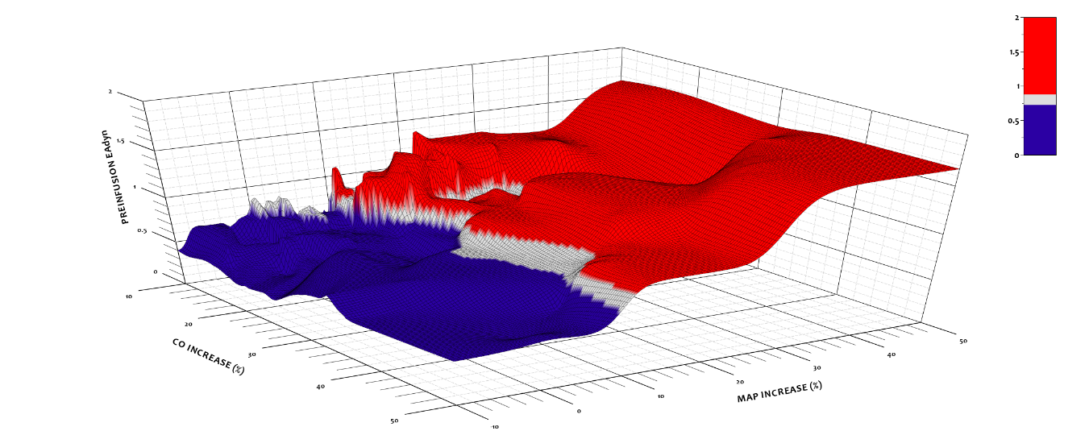

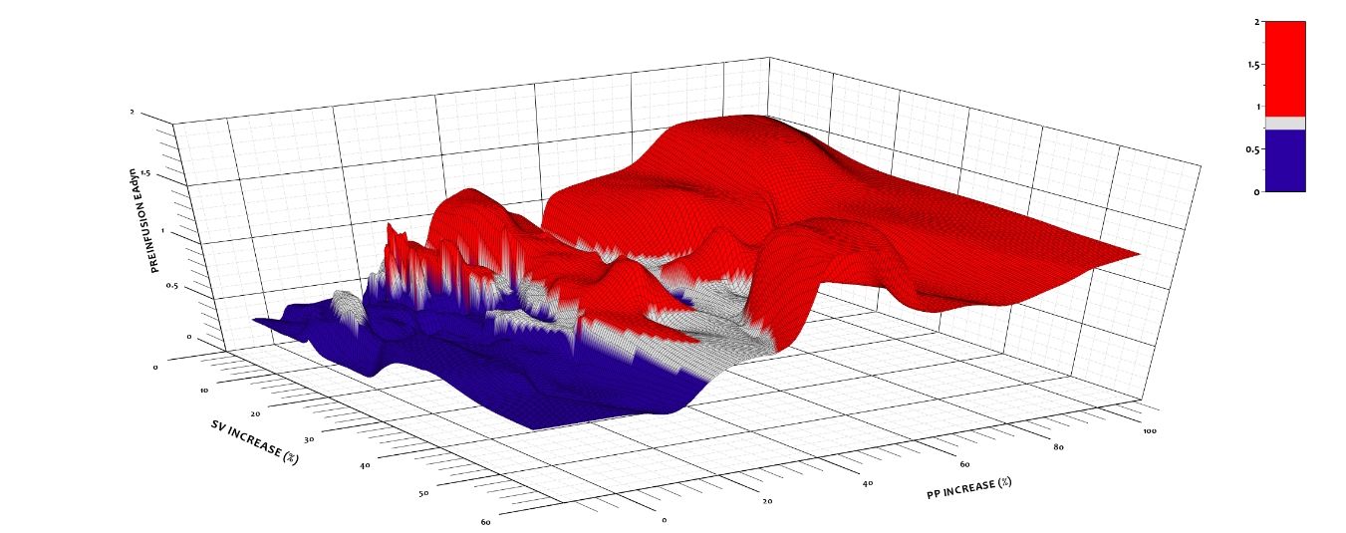

Cardiac output (CO) and mean arterial pressure (MAP) increases after volume expansion (VE) and preinfusion dynamic arterial elastance (Ea_{dyn}) relationship (above), and stroke volume (SV) and arterial pulse pressure (PP) increases after VE and preinfusion Ea_{dyn} relationship (below). Colors are defined according to preinfusion Ea_{dyn} value: < 0.72 in blue, from 0.72 to 0.88 (gray zone) in gray; and > 0.88 in red.

Figure S4. Predictive performance of arterial load parameters for predicting an increase ≥ 10% in MAP after fluid administration, when only the first fluid challenge per patient was considered (n = 53; pressure-responders = 22 patients).
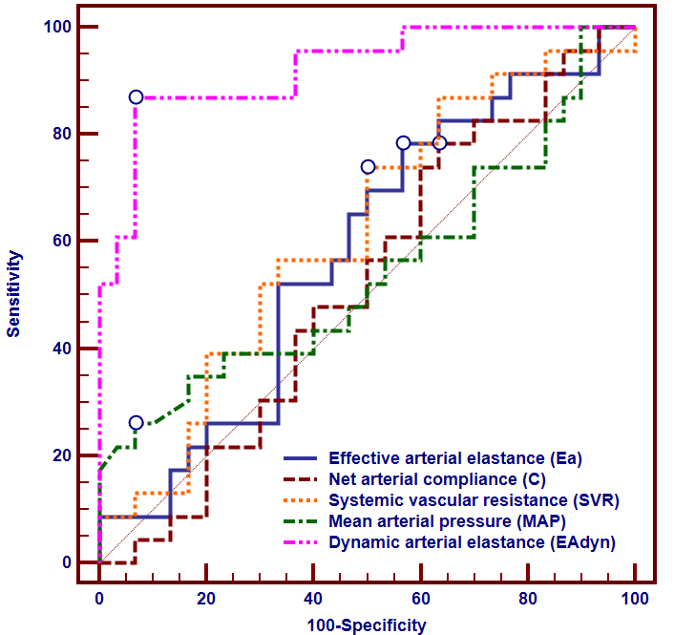

 | AUC (95%CI) | SE
Ea_{dyn} | 0.92 (0.81 – 0.98)* | 0.04
Ea, mmHg/mL | 0.58 (0.44 – 0.71) | 0.08
C, mL/mmHg | 0.52 (0.38 – 0.66) | 0.08
SVR, dyn∙s∙cm⁻⁵ | 0.62 (0.47 – 0.75) | 0.08
MAP, mmHg | 0.55 (0.40 – 0.68) | 0.08
AUC: area under the receiver operating curve; C: net arterial compliance; Ea: effective arterial elastance; Ea_{dyn}: dynamic arterial elastance; MAP: mean arterial pressure; SE: standard error; SVR: systemic vascular resistance.
*The area under the ROC curve for Ea_{dyn} was significantly higher than for other arterial load parameters (p < 0.001) according to DeLong test.

Figure S5. Predictive performance of arterial load parameters for predicting an increase ≥ 15% in MAP in patients with a cardiac output increase ≥ 15% after fluid administration (n=39; pressure-responders = 18 patients).
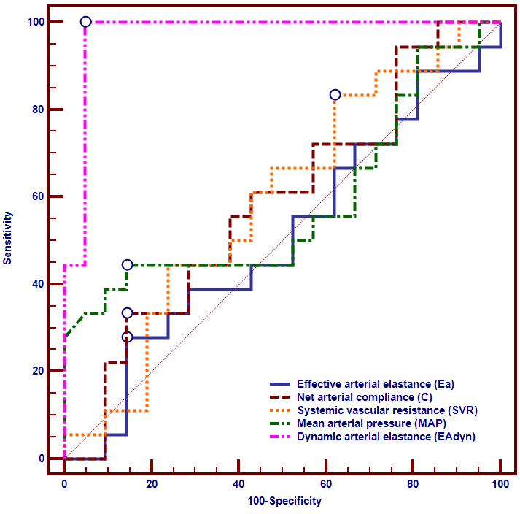
 | AUC (95%CI) | SE
Ea_{dyn} | 0.97 (0.86 – 0.99)* | 0.03
Ea, mmHg/Ml | 0.50 (0.34 – 0.67) | 0.10
C, mL/mmHg | 0.58 (0.42 – 0.74) | 0.09
SVR, dyn∙s∙cm⁻⁵ | 0.59 (0.42 – 0.70) | 0.09
MAP, mmHg | 0.58 (0.41 – 0.74) | 0.10
AUC: area under the receiver operating curve; C: net arterial compliance; Ea: effective arterial elastance; Ea_{dyn}: dynamic arterial elastance; MAP: mean arterial pressure; SE: standard error; SVR: systemic vascular resistance.
*The area under the ROC curve for Ea_{dyn} was significantly higher than for other arterial load parameters (p < 0.001) according to DeLong test.

Figure S6. Comparison of ROC curves for testing the ability of pulse pressure variation (PPV) and dynamic arterial elastance (Ea_{dyn}) to detect a mean arterial pressure (MAP) increase ≥ 10% after volume administration
 | AUC (95%CI) | SE
Ea_{dyn} | 0.94 (0.86 – 0.98)* | 0.03
PPV, % | 0.76 (0.65 – 0.85) | 0.06
AUC: area under the receiver operating curve; Ea_{dyn}: dynamic arterial elastance; PPV: pulse pressure variation; SE: standard error.
*The area under the ROC curve for Ea_{dyn} was significantly higher than for PPV (p < 0.001) according to DeLong test.

Table 1. Effects of volume expansion (VE) in the 8 non-preload responder patients (CO increase < 10%) excluded from the analysis.
 | Before VE | After VE
CO, L/min | 5.14 (3.49 to 6.02) | 5.31 (3.64 to 6.14)*
HR, beats/min | 80 (69 to 86) | 74 (66 to 80)*
SV, mL | 60 (46 to 105) | 70 (50 to 104)*
CPO, W | 0.84 (0.56 to 1.10) | 0.92 (0.58 to 1.10)*
MAP, mmHg | 71 (66 to 74) | 72 (68 to 78)
SAP, mmHg | 114 (107 to 118) | 116 (111 to 125)
DAP, mmHg | 52 (45 to 56) | 52 (46 to 56)
PP, mmHg | 59 (47 to 72) | 61 (51 to 82)*
PPV, % | 12 (8 to 15) | 8 (5 to 11)*
SVV, % | 16 (9 to 20) | 13 (9 to 16)
Ea_{dyn} | 0.67 (0.65 to 0.82) | 0.64 (0.49 to 0.77)
Ea, mmHg/mL | 1.64 (1.01 to 2.22) | 1.45 (1.10 to 2.07)
C, mL/mmHg | 1.21 (0.86 to 1.46) | 1.24 (0.91 to 1.31)
SVR, dyn∙s∙cm⁻⁵ | 1346 (925 to 1649) | 1278 (980 to 1579)
Data are expressed as median (interquartile range). CO: cardiac output; CPO: cardiac power output; DAP: diastolic arterial pressure; Ea: effective arterial elastance; Ea_{dyn}: dynamic arterial elastance; HR: heart rate; MAP: mean arterial pressure; PP: pulse pressure (systolic minus diastolic pressure); PPV: pulse pressure variation; SAP: systolic arterial pressure; SV: stroke volume; SVR: systemic vascular resistance; SVV: stroke volume variation.
* p < 0.05 vs. before volume expansion (Wilcoxon test).

Table S2. Preinfusion arterial load parameters comparison between hypotensive and non-hypotensive patients.
 | Hypotensive  (n = 32) | Non-hypotensive  (n = 48) | p
Ea_{dyn} | 0.90 ± 0.35 | 0.70 ± 0.24 | < 0.01
Ea, mmHg/mL | 1.73 ± 0.81 | 1.93 ± 0.73 | 0.26
C, mL/mmHg | 1.16 ± 0.41 | 1.15 ± 0.54 | 0.93
SVR, dyn∙s∙cm⁻⁵ | 1036 ± 605 | 1359 ± 486 | < 0.05
Data are expressed as mean ± SD. C: net arterial compliance; Ea: effective arterial elastance; Ea_{dyn}: dynamic arterial elastance; SVR: systemic vascular resistance.

Table S3. Preinfusion arterial load parameters comparison between septic and non-septic patients.
 | Septic  (n = 48) | Non-septic  (n = 34) | p
Ea_{dyn} | 0.78 ± 0.29 | 0.81 ± 0.33 | 0.62
Ea, mmHg/mL | 1.80 ± 0.73 | 1.93 ± 0.81 | 0.45
C, mL/mmHg | 1.18± 0.53 | 1.13 ± 0.43 | 0.66
SVR, dyn∙s∙cm⁻⁵ | 1143 ± 535 | 1360 ± 573 | 0.08
Data are expressed as mean ± SD. C: net arterial compliance; Ea: effective arterial elastance; Ea_{dyn}: dynamic arterial elastance; SVR: systemic vascular resistance.

Table S4. Comparison of areas under the ROC curve for predicting arterial pressure response (MAP increase ≥ 10%) after volume expansion between hypotensive and non-hypotensive patients.
 | Hypotensive  (n = 32) | Non-hypotensive  (n = 48) | p
Ea_{dyn} | 0.98 (0.85 – 1) | 0.90 (0.78 – 0.97) | 0.15
Ea, mmHg/mL | 0.66 (0.47 – 0.82) | 0.51 (0.37 – 0.66) | 0.28
C, mL/mmHg | 0.63 (0.44 – 0.79) | 0.60 (0.45 – 0.74) | 0.81
SVR, dyn∙s∙cm⁻⁵ | 0.69 (0.51 – 0.84) | 0.50 (0.35 – 0.65) | 0.13
MAP, mmHg | 0.65 (0.46 – 0.81) | 0.51 (0.37 – 0.66) | 0.32
Data are expressed as AUC (95%CI). C: net arterial compliance; Ea: effective arterial elastance; Ea_{dyn}: dynamic arterial elastance; MAP: mean arterial pressure; SVR: systemic vascular resistance.

Table S5. Comparison of areas under the ROC curve for predicting arterial pressure response (MAP ≥ 10%) after VE between septic and non-septic patients
 | Septic  (n = 48) | Non-septic  (n = 34) | p
Ea_{dyn} | 0.92 (0.81 – 0.98) | 0.96 (0.83 – 0.99) | 0.41
Ea, mmHg/mL | 0.53 (0.38 – 0.67) | 0.50 (0.33 – 0.68) | 0.86
C, mL/mmHg | 0.54 (0.39 – 0.69) | 0.53 (0.35 – 0.70) | 0.92
SVR, dyn∙s∙cm⁻⁵ | 0.52 (0.37 – 0.66) | 0.53 (0.35 – 0.70) | 0.95
MAP, mmHg | 0.58 (0.42 – 0.72) | 0.65 (0.46 – 0.80) | 0.59
Data are expressed as AUC (95%CI). C: net arterial compliance; Ea: effective arterial elastance; Ea_{dyn}: dynamic arterial elastance; MAP: mean arterial pressure; SVR: systemic vascular resistance.

