Additional file
Legend
S1 Table 1: Results search strategy.
S2 Table 2: Summary of characteristics of the included studies in the meta-analysis.
S3 Funnel plot of studies comparing low vitamin D and normal vitamin D level on the
occurrence of infections.
S4 Funnel plot of studies comparing low vitamin D and normal vitamin D on the occurrence
of sepsis.
S5 Funnel plot of studies comparing low vitamin D and normal vitamin D on the occurrence
of 30-day mortality (univariate).
S6 Funnel plot of studies comparing low vitamin D and normal vitamin D on the occurrence
of 30-day mortality (multivariate).
S7 Funnel plot of studies comparing low vitamin D and normal vitamin D on the occurrence
of in-hospital mortality.
S8 Newcastle-Ottawa-scale.
S9 Figure 1: Flow diagram for the selection of studies evaluating the effect of vitamin D in
critically ill patients.
S10 Subgroup analyses per outcome based on study design.
S11 Table 3: Summary of vitamin D interventional trials on the ICU.

S1 Table 1: Results search strategy
Embase | 371 | 359
Medline in OvidSP | 112 | 12
Cochrane central | 9 | 3
Pubmed as supplied by publisher | 7 | 7
Total | 500ª | 381^{b}
a: before deduplication, b: after deduplication

Embase 371
('Vitamin D'/exp OR 'vitamin D deficiency'/de OR ('vitamin d' OR cholecalciferol* OR ergocalciferol* OR 'Hydroxyvitamin d' OR Hydroxycholecalciferol* OR 'Dihydroxyvitamin d' OR Dihydroxycholecalciferol* OR Calcifediol* OR Calcitriol*):ab,ti) AND ('intensive care'/de OR 'intensive care unit'/de OR 'intensive care nursing'/de OR 'critically ill patient'/de OR (((intens* OR critical*) NEAR/3 care*) OR (critical* NEAR/3 ill*)):ab,ti)

Medline in OvidSP 112
(exp "Vitamin D"/ OR "Vitamin D Deficiency"/ OR ("vitamin d" OR cholecalciferol* OR ergocalciferol* OR "Hydroxyvitamin d" OR Hydroxycholecalciferol* OR "Dihydroxyvitamin d" OR Dihydroxycholecalciferol* OR Calcifediol* OR Calcitriol*).ab,ti.) AND (exp "critical care"/ OR exp "intensive care units"/ OR "Critical Illness"/ OR (((intens* OR critical*) ADJ3 care*) OR (critical* ADJ3 ill*)).ab,ti.)

Cochrane central 9
(('vitamin d' OR cholecalciferol* OR ergocalciferol* OR 'Hydroxyvitamin d' OR Hydroxycholecalciferol* OR 'Dihydroxyvitamin d' OR Dihydroxycholecalciferol* OR Calcifediol* OR Calcitriol*):ab,ti) AND ((((intens* OR critical*) NEAR/3 care*) OR (critical* NEAR/3 ill*)):ab,ti)

Pubmed as supplied by publisher 7
(vitamin D*[tiab] OR Cholecalciferol*[tiab] OR Ergocalciferol*[tiab] OR Hydroxyvitamin d*[tiab] OR Hydroxycholecalciferol*[tiab] OR Dihydroxyvitamin d*[tiab] OR Dihydroxycholecalciferol*[tiab] OR Calcifediol*[tiab] OR Calcitriol*[tiab]) AND (intensive care*[tiab] OR critical care*[tiab] OR critical ill*[tiab] OR critically ill*[tiab]) AND publisher[sb]

S2 Table 2: Summary of characteristics of the studies included in the meta-analysis.
Author | Cutoffs of  25 (OH)-D | Definition of sepsis | Definition of infection | Study period
Amrein,2014²⁵ | < 50 nmol/l  50-75 nmol/l  > 75 nmol/l | Positive blood culture | N/A | Between September 2008 and May 2010
Arnson,2012²¹ | ≤ 50 nmol/l  > 50 nmol/l  Time samples taken: Within 24 hours after ICU admission | N/A | Respiratory, abdominal or other infection at ICU admission | Between  December 2008 and June 2009
Aygencel,2013²⁴ | < 50 nmol/l  ≥ 50 nmol/l  Time samples taken:  Within 24 hours after ICU admission | N/A | Nosocomial infections | Between October 2009 and March 2011
Braun,2011³  2012⁵ | ≤ 37 nmol/l  40-75 nmol/l  ≥ 75 nmol/l  Time samples taken: 7 until 365 days before ICU admission ⁶.  7 days before until 7 days after ICU admission ²¹. | ICD-9-CM codes:  038.0-038.9, 020.0, 790.7, 117.9, 112.5, 112.81 | Positive blood culture | Between 1998-2009
Flynn,2012²² | ˂ 50 nmol/l  ≥ 50 nmol/l  Time samples taken: On admission and every 7 days | N/A | Overall infections including pneumonia, intra-abdominal, urinary tract, skin-soft tissue | Between January 2010 and February 2011
Higgins,2012²³ | ≤ 30 nmol/l  > 30-≤60 nmol/l  > 60 nmol/l  Time samples taken: Within 24 hours after ICU admission and daily for 10 days. | At any time during stay patients met SIRS criteria and had a source of infection. | ICU-acquired infection; present after 48 hours of ICU admission.  Suspected infection; by the presence of new positive culture or initiation of new AB after 48 hours of ICU admission | Between October 2002 to October 2003  Summer was defined as; admission between 21 June and 22 September
Lucidarme,2010¹⁶ | ≤ 15 nmol/l  > 15-≤ 30 nmol/l  > 30-≤ 60 nmol/l  > 60 nmol/l  Time samples taken:  On admission | N/A | N/A | Spring-Summer 2009
Matthews,2012³⁰ | ≥ 10- ≤32 nmol/l  33-65 nmol/l  66-99 nmol/l  ≥ 100- ≤175 nmol/l  Time samples taken: Within 24 hours after ICU admission | N/A | N/A | Between August 2009 and January 2011
Moromizato,2014²⁶ | ≤ 37 nmol/l  40-75 nmol/l  ≥ 75 nmol/l | ICD-9-CM codes:  038.0-038.9, 020.0, 790.7, 117.9, 112.5, 112.81, 3 days prior to critical care initiation to 7 days after critical care initiation. | N/A | Between 1998-2011
Nair,2012²⁷ | < 25 nmol/l  25-50 nmol/l  > 50 nmol/l  Time samples taken:  Within 24 hours after admission and in the morning on day 3 and 7 or at ICU discharge | N/A | N/A | Between July 2010 and February 2011
Remmelts,2012²⁸  Su,2013²⁹  Venkatram,2011⁴ | < 50 nmol/l  50-75 nmol/l  > 75 nmol/l  < 12,5 nmol/l  12,5-25 nmol/l  > 25-≤37,5  > 37,5-≤50  > 50 nmol/l  Time samples taken:  Within 24 hours after ICU admission  < 50 nmol/l  ≥ 50-75 nmol/l  ≥ 75 nmol/l  Time samples taken:  Within 24 hours after ICU admission | N/A  N/A  N/A | Community acquired pneumonia  N/A  N/A | 1 Year  Between October and December 2011  Between October 2009 and February 2010
N/A: not available; ICU: intensive care unit; SIRS: systemic inflammatory response syndrome; AB: antibiotic

S3 Funnel plot of studies comparing low vitamin D and normal vitamin D level on the
occurrence of infections.
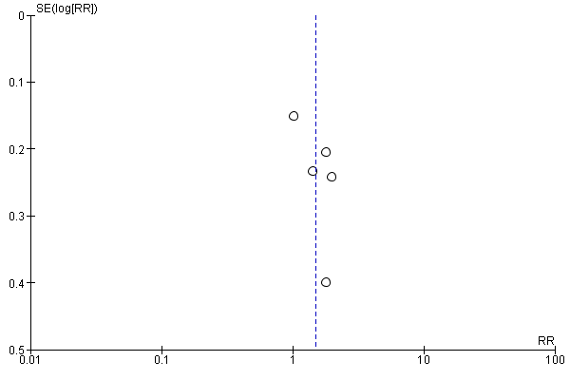
RR; relative risk, SE; standard error.

S4 Funnel plot of studies comparing low vitamin D and normal vitamin D on the occurrence
of sepsis.
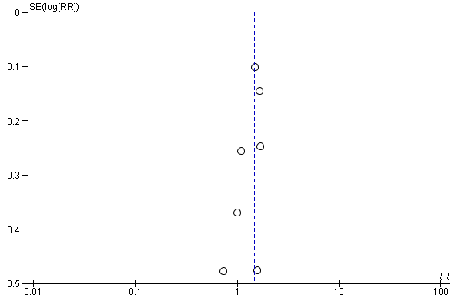
RR; relative risk, SE; standard error.
S5 Funnel plot of studies comparing low vitamin D and normal vitamin D on the occurrence
of 30-days mortality (univariate).

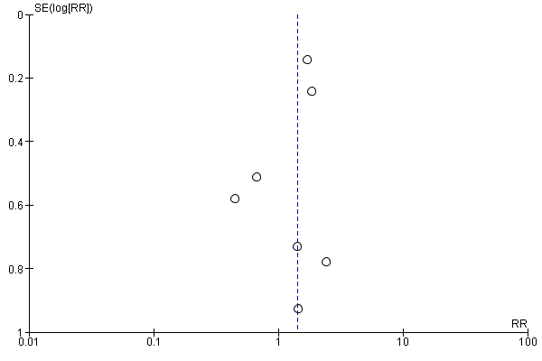
RR; relative risk, SE; standard error.

S6 Funnel plot of studies comparing low vitamin D and normal vitamin D on the occurrence
of 30-days mortality (multivariate).

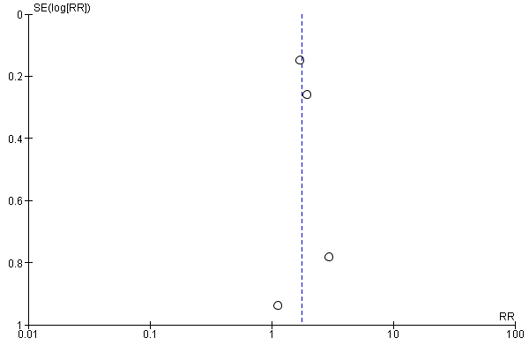
RR; relative risk, SE; standard error.

S7 Funnel plot of studies comparing low vitamin D and normal vitamin D on the occurrence
of in-hospital mortality.
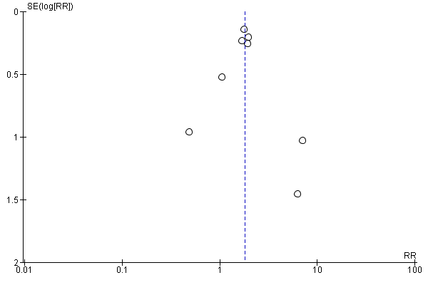
RR; relative risk, SE; standard error.

S8a Newcastle-Ottawa-scale for cohort studies data abstraction form
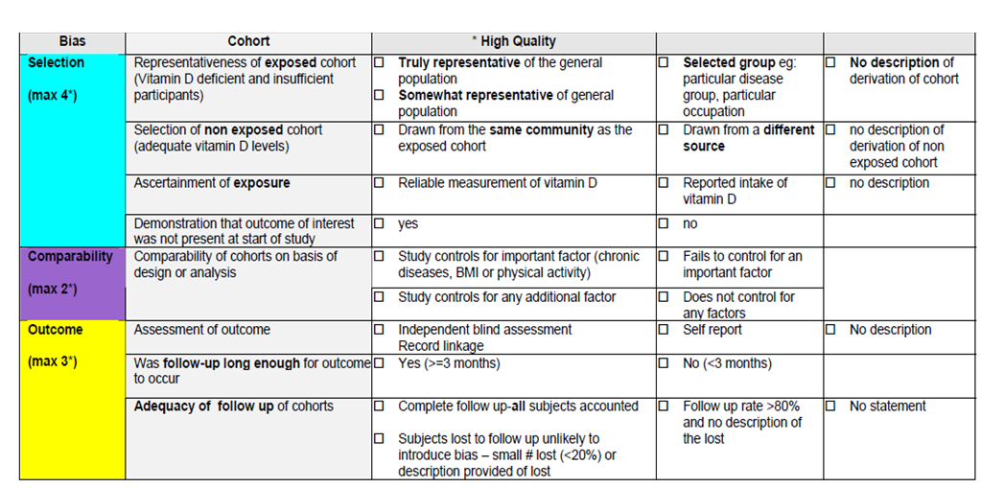

S8b Risk of bias summary for cohort studies: review authors judgments about each risk of bias item for each included study using the Newcastle-Ottawa-Scale.
 | Representativeness of exposed cohort (vitamin D deficient patients) | Selection of non exposed cohort (adequate vitamin D levels) | Ascertainment of exposure | Demonstration that outcome of interest was not present at start of study | Comparability of cohorts on basis of design or analysis (max 2 points) | Assessment of outcome | Was follow-up long enough for outcome to occur | Adequacy of follow-up of cohorts | Total points/9
Amrein²⁵ | 1 | 1 | 1 | 1 | 1 | 1 | 1 | 0 | 7/9
Arnson²¹ | 1 | 1 | 1 | 1 | 0 | 1 | 1 | 0 | 6/9
Aygencel²⁴ | 1 | 1 | 1 | 1 | 0 | 0 | 0 | 0 | 4/9
Braun,2012⁵ | 1 | 1 | 1 | 1 | 2 | 1 | 1 | 0 | 8/9
Braun,2011³ | 1 | 1 | 1 | 1 | 2 | 1 | 1 | 0 | 8/9
Flynn²² | 0 | 1 | 0 | 0 | 0 | 0 | 1 | 0 | 2/9
Higgins²³ | 1 | 1 | 1 | 1 | 1 | 1 | 1 | 0 | 7/9
Lucidarme¹⁶ | 1 | 1 | 1 | 1 | 1 | 0 | 0 | 0 | 5/9
Matthews³⁰ | 1 | 1 | 0 | 1 | 0 | 0 | 0 | 0 | 3/9
Moromizato²⁶ | 1 | 1 | 1 | 1 | 2 | 1 | 1 | 0 | 8/9
Remmelts²⁸ | 1 | 1 | 0 | 1 | 2 | 1 | 1 | 0 | 7/9
Su²⁹ | 1 | 1 | 1 | 1 | 1 | 0 | 1 | 0 | 6/9
Venkatram⁴ | 1 | 1 | 1 | 0 | 0 | 0 | 1 | 0 | 4/9

9-8 pts | Low risk of bias
7-6 pts | Moderate risk of bias
<6 pts | High risk of bias
S9 Figure 1: Flow diagram for the selection of studies evaluating the effect of vitamin D in critically ill patients.

Search results March 2014: (n=381)
Embase (n=359)
Medline (n=12)
Cochrane central (n=3)
Pubmed as supplied by publisher (n= 7)

studies excluded after title and abstract screening by inclusion criteria, described in methods. (n=358)
irrelevant/other subject (n=229)
vitamin D metabolism (n=45)
study design or n<20 (n=26)
review (n=7)
pediatric (n=46)
animal studies (n=5)

Paediatric (n=46), Animals (n=5)

studies retrieved for detailed evaluation (n=23)

studies excluded
duplicate (n=1)

studies to be included in the systematic review (n=22)
studies excluded
unable to pool results in meta-analysis (n=4)
intervention trials (n=4)

studies to be included in the meta-analysis (n=14)
reporting on:
infections (n=5)
sepsis (n=7)
30-day mortality (n=7 )
in-hospital mortality (n=8)

S10 Subgroup analyses per outcome based on study design.
Outcome | n | ref | RR, [95% CI], p
Infection  Prospective studies  Arnson, 2012  Aygencel, 2013  Flynn, 2012  Higgins, 2012  Retrospective studies  Braun, 2011 | 4  1 | 21  24  22  23  5 | 1.42, [1.01, 2.00], 0.04  1.80, [1.20, 2.70], <0.001
Sepsis  Prospective studies  Aygencel, 2013  Flynn, 2012  Higgins, 2012  Retrospective studies  Amrein, 2014  Braun, 2012  Moromizato, 2014  Venkatram, 2011 | 3  4 | 24  22  23  25  5  26  4 | 1.39, [1.00, 1.92], 0.05  1.45, [1.18, 1.78], <0.001
30-day mortality (univariate)  Prospective studies  Higgins, 2012  Lucidarme, 2010  Nair, 2012  Remmelts, 2012  Su, 2013  Retrospective studies  Braun, 2011  Braun, 2012 | 5  2 | 23  16  27  28  29  5  3 | 0.89, [0.50, 1.58], 0.69  1.73, [1.36, 2.20], <0.001
30-day mortality (multivariate)  Prospective studies  Nair, 2012  Remmelts, 2012  Retrospective studies  Braun, 2011  Braun, 2012 | 2  2 | 27  28  5  3 | 1.99, [0.62, 6.45], 0.25  1.75, [1.36, 2.26], <0.001
In-hospital mortality  Prospective studies  Aygencel, 2014  Flynn, 2012  Matthews, 2012  Nair, 2012  Retrospective studies  Amrein, 2014  Braun, 2011  Braun, 2012  Venkatram, 2011 | 4  4 | 24  22  30  27  25  5  3  4 | 1.51, [1.00, 2.27], 0.05  1.87, [1.52, 2.31], <0.001

S11 Table 3. Overview of Intervention trials on the ICU
Author | Year of Publication | Study  population | Study design | No. of patients | Endpoints
Amrein ¹⁹  Mata- Garandos¹⁸  Van den Berghe ¹⁷  Vargas-Vasserot ²⁰ | 2011  2010  2003  2011 | medical-,  ICU  ICU  Surgical-ICU  ICU | prospective double-blind  randomized placebo-controlled  randomized controlled  randomized, controlled  randomized, controlled | 25  placebo  n=13  13.5 mg  cholecalciferol PO  n= 12  33  controls  n= 11  1,5 mg cholecalciferol PO  n= 11  2 mcg  calcitriol i.v  n= 10  22  low dose  5 mcg cholecalciferol i.v  n=10  high dose  12,5 mcg  cholecalciferol i.v  n=12  23  controls  n=12  1,5 mg cholecalciferol  n=11 | normalization of 25 (OH)-D, mechanical ventilation, vasopressor therapy, hospital stay, ICU stay, hospital mortality  normalization of 25 (OH)-D, 1,25 (OH)-D,  24,25 (OH)-D  normalization of 25 (OH)-D, 1,25 (OH)-D, VDBP, PTH, iCa,  IL-6, IL-1, CRP, markers of bone formation  normalization of 25 (OH)-D, 1,25 (OH)-D, 24,25 (OH)-D,  cathelicidin (LL-37)



