Efficacy and Safety of Proton Pump Inhibitors for Stress Ulcer Prophylaxis in Critically ill patients: A Systematic Review and Meta-analysis of Randomized Trials

Authors
Fayez Alshamsi, Emilie Belley-Cote, Deborah Cook, Saleh A. Almenawer, Zuhoor Alqahtani, Dan Perri, Lehana Thabane, Awad Al-Omari, Kim Lewis, Gordon Guyatt, Waleed Alhazzani

e-Appendix

 |  | Page
 | e-Table 3: Search Strategy EMBASE and MEDLINE | 2-3
 | e-Table 4: Search Strategy for Cochrane Central Register of Controlled Trials | 4-6
 | e-Table 5: Search Strategy for ACP Journal Club | 6-7
 | e-Table 6: Risk of Bias assessment of the included trials using Cochrane Risk of Bias tool. | 8
 | e-Figure 5: Forest Plot for ICU Mortality. | 9
 | e-Figure 6: Forest Plot for ICU Length of Stay. | 9
 | e-Table 7: Subgroup Analysis for Clinically Important Bleeding outcome. | 10
 | e-Table 8: Subgroup Analysis for Overt Upper Gastrointestinal Bleeding outcome. | 10
 | e-Figure 7: Sensitivity analysis for Clinically Important Bleeding. | 11
 | e-Figure 8: Funnel Plot for Clinically Important Bleeding Outcome | 12
 | e-Figure 9: Funnel plot for pneumonia outcome. | 13
 | e-Figure 10: Funnel plot for ICU mortality outcome. | 14

e-Table 3: Search Strategy EMBASE and MEDLINE
# | Searches | Results
1 | Proton Pump Inhibitors/ or (proton adj5 pump adj5 inhibitor*).mp. or ppi*.tw. or exp Omeprazole/ or Benzimidazoles/ or Omeprazole.mp. or losec.mp. or omez.mp. or prilosec.mp. or rapinex.mp. or zegerid.mp. or esomeprazole.mp. or axagon.mp. or esporal.mp. or lucen.mp. or nexiam.mp. or nexium.mp. or sompraz.mp. or soleri.mp. or Lansoprazole.mp. or agopton.mp. or bamalite.mp. or lansoprazole.mp. or lanzor.mp. or monolitum.mp. or ogast.mp. or ogastro.mp. or ogastro.mp. or opiren.mp. or prevacid.mp. or prezal.mp. or pro ulco.mp. or promeco.mp. or takepron.mp. or ulpax.mp. or zoton.mp. or 2-Pyridinylmethylsulfinylbenzimidazoles/ or dexlansoprazole.mp. or kapidex.mp. or dexilant.mp. or pantoprazole.mp. or pantoloc.mp. or pantecta.mp. or protium.mp. or protonix.mp. or rabeprazole.mp. or AcipHex.mp. or Pariet.mp. or dexrabeprazole.mp. or rablet.mp. [mp=ti, ab, hw, tn, ot, dm, mf, dv, kw, nm, kf, px, rx, ui] | 132847
2 | exp Histamine H2 Antagonists/ or ((H2 or histamine) adj3 (blocker* or blockader*)).mp. or ((H2 or histamine) adj3 (receptor* or antagonist*)).mp. or (H2 adj1 antihistaminic*).mp. or H2RA*.mp. or exp Cimetidine/ or Guanidines/ or Imidazoles/ or cimetidine.mp. or acitak.mp. or altramet.mp. or biomet.mp. or dyspamet.mp. or eureceptor.mp. or galenamet.mp. or histodil.mp. or peptimax.mp. or phimetin.mp. or tagamet.mp. or ultec.mp. or zita.mp. or FAMOTIDINE/ or famotidine.mp. or fluxid.mp. or leader acid reducer.mp. or mylanta.mp. or pepcid.mp. or Thiazoles/ or roxatidine.mp. or Roxit.mp. or NIZATIDINE/ or Nizatidine.mp. or axid.mp. or tazac.mp. or zinga.mp. or RANITIDINE/ or ranitidine.mp. or azanplus.mp. or biotidin.mp. or pylorid.mp. or raciran.mp. or raniberl.mp. or ranisen.mp. or ranitidin.mp. or rantec.mp. or sostril.mp. or taladine.mp. or tritec.mp. or wal-zan.mp. or zantac.mp. or Furans/ [mp=ti, ab, hw, tn, ot, dm, mf, dv, kw, nm, kf, px, rx, ui] | 273683
3 | exp Peptic Ulcer/ or Ulcer*.mp. or lesion*.mp. | 2096921
4 | (bleed* or re-bleed* or rebleed* or h?emorrhag*).mp. | 1061059
5 | 3 and 4 | 143622
6 | (stress adj3 ulcer*).mp. | 7469
7 | 5 or 6 | 148693
8 | exp Gastrointestinal Hemorrhage/ | 126523
9 | ((gastrointestinal or gastro-intestinal) adj5 (bleed* or re-bleed* or rebleed* or h?emorrhag*)).mp. | 112306
10 | (h?ematochezia* or h?ematemese* or mel?ena*).mp. | 17603
11 | exp injury/ and exp gastric mucosa/ | 3344
12 | (mucos* adj5 injur*).tw. | 13118
13 | (stomach or antrum or antral or pyloric or pylorus or gastri* or gastropathy or epigastr* or duodenal or duodenum or gastro-duodenal or gastroduodenal or oeso*ag* or esp*ag* or "upper GI" or UGI or "upper gastrointestinal" or "upper gastrointestinal").mp. | 1113960
14 | 4 and 13 | 99680
15 | exp Gastritis/ | 76781
16 | 4 and 15 | 6223
17 | or/7-12,14,16 | 289683
18 | exp Critical Care/ | 559710
19 | exp intensive care/ | 534305
20 | exp Critical Illness/ | 42894
21 | exp Intensive Care Units/ | 165170
22 | ICU*.tw. | 107408
23 | ((critical or intensive) adj3 (care or illness)).tw. | 294703
24 | exp Intubation, Gastrointestinal/ | 14809
25 | exp Monitoring, Physiologic/ | 144136
26 | exp Multiple Organ Failure/ | 36501
27 | exp Acid-Base Equilibrium/ | 34737
28 | exp Multiple Trauma/ | 22099
29 | (serious* adj injur*).tw. | 8026
30 | (severe adj (traum* or shock)).tw. | 15392
31 | exp Perioperative Care/ | 163356
32 | ((preoperative or intraoperative or perioperative) adj (care or procedure* or period)).tw. | 24896
33 | exp Resuscitation/ | 162860
34 | exp Shock/ | 167096
35 | exp sepsis/ | 292378
36 | exp Ventilator Weaning/ | 144800
37 | exp Ventilators, Mechanical/ | 9597
38 | exp Ventilators, Negative-Pressure/ | 20024
39 | (protocol* adj weaning).mp. [mp=ti, ab, hw, tn, ot, dm, mf, dv, kw, nm, kf, px, rx, ui] | 97
40 | (ventilat* adj weaning).mp. [mpP=title, original title, abstract, name of substance word, subject heading word] | 4199
41 | ((artificial or mechanical) adj ventilat*).mp. | 140789
42 | ventilat*.tw. | 312929
43 | or/18-42 | 1739921
44 | randomized controlled trial.pt. or Randomi?ed Controlled trial*.mp. or Randomi?ed clinical trial*.mp. or Random Allocation/ or Random allocation.mp. or random*.tw. or clinical trial/ or controlled clinical trial/ or single-blind method/ or double-blind method/ or ((singl* or doubl* or trip* or trebl*) adj25 (blind* or mask*)).mp. or Placebos/ or placebo*.tw. or drug therapy.fs. or trial.ab. or groups.ab. | 7608212
45 | 1 or 2 | 384217
46 | 17 and 43 and 44 and 45 | 1130
47 | limit 46 to ed=20150401-20151125 [Limit not valid in Embase; records were retained] | 779
48 | limit 47 to dd=20150401-20151125 [Limit not valid in Ovid MEDLINE(R),Ovid MEDLINE(R) Daily Update,Ovid MEDLINE(R) In-Process; records were retained] | 35
49 | remove duplicates from 48 | 30
e-Table 4: Search Strategy for Cochrane Central Register of Controlled Trials
# | Searches | Results
1 | Proton Pump Inhibitors/ or (proton adj5 pump adj5 inhibitor*).mp. or ppi*.tw. or exp Omeprazole/ or Benzimidazoles/ or Omeprazole.mp. or losec.mp. or omez.mp. or prilosec.mp. or rapinex.mp. or zegerid.mp. or esomeprazole.mp. or axagon.mp. or esporal.mp. or lucen.mp. or nexiam.mp. or nexium.mp. or sompraz.mp. or soleri.mp. or Lansoprazole.mp. or agopton.mp. or bamalite.mp. or lansoprazole.mp. or lanzor.mp. or monolitum.mp. or ogast.mp. or ogastro.mp. or ogastro.mp. or opiren.mp. or prevacid.mp. or prezal.mp. or pro ulco.mp. or promeco.mp. or takepron.mp. or ulpax.mp. or zoton.mp. or 2-Pyridinylmethylsulfinylbenzimidazoles/ or dexlansoprazole.mp. or kapidex.mp. or dexilant.mp. or pantoprazole.mp. or pantoloc.mp. or pantecta.mp. or protium.mp. or protonix.mp. or rabeprazole.mp. or AcipHex.mp. or Pariet.mp. or dexrabeprazole.mp. or rablet.mp. [mp=title, abstract, subject headings, heading word, drug trade name, original title, device manufacturer, drug manufacturer, device trade name, keyword] | 6350
2 | exp Histamine H2 Antagonists/ or ((H2 or histamine) adj3 (blocker* or blockader*)).mp. or ((H2 or histamine) adj3 (receptor* or antagonist*)).mp. or (H2 adj1 antihistaminic*).mp. or H2RA*.mp. or exp Cimetidine/ or Guanidines/ or Imidazoles/ or cimetidine.mp. or acitak.mp. or altramet.mp. or biomet.mp. or dyspamet.mp. or eureceptor.mp. or galenamet.mp. or histodil.mp. or peptimax.mp. or phimetin.mp. or tagamet.mp. or ultec.mp. or zita.mp. or FAMOTIDINE/ or famotidine.mp. or fluxid.mp. or leader acid reducer.mp. or mylanta.mp. or pepcid.mp. or Thiazoles/ or roxatidine.mp. or Roxit.mp. or NIZATIDINE/ or Nizatidine.mp. or axid.mp. or tazac.mp. or zinga.mp. or RANITIDINE/ or ranitidine.mp. or azanplus.mp. or biotidin.mp. or pylorid.mp. or raciran.mp. or raniberl.mp. or ranisen.mp. or ranitidin.mp. or rantec.mp. or sostril.mp. or taladine.mp. or tritec.mp. or wal-zan.mp. or zantac.mp. or Furans/ [mp=title, abstract, subject headings, heading word, drug trade name, original title, device manufacturer, drug manufacturer, device trade name, keyword] | 10886
3 | exp Peptic Ulcer/ or Ulcer*.mp. or lesion*.mp. | 29937
4 | (bleed* or re-bleed* or rebleed* or h?emorrhag*).mp. | 24655
5 | 3 and 4 | 2251
6 | (stress adj3 ulcer*).mp. | 222
7 | 5 or 6 | 2348
8 | exp Gastrointestinal Hemorrhage/ | 1532
9 | ((gastrointestinal or gastro-intestinal) adj5 (bleed* or re-bleed* or rebleed* or h?emorrhag*)).mp. | 2326
10 | (h?ematochezia* or h?ematemese* or mel?ena*).mp. | 166
11 | exp injury/ and exp gastric mucosa/ | 10
12 | (mucos* adj5 injur*).tw. | 327
13 | (stomach or antrum or antral or pyloric or pylorus or gastri* or gastropathy or epigastr* or duodenal or duodenum or gastro-duodenal or gastroduodenal or oeso*ag* or esp*ag* or "upper GI" or UGI or "upper gastrointestinal" or "upper gastrointestinal").mp. | 23638
14 | 4 and 13 | 2490
15 | exp Gastritis/ | 518
16 | 4 and 15 | 42
17 | or/7-12,14,16 | 5011
18 | exp Critical Care/ | 1498
19 | exp intensive care/ | 938
20 | exp Critical Illness/ | 928
21 | exp Intensive Care Units/ | 2117
22 | ICU*.tw. | 3275
23 | ((critical or intensive) adj3 (care or illness)).tw. | 8057
24 | exp Intubation, Gastrointestinal/ | 528
25 | exp Monitoring, Physiologic/ | 8498
26 | exp Multiple Organ Failure/ | 296
27 | exp Acid-Base Equilibrium/ | 380
28 | exp Multiple Trauma/ | 165
29 | (serious* adj injur*).tw. | 66
30 | (severe adj (traum* or shock)).tw. | 375
31 | exp Perioperative Care/ | 9451
32 | ((preoperative or intraoperative or perioperative) adj (care or procedure* or period)).tw. | 1059
33 | exp Resuscitation/ | 3249
34 | exp Shock/ | 1198
35 | exp sepsis/ | 2630
36 | exp Ventilator Weaning/ | 351
37 | exp Ventilators, Mechanical/ | 208
38 | exp Ventilators, Negative-Pressure/ | 25
39 | (protocol* adj weaning).mp. [mp=title, abstract, subject headings, heading word, drug trade name, original title, device manufacturer, drug manufacturer, device trade name, keyword] | 12
40 | (ventilat* adj weaning).mp. [mpP=title, original title, abstract, name of substance word, subject heading word] | 424
41 | ((artificial or mechanical) adj ventilat*).mp. | 3730
42 | ventilat*.tw. | 12769
43 | or/18-42 | 41915
44 | randomized controlled trial.pt. or Randomi?ed Controlled trial*.mp. or Randomi?ed clinical trial*.mp. or Random Allocation/ or Random allocation.mp. or random*.tw. or clinical trial/ or controlled clinical trial/ or single-blind method/ or double-blind method/ or ((singl* or doubl* or trip* or trebl*) adj25 (blind* or mask*)).mp. or Placebos/ or placebo*.tw. or drug therapy.fs. or trial.ab. or groups.ab. | 590360
45 | 1 or 2 | 16054
46 | 17 and 43 and 44 and 45 | 143
47 | limit 46 to yr="2011 -Current" | 15
48 | limit 46 to yr="2014 -Current" | 3

e-Table 5: Search Strategy for ACP Journal Club
# | Searches | Results
1 | (proton adj5 pump adj5 inhibitor*).mp. | 75
2 | ppi*.tw. | 40
3 | (Omeprazole or losec or omez or prilosec or rapinex or zegerid).mp. | 65
4 | (esomeprazole or axagon or esporal or lucen or nexiam or nexium or sompraz or soleri).mp. | 12
5 | (Lansoprazole or agopton or bamalite or lansoprazole or lanzor or monolitum or ogast or ogastro or ogastro or opiren or prevacid or prezal or pro ulco or promeco or takepron or ulpax or zoton).mp. | 14
6 | (dexlansoprazole or kapidex or dexilant).mp. | 0
7 | (pantoprazole or pantoloc or pantecta or protium or protonix).mp. | 6
8 | (rabeprazole or AcipHex or Pariet or dexrabeprazole or rablet).mp. | 5
9 | or/1-8 | 108
10 | ((H2 or histamine) adj3 (blocker* or blockader*)).mp. | 14
11 | ((H2 or histamine) adj3 (receptor* or antagonist*)).mp. | 36
12 | (H2 adj1 antihistaminic*).mp. | 1
13 | H2RA*.mp. | 5
14 | (cimetidine or acitak or altramet or biomet or dyspamet or eureceptor or galenamet or histodil or peptimax or phimetin or tagamet or ultec or zita).mp. | 10
15 | (famotidine or fluxid or leader acid reducer or mylanta or pepcid).mp. | 6
16 | (roxatidine or Roxit).mp. | 0
17 | (Nizatidine or axid or tazac or zinga).mp. | 2
18 | (ranitidine or azanplus or biotidin or pylorid or raciran or raniberl or ranisen or ranitidin or rantec or sostril or taladine or tritec or wal-zan or zantac).mp. | 25
19 | or/10-18 | 58
20 | Ulcer*.mp. | 270
21 | (esophagit* adj5 (peptic or reflux)).mp. | 26
22 | lesion*.mp. | 226
23 | or/20-22 | 449
24 | (bleed* or re-bleed* or rebleed* or h?emorrhag*).mp. | 831
25 | 23 and 24 | 159
26 | (stress adj3 ulcer*).mp. | 14
27 | 25 or 26 | 162
28 | ((gastrointestinal or gastro-intestinal) adj5 (bleed* or re-bleed* or rebleed* or h?emorrhag*)).mp. | 153
29 | (h?ematochezia* or h?ematemese* or mel?ena*).mp. | 22
30 | (mucos* adj5 injur*).tw. | 3
31 | (stomach or antrum or antral or pyloric or pylorus or gastri* or gastropathy or epigastr* or duodenal or duodenum or gastro-duodenal or gastroduodenal or oeso*ag* or esp*ag* or "upper GI" or UGI or "upper gastrointestinal" or "upper gastrointestinal").mp. | 234
32 | 24 and 31 | 116
33 | Gastritis.mp. [mp=title, abstract, full text, keywords, caption text] | 22
34 | 24 and 33 | 8
35 | or/27-30,32,34 | 269
36 | ICU*.mp. | 111
37 | ((critical or intensive) adj3 (care or illness)).mp. | 290
38 | Nutritional Support.mp. | 10
39 | ((artificial or force or tube) adj3 (feeding* or nutrition)).mp. | 11
40 | ((enternal or parenteral) adj3 (feeding* or nutrition)).mp. | 18
41 | ((Nasogastric or nasointestinal or orogastric or transabdominal) adj2 (intubat* or tube*)).mp. | 13
42 | ((Gastrointestinal or gastro-intestinal) adj2 Intubation).mp. | 1
43 | ((patient or physiologic) adj2 monitoring).mp. | 31
44 | Multiple Organ Failure*.mp. | 4
45 | (multiple adj3 (wound* or trauma* or injur*)).mp. | 6
46 | (serious* adj injur*).mp. | 4
47 | (severe adj (traum* or shock)).mp. | 5
48 | ((perioperative or intraoperative or postoperative) adj3 (care or procedure* or period)).mp. | 32
49 | Resuscitation*.mp. | 86
50 | Shock.mp. | 170
51 | (circulatory adj3 (failure or collapse)).mp. | 16
52 | sepsis.mp. [mp=title, abstract, full text, keywords, caption text] | 96
53 | ventilat*.mp. | 164
54 | or/36-53 | 620
55 | 9 or 19 | 129
56 | 35 and 54 and 55 | 11

e-Table 6: Risk of Bias assessment of the included trials using Cochrane Risk of Bias tool.
Author | Sequence Generation | Allocation Concealment | Blinding | Incomplete Outcome Data | Selective Reporting Bias | Free of Other Bias | Overall Risk of Bias
Conrad  et al | Low | Low | Low | Low | Low | Low | Low
Azevedo  et al | Low | Low | High | Low | Low | Low | High
Hata et al | Low | High | High | Low | Low | Low | High
Kantorova  et al | Low | Low | Low | Low | Low | Low | Low
Kotlyanskaya  et al | Unclear | Unclear | Unclear | Unclear | Unclear | Unclear | Unclear
Levy et al | Low | Low | High | Low | Low | Low | High
Pan et al | Unclear | Unclear | High | Low | Unclear | Low | High
Phillips et al | Unclear | Unclear | Unclear | Unclear | Unclear | Unclear | Unclear
Powell  et al | Low | Unclear | Low | Low | Low | Low | Unclear
Risaliti et al | Low | Unclear | Unclear | Low | Unclear | Low | Unclear
Solouki  et al | Low | Low | Low | Low | Low | Low | Low
Somberg  et al | Low | Low | High | Low | Low | Low | High
Fink et al | Unclear | Unclear | High | Unclear | Unclear | Unclear | High
Bashar et al | Low | Low | Unclear | High | High | Unclear | High
Lee et al | Low | Low | High | Low | Unclear | Unclear | High
Liu et al | Low | Low | High | High | Low | Unclear | High
Fogas et al | Unclear | Unclear | Unclear | Unclear | Unclear | Unclear | Unclear
Wee et al | High | High | High | High | Unclear | Unclear | High
Bhanot et al | Unclear | Unclear | Unclear | Unclear | Unclear | Unclear | Unclear

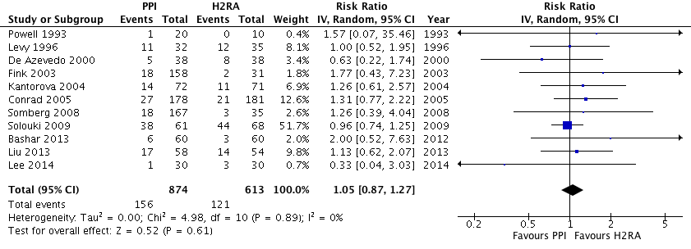
e-Figure 5: Forest Plot for ICU Mortality. Data from 11 trials (n=1487) were included, analyzed using the random effects model. The risk of death during the ICU stay was similar in both groups.

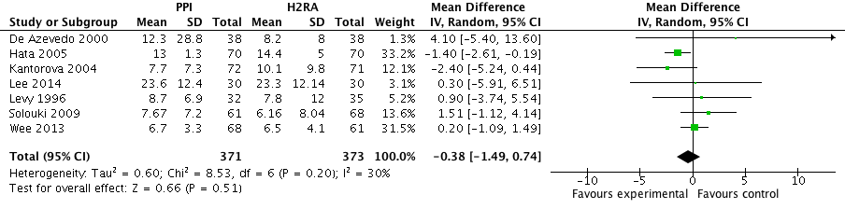
e-Figure 6: Forest Plot for ICU Length of Stay. Data from 11 trials (n=744) were included, analyzed using the random effects model. The duration of ICU stay was similar in both groups.

e-Table 7: Subgroup Analysis for Clinically Important Bleeding Outcome
Subgroup | Subtotal, n | Relative Risk  (95% Confidence Interval) | P (Interaction Between Groups) | I² (Heterogeneity Between Groups)
Risk of Bias  Low  High/unclear | 631  1048 | 0.60 (0.27, 1.35)  0.22 (0.09, 0.55) | 0.11 | 60.8%
Route  Enteral  Parenteral | 907  694 | 0.35 (0.18, 0.67)  0.91 (0.13, 6.09) | 0.35 | 0%
Frequency/day  Once  >Once | 984  551 | 0.43 (0.23, 0.84)  0.28 (0.03, 2.43) | 0.70 | 0%
Measure of treatment effect provided for each subgroup and interaction P value and I² for subgroup difference. All analyses used the inverse variance and fixed effect model.

e-Table 8: Subgroup Analysis for Overt Upper Gastrointestinal Bleeding outcome
Subgroup | Subtotal, n | Relative Risk  (95% Confidence Interval) | P (Interaction Between Groups) | I² (Heterogeneity Between Groups)
Risk of Bias  Low  High/unclear | 631  1266 | 0.60 (0.27, 1.35)  0.36 (0.21, 0.63) | 0.32 | 0%
Route  Enteral  Parenteral | 937  882 | 0.34 (0.18, 0.64)  0.58 (0.30, 1.12) | 0.25 | 25.0%
Frequency/day  Once  >Once | 1014  550 | 0.45 (0.24, 0.84)  0.48 (0.24, 0.94) | 0.90 | 0%
Measure of treatment effect provided for each subgroup and interaction P value and I² for subgroup difference. All analyses used the inverse variance and fixed effect model.

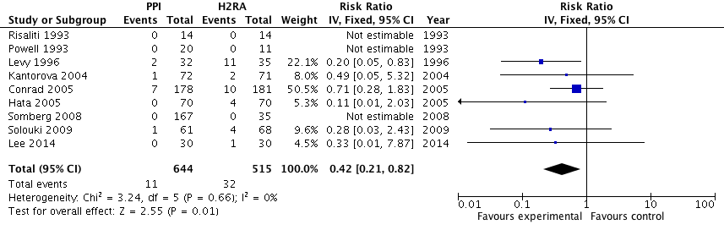
e-Figure 7: Sensitivity analysis for Clinically Important Bleeding excluding trials published as abstracts shows similar results to primary analysis.
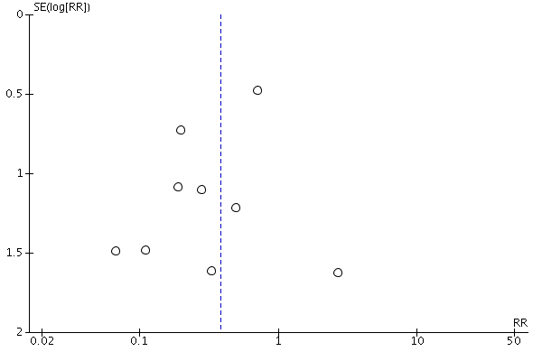
e-Figure 8: Funnel Plot for Clinically Important Bleeding Outcome. Visual inspection does not show publication bias and Egger test -0.69 (95% CI -2.44, 0.84; P=0.28).
e-Figure 9: Funnel plot for pneumonia outcome. Visual inspection does not show publication bias.
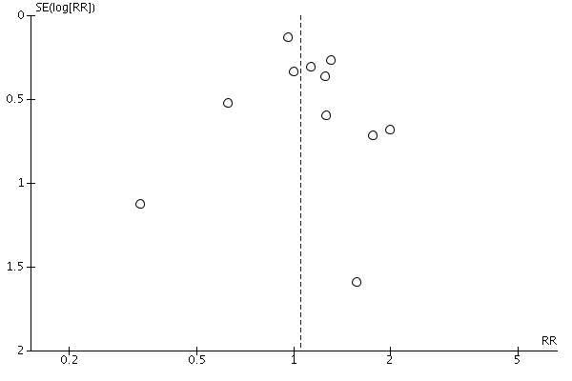
e-Figure 10: Funnel plot for ICU mortality outcome. Visual inspection does not show publication bias.

