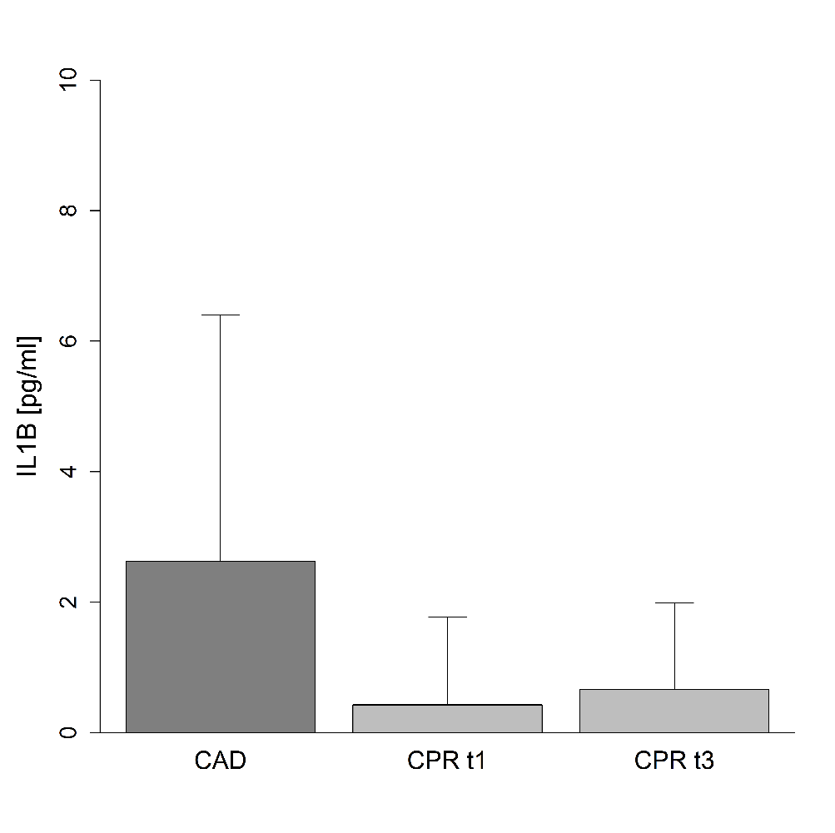
Additional file 7: Cytokine production of cultured PBMCs in response to stimulation with patients’ sera
Shown is interleukin-1β (IL1B) production of cultured PBMCs from a healthy volunteer in response to stimulation with 20% serum from either patients with coronary artery disease (CAD: n = 8) or resuscitated patients in the first 12 hours (CPR t1: n = 14) and after 48 hours following cardiac arrest (CPR t3: n = 9). Production of IL1B did not statistically differ between the three groups. Statistical hypothesis testing was performed by Kruskal-Wallis test.

