Intravenous High-dose Selenium Does Not Improve Clinical Outcomes in the Critically Ill: A Systematic Review and Meta-analysis

William Manzanares, Margot Lemieux, Gunnar Elke, Pascal L. Langlois,
Frank Bloos, Daren K. Heyland

Additional File 2

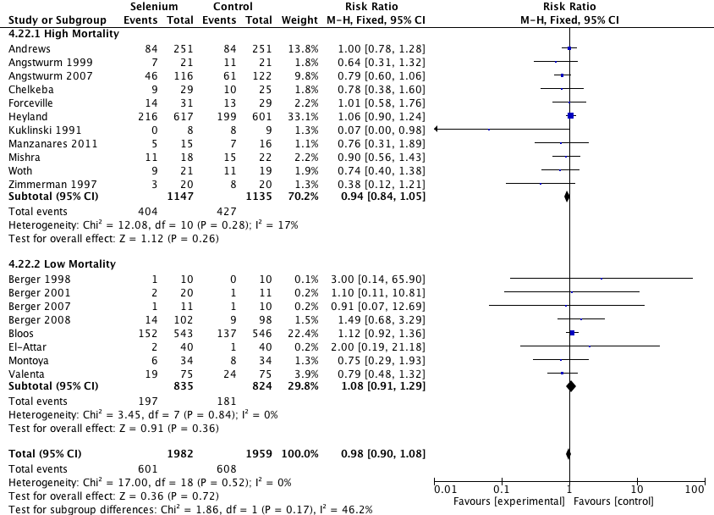

Figure S2. Effect of IV Se on Mortality: High vs. Low Mortality trials.

CI, confidence interval; M-H, Mantel-Haenszel test.

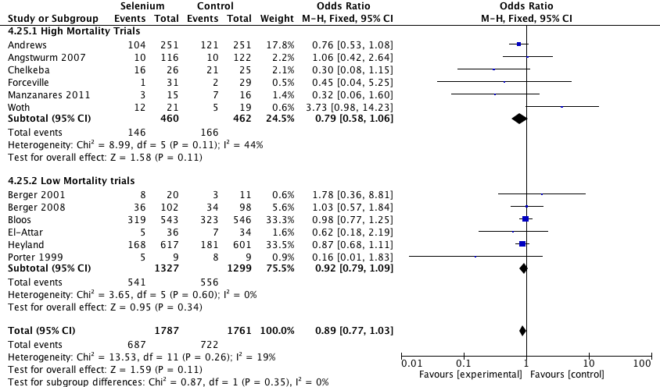

Figure S3. Effect of IV Se on Infections: High vs. Low Mortality trials.
CI, confidence interval; M-H, Mantel-Haenszel test.

