Additional file 4

Calibration Plots for the entire cohort as well as for each FS, with and without scatter

Calibration plots were calculated using the methodology of Vuk and Curk (2006). Calibration is calculated by comparing the predicted value for individual patients against the observed outcome variable, in this case mortality. The diagonal line included in the plot represents the situation where prediction perfectly matched observed outcome. As can be seen in the calibration plot for all functional status levels combined there is a near perfect fit across all areas of the probabilities spectrum 0.0 to 1.0. Similarly if bias were present in the calibration plot the LOESS regression spline would be above or below the diagonal line across all observed variable scale. As can be seen there is no bias present in the calibration provided. While predicted values tend to be lower than observed data in the lower 40% of the distribution the regression spline crosses the diagonal and nearly returns to perfect prediction in the upper portion of the scale observed variable. These results indicate that for the entire sample including all functional status levels there is a high degree of calibration within these data.

Reference:
Vuk M, Curk T. ROC Curve, Lift Chart and Calibration Plot, Metodoloski zvezki 2006:3:1:89-108

Figure S1a: Calibration Plot for the entire cohort, without scatter
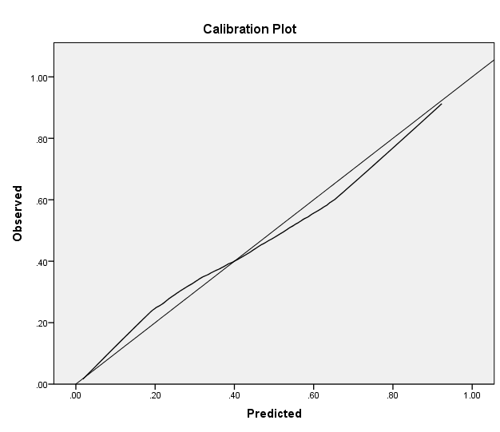

Figure S1b: Calibration Plot for the entire cohort, with scatter
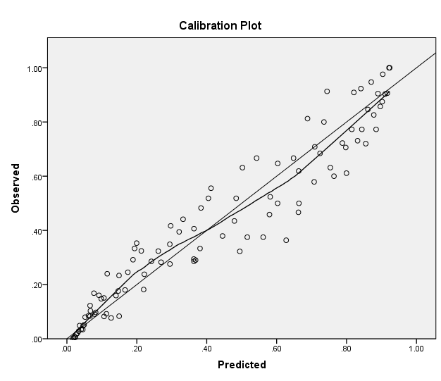
Figure S1c: Calibration Plot without scatter for FS1

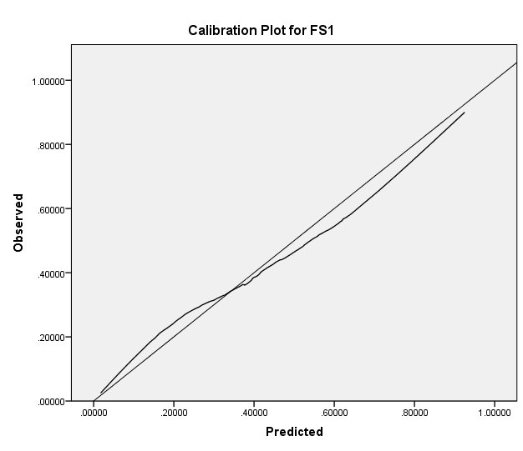

Figure S1d: Calibration Plot with scatter for FS1
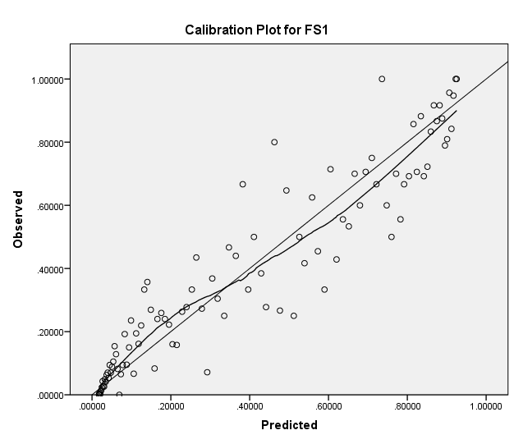

Figure S1e: Calibration Plot without scater for FS2

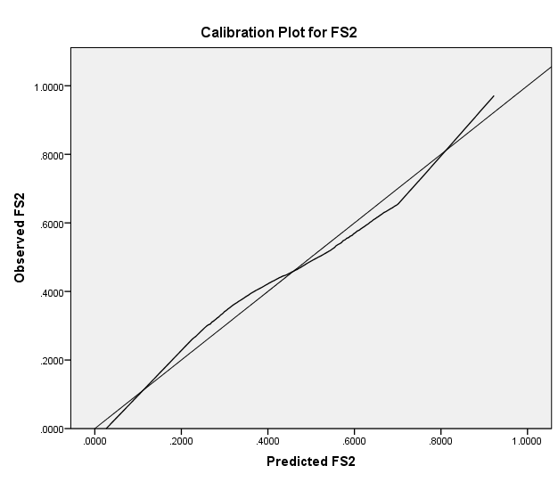

Figure S1f: Calibration Plot with scatter for FS2
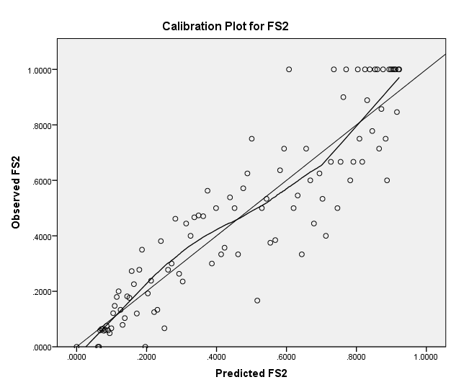

Figure S1g: Calibration Plot without scatter for FS3

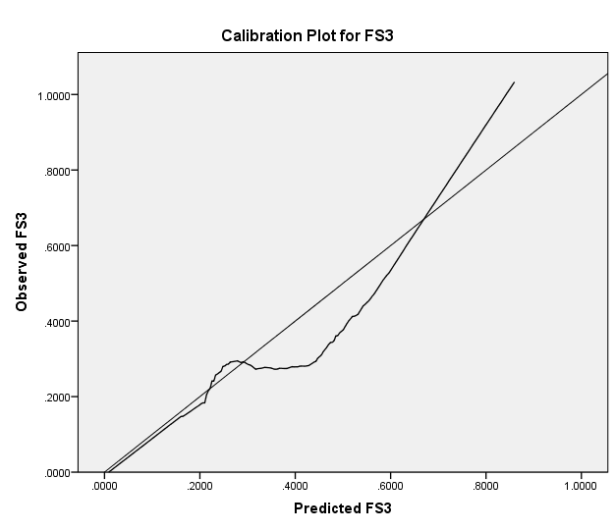

Figure S1h: Calibration Plot with scatter for FS3