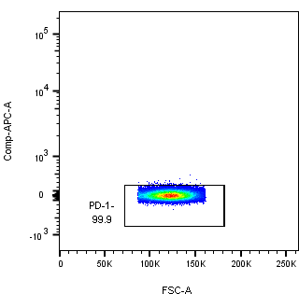
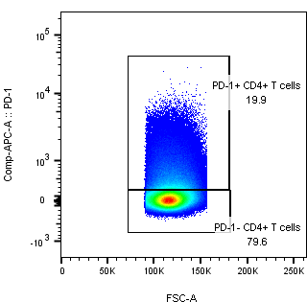
Healthy isotype
Healthy sample

Figure S1a. Example of gating used in data analysis.

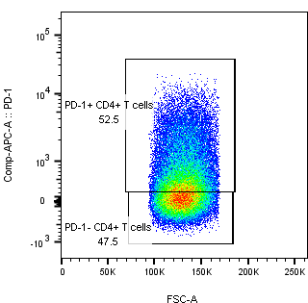
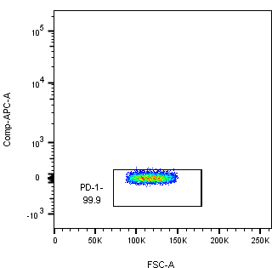
Sepsis isotype
Sepsis sample

eFigure 1b. Example of gating used in data analysis.

eFigure 1c. Example of gating used in data analysis.

