SUPPLEMET
Table S1 Variable, selected for the model
baseline demographics | age (years), sex, height (cm), weight (kg), Body Mass Index (kg/m2)
vital signs | heart rate (beats per minute), respiratory rate (per minute), systolic blood pressure (mmHg), diastolic blood pressure (mmHg), temperature (C⁰), pulse pressure¹* (relative difference between the systolic and diastolic pressure), shock index²*.
laboratory data | anion gap (meg/l)*, arterial PaCO2 (mmHg), arterial PaO2 (mmHg), arterial pH (mmHg), BUN/Creatinine ratio, hematocrit (%), hemoglobin (g/dl), lactate of an arterial or venous blood gas (nm/l), serum albumin (g/dl), serum anion gap (meg/l), serum bicarbonate (meq/l), serum blood urea nitrogen (bun) (mg/dl), serum calcium (mg/dl), serum chloride (meq/l), serum creatinine (mg/dl), serum glucose (mg/dl), serum potassium (meq/l), serum sodium (meq/l), serum total bilirubin (mg/dl), white blood count (10k/μl)
hospital intervention/assessment | vasopressor use** (dobutamine, dopamine, epinephrine, norepinephrine, vasopressin), oxygen delivery device (ranging from room air to high flow nasal cannula and BiPAP), Richmond agitation-sedation scale (RASS) value
* – variables, calculated with the variables with the closest time stamps to the initial source data;
** – the vasopressor use was defined as 1 if the patient had any dose of vasopressors at specific time-stamp and 0 otherwise.
1 - pulse pressure – relative difference between the systolic and diastolic pressure
2 - shock index – heart rate value divided by systolic blood pressure value (Allgower M, Burri C. ["Shock index"]. Dtsch Med Wochenschr. 1967;92(43):1947-1950).

Table S2 APPROVE performance in the derivation cohort to predict for event within 48 hours of score
APPROVE Score Cut Point | Sensitivity | Specificity | PPV | NPV
0.01 | 1.00 (1.00-1.00) | 0.47 (0.47-0.48) | 0.05 (0.05-0.05) | 1.00 (1.00-1.00)
0.02 | 1.00 (1.00-1.00) | 0.69 (0.69-0.70) | 0.09 (0.08-0.09) | 1.00 (1.00-1.00)
0.03 | 1.00 (1.00-1.00) | 0.81 (0.81-0.82) | 0.13 (0.13-0.14) | 1.00 (1.00-1.00)
0.04 | 1.00 (1.00-1.00) | 0.88 (0.87-0.88) | 0.19 (0.19-0.19) | 1.00 (1.00-1.00)
0.05 | 1.00 (1.00-1.00) | 0.92 (0.91-0.92) | 0.26 (0.25-0.26) | 1.00 (1.00-1.00)
0.10 | 1.00 (1.00-1.00) | 0.98 (0.98-0.98) | 0.58 (0.58-0.59) | 1.00 (1.00-1.00)
0.15 | 0.99 (0.99-0.99) | 0.99 (0.99-0.99) | 0.79 (0.78-0.79) | 1.00 (1.00-1.00)
0.20 | 0.81 (0.81-0.82) | 1.00 (1.00-1.00) | 0.87 (0.87-0.87) | 0.99 (0.99-1.00)
0.25 | 0.59 (0.58-0.59) | 1.00 (1.00-1.00) | 0.91 (0.91-0.92) | 0.99 (0.99-0.99)
0.30 | 0.45 (0.44-0.45) | 1.00 (1.00-1.00) | 0.94 (0.94-0.95) | 0.98 (0.98-0.99)
Data are presented mean and 95% confidence interval
PPV – Positive Predictive Value; NPV – Negative Predictive Value

Table S3: Median (Interquartile range) of time to event from when APPROVE first exceed the threshold during the hospitalization to the primary event of death or intubation that leads to mechanical ventilation greater than 48 hours, or to the individual events of hospital death, or intubation leading to mechanical ventilation greater than 48 hours in the 2013 and 2017 validation cohorts. For the composite qualifying event, the earliest of the event (death or intubation leading to mechanical ventilation> 48 hours) was considered the time of the event.
Event | Median time in hours (Interquartile range) from APPROVE score first exceeding threshold to event
Event | Threshold for APPROVE in Retrospective 2013 Cohort (N=34,388) |  |  | Threshold for APPROVE in Prospective 2017 Cohort (N=2258)
Event | >0.15 | >0.20 | >0.25 | >0.15 | >0.20 | >0.25
Death or Mechanical Ventilation > 48 hours | 37.2  (5.6-134.0) | 29.5  (4.5-121.2) | 26.8  (4.5-111.2) | 58.8 (14.7,171.6) | 58.8 (13.1,190.6) | 68.6 (10.7,193.8)
Death | 98.8  (22.1-224.2) | 79.9  (16.5-216.4) | 76.7  (15.2-202.0) | 145.4 (32.1,236.9) | 149.7 (47.4,234.9) | 148.6 (46.3,235.4)
Mechanical Ventilation > 48 | 12.6  (3.1,-62.0) | 10.3  (2.6-49.1) | 9.4  (2.5-43.8) | 32.8 (3.7,68.9) | 8.3 (0.8,52.1) | 7.4 (0.5,60.5)

Online Data Supplement Figure 1: Area under the curve (AUROC) for APPROVE, MEWS, and NEWS to predict for hospital mortality (Fig. 1a), mechanical ventilation (MV) > 48 hours (Fig. 1b) and MV of any duration (Fig. 1c) in the retrospective 2013 validation and the prospective 2017 validation hospital (Fig. 1 d,e,f, respectively). APPROVE, MEWS and NEWS were calculated at multiple random time points for each patient and evaluated for a qualifying event after score calculation.
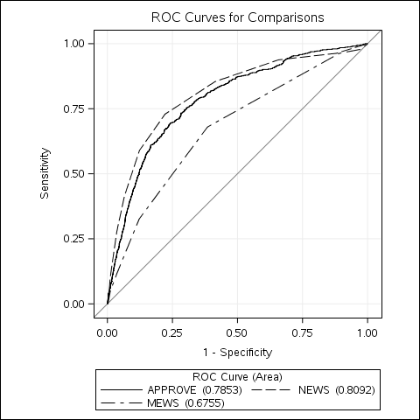
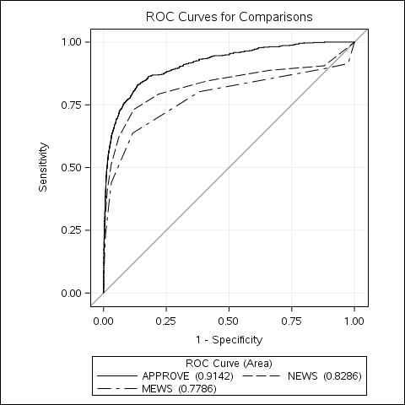
Fig. 1b: MV > 48 hours in 2013
Fig. 1a: Hospital Mortality in 2013
Fig. 1c: MV of Any Duration in 2013
Sensitivity
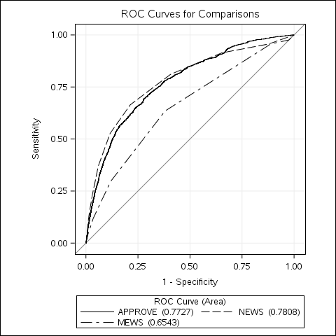

 | Any MV
APPROVE | 0.77 (0.76,0.79)
MEWS | 0.65 (0.64,0.67)
NEWS | 0.78 (0.77,0.79)
 | MV > 48 hours
APPROVE | 0.79 (0.77,0.80)
MEWS | 0.68 (0.66,0.70)
NEWS | 0.81 (0.79,0.83)
 | Hospital Mortality
APPROVE | 0.91 (0.90,0.93)
MEWS | 0.78 (0.75,0.80)
NEWS | 0.83 (0.81,0.85)

1-Specificity
1-Specificity
1-Specificity
Fig. 1f: MV of Any Duration in 2013
Fig. 1e: MV > 48 hours in 2017
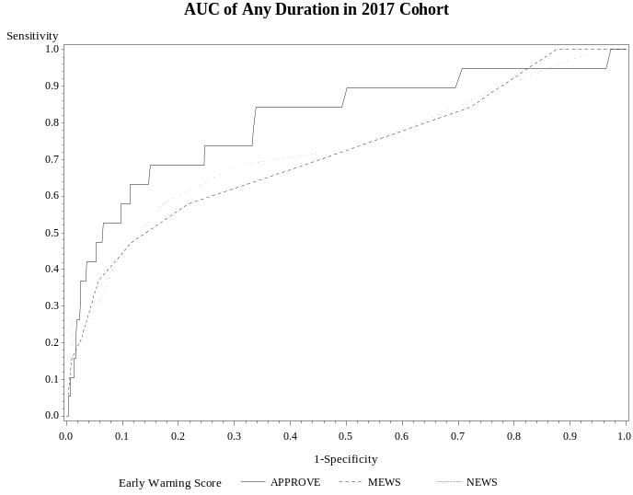
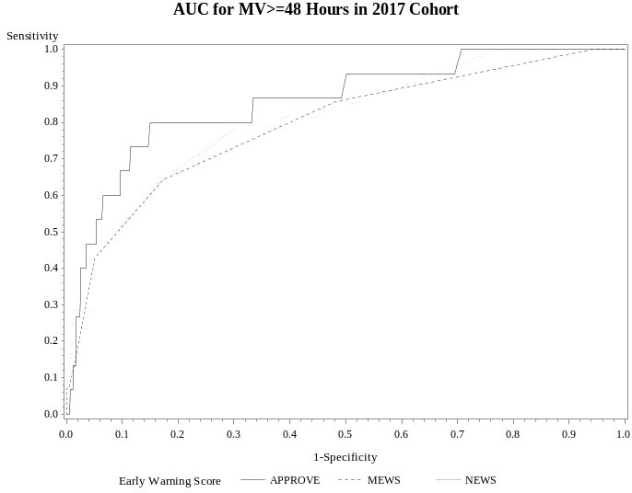
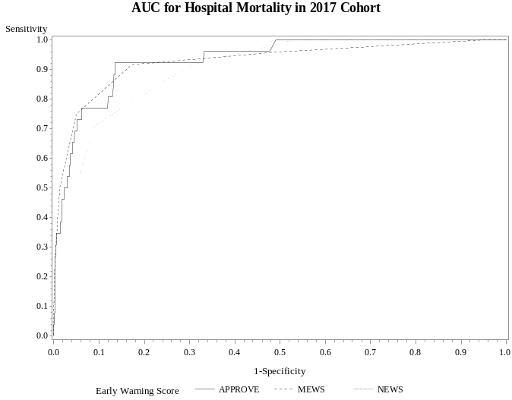
Fig. 1d: Hospital Mortality in 2017
 | Hospital Mortality
APPROVE | 0.93 (0.89,0.97)
MEWS | 0.93 (0.85,0.98)
NEWS | 0.91 (0.85,0.96)
 | MV > 48 hours
APPROVE | 0.86 (0.73,0.94)
MEWS | 0.79 (0.62,0.92)
NEWS | 0.81 (0.68,0.93)
 | Any MV
APPROVE | 0.80 (0.67,0.92)
MEWS | 0.72 (0.57,0.84)
NEWS | 0.73 (0.58,0.86)
1-Specificity
1-Specificity
1-Specificity
Sensitivity

