Additional file 1

Figure S1 Cumulative incidence (A) and in-hospital mortality (B) of pneumocystis pneumonia (PcP) at Hannover Medical School from 2000-2017

Graphs showing (A) the annual cumulative incidence of pneumocystis pneumonia cases per year from 2000-2017 in our tertiary care center in Germany (grey area highlights the mean PcP cases per year), (B) the in-hospital mortality in 2-year intervals, and (C) percentage of PcP hospital mortality grouped in etiological subgroups of immunosuppression (HIV – human immunodeficiency virus, ChTx – chemotherapy, SOTx – solid organ transplantation, IS/RD – immunosuppression / rheumatic diseases).

Figure S2 Receiver operating characteristic (ROC) curves for in-hospital mortality applied to the total sample.

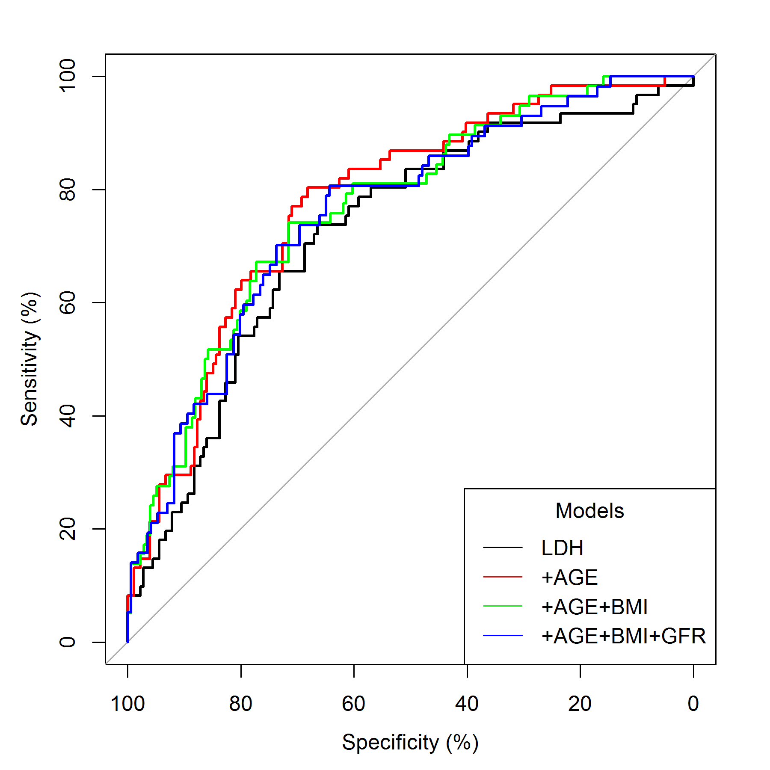

Receiver operating characteristic (ROC) curves for LDH (black), LDH + age (red curve) (p=0.06), LDH + age + BMI (green curve) (p=0.18), and for LDH + age + BMI + eGFR (blue curve) (p=0.32). P-values refer to area under the curve (AUC) comparisons to LDH alone (see Methods for details).

Figure S3 Receiver operating characteristic (ROC) curves for in-hospital mortality applied to subgroups regarding underlying etiology of immunosuppression and for the ICU cohort.

A) HIV B) CHTx
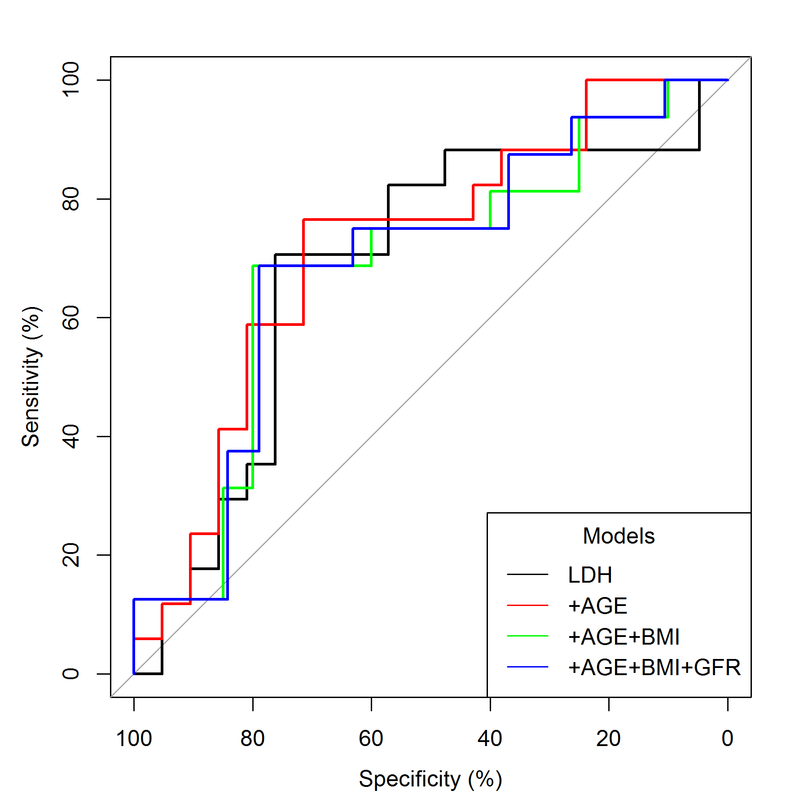
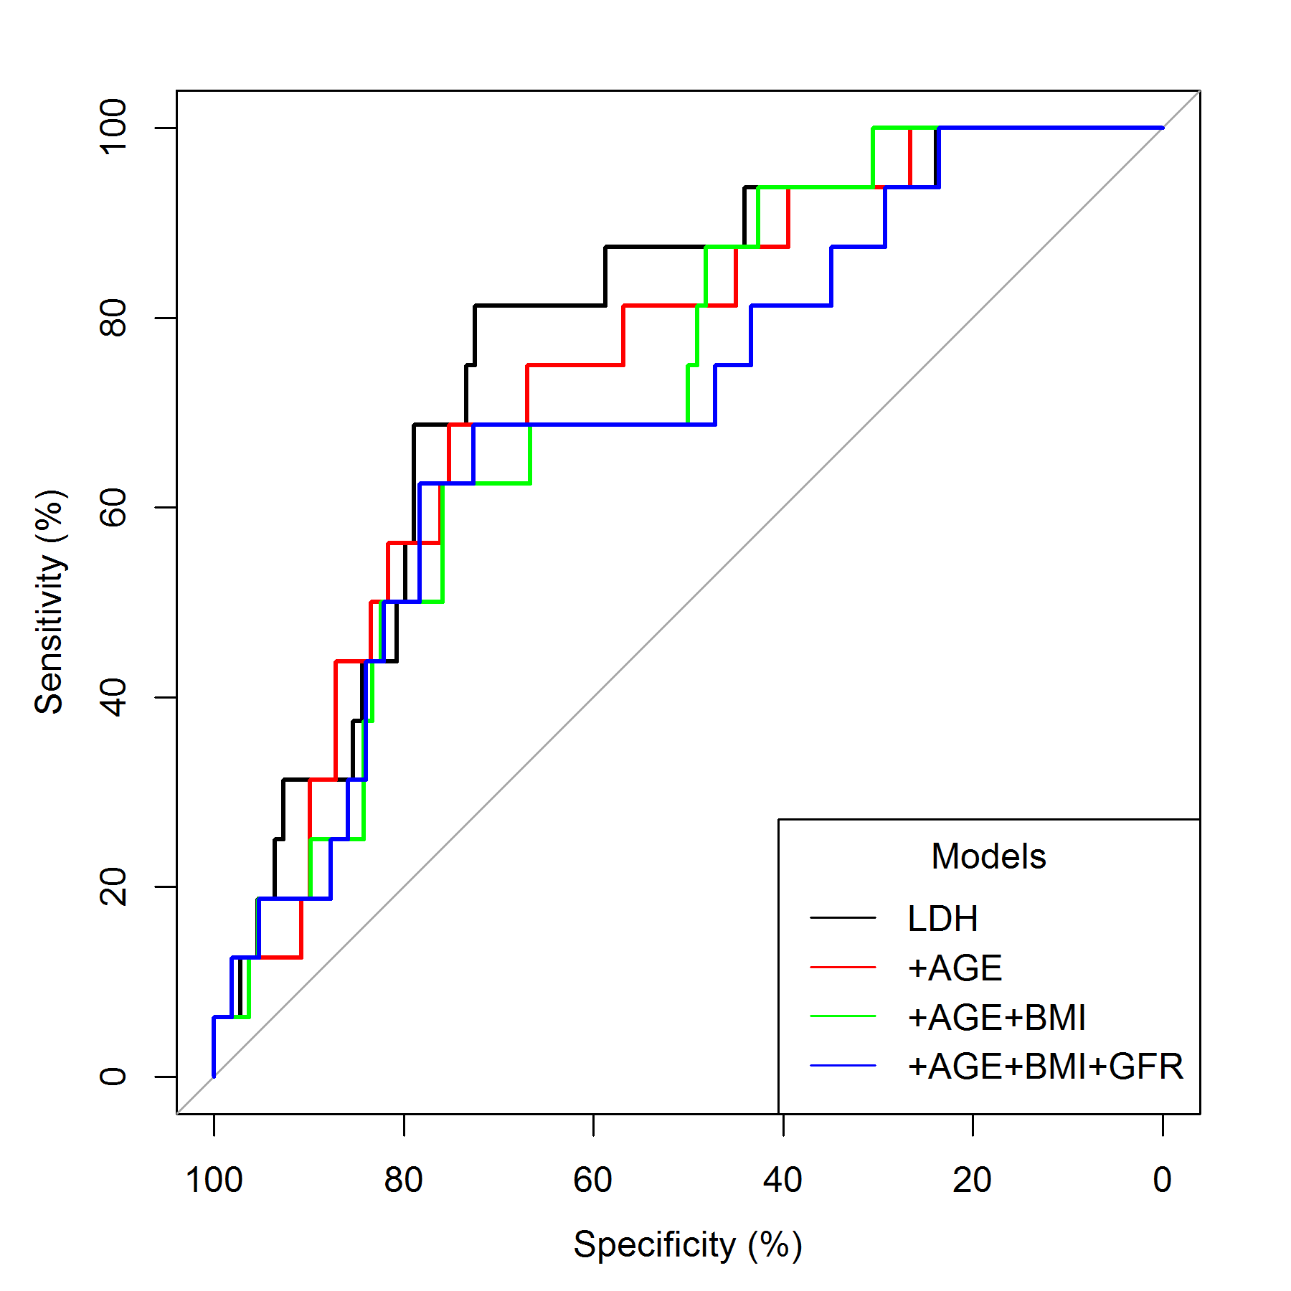
C) SOT D) IS - RD
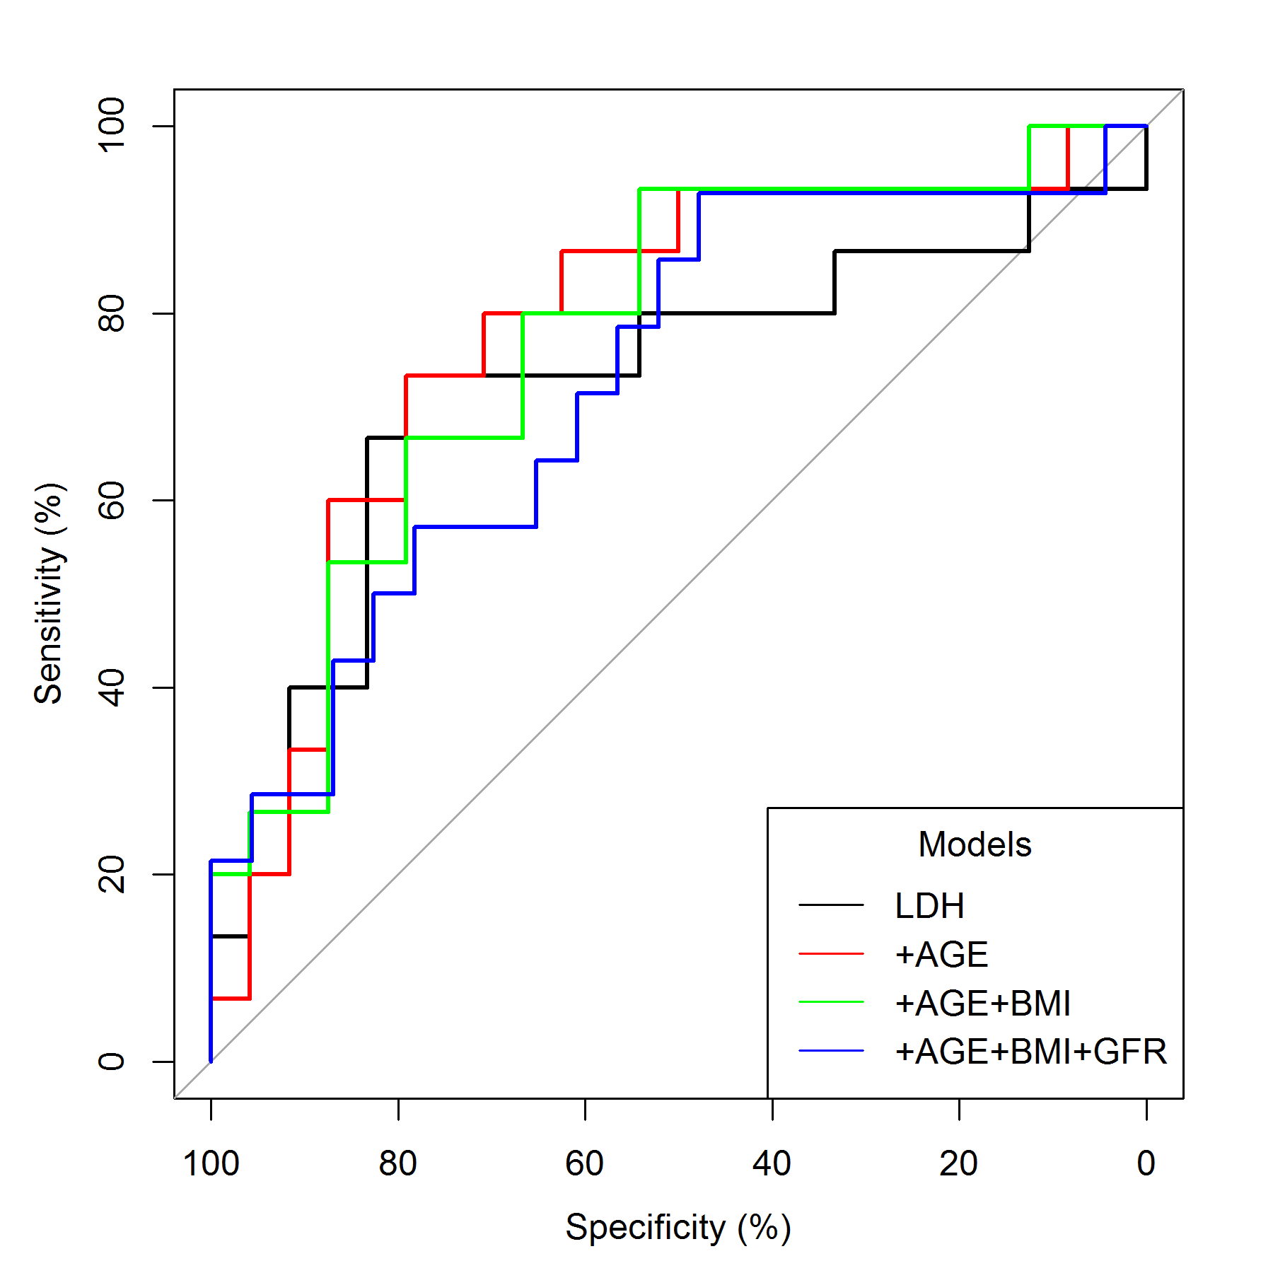
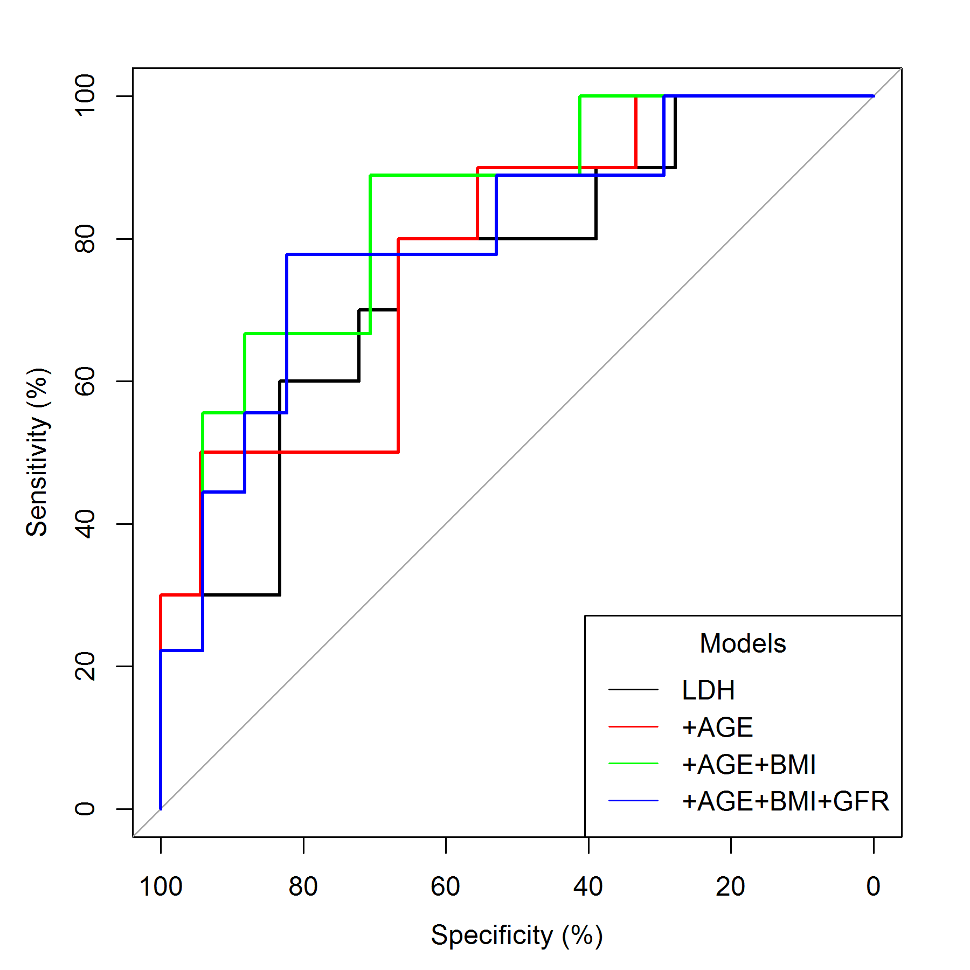

E) ICU patients
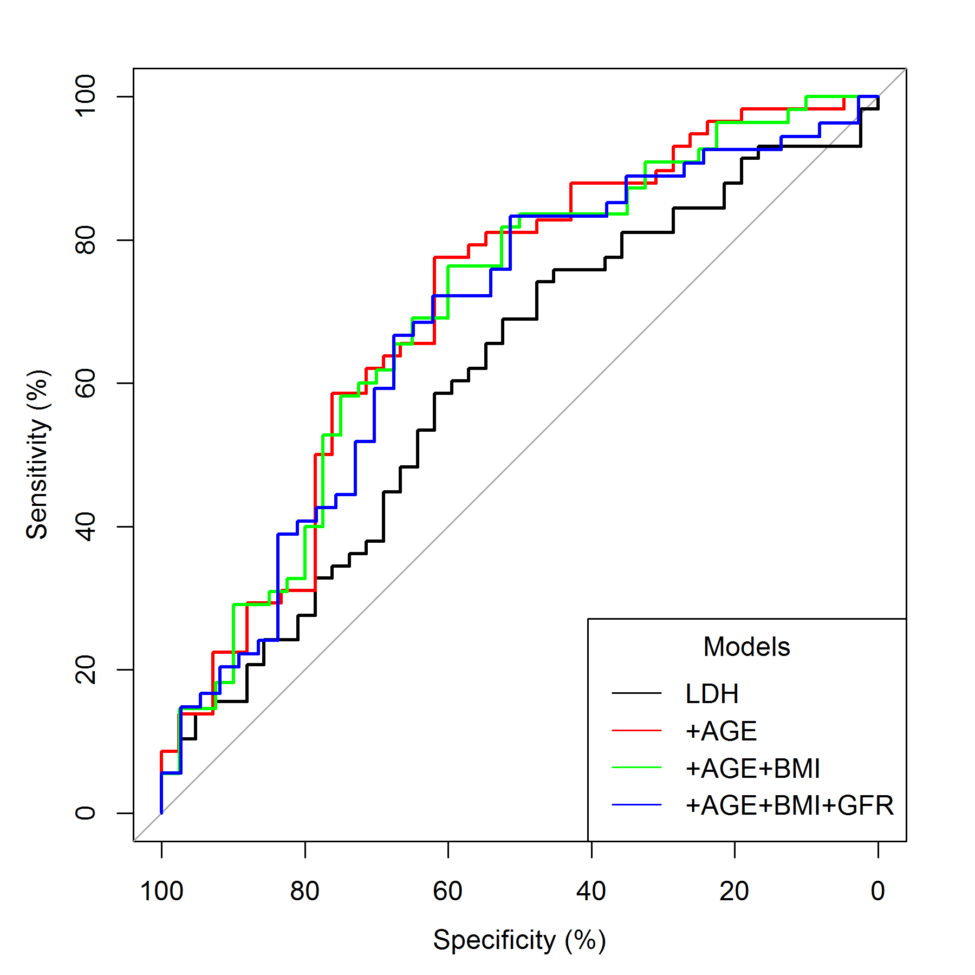

Figure S4 Receiver operating characteristic (ROC) curves for in-hospital mortality applied the LDH prediction model in three strata (years 2000-2005, 2005-2010, 2010-2017)

A 2000-2005 B 2005-2010
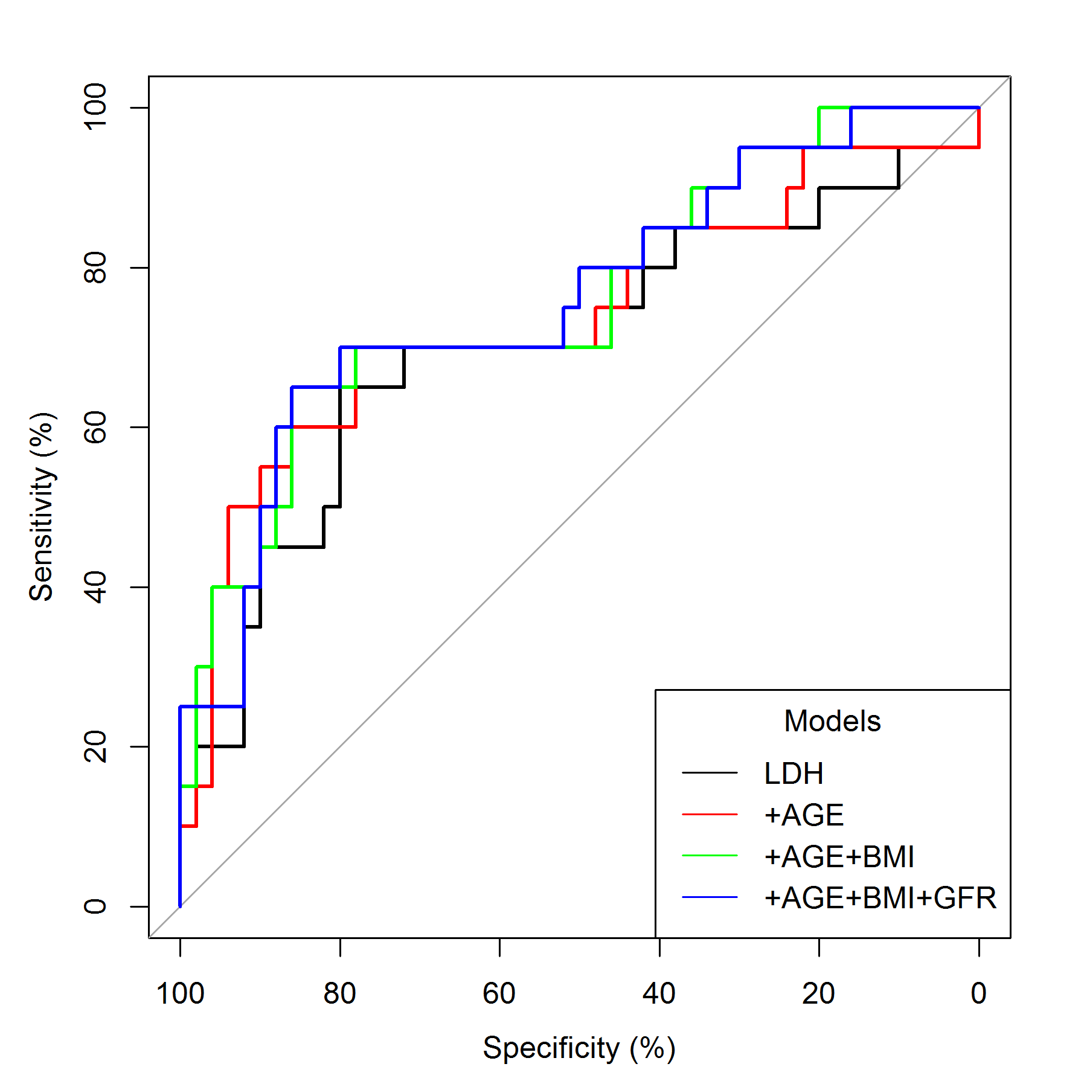
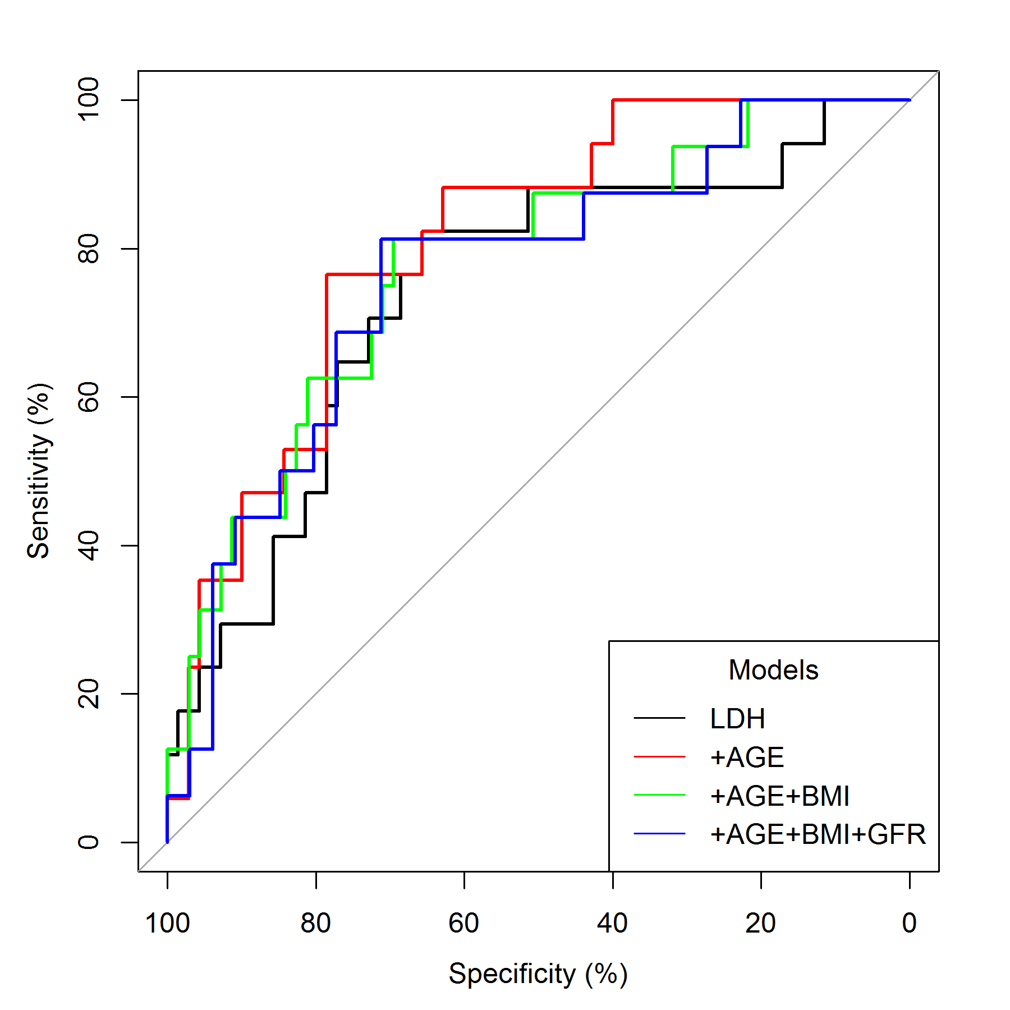

C 2010-2017
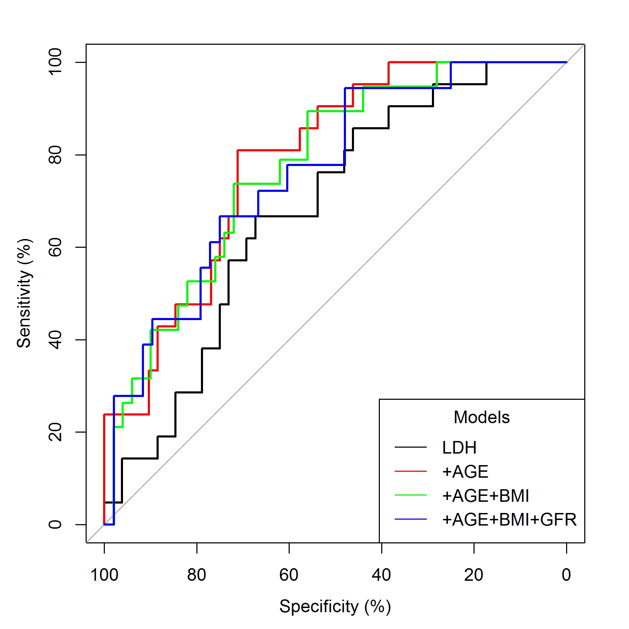

Figure S5 Association of trimethoprim-sulfamethoxazole (TMP-SMX) dose with mortality

(A) Bar graphs show individual doses of trimethoprim-sulfamethoxazole (TMP-SMX) in all 224 patients treated with this standard regimen. Green area highlights the recommended dose ≥ 15 mg/kg bodyweight (BW) (71%) and the red area the dose below < 15 mg/kg (29%). (B) Box plots show range of TMP-SMX dose upon different etiologies (HIV – human immunodeficiency virus, CHEMO – chemotherapy, SOT – solid organ transplantation, IS /RD – immunosuppression / rheumatic disease). (C) Kaplan-Meier plot shows survival in patients stratified for TMP-SMX dose < and ≥ 15 mg/kg over 120 days (p_{Log-rank test} =0.03).

