Additional file 1

Figure S1. Flow sheet

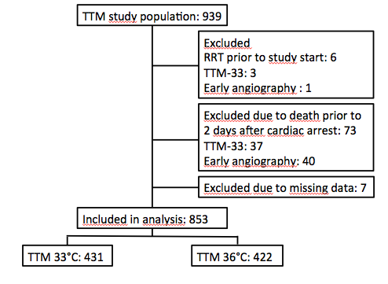

Figure S2. Number of patients and stage of AKI from day 2-7 after cardiac arrest.

Table S1. Definitions of AKI stage as used in the study.

Stage | S-Creatinine | Urine output
1 | 1.5-1.9x baseline (within 7d) or  ≥0.3 mg/dL (≥26.5 μmol/L) increase during 48 h | Not applicable
2 | 2.0-2.9x baseline | <0.5 ml/kg/h for 24 h
3 | 3.0x baseline or  Increase in S-Creatinine to ≥4.0 (≥353.6 μmol/L) or  Renal replacement therapy | <0.3 ml/kg/h for 24 h

Table S2. Patient data stratified according to temperature allocation.

 | TTM 33°C (n=431) | TTM 36°C (n=422) | p
Baseline variables
Age (years) | 65 (57-72) | 65 (56-73) | 0.71
Sex (male) | 361/431 (84 %) | 336/422 (80 %) | 0.14
Hypertension | 176/430 (41 %) | 165/420 (39 %) | 0.58
CHF (NYHA 3-4) | 29/429 (7 %) | 27/422 (6 %) | 0.89
Any IHD, PCI, AMI, CABG | 147/431 (34 %) | 120/419 (29 %) | 0.07
Diabetes | 53/428 (12 %) | 68/420 (16 %) | 0.12
Cardiac arrest variables
Shockable rhythm | 343/431 (80 %) | 343/422 (81 %) | 0.61
Bystander CPR | 318/431 (74 %) | 307/422 (73%) | 0.70
Time CA-ROSC (min) | 25 (17-37) | 25 (15-39) | 0.55
Shock on admission | 56/431 (13 %) | 56/422 (13 %) | 1.00
Lactate on admission (mmol/L | 5.6 (2.8-9.0) | 5.3 (2.4-8.8) | 0.77
IABP | 76/431 (18 %) | 68/423 (17 %) | 0.58
Angiography within 6h of CA | 262/424 (62 %) | 254/411 (62 %) | 0.94
Any vasoactive drug
Day 1 | 329/427 (77 %) | 320/418 (77 %) | 0.87
Day 2 | 373/425 (88 %) | 332/418 (79 %) | 0.001
Day 3 | 338/425 (80 %) | 274/418 (66 %) | <0.001
Noradrenaline or Adrenaline >0.1 μg/kg/min d 1-3 | 242/431 (56 %) | 199/422 (47 %) | 0.45
Renal variables/outcomes
Baseline creatinine (μmol/L) | 105 (85-125) | 105 (85-125) | 0.12
Creatinine >130 μmol/L | 73/420 (17 %) | 77/412 (19 %) | 0.65
Worst AKI stage in first week |  |  | 0.018
stage 1 | 78/431 (18 %) | 60/422 (14 %) | 0.14
stage 2 | 63/431 (15 %) | 53/422 (13 %) | 0.42
stage 3 | 70/431 (16 %) | 57/422 (14 %) | 0.29
Any AKI first week | 211/431 (49 %) | 170/422 (40 %) | 0.01
Daily fluid balance
Day 2 | 1700 (675-2925) | 1300 (375-2200) | <0.001
Day 3 | 500 (-400-+1700) | 300 (-600-+1200) | 0.001
RRT during first week | 38/432 (9 %) | 36/422 (8 %) | 0.90
Survival at 6 months | 238/431 (55 %) | 236/422 (56 %) | 0.78

