Figure S1 Subgroup analysis of mortality
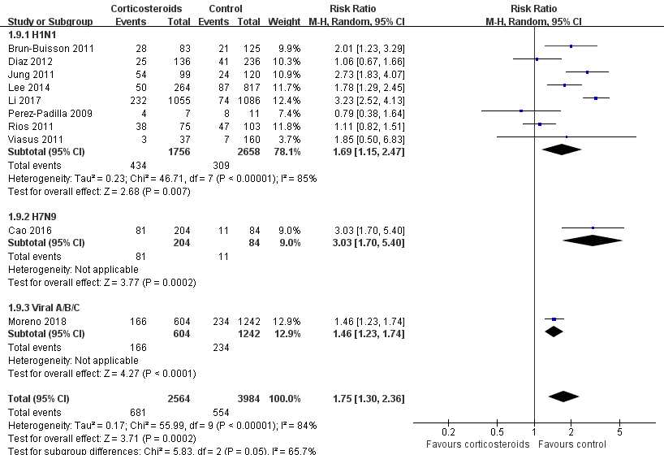

Diamonds indicate overall estimates from the meta-analysis; squares indicate point estimates of the result of each study; horizontal lines represent 95% CI.
CI, confidence interval; RR, risk ratio

Figure S2 Subgroup analysis of MV days

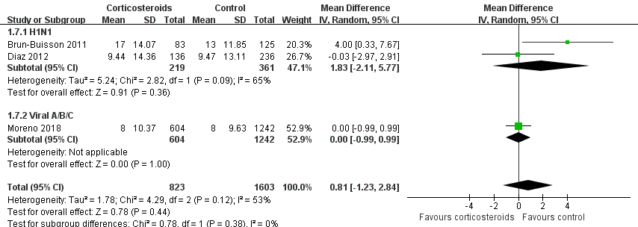
Diamonds indicate overall estimates from the meta-analysis; squares indicate point estimates of the result of each study; horizontal lines represent 95% CI.
CI, confidence interval; MV, mechanical ventilation; MD, mean difference

Figure S3 Subgroup analysis of ICU LOS
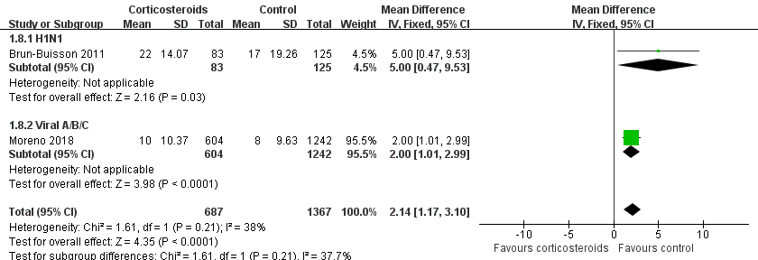

Diamonds indicate overall estimates from the meta-analysis; squares indicate point estimates of the result of each study; horizontal lines represent 95% CI.
CI, confidence interval; ICU, intensive care unit; LOS, length of stay; MD, mean difference

Figure S4 Subgroup analysis of rate of secondary infection
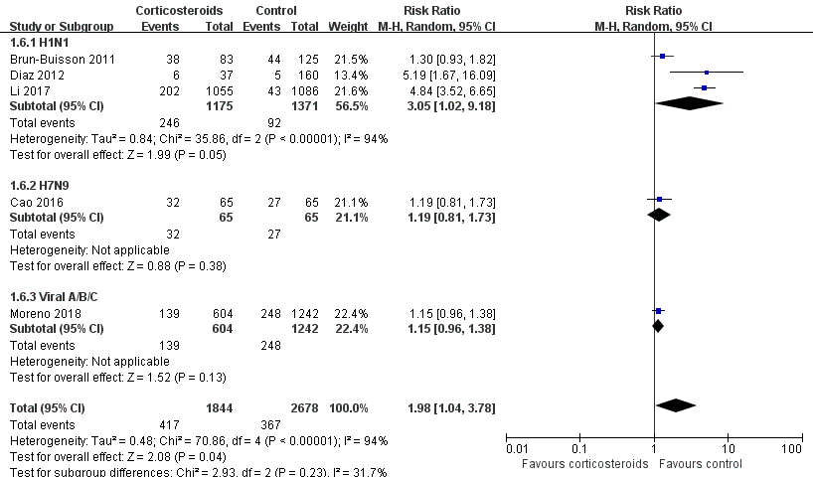

Diamonds indicate overall estimates from the meta-analysis; squares indicate point estimates of the result of each study; horizontal lines represent 95% CI.
CI, confidence interval; RR, risk ratio

