Online only supplementary material
Santhakumaran S et al. Heterogeneity of Treatment Effect by Baseline Risk of Mortality in Critically Ill Patients: Re-analysis of three recent Sepsis and ARDS Randomised Controlled Trials.

Supplementary Tables captions
Table S1: Results from multiple imputation analysis; for patients with missing APACHE-II, we assumed the proportion in the high-risk category (APACHE-II≥25) was either the same as the trial participants with complete data, 10% higher or 10% lower.
Table S2: Treatment-risk interaction using continuous APACHE II from logistic regression analysis of 28-day mortality

Supplementary Figures captions
Figure S1: Forest plots for the risk difference and risk ratio comparing related serious adverse events in treatment and control, by trial and APACHE-II subgroup
Figure S2: Forest plots for the risk difference and risk ratio comparing hospital mortality in treatment and control, by trial and APACHE-II subgroup
Figure S3: Forest plots for the risk difference and risk ratio comparing 28-day mortality in treatment and control, by trial and recalibrated APACHE-II subgroup
Figure S4: HTE assessment for APACHE II score as a continuous variable in a logistic regression model
Figures shows the estimated treatment effect with 95% confidence interval bands from regression models for 28-day mortality including a treatment x APACHE II score interaction for eFig4A: VANISH Vasopressin; eFig4B: VANISH Hydrocortisone; eFig4C: LeoPARDS and eFig4D: HARP-2.

Table S1 Results from multiple imputation analysis; for patients with missing APACHE-II, we assumed the proportion in the high risk category (APACHE-II≥25) was either the same as the trial participants with complete data, 10% higher or 10% lower.
Trial, and assumption for missing APACHE-II | % APACHE-II≥25 | Difference in RD (95% CI) | Ratio of RR (95% CI)
VANISH V-N
Same as complete data | 50% | 0.03 (-0.16,0.21) | 1.02 (0.51, 2.04)
10% higher | 60% | 0.03 (-0.16, 0.21) | 1.03 (0.51, 2.07)
10% lower | 40% | 0.01 (-0.17, 0.20) | 0.96 (0.49, 1.90)
VANISH HC-P
Same as complete data | 50% | 0.03 (-0.19,0.25) | 1.02 (0.49, 2.14)
10% higher | 60% | 0.03 (-0.20, 0.25) | 1.03 (0.48, 2.19)
10% lower | 40% | 0.02 (-0.21, 0.25) | 0.99 (0.47, 2.09)
LeoPARDS
Same as complete data | 56% | -0.01 (-0.17, 0.17) | 0.89 (0.47, 1.69)
10% higher | 66% | -0.01 (-0.17, 0.16) | 0.86 (0.45, 1.67)
10% lower | 46% | -0.02 (-0.17, 0.17) | 0.89 (0.47, 1.69)
HARP-2
Same as complete data | 19% | 0.31 (0.10, 0.52) | 2.99 (1.51, 5.90)
10% higher | 29% | 0.30 (0.08, 0.52) | 2.96 (1.43, 6.10)
10% lower | 18% | 0.30 (0.09, 0.51) | 2.86 (1.47, 5.57)

Table S2: Treatment-risk interaction using continuous APACHE II from logistic regression analysis of 28-day mortality
Trial | Ratio of OR for a 5 point increase in APACHE II | 95% confidence interval
VANISH V-N | 0.96 | (0.71, 1.29)
VANISH HC-P | 0.93 | (0.67, 1.29)
LeoPARDS | 1.00 | (0.74, 1.34)
HARP-2 | 1.33 | (0.93, 1.90)

Figure S1 Forest plots for the risk difference and risk ratio comparing related serious adverse events in treatment and control, by trial and APACHE-II subgroup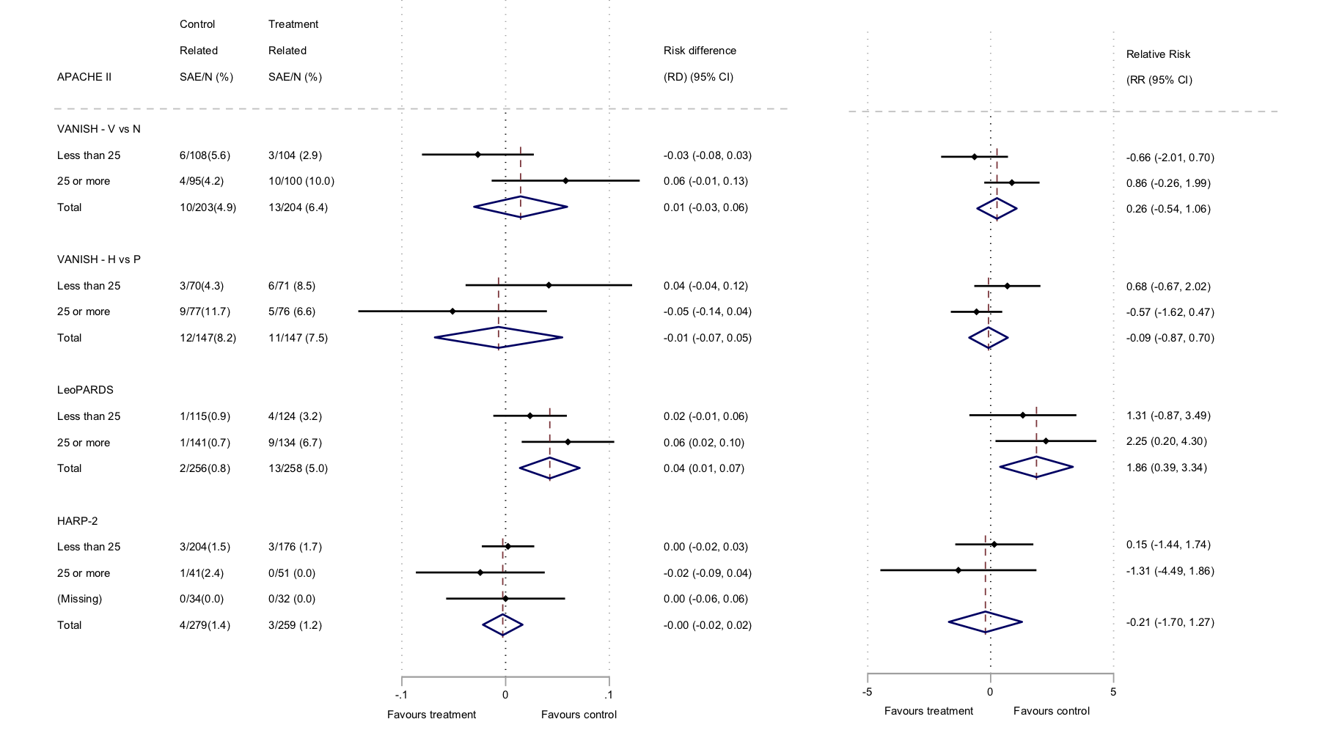

Figure S2 Forest plots for the risk difference and risk ratio comparing hospital mortality in treatment and control, by trial and APACHE-II subgroup
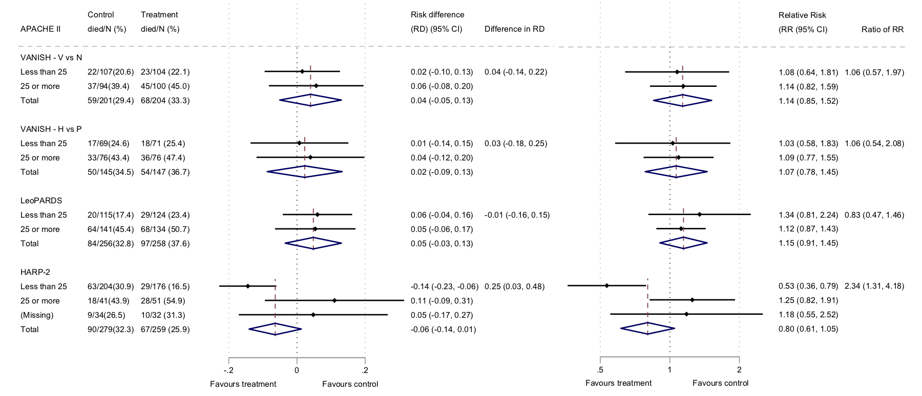

Figure S3: Forest plots for the risk difference and risk ratio comparing 28-day mortality in treatment and control, by trial and recalibrated APACHE-II subgroup

Figure S4: HTE assessment for APACHE II score as a continuous variable

