ADDITIONAL FILE
Prevalence of post-traumatic stress disorder symptoms in adult critical care survivors: a systematic review and meta-analysis

Table of contents
Supplementary material | Page
Table S1. Search strategy | 2
Table S2. Classification of studies according to the instrument used and the moment of assessment | 5
Figure S1. PTSD symptoms assessed with PTSS-10 up to three months after ICU stay. | 7
Figure S2. Clinical assessment of PTSD and assessment of PTSD symptoms with IES-R, three months after ICU stay | 8
Figure S3. PTSD symptoms assessed with IES-R and PTSS-10, six months after ICU stay | 9
Figure S4. PTSD symptoms assessed with IES-R and IES, one year after ICU stay | 10
Figure S5. Clinical assessment of PTSD assessed more than one year after ICU stay | 11
Table S3. Risk of bias in included studies (Joanna-Briggs Institute’s critical appraisal checklist) | 12
Table S4. Quality of evidence for post-traumatic stress disorder (PTSD) prevalence by the GRADE approach | 14

Table S1. Search strategy.
MEDLINE (PubMed) | 1. ("Critical Care"[MeSH] OR "Intensive Care Units"[MeSH] OR "critical illness"[MeSH] OR ICU OR Sepsis OR "Respiratory Distress Syndrome, Adult"[MeSH] OR ARDS)  2. ("Outcome Assessment (Health Care)"[MeSH] OR "Patient Outcome Assessment"[MeSH] OR "Follow-Up Studies"[MeSH] OR "Health Status"[MeSH] OR "Morbidity"[MeSH] OR "complications" [Subheading] OR "Long-Term Care"[MeSH] OR "Survivors"[MeSH])  3. (("Anxiety" OR "Anxiety"[MeSH] OR "Depression"[MeSH] OR Depres* OR "Depression"[MeSH] OR "Depressive Disorder"[MeSH]) OR "Stress Disorders, Post-Traumatic"[MeSH] OR "Stress Disorders, Traumatic, Acute"[MeSH] OR Post-Trauma* OR "Cognition"[MeSH] OR “Neurocognitive Disorders"[MeSH] OR "Cognition Disorders"[MeSH] OR "Cognitive Dysfunction"[MeSH] OR (Cogniti* AND (loss OR impairment OR disorder OR sequel OR dysfunction OR decline)) OR "Neuropsychiatry"[MeSH])  4. 1 AND 2 AND 3
WEB OF SCIENCE | 1. TS=("Critical Care") OR TS=("Intensive Care Units") OR TS=("critical illness") OR TS=(ICU) OR TS=(Sepsis) OR TS=("Respiratory Distress Syndrome, Adult") OR TS=(ARDS)  2. TS=("Critical Care") OR TS=("Intensive Care Units") OR TS=("critical illness") OR TS=(ICU) OR TS=(Sepsis) OR TS=("Respiratory Distress Syndrome, Adult") OR TS=(ARDS) AND TS=("Outcome Assessment (Health Care)") OR TS=("Patient Outcome Assessment") OR TS=("Follow-Up Studies") OR TS=("Health Status") OR TS=("Morbidity") OR TS=("complications") OR TS=("Long-Term Care") OR TS=("Survivors")  3. TS=("Anxiety") OR TS=("Depression") OR TS=(Depres*) OR TS=("Depression") OR TS=("Depressive Disorder") OR TS=("Stress Disorders, Post-Traumatic") OR TS=("Stress Disorders, Traumatic, Acute") OR TS=("Post-Trauma*") OR TS=("Cognition") OR TS=("Neurocognitive Disorders") OR TS=("Cognition Disorders") OR TS=("Cognitive Dysfunction") OR (TS=(Cogniti*) AND (TS=(loss) OR TS=( impairment) OR TS=(disorder) OR TS=(sequel) OR TS=(dysfunction) OR TS=(decline))) OR TS=("Neuropsychiatry")  4. 1 AND 2 AND 3
SCOPUS | (TITLE-ABS-KEY("Critical Care") OR TITLE-ABS-KEY("Intensive Care Units") OR TITLE-ABS-KEY("critical illness") OR TITLE-ABS-KEY(ICU) OR TITLE-ABS-KEY(Sepsis) OR TITLE-ABS-KEY("Respiratory Distress Syndrome, Adult") OR TITLE-ABS-KEY(ARDS)) AND (TITLE-ABS-KEY("Outcome Assessment (Health Care)") OR TITLE-ABS-KEY("Patient Outcome Assessment") OR TITLE-ABS-KEY("Follow-Up Studies") OR TITLE-ABS-KEY("Health Status") OR TITLE-ABS-KEY("Morbidity") OR TITLE-ABS-KEY("complications") OR TITLE-ABS-KEY("Long-Term Care") OR TITLE-ABS-KEY("Survivors")) AND (TITLE-ABS-KEY(Anxiety) OR TITLE-ABS-KEY("Depression") OR TITLE-ABS-KEY(Depres*) OR TITLE-ABS-KEY("Depression") OR TITLE-ABS-KEY("Depressive Disorder") OR TITLE-ABS-KEY("Stress Disorders, Post-Traumatic") OR TITLE-ABS-KEY("Stress Disorders, Traumatic, Acute") OR TITLE-ABS-KEY(Post-Trauma*) OR TITLE-ABS-KEY("Cognition") OR TITLE-ABS-KEY("Neurocognitive Disorders") OR TITLE-ABS-KEY("Cognition Disorders") OR TITLE-ABS-KEY("Cognitive Dysfunction") OR TITLE-ABS-KEY("Neuropsychiatry") OR (TITLE-ABS-KEY(Cogniti*) AND (TITLE-ABS-KEY(loss) OR TITLE-ABS-KEY(impairment) OR TITLE-ABS-KEY(disorder) OR TITLE-ABS-KEY(sequel) OR TITLE-ABS-KEY(dysfunction) OR TITLE-ABS-KEY(decline))))
LILACS | ("Critical Care" OR "Intensive Care Units" OR "critical illness" OR ICU OR Sepsis OR Sepse OR "Respiratory Distress Syndrome, Adult" OR ARDS OR SARA OR "Terapia Intensiva" OR CTI) AND ("Outcome Assessment (Health Care)" OR "Patient Outcome Assessment" OR "Follow-Up Studies" OR "Health Status" OR "Morbidity" OR "complications" OR "Long-Term Care" OR "Survivors" OR Desfecho OR Morbidade OR Complicações) AND ("Anxiety" OR Depres* OR "Depressive Disorder" OR "Stress Disorders, Post-Traumatic" OR "Stress Disorders, Traumatic, Acute" OR Post-Trauma* OR "Cognition" OR "Neurocognitive Disorders" OR "Cognition Disorders" OR "Cognitive Dysfunction" OR (Cogniti* AND (loss OR impairment OR disorder OR sequel OR dysfunction OR decline)) OR "Neuropsychiatry" OR Delirium OR "Stress Pós Traumático" OR "Sequela Cognitiva" OR "Déficit Cognitivo")
PSYCNET | 1. Any Field: "Critical Care" OR Any Field: "Intensive Care Units" OR Any Field:"critical illness" OR Any Field: ICU OR Any Field: Sepsis OR Any Field: "Respiratory Distress Syndrome, Adult" OR Any Field: ARDS  2. Any Field: "Outcome Assessment (Health Care)" ORAny Field: "Patient Outcome Assessment" OR Any Field: "Follow-Up Studies" OR Any Field:"Health Status" OR Any Field: "Morbidity" OR Any Field: "complications" OR Any Field: "Long-Term Care" OR Any Field: "Survivors"  3. Any Field: "Anxiety" OR Depres* OR "Depressive Disorder" OR "Stress Disorders, Post-Traumatic" OR "Stress Disorders, Traumatic, Acute" OR Post-Trauma* OR "Cognition" OR “Neurocognitive Disorders" OR "Cognition Disorders" OR "Cognitive Dysfunction" OR (Cogniti* AND (loss OR impairment OR disorder OR sequel OR dysfunction OR decline)) OR "Neuropsychiatry"  4. 1 AND 2 AND 3
EMBASE | (('outcome assessment (health care)'/de OR 'patient outcome assessment'/de OR 'follow-up studies'/de OR 'health status'/de OR 'morbidity'/de OR complications OR 'long-term care'/de OR 'survivors'/de) AND ('critical care'/de OR 'intensive care units'/de OR 'critical illness'/de OR icu OR sepsis OR 'respiratory distress syndrome, adult'/de OR ards) AND ('anxiety'/de OR depres* OR 'depressive disorder' OR 'depression'/de OR 'stress disorders, post-traumatic'/de OR 'stress disorders, traumatic, acute'/de OR 'post trauma*' OR 'cognition'/de OR 'neurocognitive disorders'/de OR 'cognition disorders'/de OR 'cognitive dysfunction'/de OR (cogniti* AND (loss OR impairment OR disorder OR sequel OR dysfunction OR decline)) OR 'neuropsychiatry'/de)) AND ('article'/it OR 'article in press'/it OR 'letter'/it OR 'review'/it OR 'short survey'/it)

Table S2. Classification of studies according to the instrument used and the moment of assessment.
 | < 3 months | 3 months | 6 months | 12 months | > 12 months
CAPS |  |  | Hepp, 2008 | Hepp, 2008 | Hepp, 2008
DTS |  | Cuthbertson, 2004 |  | Abraham, 2014
IES | Myhren, 2009 |  | Hepp, 2008 | Hepp, 2008  Myhren, 2010 | Hepp, 2008 Van der Schaaf, 2009
IES-R | Bashar, 2018  Samuelson, 2007  Wallen, 2008 | Bienvenu, 2016  Chahraoui, 2015  Da Costa, 2012  De Miranda, 2008  Jonasdottir, 2017  Kress, 2003 | Bienvenu, 2016  Huang, 2016  Jonasdottir, 2017 | Bienvenu, 2016  Boer, 2008  Huang, 2016  Jonasdottir, 2017  Samuelson, 2007 | Bienvenu, 2016
Clinical assessment | Kapfhammer, 2004  Schyneder, 2001 | Asimakopoulou, 2015  Jubran, 2010 |  | Schelling, 2001 | Hauer, 2009  Kapfhammer, 2004  Richter, 2006
PCL-17 |  |  |  | Davydow, 2009
PCL-5 |  | Aitken, 2017
PCL-C |  | Davydow, 2014 | Elliot, 2016 | Davydow, 2014
PCL-S |  | Jackson, 2014 |  | Jackson, 2014
PDS |  | Wade, 2012 | Weinert, 2008
PTSS-10 | Cox, 2012  Gunther, 2017 | Castillo, 2016  Griffiths, 2006 | Castillo, 2016  Girard, 2007  Hauer, 2011  Wintermann, 2017 | Boer, 2008  Buguedo, 2013 | Strøm, 2011
PTSS-14 | Bashar, 2018 | Jones, 2007  Twigg. 2008 | Granja, 2008
SCID |  |  | Nickel, 2004
TSQ |  | Jones, 2012
CAPS, clinician-administered post-traumatic stress disorder scale; DTS, Davidson trauma scale; IES, impact event scale; IES-R, impact event scale revised; PCL-17, post-traumatic stress disorder checklist (17-item scale); PCL-5, Post-traumatic stress disorder checklist for DSM-5; PCL-C; post-traumatic stress disorder checklist-civilian version; PCL-S, post-traumatic stress disorder checklist-specific stressful experience version; PDS, Posttraumatic Stress Diagnostic Scale; PTSS-10, post-traumatic symptom scale (10-item scale); PTSS-14, post-traumatic symptom scale (14-item scale); SCID, Structured Clinical Interview; TSQ, Trauma Screening Questionnaire

Figure S1. PTSD symptoms assessed with IES-R and PTSS-10 up to three months after ICU stay.
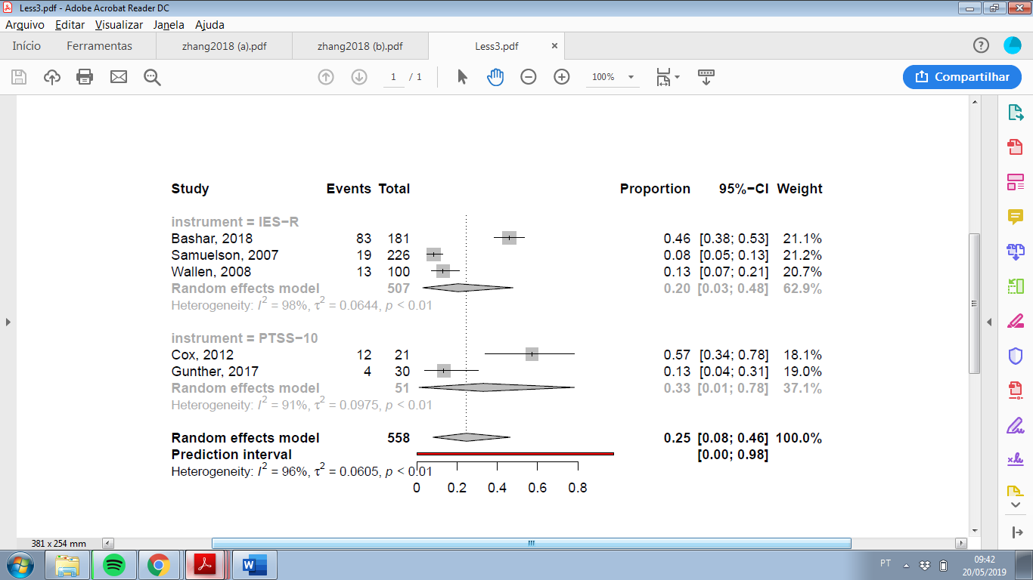

Figure S2. Clinical assessment of PTSD and assessment of PTSD symptoms with IES-R, three months after ICU stay.
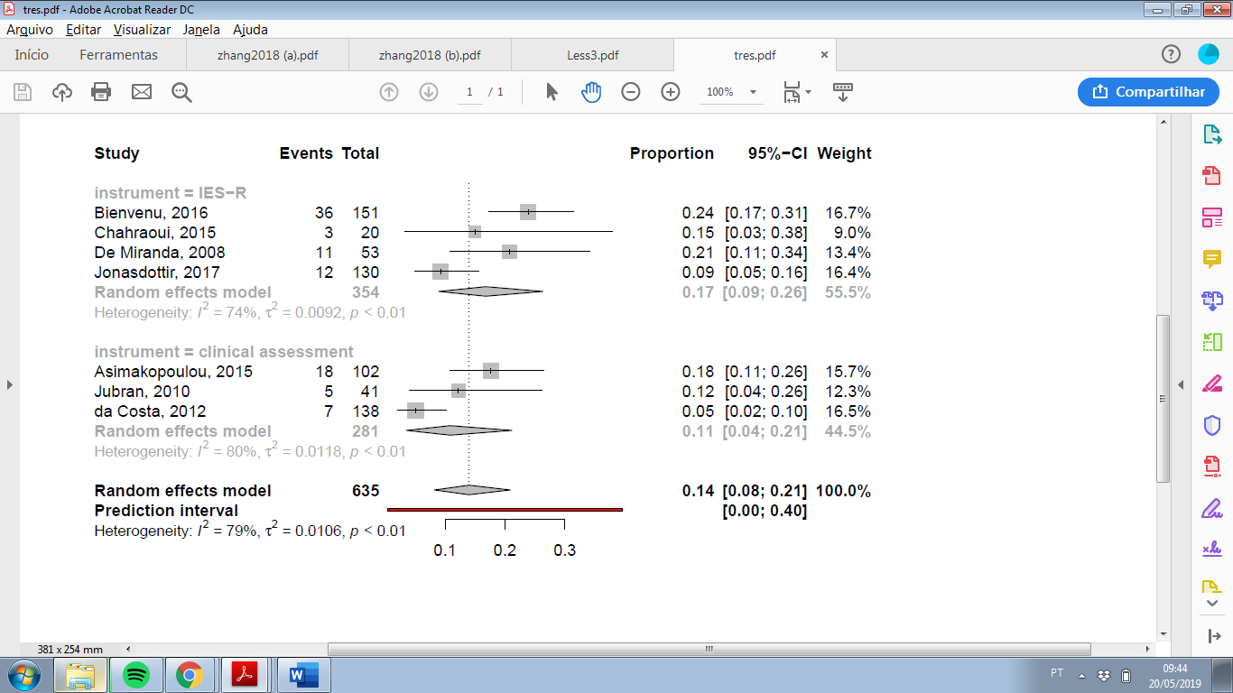

Figure S3. Clinical assessment of PTSD and assessement of PTDS symptoms with IES-R and PTSS-10, six months after ICU stay.
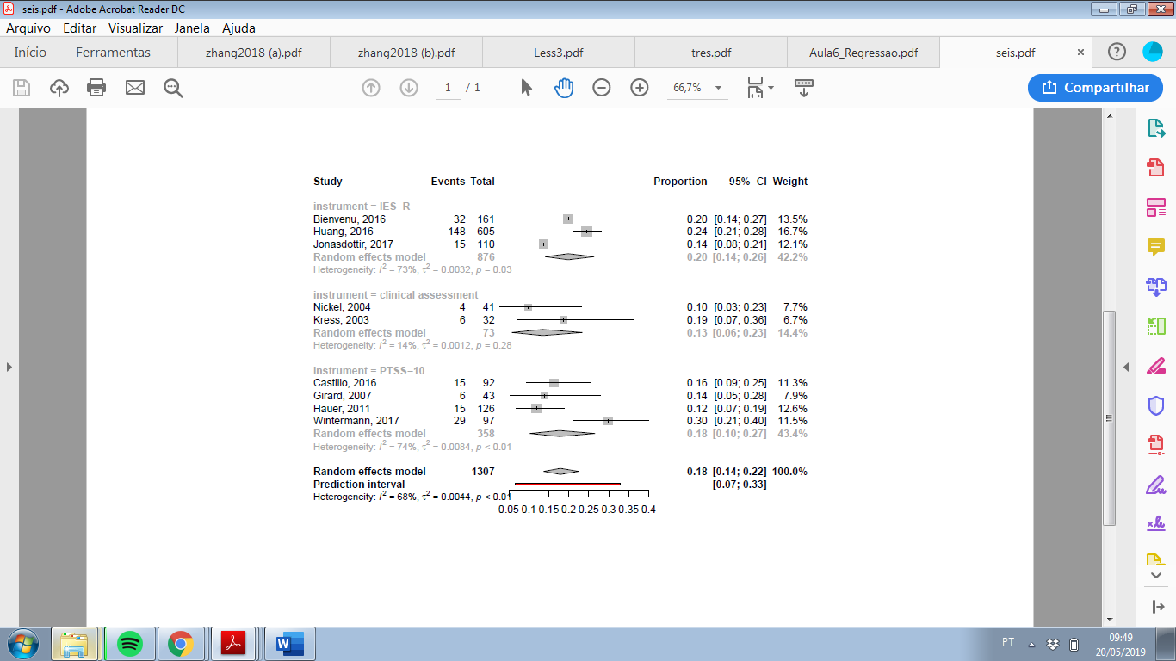

Figure S4. PTSD symptoms assessed with IES-R and IES, one year after ICU stay.
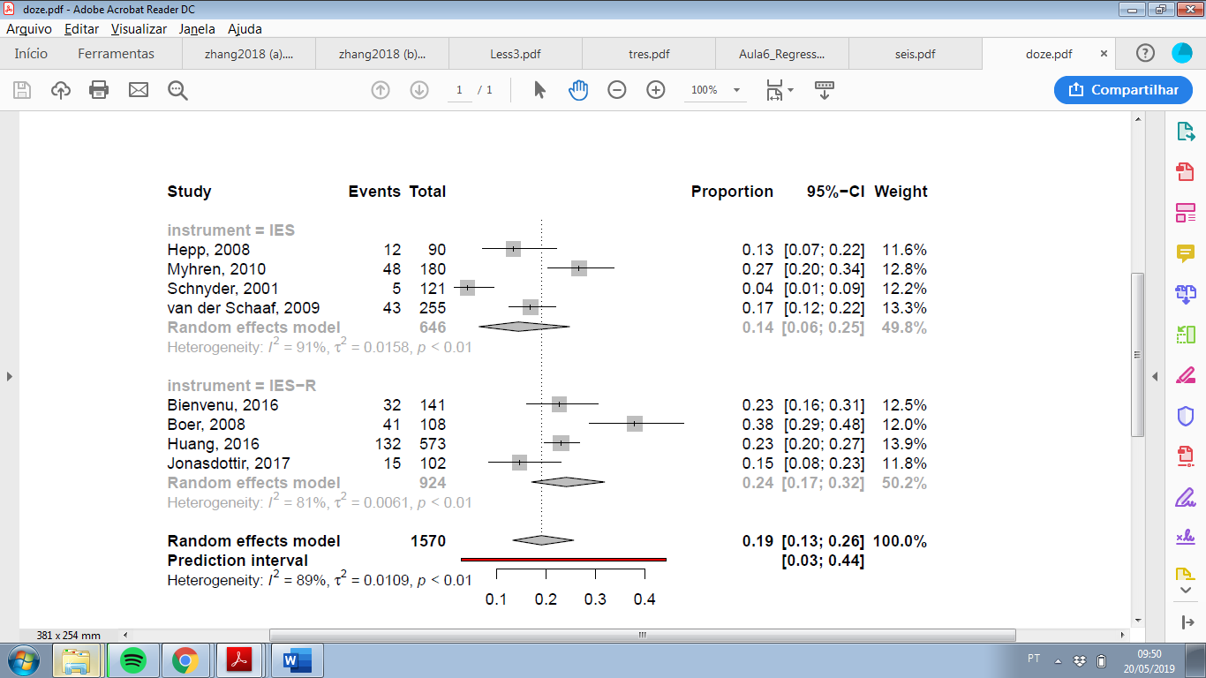

Figure S5. Clinical assessment of PTSD assessed more than one year after ICU stay.
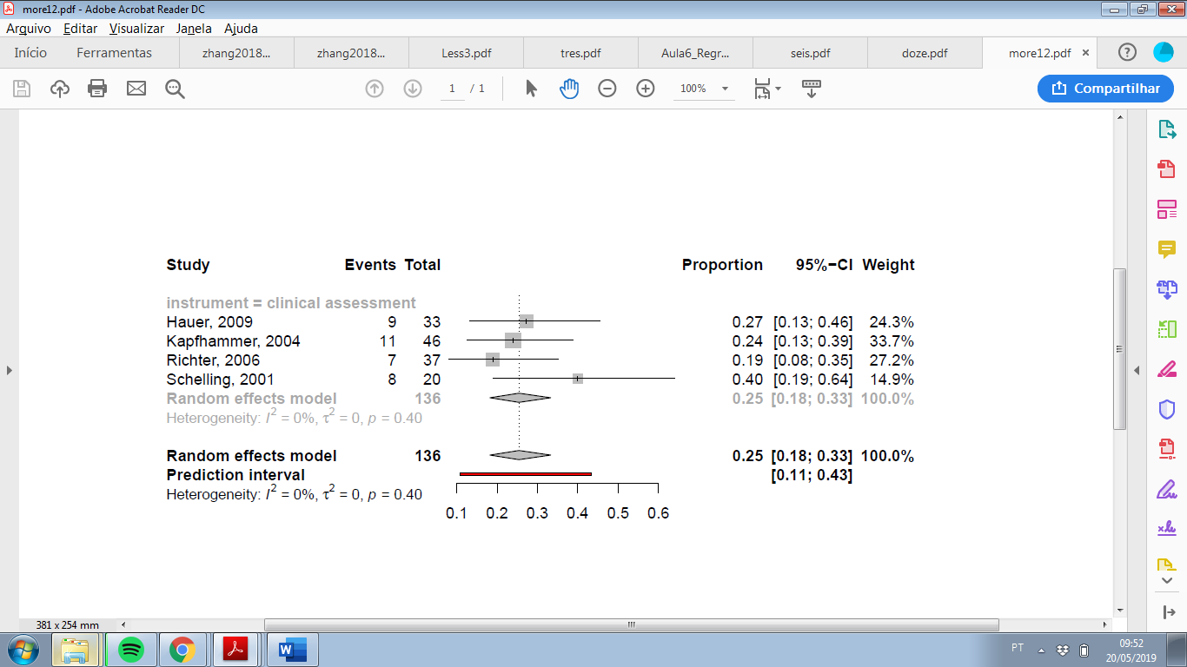

Table S3. Risk of bias in included studies (Joanna-Briggs Institute’s critical appraisal checklist).
Question | Abraham, 2014 | Aitken, 2017 | Asimakopoulou, 2015 | Bashar, 2018 | Bienvenu, 2016 | Boer, 2008 | Buguedo, 2013 | Castillo, 2016 | Chahraoui, 2015 | Cox, 2012 | Cuthbertson, 2004 | da Costa, 2012 | Davydow, 2009 | Davydow, 2014 | De Miranda, 2008 | Elliott, 2016 | Girard, 2007 | Granja, 2008 | Griffiths, 2006 | Gunther, 2017 | Hauer, 2009 | Hauer, 2011 | Hepp, 2008 | Huang, 2016
1. Was the sample frame appropriate to address the target population? | N | Y | Y | N | N | N | N | Y | N | Y | Y | Y | N | N | N | Y | N | Y | Y | Y | N | N | N | N
2. Were study participants sampled in an appropriate way? | Y | U | N | Y | Y | U | U | U | Y | Y | Y | Y | U | U | Y | U | U | U | Y | U | U | U | Y | U
3. Was the sample size adequate? | Y | N | Y | Y | Y | Y | N | Y | N | N | N | Y | Y | Y | N | Y | N | Y | Y | N | N | Y | Y | Y
4. Were the study subjects and the setting described in detail? | Y | Y | Y | Y | Y | Y | Y | Y | Y | Y | Y | Y | Y | Y | Y | Y | Y | Y | Y | Y | Y | Y | Y | Y
5. Was the data analysis conducted with sufficient coverage of the identified sample? | Y | N | U | Y | U | Y | U | N | Y | U | Y | U | U | N | U | U | Y | Y | U | U | U | U | Y | U
6. Were valid methods used for the identification of the condition? | N | N | N | N | N | N | N | N | Y | N | N | Y | N | N | N | N | N | N | N | N | Y | N | N | N
7. Was the condition measured in a standard, reliable way for all participants? | Y | Y | Y | Y | N | Y | Y | Y | Y | Y | Y | Y | U | Y | Y | Y | Y | Y | Y | Y | Y | Y | Y | Y
8. Was there appropriate statistical analysis? | Y | Y | Y | Y | Y | Y | Y | Y | Y | Y | Y | Y | Y | Y | Y | Y | Y | Y | Y | Y | Y | Y | Y | Y
9. Was the response rate adequate, and if not, was the low response rate managed appropriately? | Y | Y | Y | Y | Y | Y | N | Y | Y | Y | Y | N | Y | Y | N | Y | N | N | N | Y | Y | Y | Y | Y
Question | Jackson, 2014 | Jónasdóttir, 2017 | Jones, 2007 | Jones, 2012 | Jubran, 2010 | Kapfhammer, 2004 | Kress, 2003 | Myhren, 2009 | Myhren, 2010 | Nickel, 2004 | Richter, 2006 | Samuelson, 2007 | Schelling, 1999 | Schelling, 2001 | Schnyder, 2001 | Scragg, 2001 | Shaw, 2001 | Strom, 2011 | Twigg 2008 | van der Schaaf, 2009 | Wade, 2012 | Wallen, 2008 | Weinert, 2008 | Wintermann, 2017
1. Was the sample frame appropriate to address the target population? | N | Y | Y | N | N | N | N | Y | Y | N | N | Y | N | N | N | N | N | N | Y | Y | Y | Y | N | N
2. Were study participants sampled in an appropriate way? | U | U | Y | U | U | U | U | Y | U | Y | U | Y | U | U | Y | Y | U | U | N | Y | Y | U | U | Y
3. Was the sample size adequate? | Y | Y | Y | Y | N | N | N | Y | Y | N | N | Y | N | N | Y | Y | N | N | N | Y | Y | Y | Y | Y
4. Were the study subjects and the setting described in detail? | Y | Y | Y | Y | Y | Y | Y | Y | Y | N | Y | Y | Y | Y | Y | N | N | Y | Y | Y | Y | Y | Y | Y
5. Was the data analysis conducted with sufficient coverage of the identified sample? | N | U | U | Y | Y | Y | U | U | N | N | N | Y | U | Y | Y | U | Y | U | U | N | Y | U | N | N
6. Were valid methods used for the identification of the condition? | N | N | N | N | Y | Y | Y | N | N | Y | Y | N | N | Y | N | N | N | N | N | N | N | N | N | Y
7. Was the condition measured in a standard, reliable way for all participants? | Y | Y | Y | Y | Y | Y | Y | Y | Y | Y | Y | Y | Y | Y | Y | Y | Y | Y | Y | Y | Y | N | Y | Y
8. Was there appropriate statistical analysis? | Y | Y | Y | Y | Y | Y | Y | Y | Y | Y | Y | Y | Y | Y | Y | Y | Y | Y | Y | Y | Y | Y | Y | Y
9. Was the response rate adequate, and if not, was the low response rate managed appropriately? | Y | Y | Y | Y | Y | Y | N | Y | Y | Y | N | Y | Y | Y | Y | Y | Y | N | Y | Y | Y | Y | N | N
N, No; U, Unclear; Y, Yes. Prespecified domains for quality assessment: a) participants (questions 1, 2, 4, and 9); b) outcome measurement (questions 6 and 7); and c) statistics (questions 3, 5, and 8).
Table S4. Quality of evidence for post-traumatic stress disorder (PTSD) prevalence by the GRADE approach.
Certainty assessment |  |  |  |  |  |  | Summary of findings
No. of participants (studies) | Risk of bias | Inconsistency | Indirectness | Imprecision | Other | Overall certainty of evidence | Impact
5077 (29 studies) | seriousª | not serious^{b} | serious^{c} | not serious | none | ⨁⨁◯◯  LOW | The prevalence of PTSD in ICU survivors was 19.83% (95%CI, 16.72-23.13; 95% prediction interval, 3.70-43.73).
CI, confidence interval; ICU, intensive care unit; PTSD, post-traumatic stress disorder.
Explanations:
a. Most studies did not use appropriate instruments to measure PTSD prevalence and did not report how participants were recruited. Many studies had issues related to sample size and sample coverage.
b. Even though I²=90%, studies yielded similar results, with the point estimates of most studies ranging from 15 to 25% and showing an overlap of CIs. High I² values are expected in a meta-analysis of prevalence studies, with limited significance in this context. In addition, most probable cause of statistical heterogeneity is the difference in study population, factor that has been penalized in the assessment of indirectness domain.
c. Many studies included patients from specific settings (such as patients with specific medical conditions), rather than from general ICUs, contributing for the sample heterogeneity.

