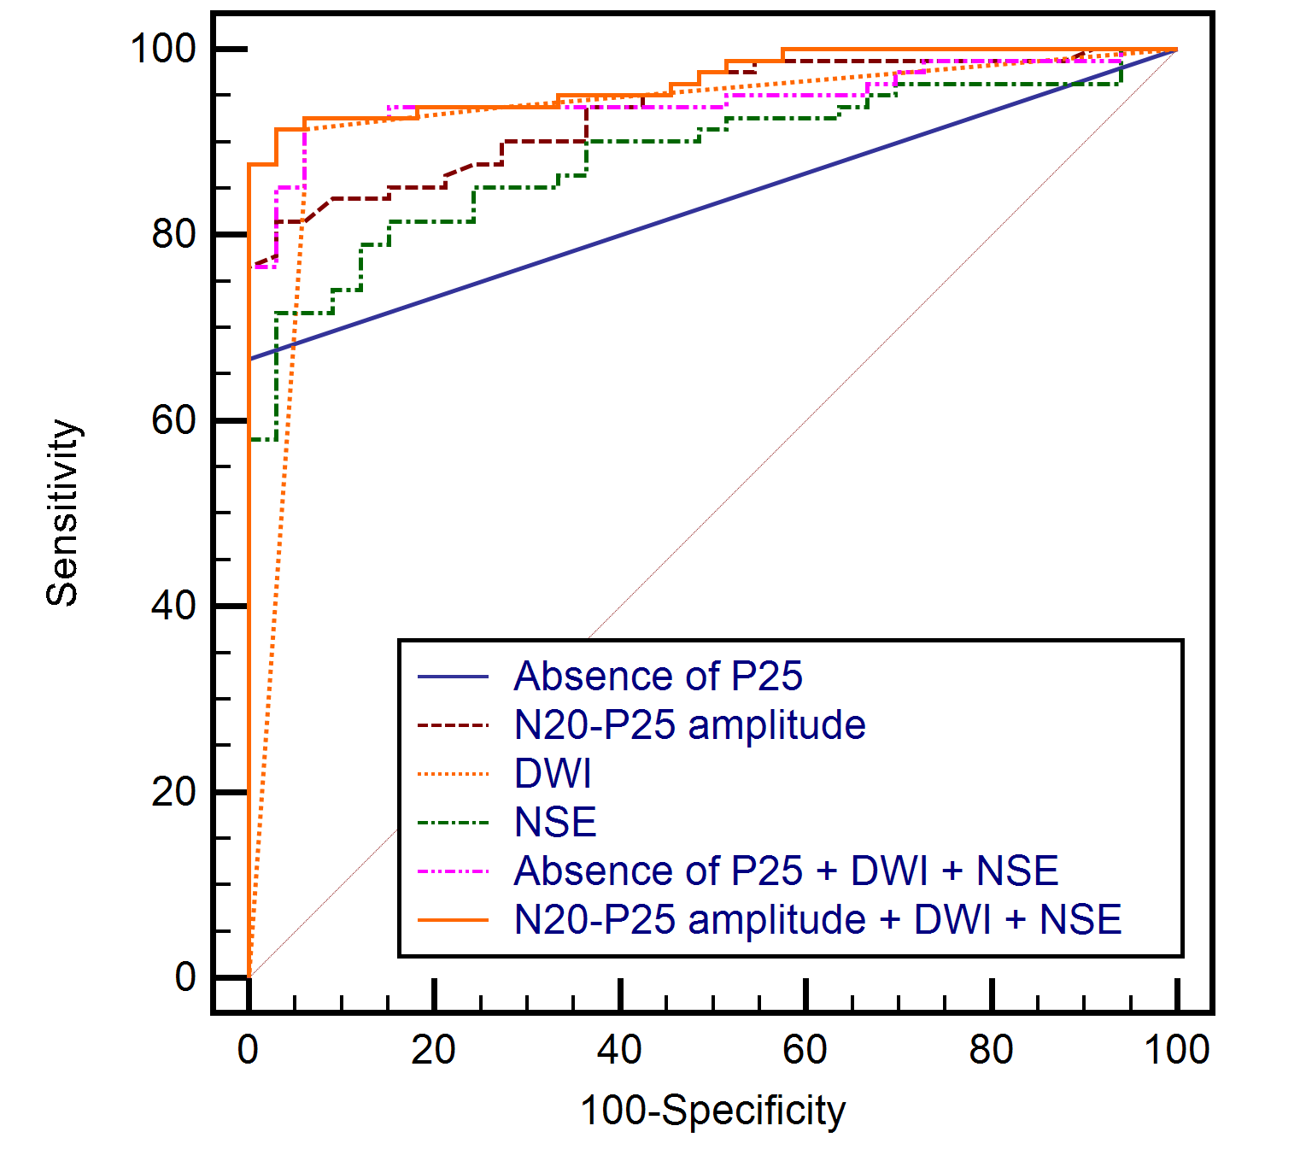
Figure S2. The receiver operating characteristic curves for Cerebral Performance Category scores 3–5 at 6 months showing the predictive powers of various prognostic tests and combination models in the subgroup that had all 3 prognostic tests (n= 114; CPC 1–2, 33; and CPC 3–5, 81).
SSEP, somatosensory evoked potentials; DWI, diffusion-weighted imaging; NSE, neuron-specific enolase; CPC, Cerebral Performance Category.

