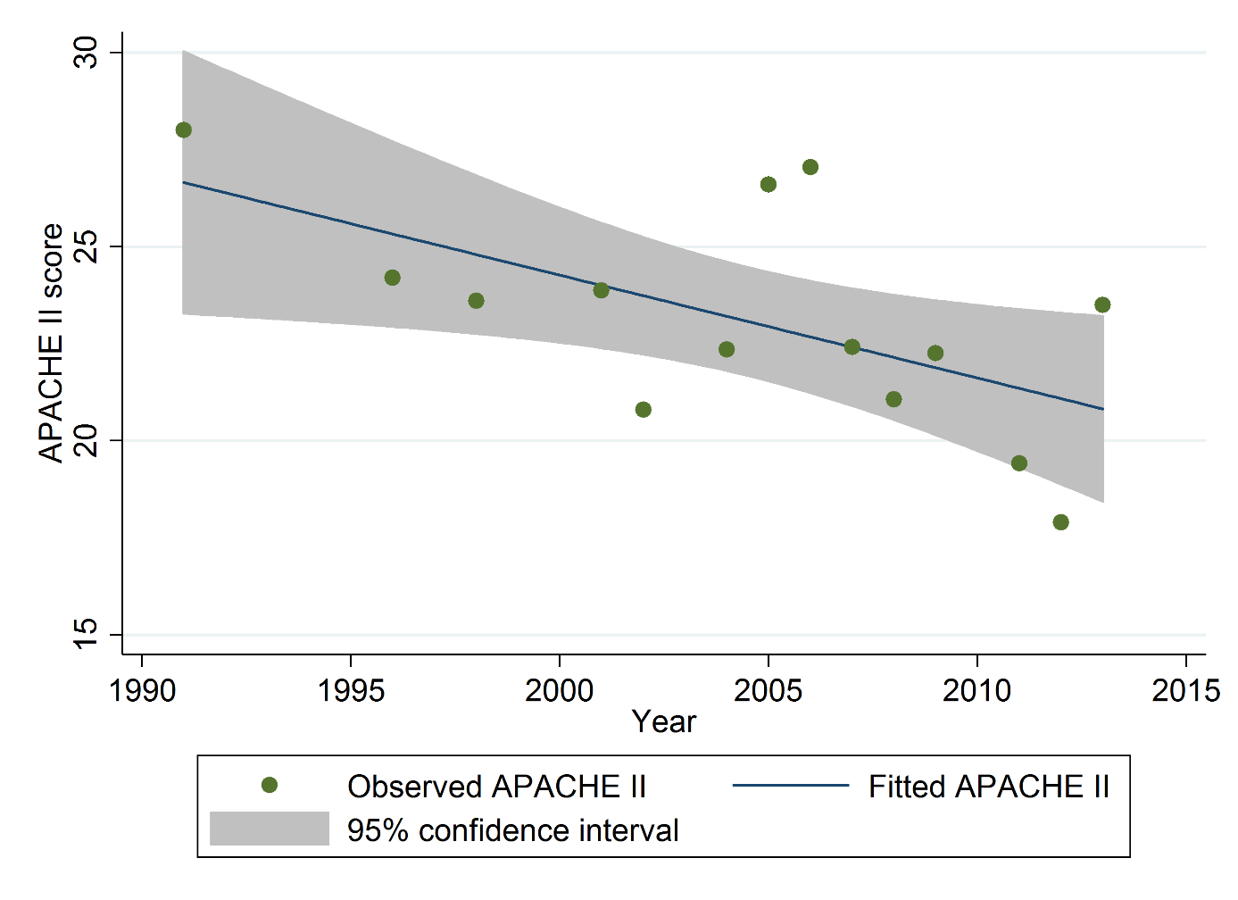
Figure S1 Meta-regression analysis of the temporal trend in Acute Physiology And Chronic Health Evaluation (APACHE) II score between 1991 and 2013 in the included sepsis trials.

