Figure S1. Timing of preoxygenation methods

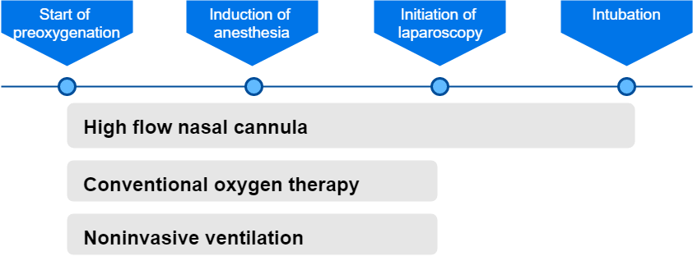

Figure S2. Network of preoxygenation methods for evaluating lowest SpO₂

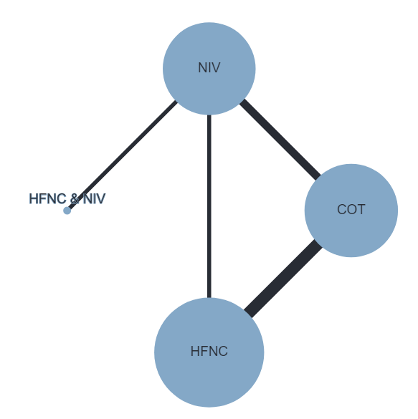
The size of the nodes was proportional to the number of patients randomized to each preoxygenation methods and thickness of the lines to the number of direct comparisons.

Figure S3. Sensitivity analysis of forest plot of lowest SpO₂ during intubation
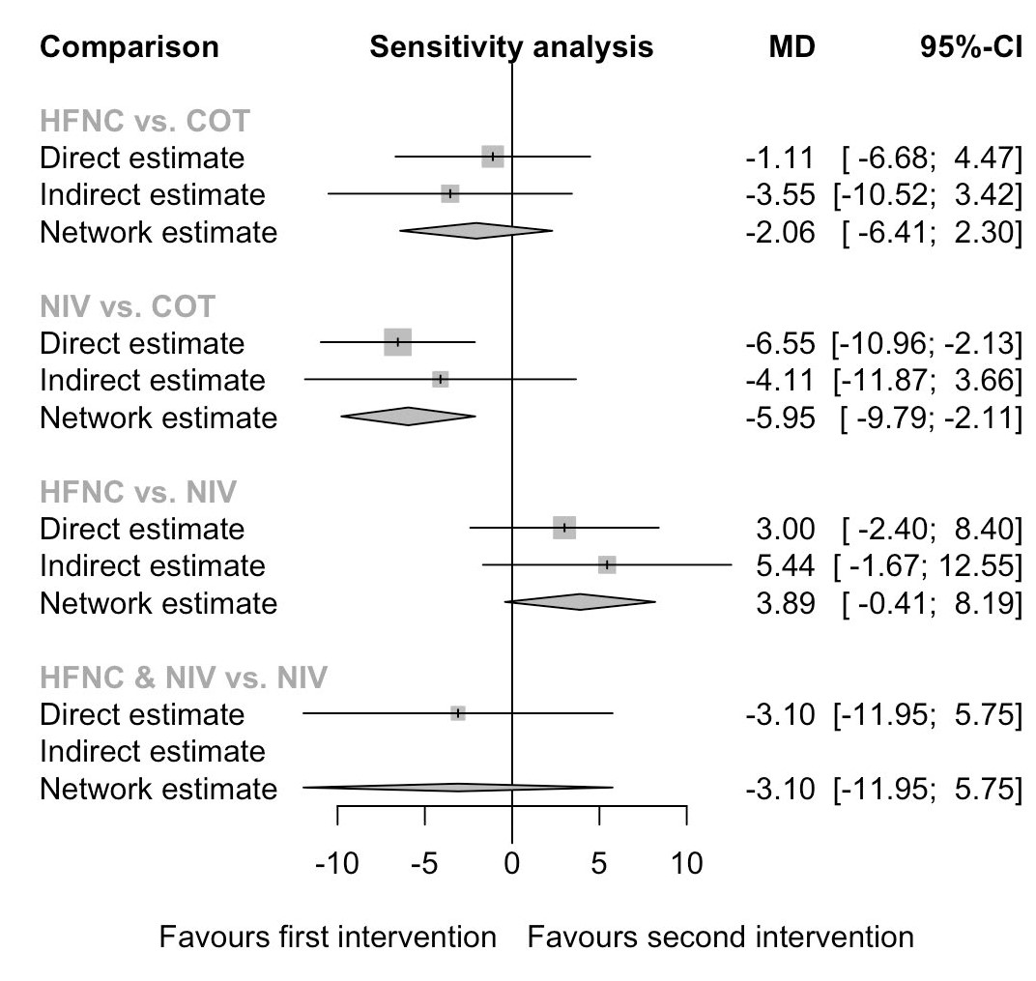
I² = 42.6%
Q-statistics for heterogeneity (within designs) and inconsistency (between designs)
Total: p=0.156, within designs: p=0.083, between designs: p=0.616

Figure S4. Sensitivity analysis of forest plot of SpO₂<80% during intubation
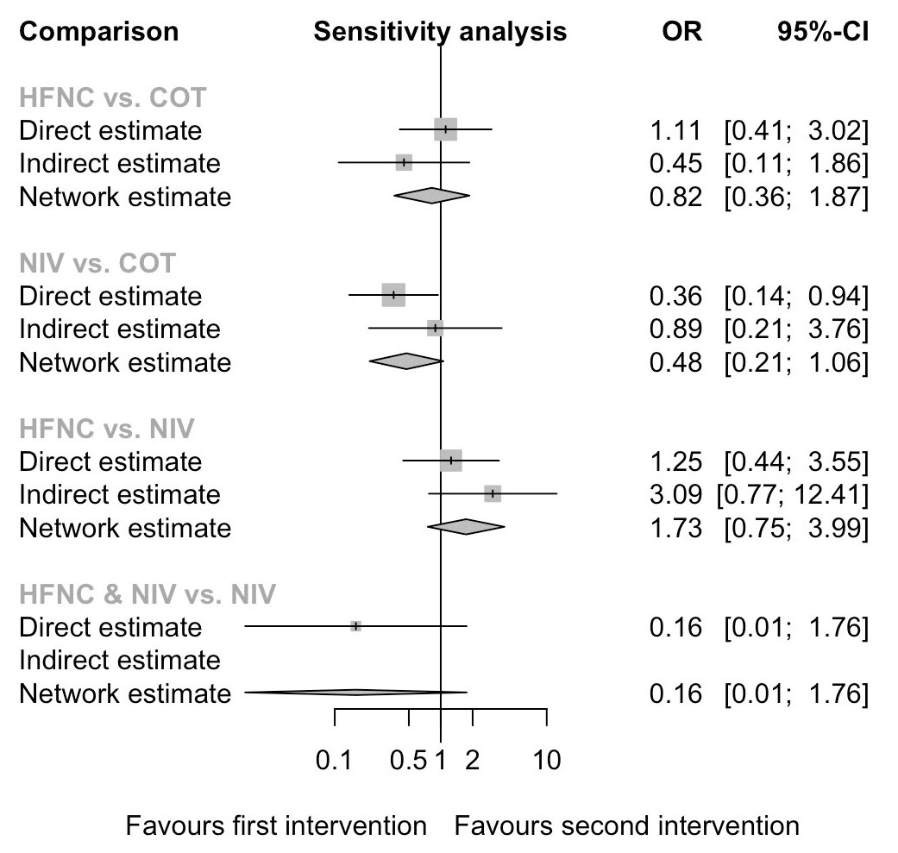
I² = 0%
Q-statistics for heterogeneity (within designs) and inconsistency (between designs)
Total: p=0.574, within designs: p=0.354, between designs: p=0.615

Figure S5. Sensitivity analysis of forest plot of intubation-related complications
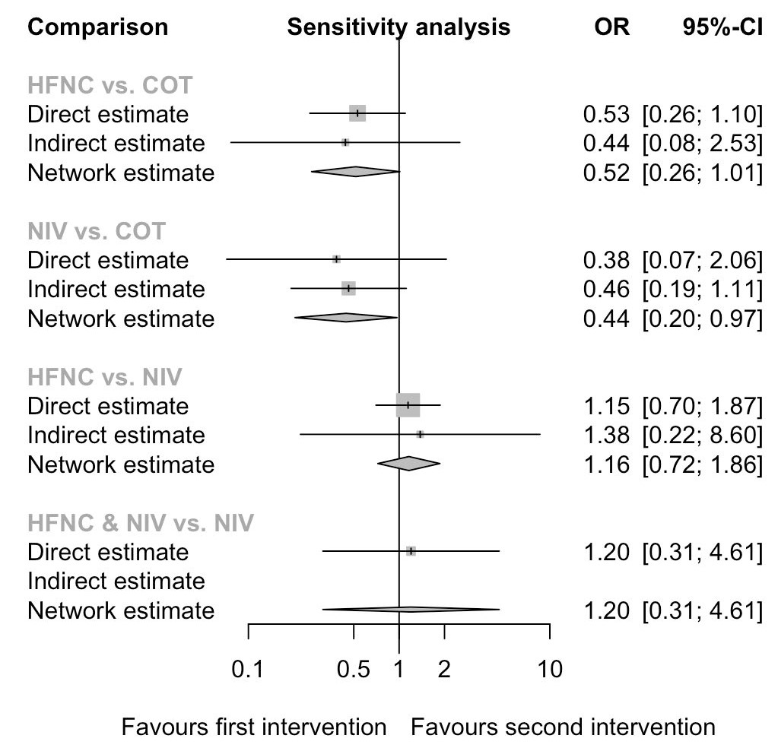
I² = 0%
Q-statistics for heterogeneity (within designs) and inconsistency (between designs)
Total: p=0.933, within designs: p=0.749, between designs: p=0.848

Figure S6. Sensitivity analysis of forest plot of mortality
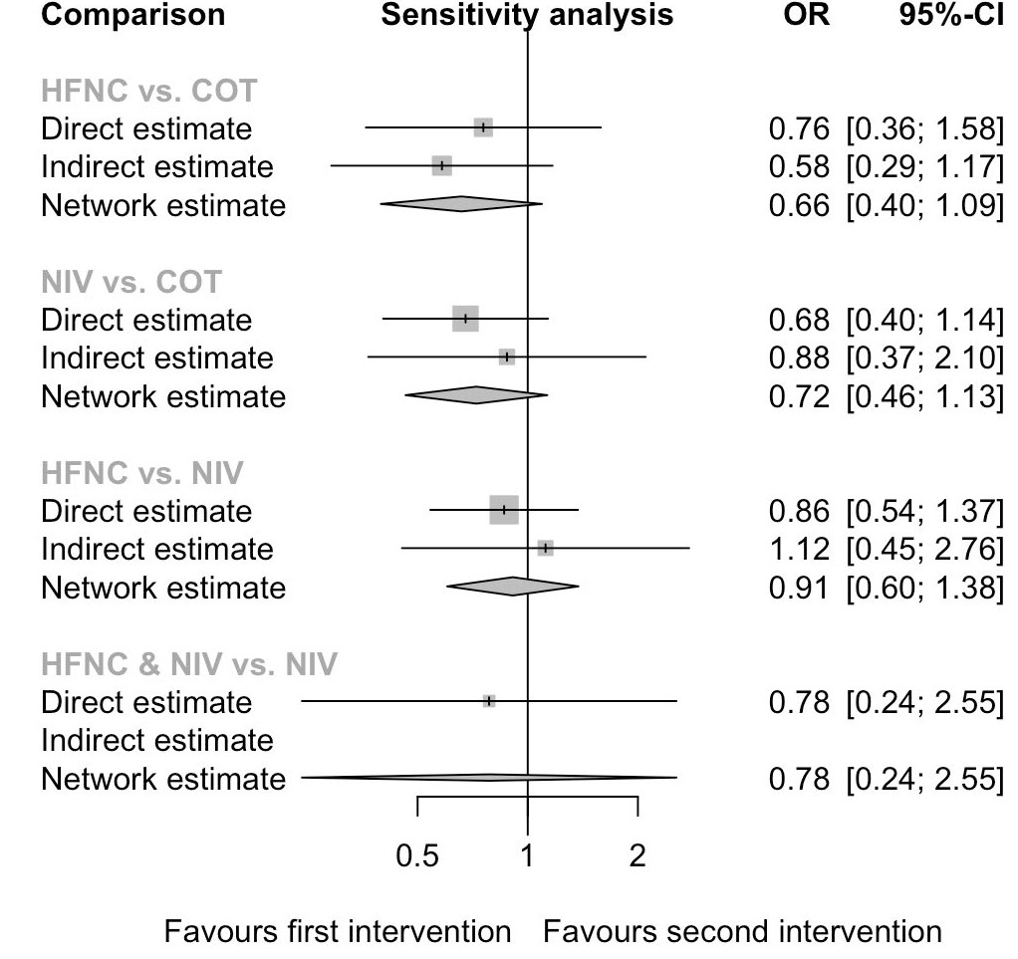
I² = 0%
Q-statistics for heterogeneity (within designs) and inconsistency (between designs)
Total: p=0.574, within designs: p=0.354, between designs: p=0.615

Table S1. PubMED search strategy
# | Searches
1 | (hypox*) OR respiratory failure) OR ((intensive care) OR ICU OR critical OR emergency)
2 | ((((high flow) or (high-flow)) AND (nasal OR oxygen))) OR apn*ic oxygenation) OR ((bag valve mask) OR (non rebreath*))) OR ((noninvasive OR (non invasive) OR (non-invasive)) AND ventilation
3 | intubation OR preoxygenation OR (pre oxygenation)
4 | (((clinical trials as topic[MeSH Terms]) OR randomized controlled trial[Publication Type]) OR controlled clinical trial[Publication Type]) OR trial [Title/Abstract]) OR random [Title/Abstract]
5 | #1 AND #2 AND #3 AND #4

Table S2. Lowest SpO₂, incidence of SpO₂ <80% during intubation, and mortality
 |  |  | First intervention |  |  |  |  | Second intervention
 | First intervention | n | Lowest SpO₂ during intubation,  mean±SD | Incidence of SpO₂ < 80% during intubation,  n (%) | Mortality,  n (%) | Second intervention | n | Lowest SpO₂ during intubation,  mean±SD | Incidence of SpO₂ < 80% during intubation,  n (%) | Mortality,  n (%)
Baillard et al. [6] | COT | 26 | 81 ± 5% | 12 (46.2) | 13 (50)ª | NIV | 27 | 93 ± 8% | 2 (7.4) | 8 (29.6)ª
Vourc’h et al. [3] | COT | 57 | 85.9 ± 12.9% | 13 (22.8) | 24 (42.1)^{b} | HFNC | 62 | 86.2 ± 15.2% | 16 (25.8) | 22 (35.5)^{b}
Jaber et al.  [20] | HFNC and NIV | 25 | 94.6 ± 15.0% | 1 (4.0) | 8 (32.0)^{b} | NIV | 24 | 91.5 ± 12.5% | 5 (20.8) | 9 (37.5)^{b}
Simon et al.ª [4] | COT | 20 | 86 ± 11% | 5 (25.0) | NR | HFNC | 20 | 89 ± 18% | 5 (25.0) | NR
Baillard et al. [7] | COT | 102 | 87.33 ± 12.03%^{c} | 28 (27.5) | 38 (37.3)^{b} | NIV | 99 | 91.33±10.53%^{c} | 18 (18.2) | 31 (31.3)^{b}
Guitton et al. [5] | COT | 89 | 95 ± 12% | 7 (7.9) | 24 (27.0)^{b} | HFNC | 95 | 97 ± 5% | 2 (2.1) | 26 (27.4)^{b}
Frat et al. [8] | HFNC | 171 | 84 ± 16% | 47 (27.5) | 58 (33.9)^{b} | NIV | 142 | 87 ± 13% | 33 (23.2) | 53 (37.3)^{b}

NR, not reported; SD, standard deviation
ªICU mortality
^{b}28-day mortality
^{c}Only median and interquarile range were provided in the study: NIV 92 (84-98), COT 88 (79-95). Data were transformed into mean and standard deviation using a published equation [12].

Table S3. Intubation-related complications
 |  |  | First intervention |  |  |  |  | Second intervention
 | First intervention | n | Aspiration/ new infiltrate on post-intubation chest radiograph, n(%) | Haemodynamic instability, n(%) | Cardiac arrest, n(%) | Second intervention | n | Aspiration/ new infiltrate on post-intubation chest radiograph, n(%) | Haemodynamic instability, n(%) | Cardiac arrest, n(%)
Baillard et al. [6] | COT | 26 | 3 (11.5) | NR | NR | NIV | 27 | 1 (3.7) | NR | NR
Vourc’h et al. [3] | COT | 57 | 0 | 30 (52.6) | 1 (1.6) | HFNC | 62 | 0 | 24 (38.7) | 0
Jaber et al. [20] | HFNC and NIV | 25 | 0 | 6 (24.0) | 0 | NIV | 24 | 0 | 5 (20.8) | 0
Simon et al.ª [4] | COT | 20 | 0 | 0 | 0 | HFNC | 20 | 0 | 0 | 0
Baillard et al. [7] | COT | 102 | 0 | 2 (2.0) | NR | NIV | 99 | 0 | 1 (1.0) | NR
Guitton et al. [5] | COT | 89 | 2 (2.2) | 8 (9.0) | 0 | HFNC | 95 | 0 | 4 (4.2) | 1 (1.1)
Frat et al. [8] | HFNC | 171 | 33 (19.3) | 86 (50.3) | 5 (2.9) | NIV | 142 | 28 (19.7) | 70 (49.3) | 1 (0.7)
NR, not reported; COT, conventional oxygen therapy (bag-valve mask or facial mask); HFNC, high-flow nasal cannula; NIV, noninvasive ventilation;
ªAdverse events including cardiac arrest, haemodynamic instability and aspiration of gastric contents were included as outcome measure and it was reported that there were no adverse events related to intubation in the study.

Table S4. Advanced oxygen devices used before study inclusion
 |  |  | Oxygen devices |  |  |  | Oxygen devices
 | First intervention | n | NIV, n (%) | HFNC, n (%) | Second intervention | n | NIV, n (%) | HFNC, n (%)
Baillard et al. [6] | COT | 26 | NR | NR | NIV | 27 | NR | NR
Vourc’h et al. [3] | COT | 57 | 8 (14) | 3 (5.3) | HFNC | 62 | 11 (17.8) | 10 (16.1)
Jaber et al. [20] | HFNC and NIV | 25 | 7 (28) | 11 (33) | NIV | 24 | 8 (33) | 11 (46)
Simon et al.ª [4] | COT | 20 | 2 (10) | 1 (5) | HFNC | 20 | 3 (15) | 5 (25)
Baillard et al. [7] | COT | 102 | 46 (45.1) | NR | NIV | 99 | 45 (45.5) | NR
Guitton et al. [5] | COT | 89 | 8 (9.0) | 2 (2.2) | HFNC | 95 | 6 (6.3) | 3 (3.2)
Frat et al. [8] | HFNC | 171 | 41(24.0) | 57 (33.3) | NIV | 142 | 31(21.8) | 48 (3.8)

NR, not reported; COT, conventional oxygen therapy (bag-valve mask or facial mask); HFNC, high-flow nasal cannula; NIV, noninvasive ventilation;

Table S5 P-scores statistics of sensitivity analysis
 | HFNC & NIV | NIV | HFNC | COT
Lowest SpO₂ during intubation | 0.880 | 0.736 | 0.314 | 0.070
SpO₂ < 80% during intubation | 0.959 | 0.645 | 0.270 | 0.126
Intubation-related complications | 0.554 | 0.772 | 0.587 | 0.087
Mortality | 0.687 | 0.531 | 0.676 | 0.107

