Table S1 Missing number (%) for included variables in dataset
Variables | Missing, n (%)
Age | 0 (0)
Gender | 0 (0)
Weight (kg) | 55 (2.1)
Admission type | 0 (0)
Admission period | 0 (0)
Race | 0 (0)
Severity of illness
SOFA score | 0 (0)
qSOFA score | 0 (0)
SAPS II score | 0 (0)
OASIS score | 0 (0)
Elixhauser comorbidity score | 0 (0)
Interventions
RRT use (1st 24 h) | 0 (0)
Mechanical ventilation use (1st 24 h) | 0 (0)
Vasopressor use (1st 24 h) | 0 (0)
Comorbidities
CHF | 0 (0)
AFIB | 0 (0)
Chronic renal disease | 0 (0)
Liver disease | 0 (0)
COPD | 0 (0)
Stroke | 0 (0)
Malignancy | 0 (0)
Septic shock | 0 (0)
Site of infection
Respiratory | 0 (0)
Urinary | 0 (0)
Gastrointestinal | 0 (0)
Other | 0 (0)
Positive blood cultures | 0 (0)
Vital signs
MAP (mmHg) | 13 (0.5)
Heart rate (bpm) | 13 (0.5)
Temperature (℃) | 118 (4.5)
Respiratory rate(bpm) | 13 (0.5)
Initial lactate(mmol/L) | 0 (0)
Time to initial vasopressor (hours) | 0 (0)
Time to initial antibiotic (hours) | 489 (18.5)
Time to initial IVF (hours) | 14 (0.5)
AKI stage | 0 (0)
ICU duration (days) | 0 (0)
Hospital duration (days) | 0 (0)
Use of vasopressors | 0 (0)
Volume of IVF within 6 hours (L) | 14 (0.5)
Volume of IVF within 24 hours (L) | 13 (0.5)
SOFA: Sequential Organ Failure Assessment; qSOFA: quick Sequential Organ Failure Assessment; SAPS II: Simplified Acute Physiology Score II; OASIS: Overall Anxiety Severity And Impairment Scale; RRT: renal replacement therapy; CHF: congestive heart failure; AFIB: atrial fibrillation; COPD: chronic obstructive pulmonary disease; MAP: mean arterial pressure; IVF: intravenous fluid, AKI: acute kidney injury; ICU: intensive care unit.

Table S2 Additional demographic data between the early lactate group and the late lactate group.
Variables | EL Group  (n=738) | LL Group  (n=1904) | P value | SMD
ICU type, n (%) |  |  | <0.001 |  | 0.167
MICU | 292/738 (39.6) | 850/1904 (44.6)
CCU/CSRU | 186/738 (25.2) | 530/1904 (27.8)
TSICU/SICU | 260/738 (35.2) | 524/1904 (27.5)
Time interval between hospital admission and ICU admission (hours) | 0 (0-16) | 0 (0-18) | 0.669 | 0.022
Biochemical markers
pH | 7.24 (0.131) | 7.27 (0.113) | <0.001 | 0.274
pO₂ (mmHg) | 78 (63-98) | 79 (64-102) | 0.168 | 0.096
pCO₂ (mmHg) | 32.1 (6.98) | 32.1 (7.41) | 0.984 | 0.001
PaO2/FiO2 (mmHg) | 156 (102-225) | 160 (103-240) | 0.120 | 0.113
WBC (*10⁹/L) | 10.35 (6.2-15.2) | 10.3 (6.6-14.8) | 0.954 | 0.001
Hemoglobin (g/dL) | 9.36 (2.13) | 9.58 (2.22) | 0.017 | 0.103
Platelet (*10⁹/L) | 141.5 (85-209) | 148 (92-220) | 0.184 | 0.032
Albumin (g/dL) | 2.65 (0.695) | 2.77 (0.718) | 0.002 | 0.170
Proportion of different vasopressors, n (%)
Norepinephrine | 357/738 (48.4) | 928/1904 (48.7) | 0.900 | 0.007
Epinephrine | 50/738 (6.8) | 173/1904 (9.1) | 0.066 | 0.086
Dopamine | 109/738 (14.8) | 323/1904 (17.0) | 0.190 | 0.060
Dobutamine | 53/738 (7.2) | 122/1904 (6.4) | 0.528 | 0.031
Phenylephrine | 322/738 (43.6) | 804/1904 (42.2) | 0.541 | 0.028
Vasopressin | 165/738 (22.3) | 385/1904 (20.1) | 0.246 | 0.052
ICU, intensive care unit; MICU, medical intensive care; CCU, coronary care unit; CSRU, cardiac surgery unit; SICU, surgical intensive care unit; TSICU, trauma surgical intensive care unit. WBC; white blood cell.

Table S3 Univariate models and full multivariate model assessing the impact of the early lactate measurement and other important factors on 28-day mortality in the original cohort.
Variables | Univariate models |  | Full multivariate model
Variables | Odds Ratio  (95% CI) | P value | Odds Ratio  (95% CI) | P value
Early lactate measurement* | 0.76 (0.62-0.93) | 0.008 | 0.69 (0.55-0.87) | 0.001
Age | 1.02 (1.01-1.02) | <0.001 | 1.01 (1-1.02) | 0.017
Gender (Male) | 0.97 (0.82-1.16) | 0.757 | 0.98 (0.80-1.21) | 0.880
Weight | 0.99 (0.98-0.99) | <0.001 | 0.99 (0.99-1) | 0.087
Admission type
Surgical elective | Reference |  | Reference
Emergency | 3.28 (2.21,4.88) | <0.001 | 2.32 (1.47-3.66) | <0.001
Surgical emergency | 2.32 (1.21,4.44) | <0.001 | 1.20 (0.57-2.53) | 0.630
Admission period (2008-2012) | 0.89 (0.75-1.06) | 0.201 | 0.75 (0.61-0.92) | 0.005
SOFA | 1.14 (1.11,1.17) | <0.001 | 1.06 (1.02-1.11) | 0.004
qSOFA | 1.36 (1.18,1.57) | <0.001 | 0.83 (0.69-0.99) | 0.049
SAPS II | 1.05 (1.04,1.05) | <0.001 | 1.02 (1-1.04) | <0.001
OASIS | 1.06 (1.05,1.07) | <0.001 | 1.02 (1-1.03) | 0.008
Elixhauser comorbidity score | 1.07 (1.06,1.08) | <0.001 | 1.03 (1.01-1.06) | 0.002
RRT use (1st 24 h) | 1.76 (1.25,2.48) | <0.001 | 0.98 (0.66-1.47) | 0.935
Mechanical ventilation use (1st 24 h) | 0.8 (0.66,0.97) | <0.001 | 0.63 (0.48-0.84) | 0.001
Vasopressor use(1st 24 h) | 1.23 (1.03,1.47) | 0.022 | 0.52 (0.3-0.88) | 0.014
CHF | 1.17 (0.98,1.41) | 0.081 | 0.91 (0.71-1.18) | 0.499
AFIB | 1.16 (0.97,1.38) | 0.097 | 1.16 (0.94-1.43) | 0.177
Chronic renal disease | 1.46 (1.16,1.84) | 0.001 | 0.99 (0.74-1.32) | 0.942
Liver disease | 2.4 (1.98,2.92) | <0.001 | 1.52 (1.08-2.14) | 0.017
COPD | 0.91 (0.73,1.14) | 0.418 | 0.85 (0.66-1.11) | 0.237
Stroke | 0.73 (0.4,1.32) | 0.285 | 0.90 (0.45-1.77) | 0.753
Malignancy | 2.99 (2.34,3.81) | <0.001 | 2.21 (1.56-3.12) | <0.001
Site of infection,
Respiratory | Reference |  | Reference
Urinary | 0.9 (0.66,1.22) | 0.494 | 0.65 (0.46-0.92) | 0.014
Gastrointestinal | 0.86 (0.69,1.08) | 0.203 | 0.70 (0.54-0.91) | 0.008
Other | 0.92 (0.74,1.14) | 0.449 | 0.80 (0.62-1.04) | 0.092
Positive blood culture | 1.12 (0.93,1.34) | 0.243 | 0.99 (0.81-1.22) | 0.948
MAP | 0.97 (0.96,0.98) | <0.001 | 0.99 (0.98-1) | 0.338
Initial lactate level | 1.1 (1.06,1.14) | <0.001 | 1.03 (0.99-1.07) | 0.164
SOFA: Sequential Organ Failure Assessment; qSOFA: quick Sequential Organ Failure Assessment; SAPS II: Simplified Acute Physiology Score II; OASIS: Overall Anxiety Severity And Impairment scale; RRT: renal replacement therapy; CHF: congestive heart failure; AFIB: atrial fibrillation; COPD: chronic obstructive pulmonary disease; MAP: mean arterial pressure
*Early lactate measurement refers to an initial lactate level measured within 1 h after ICU admission.

Table S4 Demographic data and comparisons between the early lactate group and the late lactate group after matching
Variables | EL Group  (n=701) | LL Group  (n=701) | P value | SMD
Age (years) | 68 (53-78) | 68 (53-79) | 0.869 | 0.010
Male, n (%) | 396/701 (56.5) | 416/701 (59.3) | 0.304 | 0.058
Weight (kg) | 79.5 (67-93.4) | 81.2 (68.9-86.8) | 0.069 | 0.043
Admission type, n (%) |  |  | 0.365 | 0.076
Emergency | 598/701 (85.3) | 615/701 (87.7)
Surgical elective | 81/701 (11.5) | 65/701 (9.3)
Surgical urgency | 22/701 (3.1) | 21/701 (3.0)
Admission period, n (%) |  |  | 0.999 | 0.003
Before 2008 | 411/701 (58.6) | 410/701 (58.5)
2008-2012 | 290/701 (41.3) | 291/701 (41.5)
Severity of illness
SOFA score | 7.64 (3.47) | 7.70 (3.68) | 0.788 | 0.014
qSOFA score | 2 (2-2) | 2 (2-2) | 0.792 | 0.032
SAPS II score | 47.4 (14.8) | 47.2 (14.1) | 0.819 | 0.012
OASIS score | 38.4 (8.18) | 38.5 (7.89) | 0.826 | 0.012
Elixhauser comorbidity score | 11.3 (8.49) | 10.9 (8.45) | 0.407 | 0.044
Interventions, n (%)
RRT use (1st 24 h) | 36/701 (5.1) | 33/701 (4.7) | 0.805 | 0.020
Mechanical ventilation use (1st 24 h) | 554/701 (79) | 544/701 (77.6) | 0.560 | 0.035
Vasopressor use(1st 24 h) | 430/701 (61.3) | 444/701 (63.3) | 0.474 | 0.041
Comorbidities, n (%)
CHF | 228/701 (32.5) | 218/701 (31.1) | 0.606 | 0.031
AFIB | 285/701 (40.1) | 311/701 (44.3) | 0.177 | 0.075
Chronic renal disease | 108/701 (15.4) | 110/701 (15.7) | 0.941 | 0.008
Liver disease | 138/701 (19.9) | 153/701 (21.8) | 0.357 | 0.075
COPD | 131/701 (18.9) | 133/701 (19.0) | 0.946 | 0.007
Stroke | 15/701 (2.1) | 18/701 (2.6) | 0.725 | 0.028
Malignancy | 83/701 (11.8) | 71/701 (10.1) | 0.348 | 0.055
Site of infection, n (%)
Respiratory | 320/701 (45.6) | 306/701 (43.6) | 0.485 | 0.040
Urinary  Gastrointestinal | 146/701 (20.8)  76/701 (10.8) | 156/701 (22.2)  78/701 (11.1) | 0.559  0.932 | 0.035  0.009
Other | 159/701 (22.7) | 161/701 (23.0) | 0.949 | 0.007
Positive blood cultures, n (%) | 229/701 (32.7) | 225/701 (32.1) | 0.864 | 0.012
MAP(mmHg) | 76.1 (9.6) | 76.6 (10.3) | 0.390 | 0.046
Initial lactate level (mmol/L) | 3.5 (2.7-4.8) | 3.4 (2.6-4.8) | 0.337 | 0.023
SOFA: Sequential Organ Failure Assessment; qSOFA: quick Sequential Organ Failure Assessment; SAPS II: Simplified Acute Physiology Score II; OASIS: Overall Anxiety Severity And Impairment Scale; RRT: renal replacement therapy; CHF: congestive heart failure; AFIB: atrial fibrillation; COPD: chronic obstructive pulmonary disease; MAP: mean arterial pressure.

Table S5 Details of the double robust model on 28-day mortality in the PSM cohorts
Variables | Odds Ratio(95% CI) | P value
Early lactate measurement* | 0.70 (0.53-0.93) | 0.013
Age | 1.01 (1-1.02) | 0.018
Gender (Male) | 0.98 (0.73-1.31) | 0.885
Weight | 0.99 (0.98-0.99) | 0.040
Admission type
Surgical elective | Reference | -
Emergency | 2.55 (1.28-5.07) | 0.007
Surgical emergency | 1.43 (0.48-4.32) | 0.517
Admission period (2008-2012) | 0.65 (0.48-0.88) | 0.006
SOFA | 1.04 (0.98-1.12) | 0.181
qSOFA | 0.79 (0.60-1.04) | 0.092
SAPS II | 1.03 (1.01-1.05) | 0.001
OASIS | 1 (0.98-1.03) | 0.734
Elixhauser comorbidity score | 1.03 (0.99-1.06) | 0.101
RRT use (1st 24 h) | 0.76 (0.41-1.42) | 0.394
Mechanical ventilation use (1st 24 h) | 0.86 (0.55-1.33) | 0.488
Vasopressor use(1st 24 h) | 0.37 (0.17-0.81) | 0.013
CHF | 0.85 (0.58-1.23) | 0.396
AFIB | 1.29 (0.95-1.75) | 0.107
Chronic renal disease | 0.97 (0.64-1.47) | 0.886
Liver disease | 1.83 (1.12-3.01) | 0.016
COPD | 0.97 (0.67-1.41) | 0.888
Stroke | 0.82 (0.28-2.42) | 0.726
Malignancy | 1.58 (0.98-2.55) | 0.059
Site of infection,
Respiratory | Reference | -
Urinary | 0.84 (0.53-1.34) | 0.475
Gastrointestinal | 0.70 (0.48-1.02) | 0.061
Other | 0.98 (0.68-1.42) | 0.922
Positive blood culture | 0.85 (0.62-1.15) | 0.283
MAP | 1 (0.99-1.02) | 0.627
Initial lactate level | 1.04 (0.97-1.10) | 0.267
SOFA: Sequential Organ Failure Assessment; qSOFA: quick Sequential Organ Failure Assessment; SAPS II: Simplified Acute Physiology Score II; OASIS: Overall Anxiety Severity And Impairment scale; RRT: renal replacement therapy; CHF: congestive heart failure; AFIB: atrial fibrillation; COPD: chronic obstructive pulmonary disease; MAP: mean arterial pressure.
*Early lactate measurement refers to an initial lactate level measured within 1 h after ICU admission

Table S6 Sensitivity analysis for patients with positive blood culture
 | Odds ratio | 95% CI | P value
Model 1 | 0.63 | 0.42-0.94 | 0.023
Model 2 | 0.54 | 0.35-0.83 | 0.005
Model3 | 0.44 | 0.26-0.72 | 0.001
Model1, multivariate logistic regression model; Model 2, propensity score matching model; Model 3, doubly robust model with all covariates; CI: confidence interval.

Table S7 Full multivariate model assessing the impact of timing of the initial lactate level measurements and other important factors on 28-day mortality in the original cohort.
Variables | Odds Ratio (95% CI) | P value
Timing of the initial lactate measurements | 1.04 (1.02-1.05) | <0.001
Age | 1.01 (1-1.02) | 0.007
Gender(Male) | 0.95 (0.77-1.16) | 0.603
Weight | 1 (1-1) | 0.143
Admission type
Surgical elective | Reference
Emergency | 2,32 (1.47-3.67) | <0.001
Surgical emergency | 1.25 (0.6-2.62) | 0.547
Admission period (2008-2012) | 0.79 (0.64-0.98) | 0.031
SOFA | 1.07 (1.02-1.11) | 0.003
qSOFA | 0.83 (0.69-0.99) | 0.042
SAPS II | 1.02 (1-1.03) | <0.001
OASIS | 1.02 (1-1.04) | 0.011
Elixhauser comorbidity score | 1.03 (1.01-1.06) | 0.001
RRT use (1st 24 h) | 0.95 (0.63-1.42) | 0.805
Mechanical ventilation use (1st 24 h) | 0.73 (0.55-0.97) | 0.03
Vasopressor use(1st 24 h) | 0.85 (0.67-1.09) | 0.203
CHF | 0.89 (0.69-1.16) | 0.393
AFIB | 1.15 (0.93-1.42) | 0.189
Chronic renal disease | 0.93 (0.69-1.24) | 0.617
Liver disease | 1.44 (1.02-2.03) | 0.038
COPD | 0.84 (0.65-1.09) | 0.192
Stroke | 0.83 (0.42-1.65) | 0.597
Malignancy | 2.08 (1.47-2.94) | <0.001
Site of infection,
Respiratory | Reference | -
Urinary | 0.67 (0.47-0.94) | 0.02
Gastrointestinal | 0.71 (0.55-0.93) | 0.012
Other | 0.83 (0.64-1.07) | 0.157
Positive blood culture | 0.98 (0.80-1.22) | 0.888
MAP | 0.99 (0.98-1) | 0.313
Initial lactate level | 1.03 (0.98-1.07) | 0.206
SOFA: Sequential Organ Failure Assessment; qSOFA: quick Sequential Organ Failure Assessment; SAPS II: Simplified Acute Physiology Score II; OASIS: Overall Anxiety Severity And Impairment scale; RRT: renal replacement therapy; CHF: congestive heart failure; AFIB: atrial fibrillation; COPD: chronic obstructive pulmonary disease; MAP: mean arterial pressure.

Table S8 Univariate models and full multivariate model assessing the impact of the timing of lactate remeasurements and other important factors in the early lactate group on 28-day mortality
Variables | Univariate models |  |  | Full multivariate model
Variables | Odds Ratio  (95% CI) | p value |  | Odds Ratio  (95% CI) | p value
Timing of lactate remeasurements | 1.08 (1.03-1.13) | 0.012 | 1.09 (1.04-1.15) |  | <0.001
Age | 1 (1-1) | 0.317 | 1 (1-1) |  | 0.507
Gender(Male) | 1.15 (0.79-1.68) | 0.445 | 1.08 (0.71-1.67) |  | 0.71
Weight | 1 (0.99-1.01) | 0.114 | 1 (1-1.01) |  | 0.275
Admission type
Surgical elective | Reference |  | Reference
Emergency | 0.57 (0.33-0.99) | 0.05 | 0.37 (0.19-0.74) |  | 0.005
Surgical emergency | 0.68 (0.2-2.36) | 0.545 | 0.51 (0.13-1.91) |  | 0.317
Admission period (2008-2012) | 1.17 (0.81-1.7) | 0.451 | 1.12 (0.74-1.7) |  | 0.596
SOFA | 1.07 (1.02-1.13) | 0.012 | 1.09 (1-1.19) |  | 0.038
qSOFA | 0.95 (0.7-1.27) | 0.423 | 0.76 (0.52-1.11) |  | 0.157
SAPS II | 1 (1-1) | 0.621 | 0.99 (0.97-1.02) |  | 0.616
OASIS | 1.01 (0.99-1.03) | 0.573 | 1.03 (0.99-1.06) |  | 0.184
Elixhauser comorbidity score | 1.01 (0.99-1.03) | 0.576 | 0.97 (0.93-1.02) |  | 0.209
RRT use (1st 24 h) | 1.39 (0.67-2.87) | 0.402 | 1.1 (0.46-2.65) |  | 0.828
Mechanical ventilation use (1st 24 h) | 0.98 (0.6-1.62) | 0.671 | 0.56 (0.29-1.09) |  | 0.088
Vasopressor use(1st 24 h) | 1.14 (0.77-1.68) | 0.665 | 1.89 (0.3-11.89) |  | 0.499
CHF | 1.14 (0.77-1.68) | 0.469 | 1.28 (0.74-2.24) |  | 0.381
AFIB | 1.35 (0.93-1.96) | 0.143 | 1.41 (0.9-2.2) |  | 0.129
Chronic renal disease | 0.82 (0.48-1.39) | 0.366 | 0.74 (0.39-1.4) |  | 0.354
Liver disease | 1.35 (0.87-2.08) | 0.319 | 1.38 (0.66-2.9) |  | 0.391
COPD | 0.88 (0.54-1.43) | 0.649 | 0.96 (0.55-1.66) |  | 0.87
Stroke | 4.65 (1.59-13.63) | 0.006 | 6.49 (1.94-21.72) |  | 0.003
Malignancy | 1.09 (0.62-1.89) | 0.909 | 1.27 (0.63-2.55) |  | 0.498
Site of infection,
Respiratory | Reference |  | Reference
Urinary | 0.92 (0.5-1.7) | 0.92 | 0.84 (0.44-1.62) |  | 0.611
Gastrointestinal | 1.09 (0.68-1.75) | 0.713 | 1.05 (0.62-1.78) |  | 0.845
Other | 0.79 (0.48-1.3) | 0.295 | 0.73 (0.42-1.27) |  | 0.261
Positive blood culture | 1.43 (0.97-2.09) | 0.084 | 1.44 (0.95-2.19) |  | 0.085
MAP | 1 (0.98-1) | 0.863 | 1 (0.98-1.03) |  | 0.749
Initial lactate level | 1.04 (0.97-1.1) | 0.393 | 1.03 (0.95-1.1) |  | 0.507
SOFA: Sequential Organ Failure Assessment; qSOFA: quick Sequential Organ Failure Assessment; SAPS II: Simplified Acute Physiology Score II; OASIS: Overall Anxiety Severity And Impairment Scale; RRT: renal replacement therapy; CHF: congestive heart failure; AFIB: atrial fibrillation; COPD: chronic obstructive pulmonary disease; MAP: mean arterial pressure.

Table S9 Time course of lactate remeasurements for septic patients in the early lactate group
Time of lactate remeasurements | No. of patients n (%) | Lactate value (mmol/L)
0-1 hour | 126/635(19.8) | 3.7(2.8-5.4)
1-2 hours | 150/635(23.6) | 3.8(2.7-5.8)
2-3 hours | 78/635(12.3) | 3.2(2.2-5.1)
3-4 hours | 63/635(9.9) | 2.9(1.9-4.7)
4-5 hours | 54/635(8.5) | 2.9(2.2-4.2)
5-6 hours | 26/635(4.1) | 3.3(2.0-4.7)
6-7 hours | 29/635(4.6) | 3.0(1.9-4.6)
7-8 hours | 25/635(3.9) | 2.4(1.9-3.7)
8-9 hours | 24/635(3.8) | 2.8(2.0-4.3)
9-10 hours | 16/635(2.5) | 4.4(2.0-7.3)
10-11 hours | 14/635(2.2) | 2.4(1.9-4.1)
11-12 hours | 15/635(2.3) | 3.1(1.7-4.8)

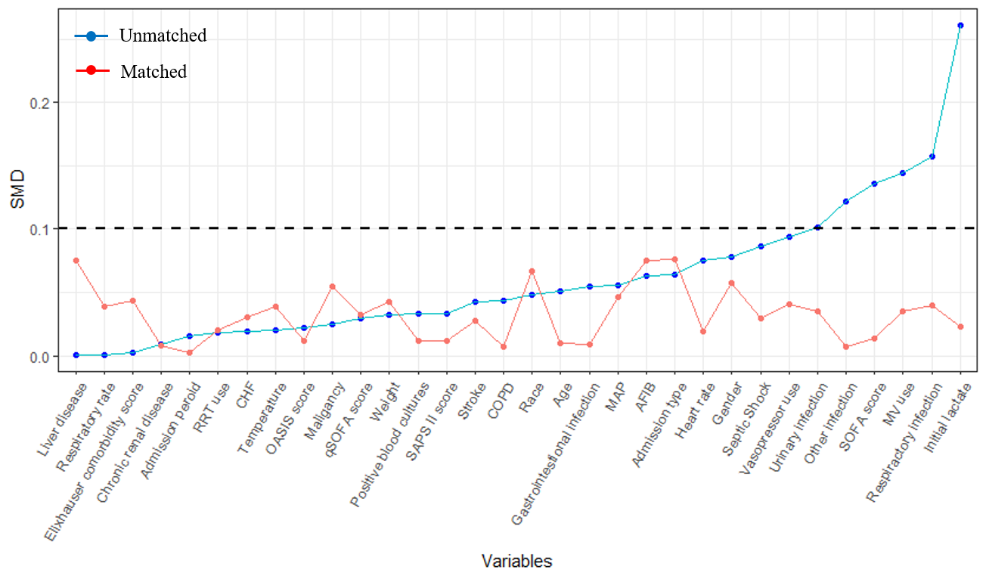
Figure S1 Standard mean differences in covariates between the early lactate group and the late lactate group for the original cohort and the matched cohort.

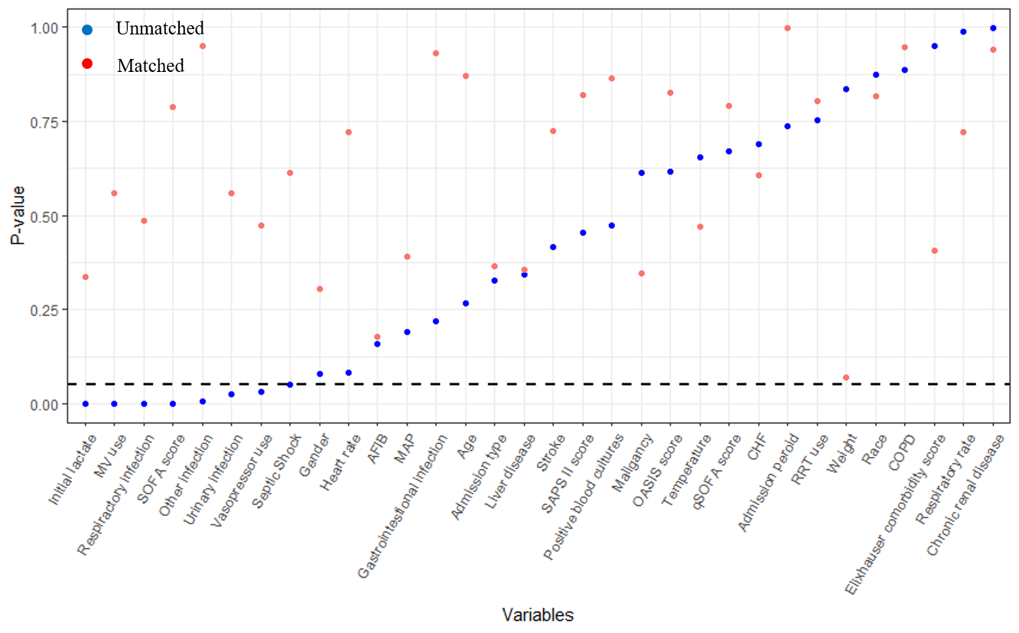
Figure S2 P values measuring the significant differences in covariates for the original cohort and the matched cohort.

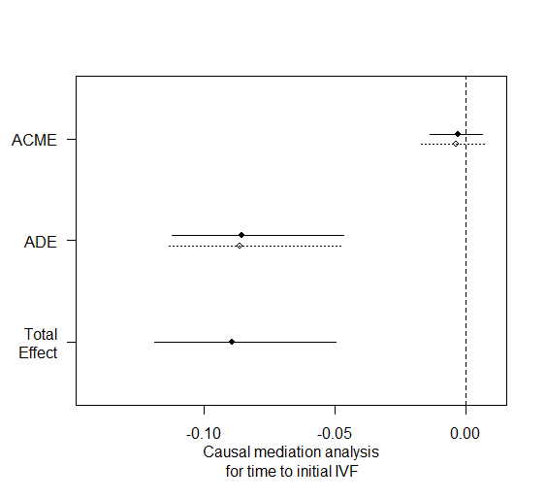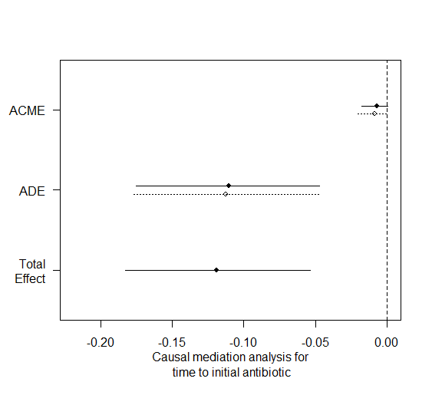
Figure S3 Causal mediation analysis for time to initial IVF and antibiotic. The solid line represents the early lactate measurement, and the dashed line represents the late lactate measurement.

