SUPPLEMENTAL

S1: Correlations between transcortine blood level and cortisol_{total} blood level in the entire population.

S2: Receiver Operating Characteristic (ROC) curve of the risk of Hospital Acquired Pneumonia in the entire population for the CRP blood levels
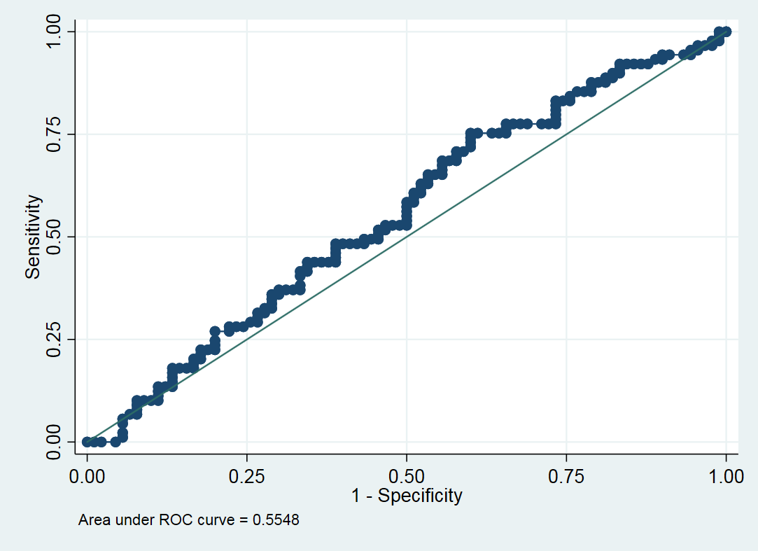

S3: Comparison of the cortisol_{total}/CRP ratio in the entire population. Results are given in median +/- SD

S4: Receiver Operating Characteristic (ROC) curve of the risk of Hospital Acquired Pneumonia in the entire population for the cortisol/CRP ratios.

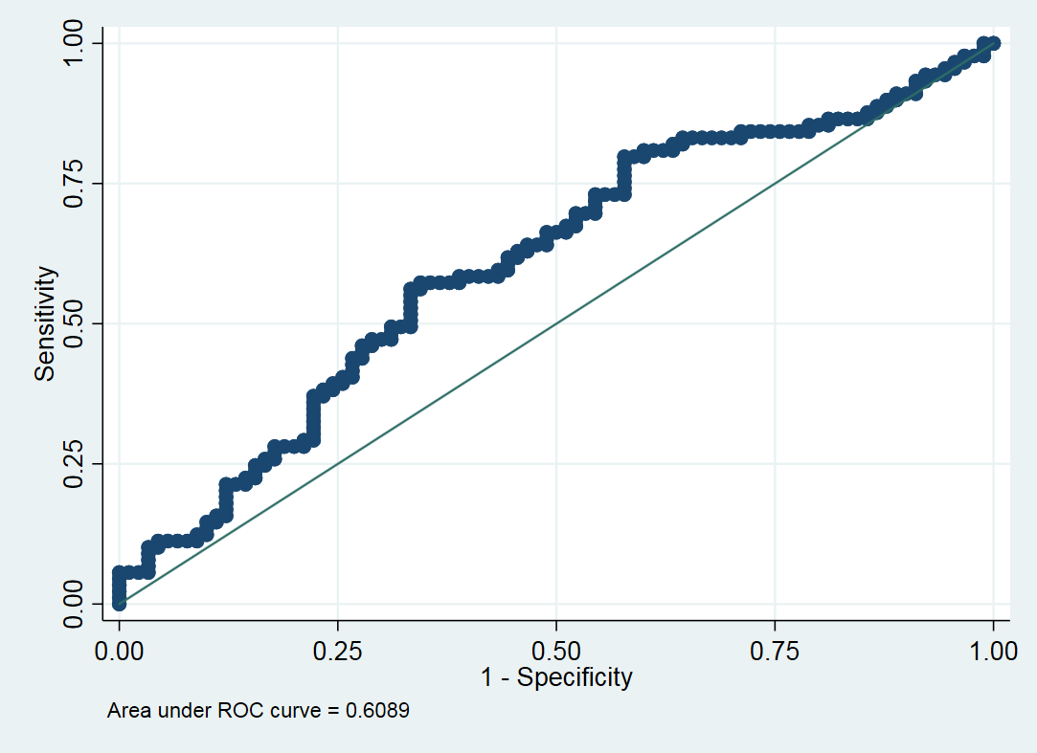

S5 : Main characteristics of patients treated with corticosteroids compared to those treated with placebo amongst the subset with ratio >3

Patients with ratio >3 | Corticosteroids group | Placebo group | P-value
 | N=37 | N=53
Age, years | 32 [24- 48] | 32 [27-53] | 0.55
Men % | 78.3 | 84.9 | 0.62
Medical history, No. (%)
Diabete | 0 (0) | 1 (1.8) | >0.99
Obesity | 1 (2.7) | 1 (1.8) | >0.99
Cardiac insufficiency | 1 (2.7) | 1 (1.8) | >0.99
Chronic pulmonary disease | 0 (0) | 0 (0) | >0.99
Pathological admission status, median.
IGS II | 44 [38-54] | 37 [43-50] | 0.59
SOFA day 0 | 9 [7-10] | 9 [7-10] | >0.99
Glasgow Coma Scale | 6 [3-7] | 6 [3-7] | >0.99
MGAP Score | 18 [17-20] | 18 [17-20] | >0.99
Etomidate use (%) | 70,2 | 64 | 0.48
Results expressed as median (1st-3rd quartile) or N (%). SOFA =Sequential Organ Failure Assessment, MGAP= Mechanism, Glasgow coma scale, Age, and arterialPressure
IGS = simplify gravity index

