Additional file to The performance of acute versus antecedent patient characteristics for one-year mortality prediction during intensive care unit admission; a national cohort study.
Table E1. Detailed demographic characteristics. ICU Intensive Care Unit, COPD Chronic Obstructive Pulmonary Disease
Figure E1. Percentage survival over time for groups with different ICU lengths of stay.
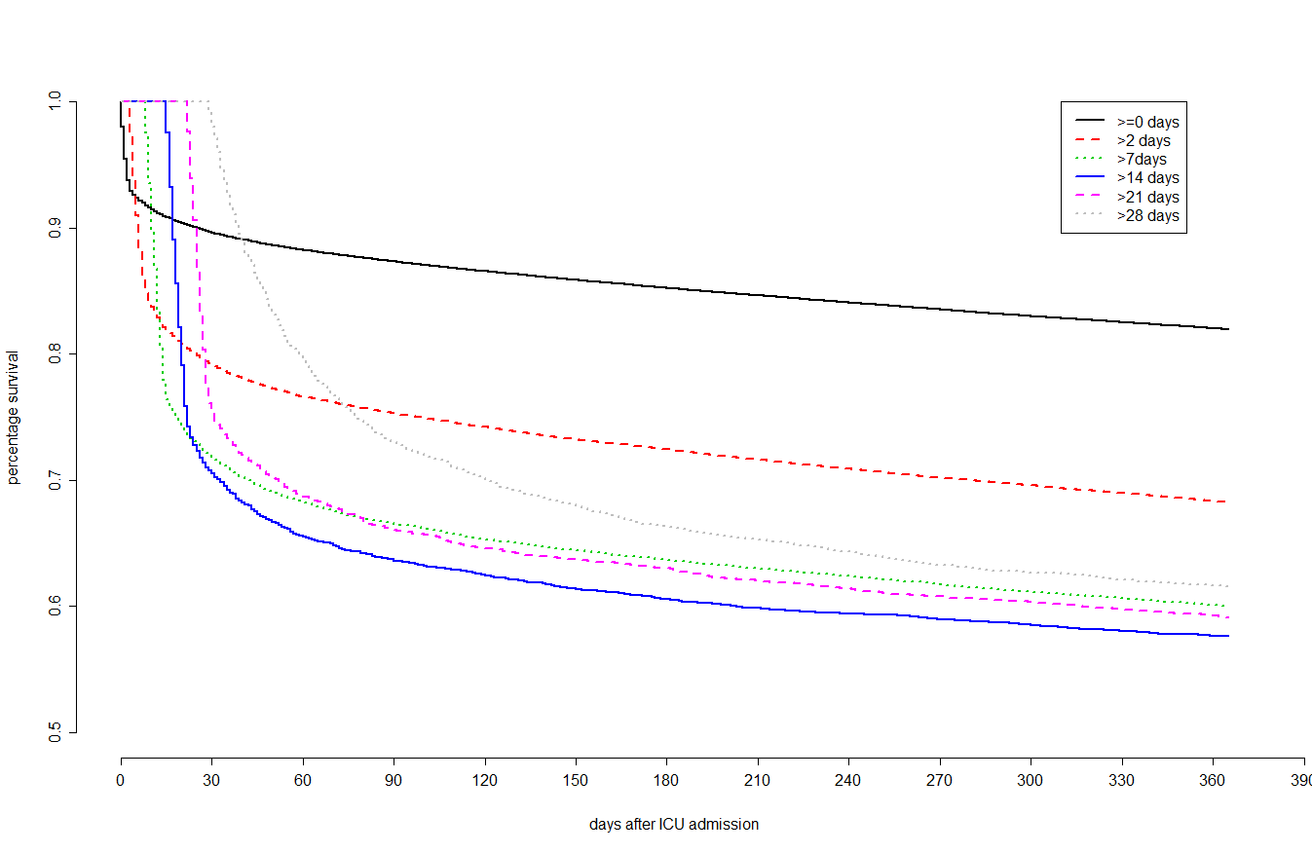
ICU intensive care unit

