MECHANICAL POWER: BEDSIDE CALCULATION DURING VOLUME AND PRESSURE CONTROLLED VENTILATION

SUPPLEMENTAL MATERIAL

Supplemental methods

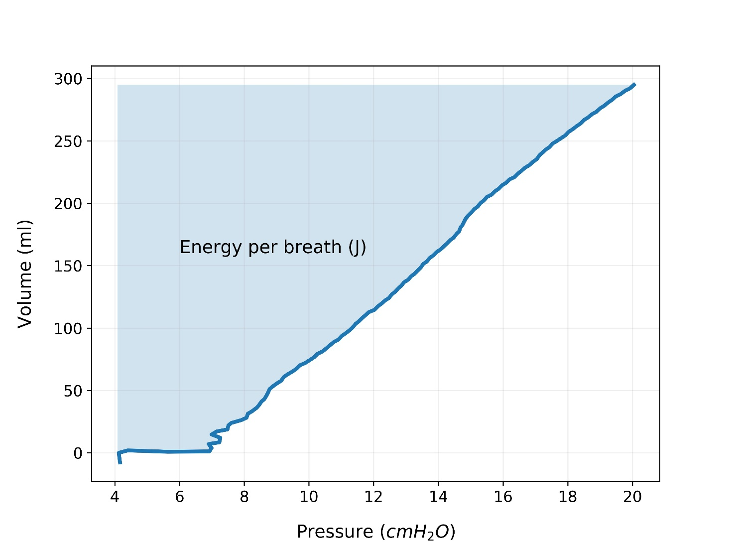
Figure S1: Geometrical method to calculate mechanical power. The value obtained as the area of the pressure-volume loop needs to be multiplied by the respiratory rate.

Supplemental results

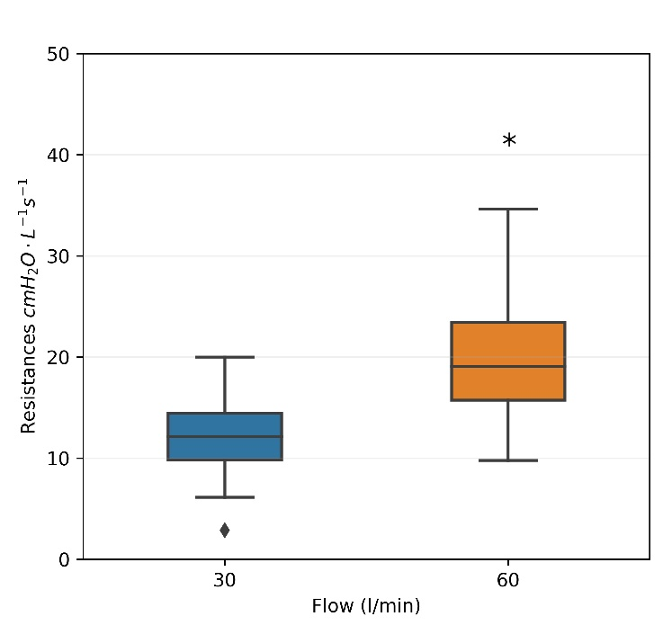
Figure S2: Airway resistances measured during volume-controlled ventilation at 30 and 60 l/min.
*) p < 0.05 compared to 30 l/min.

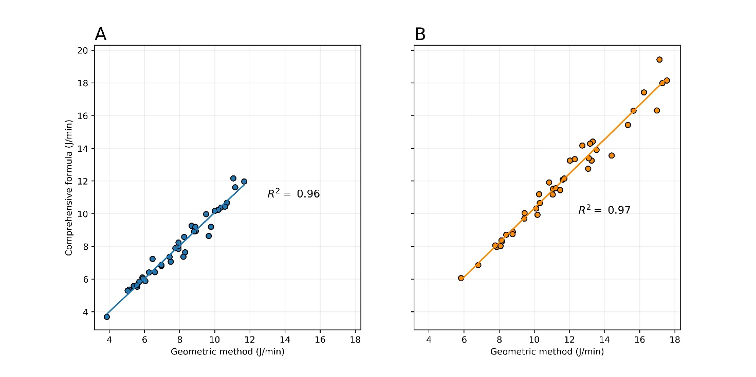
Figure S3: Linear regressions between the geometrical method and the comprehensive algebraic formula, for volume-controlled ventilation, at 30 L/min of inspiratory flow (Panel A) and 60 L/min of inspiratory flow (Panel B)

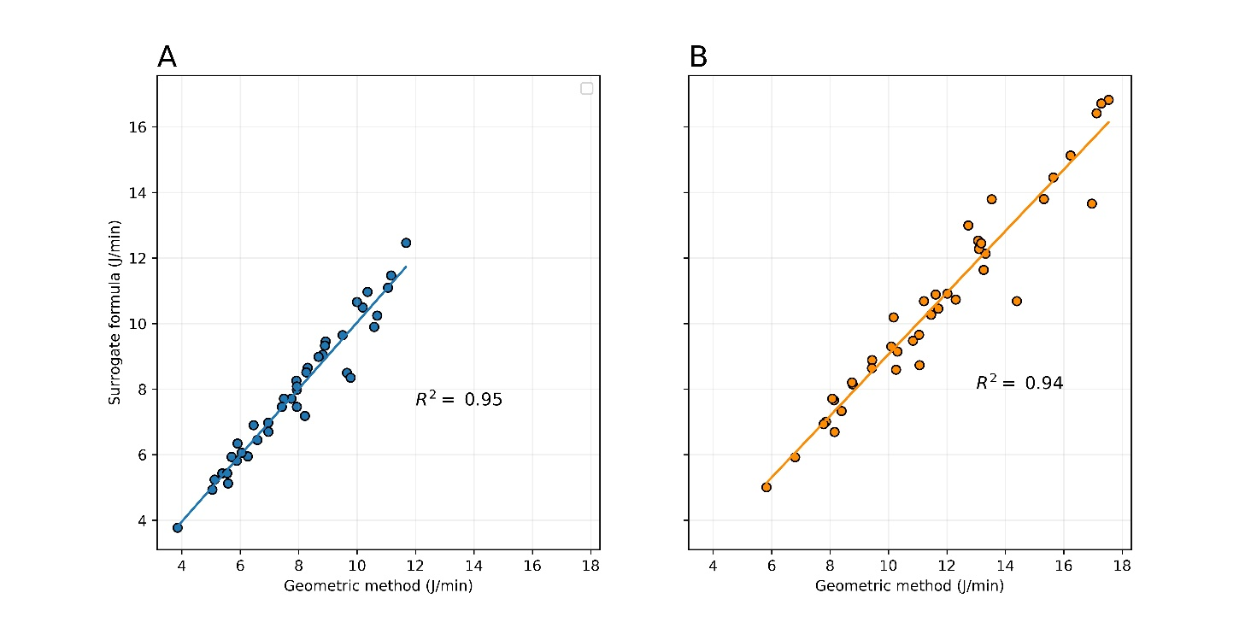
Figure S4: Linear regressions between the geometrical method and the simplified surrogate formula, for volume-controlled ventilation, at 30 L/min of inspiratory flow (Panel A) and 60 L/min of inspiratory flow (Panel B)

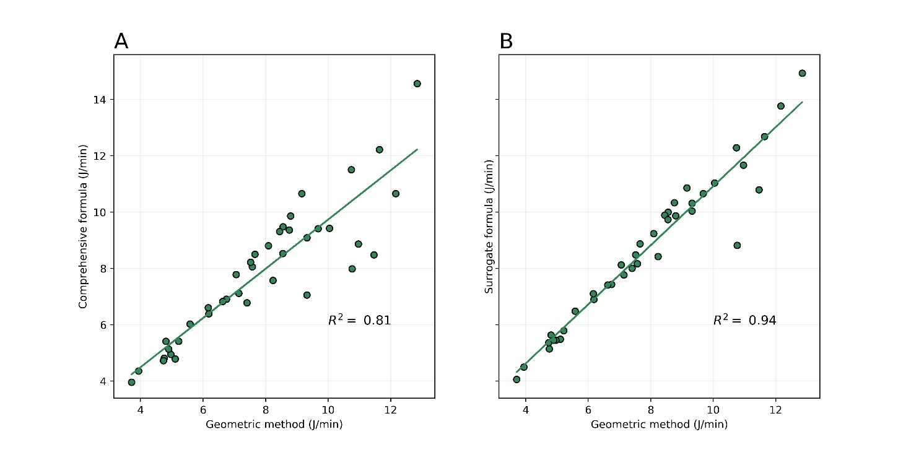
Figure S5: (Panel A): Linear regression between the geometrical method and the comprehensive formula proposed by Van der Meijden for pressure-controlled ventilation.
(Panel B): Linear regression between the geometrical method and the surrogate equation proposed by Becher for pressure-controlled ventilation.

 | VCV 30 L/min |  |  |  | VCV 60 l/min |  |  |  | PCV
 | Geometric loop | Algebric | Surrogate | p value | Geometric loop | Algebric | Surrogate | p value | Geometric loop | Algebric | Surrogate | p value
Mechanical power | 7.91 ± 1.98 | 7.96 ± 2.04 | 7.91 ± 2.06 | 0.695 | 11.60 ± 3.08 $£ | 12.02 ± 3.29 *£ | 10.56 ± 2.99 *$ | 0.01 | 7.84 ± 2.39 | 7.84 ± 2.35 | 8.64 ± 2.62 *$ | 0.01

Table S1: Summary table of the mean ± standard deviation of the mechanical power values for each experimental setup.
* p < 0.05, different from Geometric loop
$ p < 0.05, different from Algebric
£ p < 0.05, different from Surrogate

