Airway pressure morphology and respiratory muscle activity during end-inspiratory occlusions in pressure support ventilation.
Additional File 1

Table S1: Timing of expiratory muscle contraction during end-inspiratory occlusion
Timing of appearance of expiratory muscle contraction
From the end of neural inspiration  (median, 5-95% range) | 0.40, 0.08 -1.08 sec
From the point of occlusion (median, 5-95% range) | 0.19, 0 - 1 sec
Expiratory muscle activity present at the time of occlusion (% of patients) | 25

Figure A1: Patterns of expiratory muscle activity during end-inspiratory occlusion
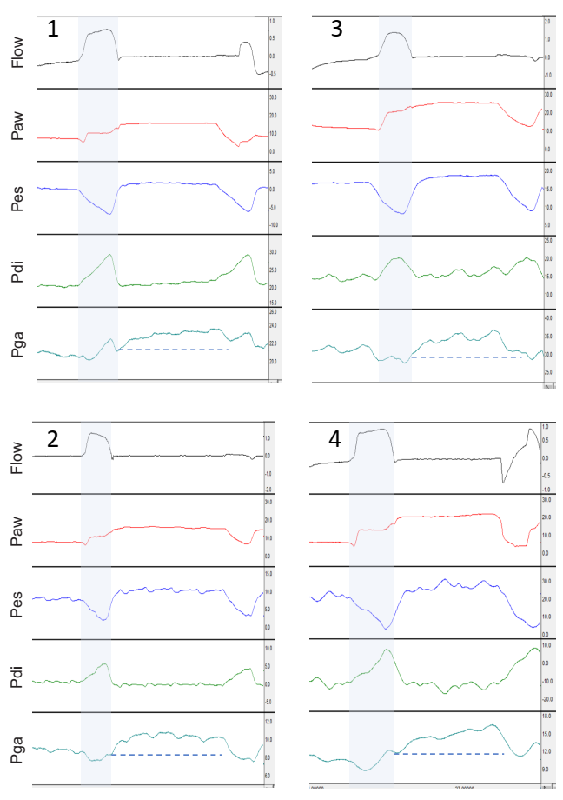
Representative waveforms of flow (l/sec), airway (Paw), esophageal (Pes), transdiaphragmatic (Pdi), and gastric (Pga) pressures (cmH₂O), during an end-inspiratory occlusion, from four patients (1-4). The blue shaded area indicates the mechanical inspiratory time and the dashed blue lines show Pga at the beginning of occlusion (zero flow). The expiratory muscle activity in patients 1 and 2 is rather constant during the occlusion (tonic), and this was observed in 47% of cases. The expiratory muscle activity in patients 3 and 4 progressively increases in patients, and this was observed in 53% of cases. In all cases a plateau can be identified in Paw.

Figure A2: Respiratory rate and drive in the presence or absence of expiratory muscle activity during occlusion
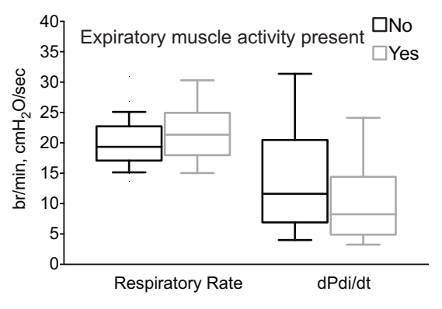
Respiratory rate in breaths per minute (br/min) and respiratory drive as indicated by the rate of change of transdiaphragmatic pressure during inspiration (dPdi/dt) of the occluded breath, in the presence or absence of expiratory muscle activity during the end-inspiratory occlusion. Box: interquartile range, whiskers: 5-95 range, line at median

