Electronic Supplement

Awake prone positioning does not reduce the risk of intubation in COVID-19 treated with High-Flow Nasal Oxygen therapy.
A multicenter, adjusted cohort study

Authors: Ferrando C, Mellado-Artigas R, Gea A, et al.

Table 1. Baseline characteristics of patients with HFNO before and after adjustment.

 | Original sample |  | Weighted sample
 | Non-intubated  (n=117) | Intubated  (n=82) | Non-intubated  64.27% | Intubated  35.73%
Patients demographics and comorbidities
Age | 62.0 [55.0-68.0] /117 | 63.0 [55.0-71.0] /82 | 59.4 | 62.5
Gender, female | 29/117 (24.8%) | 23/80 (28.7%) | 31.7% | 28.0.%
Body mass index, kg/m² | 26.7 [24.9-30.5] /98 | 27.8 [25.0-29.4] /71 | 28.5 | 28.5
Arterial Hypertension | 41/117 (35.0%) | 39/82 (47.6%) | 34.8% | 49.6%
Diabetes Mellitus | 17/117 (14.5%) | 15/82 (18.3%) | 11.9% | 22.7%
Chronic cardiac failure | 4/117 (3.4%) | 0/82 (0.0%) | 4.0% | 0.0%
Chronic renal failure | 10/117 (8.5%) | 8/82 (9.8%) | 7.6% | 3.99%
Asthma | 5/117 (4.3%) | 1/82 (1.2%) | 10.0% | 1.91%
COPD | 5/117 (4.3%) | 5/82 (6.1%) | 4.5% | 7.09%
Obesity | 26/98 (26.5%) | 16/71 (22.5%) | 34.0% | 25.4%
Dyslipidemia | 7/117 (5.9%) | 12/82 (14.6%) | 4.8% | 10.8%
Malignancy | 10/117 (8.5%) | 2/82 (2.4%) | 5.8% | 1.8%
Medical treatment
Antihypertensives | 44/117 (37.6%) | 37/82 (45.1%) | 39.7% | 44.4%
Hypoglycemic agents | 12/117 (10.3%) | 13/82 (15.8%) | 10.5% | 30.3%
Antiplatelet agents | 15/117 (12.8%) | 7/82 (8.5%) | 11.3% | 7.7%
Anticoagulants | 8/117 (6.8%) | 3/82 (3.7%) | 8.6% | 6.0%
Bronchodilators | 25/117 (21.4%) | 20/82 (24.4%) | 22.3% | 23.3%
Lipid lowering agents | 5/117 (4.3%) | 6/82 (7.3%) | 6.7% | 5.7%
Thyroid hormone replacement | 11/117 (9.4%) | 8/82 (9.8%) | 16.4% | 16.7%
Immunossupressors | 5/117 (4.3%) | 5/82 (6.1%) | 3.4% | 1.8%
Corticosteroids | 5/117 (4.3%) | 6/82 (7.3%) | 3.4% | 1.8%
Chronology
Time from symptoms onset to hospital admission | 7.0 [5.0-10.0] /115 | 7.0 [3.0-9.0] /81 | 7.7 | 7.1
Time from symptoms onset to HFNO | 11.0 [9.0-13.5] /116 | 10.0 [6.0-12.0] /81 | 10.4 | 9.5
Symptoms at ICU admission
Fever | 105/117 (89.7%) | 67/82 (81.7%) | 90.2% | 83.9%
Cough | 83/117 (70.9%) | 47/82 (57.3%) | 73.3% | 55.7%
Dyspnoea | 71/117 (60.7%) | 60/82 (73.2%) | 60.6% | 75.7%
Malaise | 50/117 (42.7%) | 34/82 (41.5%) | 42.9% | 53.2%
Myalgia | 20/117 (17.1%) | 12/82 (14.6%) | 17.7% | 19.1%
Headache | 11/117 (9.4%) | 7/82 (8.5%) | 8.0% | 5.5%
Rhinorrhea | 1/117 (0.8%) | 1/82 (1.2%) | 1.2% | 2.9%
Vomiting | 7/117 (5.9%) | 7/82 (8.5%) | 6.9% | 3.3%
Arthralgia | 7/117 (5.9%) | 3/82 (3.7%) | 5.2% | 1.9%
Chest pain | 10/117 (8.5%) | 3/82 (3.7%) | 7.4% | 4.1%
Increased sputum | 12/117 (10.3%) | 8/82 (9.8%) | 10.8% | 4.8%
Anosmia | 10/117 (8.5%) | 0/82 (0.0%) | 10.0% | 0.0%
Pharyngodynia | 5/117 (4.3%) | 1/82 (1.2%) | 3.7% | 1.0%
Diarrhea | 16/117 (13.7%) | 13/82 (15.8%) | 15.2% | 16.2%
Fatigue | 2/117 (1.7%) | 3/82 (3.7%) | 0.8% | 4.3%
Scores
APACHE II | 10.0 [6.0-13.0] /94 | 12.0 [9.0-15.0] /59 | 10 | 12
Non-respiratory SOFA | 4.0 [4.0-4.0] /99 | 4.0 [4.0-6.0] /63 | 4.4 | 5.1
Vital Signs
Temperature, ºC | 36.8 [36.1-37.4] /113 | 37.0 [36.1-37.8] /82 | 36.8 | 36.9
Mean arterial pressure, mmHg | 86.7 [80.0-93.3] /114 | 86.7 [78.7-96.7] /82 | 87.5 | 86.4
Heart rate, bpm | 76.5 [70.0-90.0] /114 | 85.0 [78.0-93.0] /81 | 79.8 | 84.1
SpO₂, % | 90.5 [89.0-94.0] /114 | 89.0 [86.0-92.0] /81 | 90.7 | 89.7
Respiratory rate, bpm | 24.0 [20.0-28.0] /113 | 26.0 [23.0-32.0] /77 | 24.5 | 27.7
Arterial blood gas
PaO₂/FiO₂ | 125.0 [93.0-164.0] /101 | 99.5 [82.0-144.0] /74 | 134.0 | 127.5
PaCO₂, mmHg | 34.2 [31.0-37.3] /105 | 34.0 [29.0-38.0] /75 | 34.8 | 33.8
Laboratory findings
Ferritin, ng/mL | 990 [573-1857] /79 | 1394 [798-2302] /49 | 1478 | 2074
D-Dimer, ng/mL | 900 [565-1672] /99 | 1070 [572-2139] /63 | 1458 | 1916
CRP, mg/dL | 15.9 [8.32-40.53] /108 | 19.3 [9.12-53.48] /76 | 57.6 | 55.4
Lymphocytes, 10³/μL | 0.62 [0.40-0.90] /109 | 0.60 [0.40-0.82] /76 | 0.83 | 0.69
IL-6, pg/mL | 132.0 [47.0-202.0] /15 | 93.0 [42.0-334.0] /13 | 186.3 | 123.4
LDH, U/L | 372 [311-450] /107 | 450.0 [352.0-597.0] /69 | 366.8 | 530.4
Leukocytes, 10³/μL | 7.1 [5.2-10.9] /108 | 6.7 [4.3-9.2] /75 | 8.1 | 6.7
Procalcitonin, ng/mL | 0.17 [0.1-0.3] /80 | 0.23 [0.1-0.6] /58 | 0.49 | 0.67
Platelets, 1000/mm³ | 255.0 [181.0-359.0] /109 | 190.0 [135.0-264.0] /77 | 272.7 | 206.8
Bilirrubin, mg/dL | 0.70 [0.5-1.0] /102 | 0.59 [0.4-0.8] /70 | 0.79 | 0.86
GPT, U/L | 42.0 [24.0-86.0] /106 | 37.9 [22.9-69.9] /76 | 60.2 | 72.4
Creatinine, mg/dL | 0.81 [0.6-0.9] /108 | 0.86 [0.7-1.1] /76 | 0.93 | 1.11
Urea, mg/dL | 34.4 [25.0-54.0] /64 | 36.0 [25.0-48.0] /54 | 44.6 | 36.3
Troponin, ng/mL | 9.5 [2.8-20.1] /60 | 13.5 [4.9-23.8] /42 | 11.0 | 22.6
NTproBNP, pg/mL | 464.0 [91.0-1451.0] /17 | 261.0 [152.5-372.0] /5 | 777.9 | 686.7
Hematocrite, % | 39.0 [35.1-42.9] /108 | 38.2 [35.0-42.5] /68 | 39.5 | 37.9
Lactate, mmol/L | 1.6 [1.2-2.0] /69 | 1.3 [1.1-1.9] /46 | 1.8 | 1.8

Values were obtained from each patient on day 1 of HFNO. Categorical variables are expressed as proportion, and continuous variables as median (IQR) for original-eligible population and percentage and mean for weighted population. Abbreviations. HFNO: high flow nasal oxygen therapy; COPD: chronic obstructive pulmonary disease; SOFA: sequential organ failure assessment; RCP: C-reactive protein; IL: interleukin; LDH: lactate dehydrogenase; GPT: Glutamate pyruvate transaminase.

Table 2. Clinical evolution of patients with HFNO (maximum or minimum values) before and after adjustment.

 | Original sample |  | Weighted sample
 | Non-intubated  (n=117) | Intubated  (n=82) | Non-intubated  64.27% | Intubated  35.73%
Scores
Non-respiratory SOFA | 4.0 [4.0-4.5] /104 | 5.0 [4.0-7.0] /67 | 4.5 | 5.6
Vital Signs
Temperature, ºC | 37.0 [36.5-37.7] /113 | 37.4 [36.5-38.0] /82 | 37.1 | 37.3
Mean arterial pressure, mmHg | 78.7 [73.3-84.7] /113 | 74.3 [66.7-82.0] /81 | 78.3 | 73.1
Heart rate, bpm | 84.0 [75.0-95.0] /113 | 89.5 [80.0-99.0] /82 | 86.3 | 92.7
SpO₂, % | 90.0 [87.0-92.0] /114 | 87.0 [83.0-90.0] /81 | 89.1 | 87.2
Respiratory rate minimum, bpm | 20.0 [17.0-23.0] /113 | 22.0 [19.0-25.0] /82 | 19.9 | 21.5
Respiratory rate, maximum bpm | 25.0 [23.0-30.0] /113 | 28.5 [25.0-35.0] /82 | 26.2 | 29.8
Arterial blood gas
PaO₂/FiO₂ | 104.0 [81.0-133.0] /102 | 88.0 [76.0-110.0] /79 | 117.9 | 98.9
PaCO₂, mmHg | 39.0 [34.1-42.0] /105 | 46.0 [37.0-55.0] /79 | 40.3 | 50.7
Laboratory findings
Ferritin, ng/mL | 1222 [731-1979] /95 | 1650 [766-2955] /57 | 1722 | 2131
D- Dimer, ng/mL | 1768 [1050-4135] /104 | 1112 [700-3835] /68 | 2926 | 2375
CRP, mg/dL | 20.4 [8.5-42.0] /108 | 24.1 [12.1-74.0] /77 | 60.9 | 65.2
Lymphocytes, 10³/μL | 0.46 [0.3-0.7] /111 | 0.45 [0.3-0.7] /77 | 0.5 | 0.5
IL-6, pg/mL | 166.5 [42.8-358.5] /16 | 61.8 [35.6-578.0] /15 | 711.2 | 252.9
LDH, U/L | 394.7 [329.0-482.0] /106 | 506.0 [383.0-664.0] /70 | 407.7 | 570.8
Leukocytes, 10³/μL | 8.8 [5.9-12.6] /103 | 7.6 [5.3-11.3] /70 | 9.8 | 8.9
Procalcitonin, ng/mL | 0.18 [0.1-0.4] /96 | 0.25 [0.1-0.6] /63 | 0.5 | 1.7
Platelets, 1000/mm³ | 351.0 [260.0-436.0] /111 | 241.5 [171.0-353.0] /78 | 368.4 | 261.8
Bilirrubin, mg/dL | 0.8 [0.6-1.3] /107 | 0.7 [0.5-1.0] /73 | 1.1 | 1.1
GPT, U/L | 70.5 [32.0-121.0] /110 | 51.0 [26.0-86.0] /78 | 96.6 | 83.0
Creatinine, mg/dL | 0.85 [0.68-1.04] /111 | 0.97 [0.74-1.26] /77 | 1.00 | 1.22
Urea, mg/dL | 40.0 [28.0-61.9] /81 | 43.2 [30.5-63.0] /60 | 50.1 | 45.6
Troponin, ng/mL | 9.4 [3.8-19.9] /81 | 15.8 [8.0-40.3] /47 | 30.1 | 26.8
NTproBNP, pg/mL | 258.1 [91.0-1080.0] /22 | 343.5 [205.5-892.8] /12 | 680.6 | 733.7
Hematocrite, % | 39.0 [35.3-42.0] /93 | 38.0 [34.0-41.0] /63 | 39.0 | 37.7
Lactate, mmol/L | 1.6 [1.2-2.1] /60 | 1.3 [1.1-2.0] /48 | 1.8 | 1.9

Maximum or minimum values during the period of HFNO. Categorical variables are expressed as proportion, and continuous variables as median (IQR) for original-eligible population and percentage and mean for weighted population. Abbreviations. HFNO: high flow nasal oxygen therapy; SpO₂: peripheral oxyhemoglobin saturation; SOFA: sequential organ failure assessment; RCP: C-reactive protein; IL: interleukin; LDH: lactate dehydrogenase; GPT: Glutamate pyruvate transaminase.

Table 3. Baseline characteristics of patients with HFNO plus awake prone positioning before and after adjustment.

 | Original sample |  | Weighted sample
 | Non-intubated  (n=33) | Intubated  (n=22) | Non-intubated  62.66% | Intubated  37.34%
Patients demographics and comorbidities
Age | 60.0 [55.0-67.0] /33 | 63.5 [53.0-71.0] /22 | 60.2 | 62.0
Gender, female | 8/33 (24.2%) | 5/21 (23.8%) | 37.9% | 27.3%
Body mass index, kg/m² | 26.3 [24.9-32.5] /28 | 27.3 [24.5-31.1] /21 | 28.6 | 27.6
Arterial Hypertension | 10/33 (30.3%) | 10/22 (45.4%) | 27.5% | 45.5%
Diabetes Mellitus | 6/33 (18.2%) | 3/22 (13.6%) | 14.7% | 3.9%
Chronic cardiac failure | 2/33 (6.1%) | 0/22 (0.0%) | 8.3% | 0%
Chronic renal failure | 3/33 (9.1%) | 1/22 (4.5%) | 9.9% | 0%
Asthma | 1/33 (3.0%) | 0/22 (0.0%) | 9.9% | 0%
COPD | 2/33 (6.1%) | 2/22 (9.1%) | 7.7% | 8.8%
Obesity | 11/28 (39.3%) | 6/21 (28.6%) | 38.5% | 22.3%
Dyslipidemia | 1/33 (3.0%) | 3/22 (13.6%) | 2.8% | 7.5%
Malignancy | 2/33 (6.1%) | 1/22 (4.5%) | 5.2% | 0%
Medical treatment
Antihypertensives | 8/33 (24.2%) | 11/22 (50.0%) | 26.4% | 51.8%
Hypoglycemic agents | 4/33 (12.1%) | 3/22 (13.6%) | 10.4% | 28.2%
Antiplatelet agents | 3/33 (9.1%) | 2/22 (9.1%) | 10.4% | 16.8%
Anticoagulants | 1/33 (3.0%) | 0/22 (0.0%) | 1.9% | 0%
Bronchodilators | 5/33 (15.1%) | 5/22 (22.7%) | 21.4% | 26.4%
Lipid lowering agents | 1/33 (3.0%) | 2/22 (9.1%) | 5.1% | 0%
Thyroid hormone replacement | 4/33 (12.1%) | 5/22 (22.7%) | 20.1% | 33.1%
Immunossupressors | 0/33 (0.0%) | 1/22 (4.5%) | 0% | 0%
Corticosteroids | 0/33 (0.0%) | 2/22 (9.1%) | 0% | 0%
Chronology
Time from symptoms onset to hospital admission | 7.0 [5.0-10.0] /33 | 7.5 [3.0-10.0] /22 | 7.7 | 7.6
Time from symptoms onset to HFNO | 11.0 [9.0-12.0] /33 | 10.5 [8.0-13.0] /22 | 9.9 | 10.6
Symptoms at ICU admission
Fever | 32/33 (96.9%) | 19/22 (86.4%) | 97.3% | 77.6%
Cough | 22/33 (66.7%) | 14/22 (63.6%) | 69.9% | 49.2%
Dyspnoea | 21/33 (63.6%) | 18/22 (81.8%) | 67.6% | 84.3%
Malaise | 18/33 (54.5%) | 9/22 (40.9%) | 56.1% | 56.8%
Myalgia | 6/33 (18.2%) | 4/22 (18.2%) | 15.8% | 23.6%
Headache | 5/33 (15.1%) | 1/22 (4.5%) | 7.3% | 3.2%
Rhinorrhea | 0/33 (0.0%) | 1/22 (4.5%) | 0% | 8.8%
Vomiting | 2/33 (6.1%) | 2/22 (9.2%) | 10.2% | 3.9%
Arthralgia | 3/33 (9.1%) | 1/22 (4.5%) | 8.7% | 0%
Chest pain | 0/33 (0.0%) | 1/22 (4.5%) | 0% | 0%
Increased sputum | 3/33 (9.1%) | 3/22 (13.6%) | 8.7% | 14.6%
Anosmia | 4/33 (12.1%) | 0/22 (0.0%) | 10.3% | 0%
Pharyngodynia | 0/33 (0.0%) | 1/22 (4.5%) | 0% | 3.2%
Diarrhea | 6/33 (18.2%) | 3/22 (13.6%) | 18.2% | 9.5%
Fatigue | 1/33 (3.0%) | 3/22 (13.6%) | 2.6% | 13.1%
Scores
APACHE II | 8.0 [5.0-11.0] /30 | 13.0 [8.0-18.7] /16 | 8.9 | 14.4
Non-respiratory SOFA | 4.0 [4.0-4.0] /30 | 4.0 [4.0-4.0] /16 | 4.7 | 4.6
Vital Signs
Temperature, ºC | 36.8 [36.3-37.4] /32 | 36.6 [36.0-37.3] /22 | 37.0 | 36.6
Mean arterial pressure, mmHg | 86.8 [79.0-91.7] /32 | 83.0 [70.7-93.3] /22 | 84.1 | 80.9
Heart rate, bpm | 71.0 [65.0-82.0] /32 | 80.5 [71.0-96.0] /22 | 75.9 | 83.9
SpO₂, % | 90.0 [89.0-92.5] /32 | 89.0 [86.0-92.0] /22 | 90.1 | 90.8
Respiratory rate, bpm | 22.0 [20.0-27.0] /32 | 27.0 [20.0-32.0] /22 | 24.5 | 27.3
Arterial blood gas
PaO₂/FiO₂ | 125.0 [104.5-178.5] /32 | 120.0 [84.0-219.0] /19 | 139.5 | 162.9
PaCO₂, mmHg | 35.3 [30.8-38.0] /32 | 34.5 [30.0-39.7] /19 | 33.9 | 33.9
Laboratory findings
Ferritin, ng/mL | 787 [573-985] /24 | 1832 [987-3422] /17 | 1099 | 2743
D- Dimer, ng/mL | 895 [557-1700] /30 | 1090 [540-2250]/18 | 1629 | 1574
CRP, mg/dL | 14.6 [8.4-124.1] /32 | 36.0 [9.5-167.0] /21 | 48.2 | 73.7
Lymphocytes, 10³/μL | 0.7 [0.4-1.0] /32 | 0.58 [0.4-0.7] /21 | 0.8 | 0.56
IL-6, pg/mL | 119.0 [43.0-132.0] /5 | 67.5 [35.5-578.0] /6 | 131.0 | 137.6
LDH, U/L | 361.0 [309.0-412.0] /31 | 511.0 [348.0-617.5] /20 | 382.2 | 518.9
Leukocytes, 10³/μL | 6.5 [4.3-8.6] /32 | 6.6 [4.5-9.7] /20 | 7.0 | 6.1
Procalcitonin, ng/mL | 0.12 [0.1-0.3] /24 | 0.18 [0.1-1.7] /15 | 0.26 | 0.36
Platelets, 1000/mm³ | 239.5 [168.5-300.5] /32 | 231.0 [131.0-264.0] /21 | 234.8 | 198.7
Bilirrubin, mg/dL | 0.7 [0.5-1.1] /30 | 0.6 [0.4-0.8] /18 | 0.72 | 0.69
GPT, U/L | 38.0 [26.0-94.0] /31 | 35.0 [22.0-62.0] /21 | 64.4 | 59.6
Creatinine, mg/dL | 0.8 [0.6-0.9] /32 | 0.8 [0.7-1.0] /20 | 1.0 | 1.1
Urea, mg/dL | 30.0 [19.5-45.0] /24 | 43.5 [21.0-62.0] /18 | 35.0 | 32.2
Troponin, ng/mL | 7.04 [2.8-13.0] /21 | 11.0 [2.7-34.7] /12 | 7.9 | 19.9
NTproBNP, pg/mL | 91.0 [50.0-360.0] /5 | 1263.0 [1263.0-1263.0]/1 | 320.5 | 1263.0
Hematocrite, % | 42.0 [35.8-44.0] /32 | 39.5 [38.0-42.0] /18 | 39.9 | 38.4
Lactate, mmol/L | 1.7 [1.3-2.0] /21 | 1.4 [1.2-1.8] /12 | 1.9 | 1.7

Values were obtained from each patient on day 1 of HFNO+awake-PP. Categorical variables are expressed as proportion, and continuous variables as median (IQR) for original-eligible population and percentage and mean for weighted population. Abbreviations. HFNO: high flow nasal oxygen therapy; COPD: chronic obstructive pulmonary disease; SOFA: sequential organ failure assessment; RCP: C-reactive protein; IL: interleukin; LDH: lactate dehydrogenase; GPT: Glutamate pyruvate transaminase.

Table 4. Clinical evolution (maximum or minimum values) of patients with HFNO plus awake prone position before and after adjustment.

 | Original sample |  | Weighted sample
 | Non-intubated  (n=33) | Intubated  (n=22) | Non-intubated  62.66% | Intubated  37.34%
Scores
Non-respiratory SOFA | 4.0 [4.0-4.0] /30 | 4.0 [4.0-7.0] /16 | 4.7 | 5.5
Vital Signs
Temperature, ºC | 36.9 [36.7-38.1] /32 | 37.2 [36.5-37.8] /22 | 37.4 | 37.0
Mean arterial pressure, mmHg | 76.7 [72.3-82.0] /32 | 73.5 [66.7-86.7] /22 | 75.2 | 70.3
Heart rate, bpm | 83.0 [73.5-99.0] /32 | 86.5 [80.0-103.0] /22 | 90.0 | 93.8
SpO₂, % | 89.0 [86.5-91.5] /32 | 86.5 [82.0-88.0] /22 | 87.6 | 87.6
Respiratory rate minimum, bpm | 18.0 [15.5-21.0] /32 | 20.0 [17.0-24.0] /22 | 19.2 | 20.5
Respiratory rate, maximum bpm | 25.0 [22.5-28.5] /32 | 29.0 [26.0-33.0] /22 | 25.7 | 29.5
Arterial blood gas
PaO₂/FiO₂ | 109.5 [87.0-130.5] /32 | 86.0 [68.0-111.0] /21 | 123.8 | 97.2
PaCO₂, mmHg | 40.3 [35.2-42.3] /32 | 47.0 [38.0-53.6] /21 | 39.0 | 48.2
Laboratory findings
Ferritin, ng/mL | 1027 [751-2125] /27 | 1962 [987-3422] /18 | 1477 | 2704
D- Dimer, ng/mL | 1880 [1200-4000]/31 | 1080 [800-2400] /19 | 3209 | 1457
CRP, mg/dL | 20.6 [8.5-124.1] /32 | 36.0 [14.7-178.0] /21 | 52.2 | 80.0
Lymphocytes, 10e³/μL | 0.51 [0.3-0.7] /32 | 0.40 [0.2-0.5] /21 | 0.48 | 0.31
IL-6, pg/mL | 43.0 [9.5-156.0] /7 | 142.9 [24.0-932.0] /7 | 96.6 | 402.2
LDH, U/L | 413.0 [352.0-493.0] /31 | 560.5 [369.0-722.5] /20 | 455.7 | 547.6
Leukocytes, 10³/μL | 7.8 [5.6-12.5] /32 | 7.7 [4.2-11.3] /19 | 9.7 | 7.8
Procalcitonin, ng/mL | 0.17 [0.0-0.3] /29 | 0.29 [0.1-1.1] /16 | 0.24 | 0.51
Platelets, 1000/mm³ | 335.0 [292.0-401.0] /32 | 255.0 [184.0-311.0] /21 | 369.9 | 262.3
Bilirrubin, mg/dL | 0.9 [0.6-1.3] /31 | 0.8 [0.6-1.0] /19 | 0.8 | 0.9
GPT, U/L | 79.0 [32.0-159.5] /32 | 40.0 [26.0-62.0] /21 | 127.1 | 69.6
Creatinine, mg/dL | 0.83 [0.7-0.9] /32 | 0.97 [0.8-1.2] /20 | 1.07 | 1.14
Urea, mg/dL | 32.0 [26.0-56.0] /31 | 47.5 [33.8-67.0] /19 | 40.7 | 45.9
Troponin, ng/mL | 9.0 [5.3-18.1] /26 | 10.0 [4.6-40.3] /13 | 62.9 | 25.2
NTproBNP, pg/mL | 158.0 [33.0-685.6] /8 | 761.0 [315.0-1019.0] /6 | 380.5 | 864.4
Hematocrite, % | 41.4 [35.8-43.5] /28 | 38.5 [38.0-39.9] /17 | 39.8 | 38.7
Lactate, mmol/L | 1.5 [1.2-2.1] /18 | 1.4 [1.3-1.9] /13 | 1.9 | 1.8

Maximum or minimum values during the period of HFNO. Categorical variables are expressed as proportion, and continuous variables as median (IQR) for original-eligible population and percentage and mean for weighted population. Abbreviations. HFNO: high flow nasal oxygen therapy; SpO₂: peripheral oxyhemoglobin saturation; SOFA: sequential organ failure assessment; RCP: C-reactive protein; IL: interleukin; LDH: lactate dehydrogenase; GPT: Glutamate pyruvate transaminase.

Table 5. Outcomes of the original-eligible population and weighted population.

Outcome | Original sample |  |  | Weighted sample
Outcome | HFNO  (n=144) | HFNO+awake-PP  (n=55) | p-value | HFNO  67.4% | HFNO+awake-PP  32.5% | p-value
Intubated | 60 (41.7%) | 22 (40.0%) | 0.481 | 35.0% | 37.3% | 0.824
Days from HFNO start to intubation* | 1 [1-2.5] | 2 [1-3] | 0.055 | 2.05 | 4.18 | 0.054
ICU length of stay** | 7.5 [4-14] | 8 [5-14] | 0.276 | 11.6 | 11.4 | 0.950
ICU length of stay of discharge patients** | 7 [4-12] | 8 [5-13] | 0.417 | 10.5 | 9.3 | 0.472
Discharge from ICU** | 105/122 (86.1%) | 41/49 (83.7%) | 0.427 | 90.8% | 80.0% | 0.18
ICU mortality** | 17/122 (13.9%) | 8/49 (16.3% | 0.427 | 9.2% | 20.0% | 0.18

Categorical variables are expressed as proportion, and continuous variables as median (IQR) for original-eligible population and percentage and mean for weighted population. P-value cut-off at 0.05. * Intubated patients, **Excluding patients who are in ICU. Abbreviations. HFNO: high flow nasal oxygen therapy; ICU: intensive care unit.

Figure 1. Peripheral oxyhemoglobin saturation (%) over time in the adjusted population.

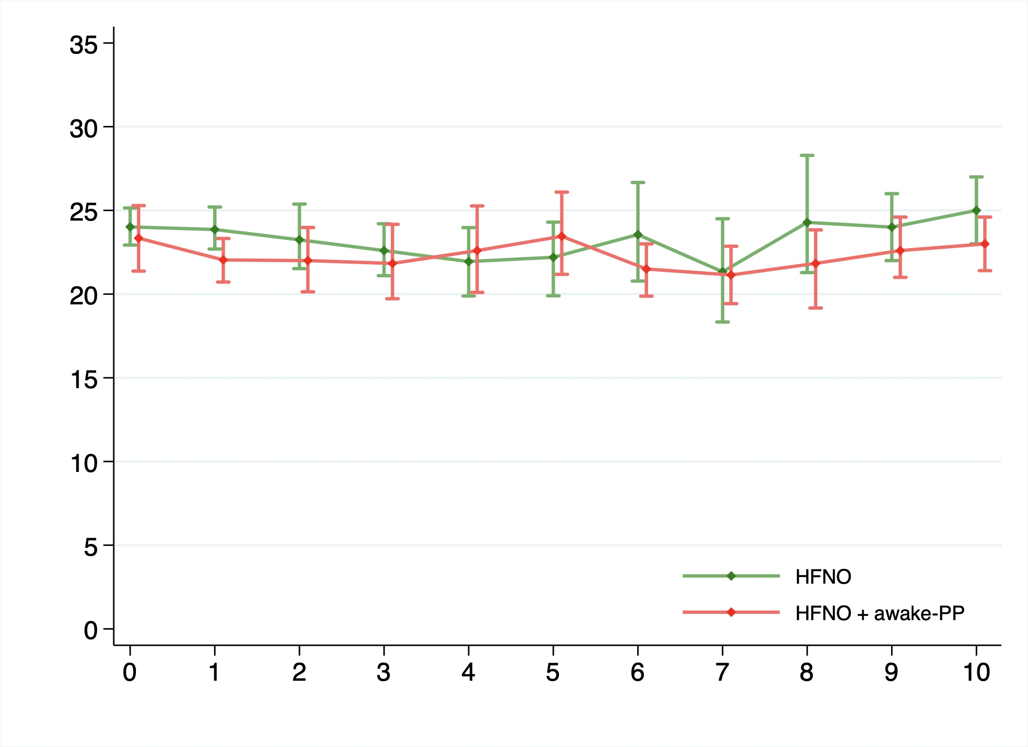

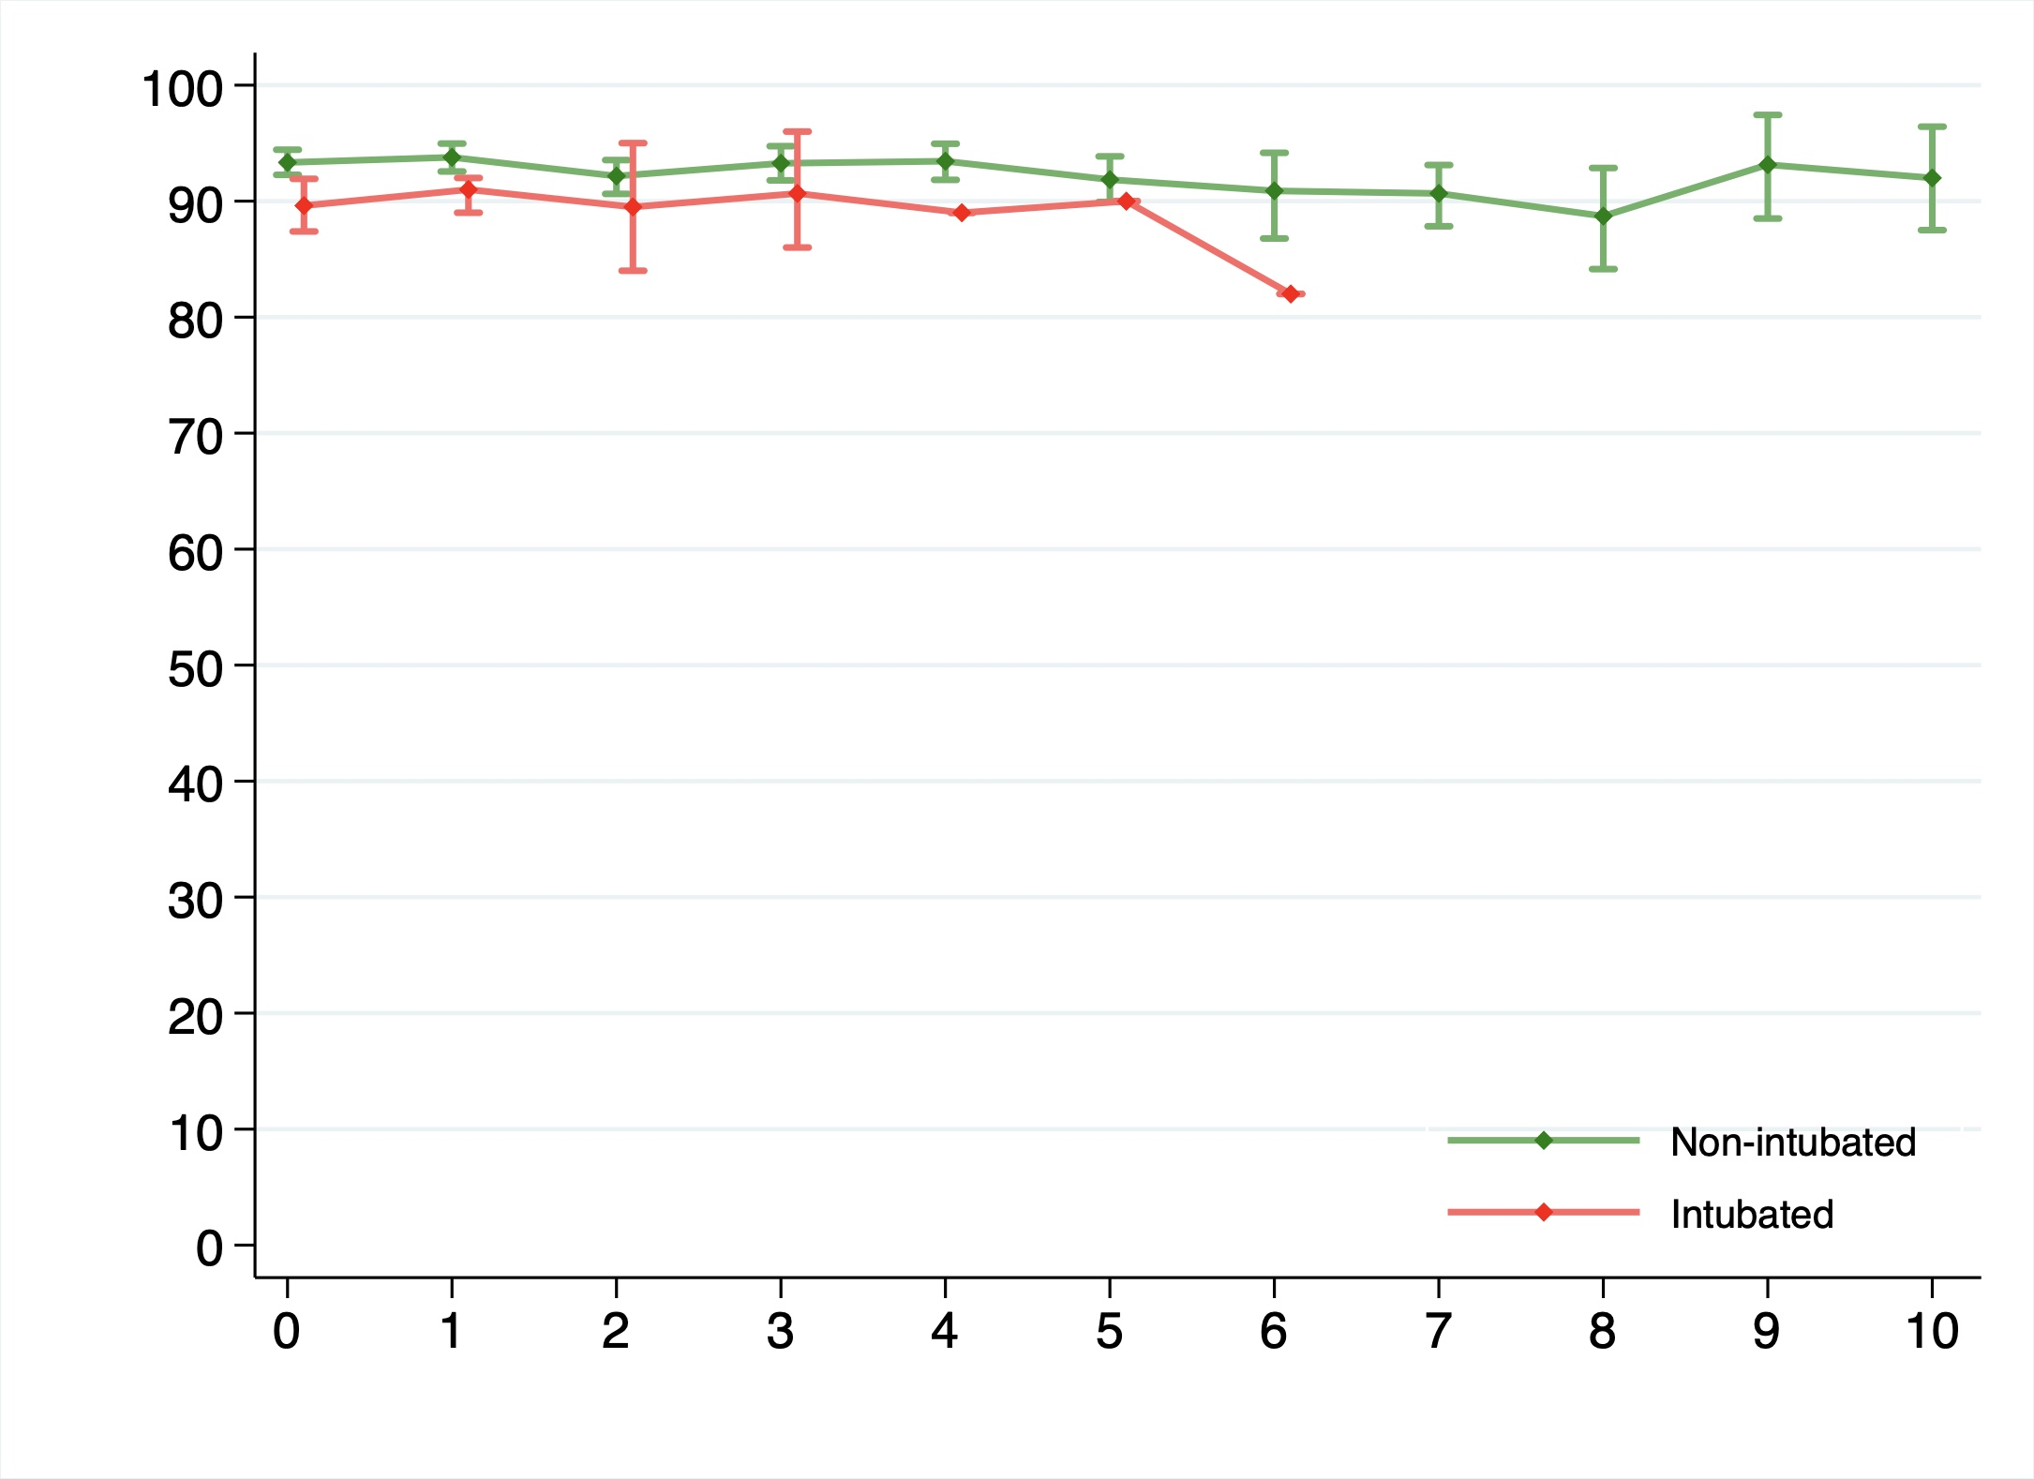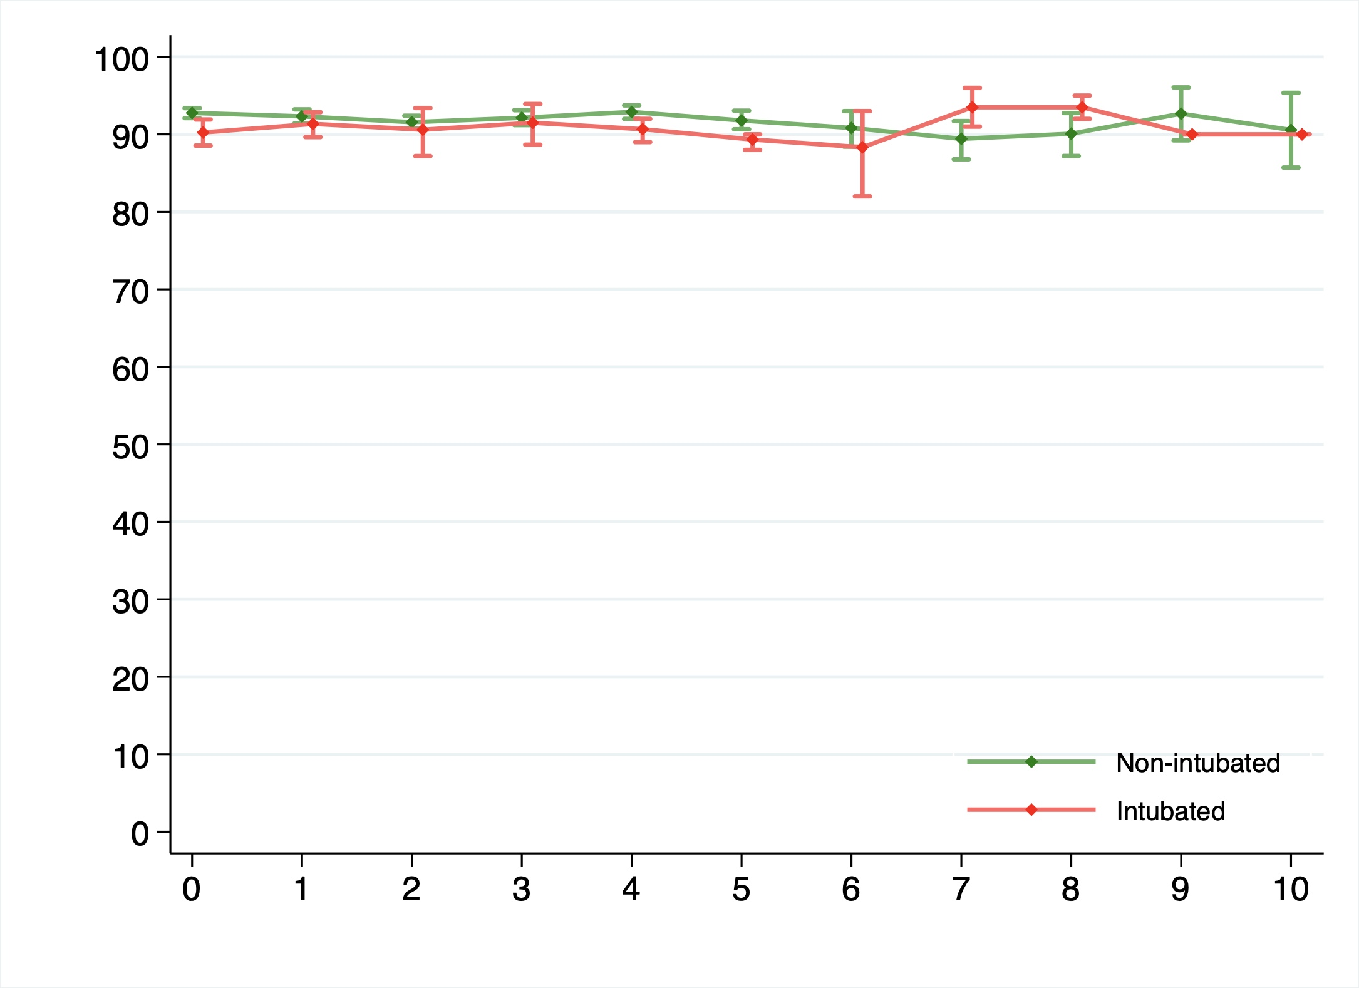

Figure 1. From top to bottom: HFNO vs HFNO+awake-PP, non-intubated vs intubated in patients with HFNO, non-intubated vs intubated in patients with HFNO+awake-PP. HFNO: High flow nasal oxygen therapy.

Figure 2. Respiratory rate (breath per minute) over time in the adjusted population.

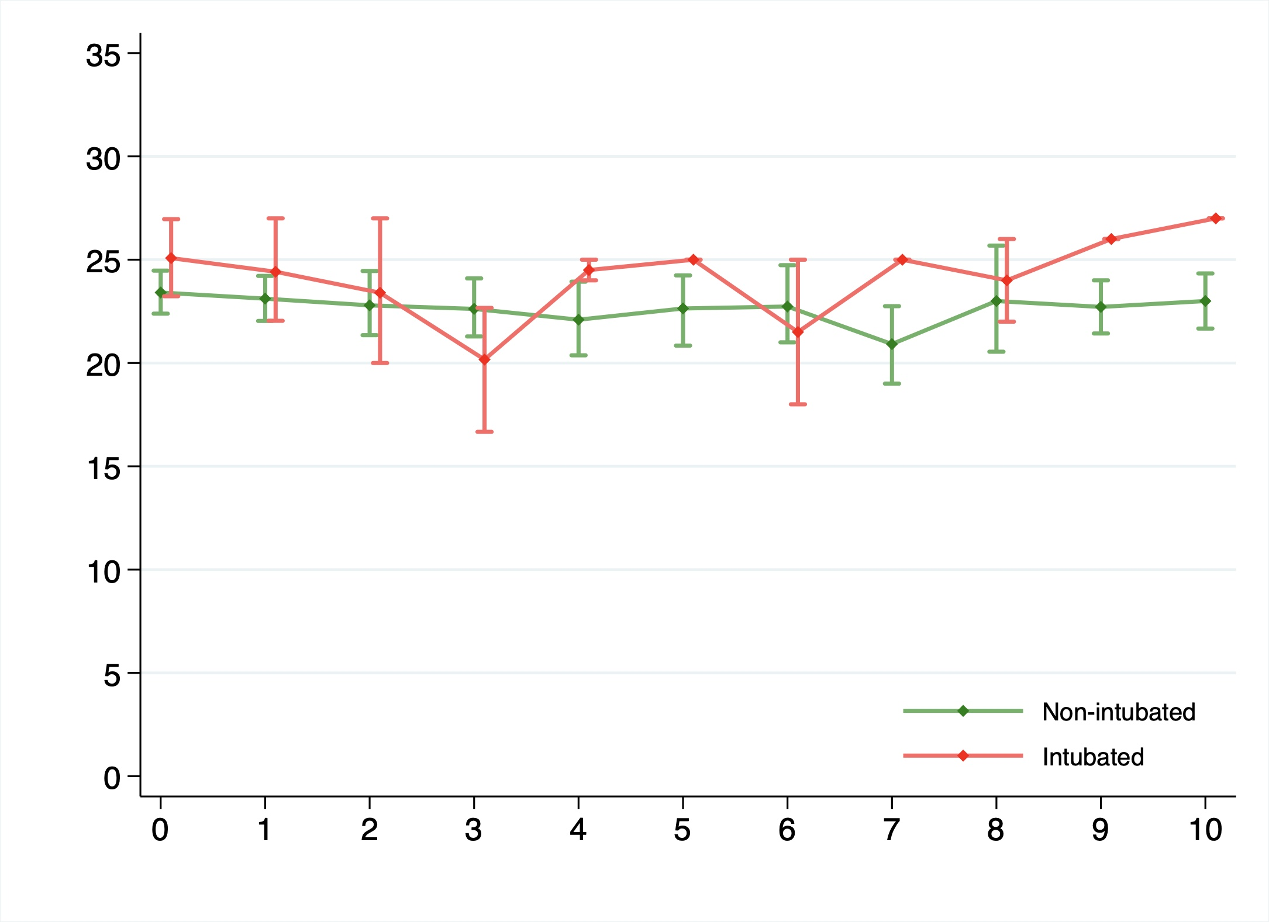
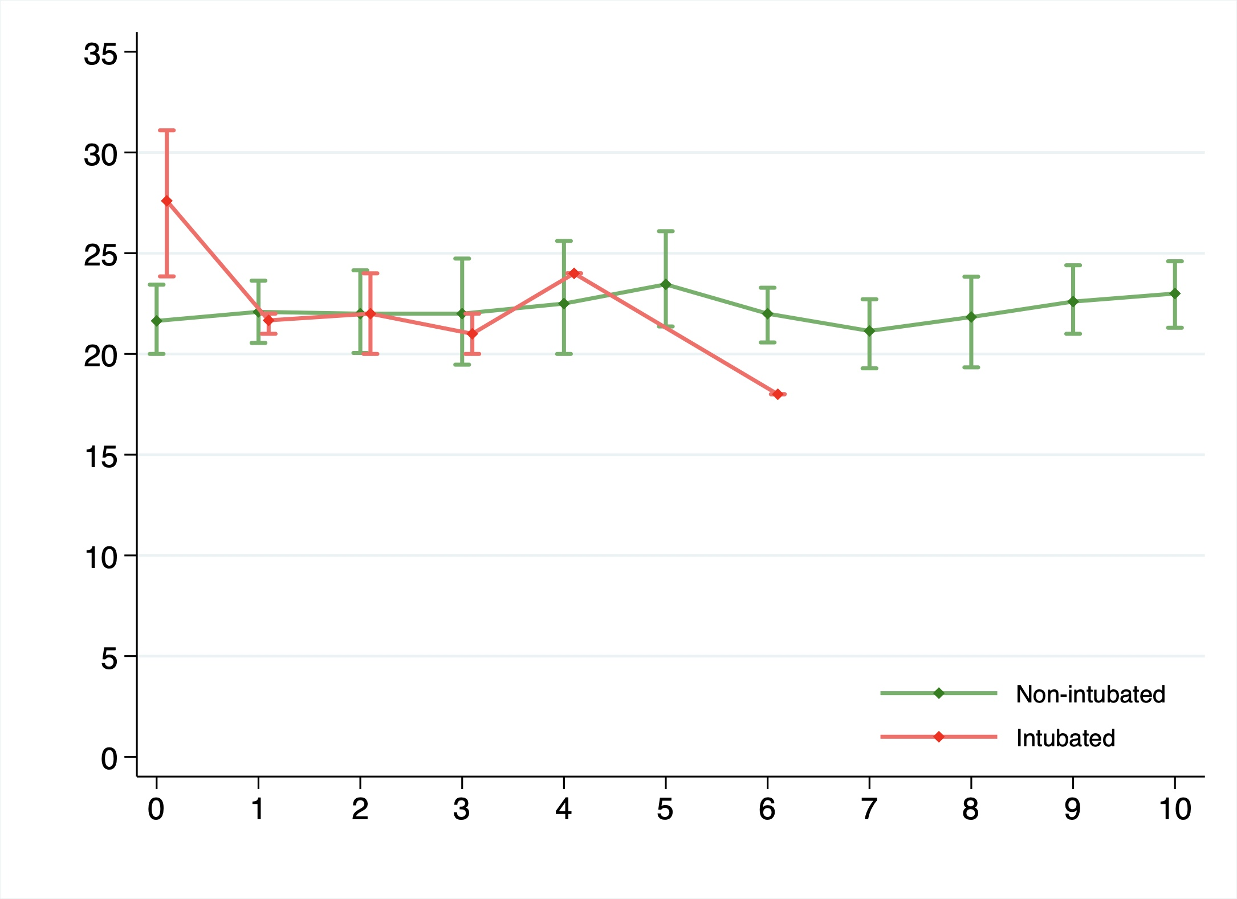

Figure 2. From to bottom: HFNO vs HFNO+awake-PP, non-intubated vs intubated in patients with HFNO, non-intubated vs intubated in patients with HFNO+awake-PP. HFNO: High flow nasal oxygen therapy.

Figure 3. ROX Index [(SpO₂/FiO₂) / Respiratory rate] over time in the adjusted population.

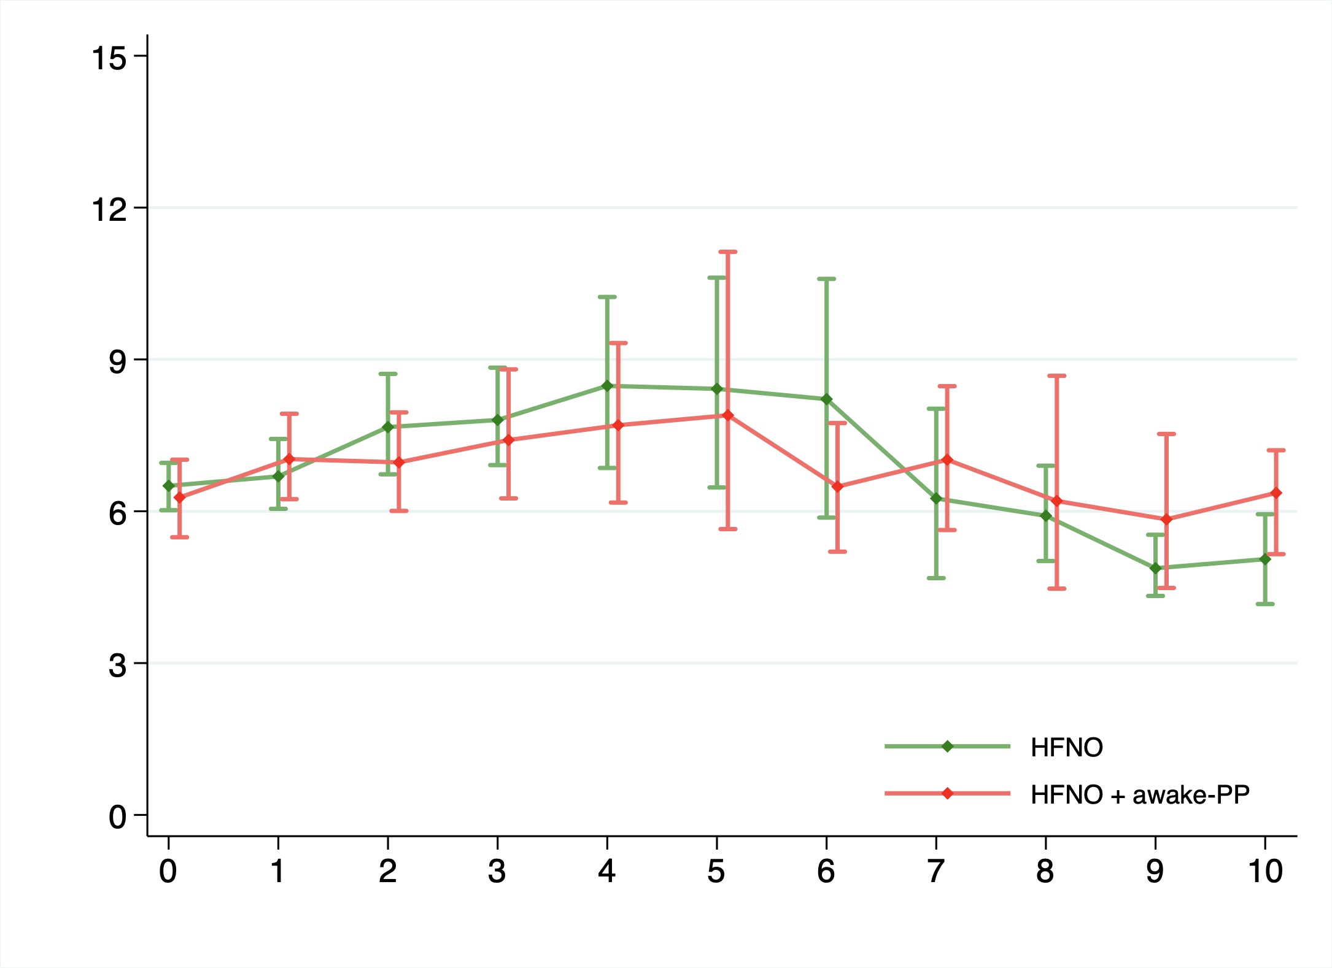
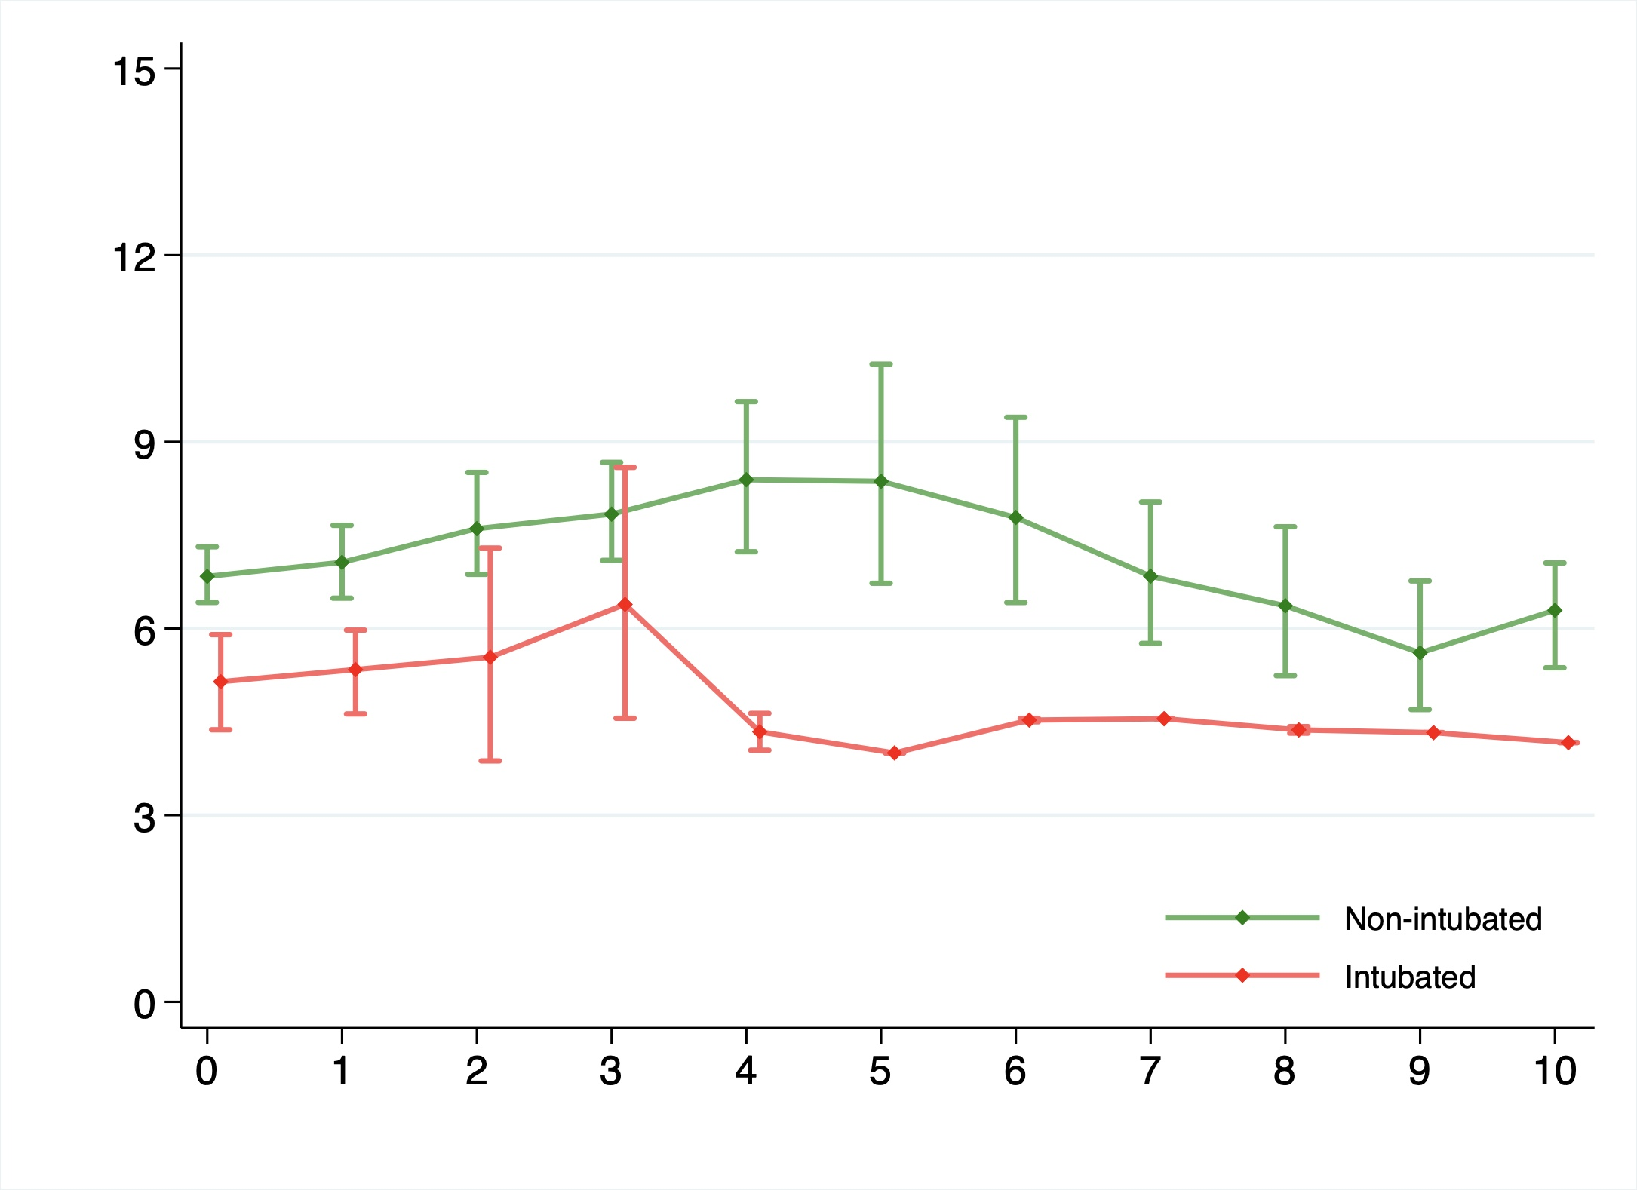
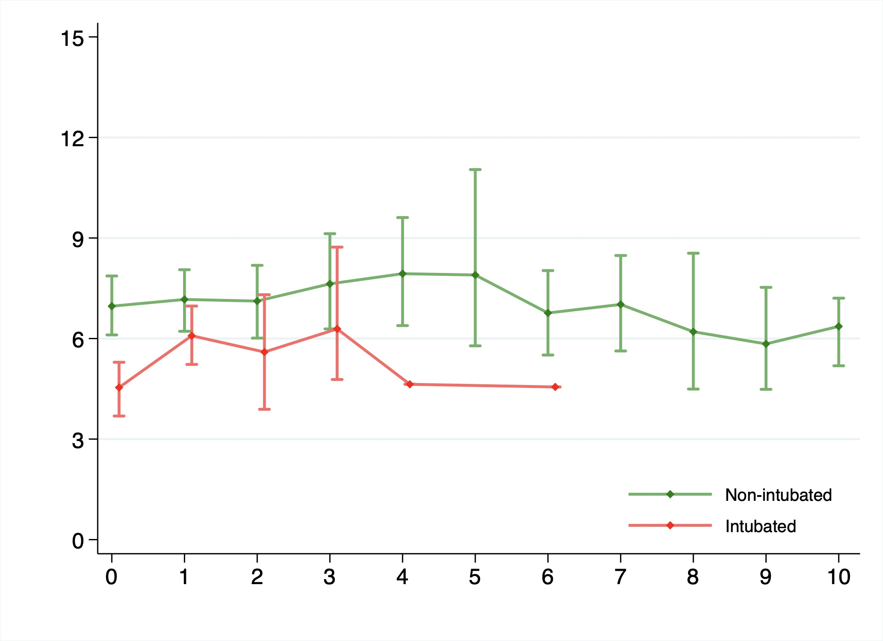

Figure 3. From to bottom: HFNO vs HFNO+awake-PP, non-intubated vs intubated in patients with HFNO, non-intubated vs intubated in patients with HFNO+awake-PP. HFNO: High flow nasal oxygen therapy.

Figure 4. Probability of being intubated in patients stratified by PaO₂/FiO₂.

Figure 4. Time to event curves using Kaplan-Meier with multivariate Cox regression. The probability of being intubated in the original samples. Top: Patients with baseline PaO₂/FiO₂ < 100; [HR 1.30 (95%CI: 0.59-2.88); p=0.51]. Bottom: Patients with baseline PaO₂/FiO₂ > 100; [HR 0.53 (95%CI: 0.25-1.50); p=0.10]. P-value for interaction=0.13.

Figure 5. Probability of 28-day mortality in patients stratified by PaO₂/FiO₂.

Figure 5. Time to event curves using Kaplan-Meier with multivariate Cox regression. The probability of 28-day mortality in the original samples. Top: Patients with baseline PaO₂/FiO₂ < 100; [HR 1.68 (95%CI: 0.33-8.66); p=0.53]. Bottom: Patients with baseline PaO₂/FiO₂ > 100; [HR 0.64 (95%CI: 0.12-3.32); p=0.59]. P-value for interaction=0.42.

