Additional File 10.

Supplemental Figure 1. 73-year old male with V-A extracorporeal membrane oxygenation for cardiogenic shock.
- Initial EEG recording showing diffuse low-voltage alpha and beta activity indicative of sedation.
- EEG 5 days later showing diffuse slowing and left hemispheric attenuation.
- Head computed tomography scan showing acute ischemic stroke in the left hemisphere and right parieto-occipital.

EEG settings : longitudinal bipolar montage ; low-pass filter 70Hz ; high-pass filter : 0.53 Hz ; notch filter off.

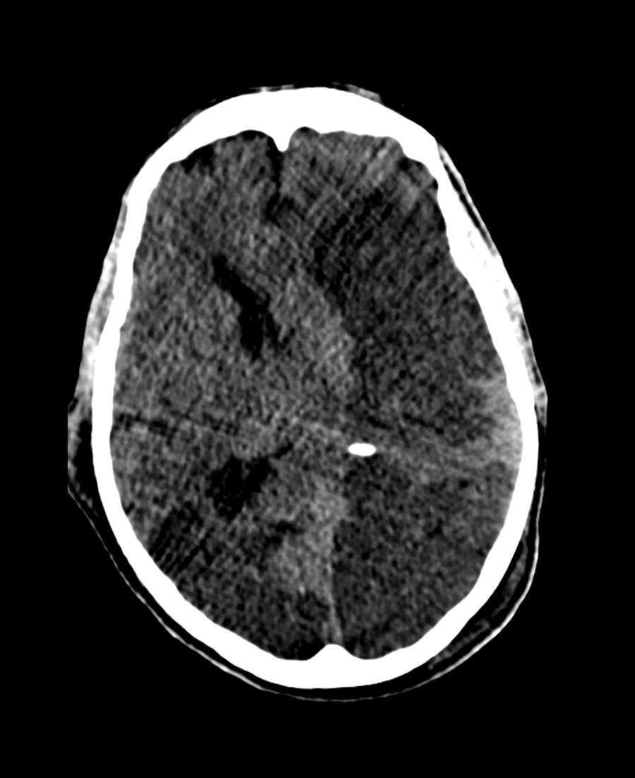

Peluso et al. Supplemental Figure 1C

