Supplement 6
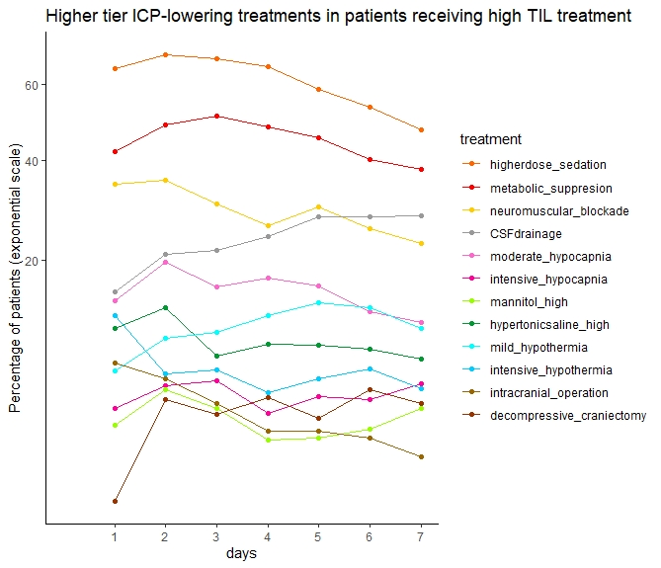
This figure shows the proportion of patients that receive first and second tier treatments of the high TIL patients across 7 days at the Intensive Care Unit. Decompressive craniectiomies at day 1 were excluded. Mannitol_high: >2 g/kg/24h, hypertonicsaline_high: > 0.3 g/kg/24h

