Additional File 4 – Baseline patient characteristics comparison between successful and unsuccessful liberation from mechanical ventilation

Age
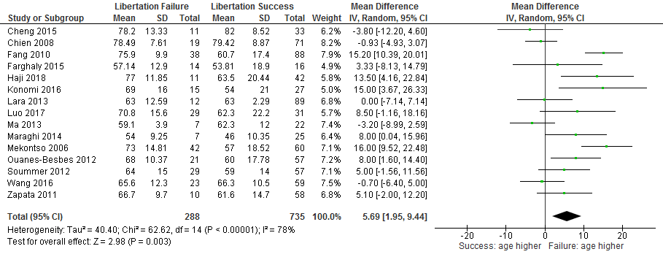

EF
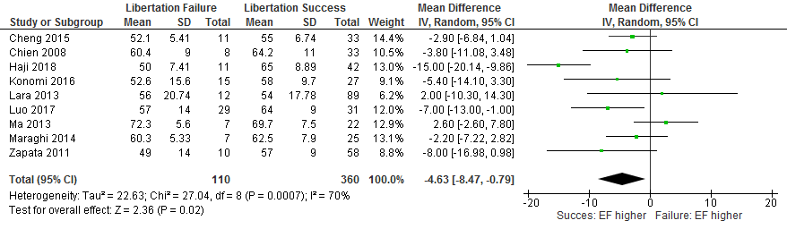
Males
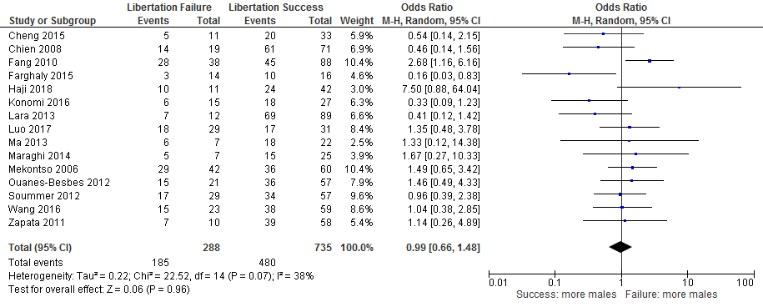

Creat
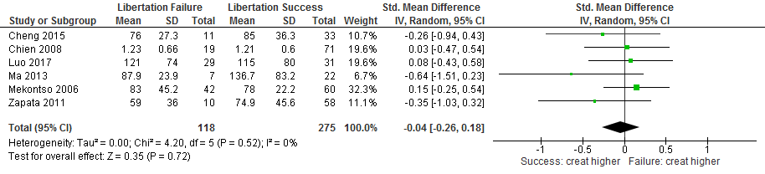
APACHE
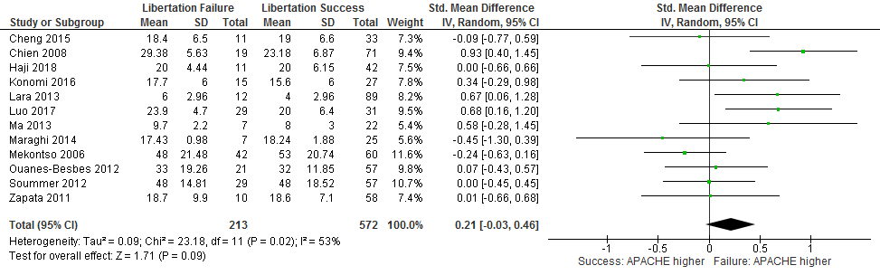
Duration
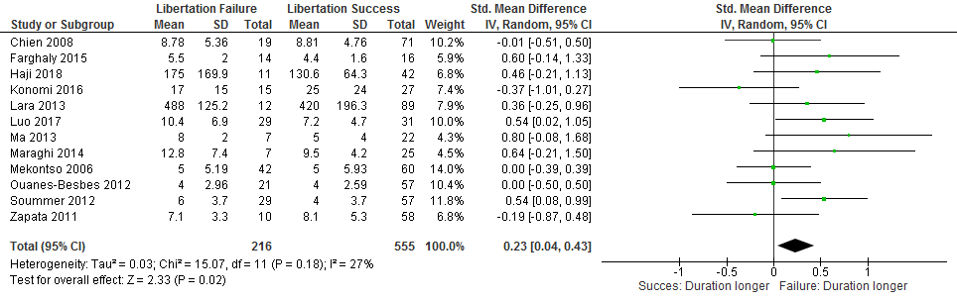

RR24 (b/min)
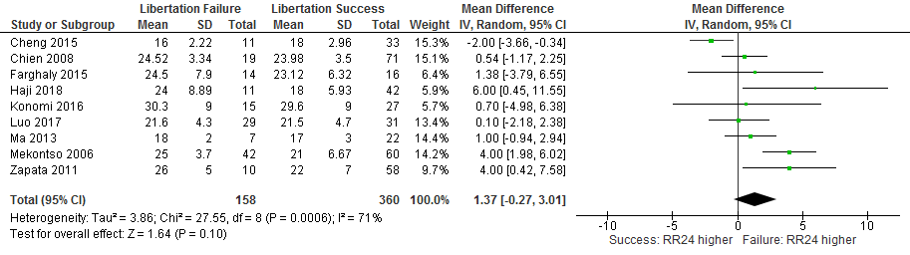
Vt4 (mL)
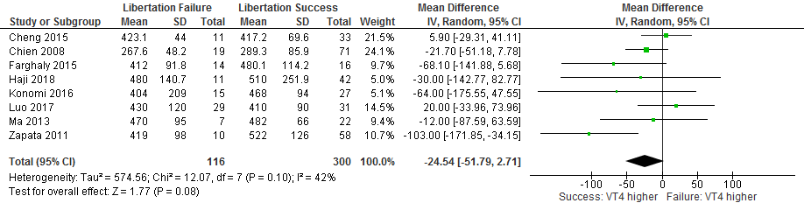
VE (L/min)
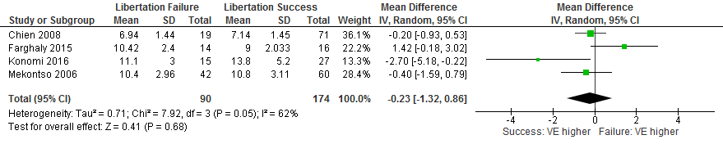
RSBI

PH
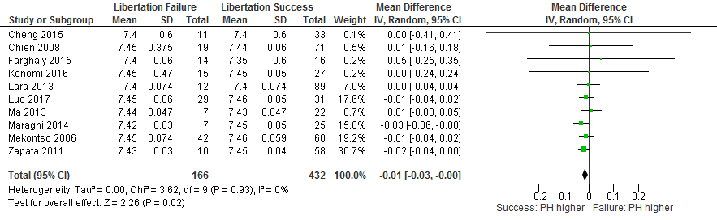

PaO (mmHG)
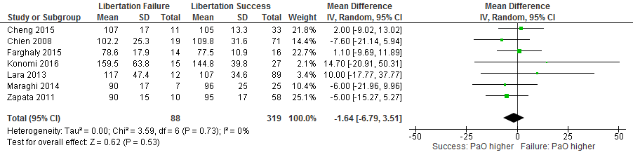
PCO2 (mmHG)
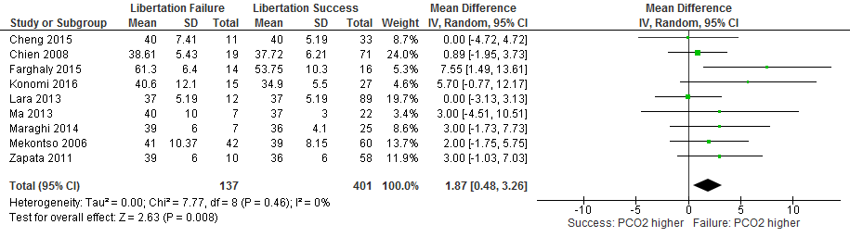

Pa02/fIO227
