Additional file 1 Sites of sampling from the CVVHD circuit
(A) Pre-dialyzer sampling port, (B) Post-dialyzer sampling port, (C) Effluent fluid sampling port
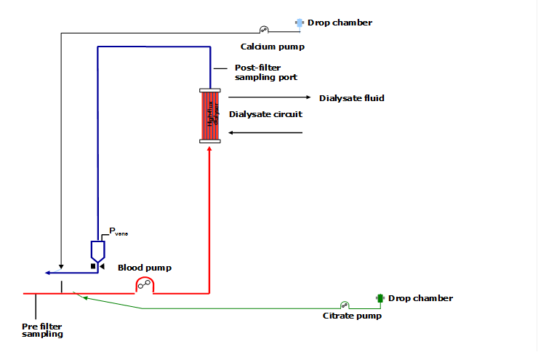
(A) Pre-dialyzer sampling port
(B) Post-dialyzer sampling port
(C) Effluent fluid sampling port

