Computed Tomography Assessment of PEEP-induced Alveolar Recruitment in Patients with Severe COVID-19 Pneumonia
Lorenzo Ball, Chiara Robba, Lorenzo Maiello, Jacob Herrmann, Sarah E Gerard, Yi Xin, Denise Battaglini, Iole Brunetti, Giuseppe Minetti, Sara Seitun, Antonio Vena, Daniele Roberto Giacobbe, Matteo Bassetti, Patricia RM Rocco, Maurizio Cereda, Lucio Castellan, Nicolò Patroniti, Paolo Pelosi

Table of Contents
Clinical context, rationale and indications for CT scan 2
Protocol for the two-PEEP CT scan acquisition and analysis 2
Assessment of gas exchange and respiratory mechanics 3
Definition of Ventilator-Associated Pneumonia 4
eFigure 1 – Patient inclusion flow 5
eTable 1. Characteristics of patients with and without gas exchange data on the day of CT scan. 6
eTable 2 – Associations with inflammatory and thrombophilia markers 7
eTable 3. Characteristics of patients in two respiratory system compliance groups. 8
eFigure 2 – Associations between lung excess mass and aeration at PEEP 8 cmH₂O. 10
eFigure 3 – Ventral-dorsal and apical-caudal ROIs 11
eFigure 4 – Associations between lung recruitment and disease severity 12
eFigure 5 – Ventilatory ratio at two PEEP levels 13
eFigure 6 – Associations between recruitment and gas exchange 13
References 14

Clinical context, rationale and indications for CT scan
The first intubated COVID-19 patient was admitted to our intensive care unit (ICU) on February 29th, 2020, during a national emergency and in lack of clinical data concerning the disease. Most patients at admission met the criteria for moderate to severe acute respiratory distress syndrome (ARDS) and were treated according to the current clinical practice and recommendations, including the use of moderate to high positive end-expiratory pressure (PEEP) levels(1). In the first weeks, we observed a wide range of respiratory system compliance at admission and dissociation between compliance and the PaO₂/FiO₂ ratio, suggesting differences with classical ARDS. Moreover, the response to PEEP increase, while improving gas exchange, often resulted in worsening of the respiratory mechanics, with increased driving pressure and decreased compliance. Therefore, starting from March 20th 2020, we started performing two-PEEP computed tomography (CT) as part of the clinical evaluation of patients with COVID-19 pneumonia. Images were initially evaluated visually to estimate the individual potential for lung recruitment(2), then after approval of the Ethical Review Board we started retrieving images for quantitative analysis. We performed the two-PEEP CT scan in all patients with a clinical indication for chest CT, excluding those: 1) requiring contrast medium for clinical reasons, 2) having contraindications to higher PEEP (e.g. undrained pneumothorax), 3) judged too instable to be safely transported to the CT facility.

Protocol for the two-PEEP CT scan acquisition and analysis
Chest CT scans were performed during end-expiratory breath hold using one of the two available scanners: a Somatom Definition Flash (38 patients, Siemens, Erlangen, Germany) and an Optima CT660 (4 patients, GE Medical Systems, Little Chalfont, Buckinghamshire, United Kingdom). The former was operated at 140 kVp, the latter at 120 kVp, with dose modulation activated on both scanners. Images were reconstructed at a slice thickness of 0.75 mm (N = 36), 1.25 mm (N = 2), 2.5 mm (N = 2) or 5 mm (N = 2), using sharp lung kernels (B80f on the Siemens scanner, Lung kernel on the GE scanner). The lung weight was assumed proportional to the gas vs. tissue fraction contained in each voxel, approximating the tissue density as equal to the water density. (3) Segmentation of lung parenchyma was performed automatically using a multi-resolution convolutional neural network(4) with automated exclusion of airways, followed by manual refinement as necessary. Three regions of interests (ROIs) of equal lung tissue weight(3, 5) were obtained along the ventral-dorsal and craniocaudal axes. In all analyses, ROIs were further subdivided according to their degree of aeration, using standard thresholds (-900 HU, -500 HU, and -100 HU to define hyper-aerated, normal, poorly aerated, and non-aerated lung regions)(6).

Assessment of gas exchange and respiratory mechanics
We assessed gas exchange and respiratory mechanics at PEEP 8 cmH₂O and 16 cmH₂O to help the clinician in deciding the individual level of PEEP. In this analysis, we included gas exchange and respiratory mechanics data of patients in which the assessment was performed within two hours from the execution of the CT scan. The assessment was performed during volume-controlled mechanical ventilation, with tidal volume, respiratory rate and FiO₂ set as per clinical indication. Gas exchange was assessed at a FiO₂ of 0.5 and 1.0. Blood gas analyses were performed after allowing 5 minutes for stabilization. Venous admixture was assessed at FiO₂ 1.0 at the two PEEP levels with the following formula:
$$\frac{{\dot{Q}}_{VA}}{{\dot{Q}}_{T}}=\frac{CcO_{2}-CaO_{2}}{CcO_{2}-CvO_{2}}$$
Where the capillary oxygen content (CcO₂) was computed as:
$${CcO}_{2}=\left({P_{A}O}_{2}∙0.0031\right)+\left[Hb\right]∙100\%∙1.36$$
assuming
$${P_{A}O}_{2}=\left(760 mmHg-47 mmHg\right)∙1-\frac{{PaCO}_{2}}{0.8}$$
The arterial oxygen content (CaO₂) was computed as:
$${CaO}_{2}=\left({PaO}_{2}∙0.0031\right)+\left[Hb\right]∙{SaO}_{2}∙1.36$$
The venous oxygen content (CvO₂) was estimated from a central venous blood sample as:
$${CvO}_{2}=\left({PvO}_{2}∙0.0031\right)+\left[Hb\right]∙{SvO}_{2}∙1.36$$
The compliance of the respiratory system was computed as:
$$C_{rs}=\frac{V_{T}}{P_{plat}-PEEP}$$
Where V_{T} is the tidal volume and P_{plat} the plateau pressure measured after a manual inspiratory hold.

Definition of Ventilator-Associated Pneumonia
Patients were classified as having or not having ventilator-associated pneumonia (VAP) on the day of computed tomography (CT) scan based on clinical adjudication, performed by two independent infectious disease specialists, based on the following criteria: new chest X-ray infiltrates occurring more than 48 hours after initiation of invasive ventilation, plus:
- New onset of body temperature ≥38 °C or ≤35 °C AND/OR White blood cell count ≥10,000 cells/μL or ≤4500 cells/μL
AND
- New onset of respiratory secretions requiring suctioning AND/OR Need for increased FiO2 or PEEP to maintain oxygenation

eFigure 1 – Patient inclusion flow
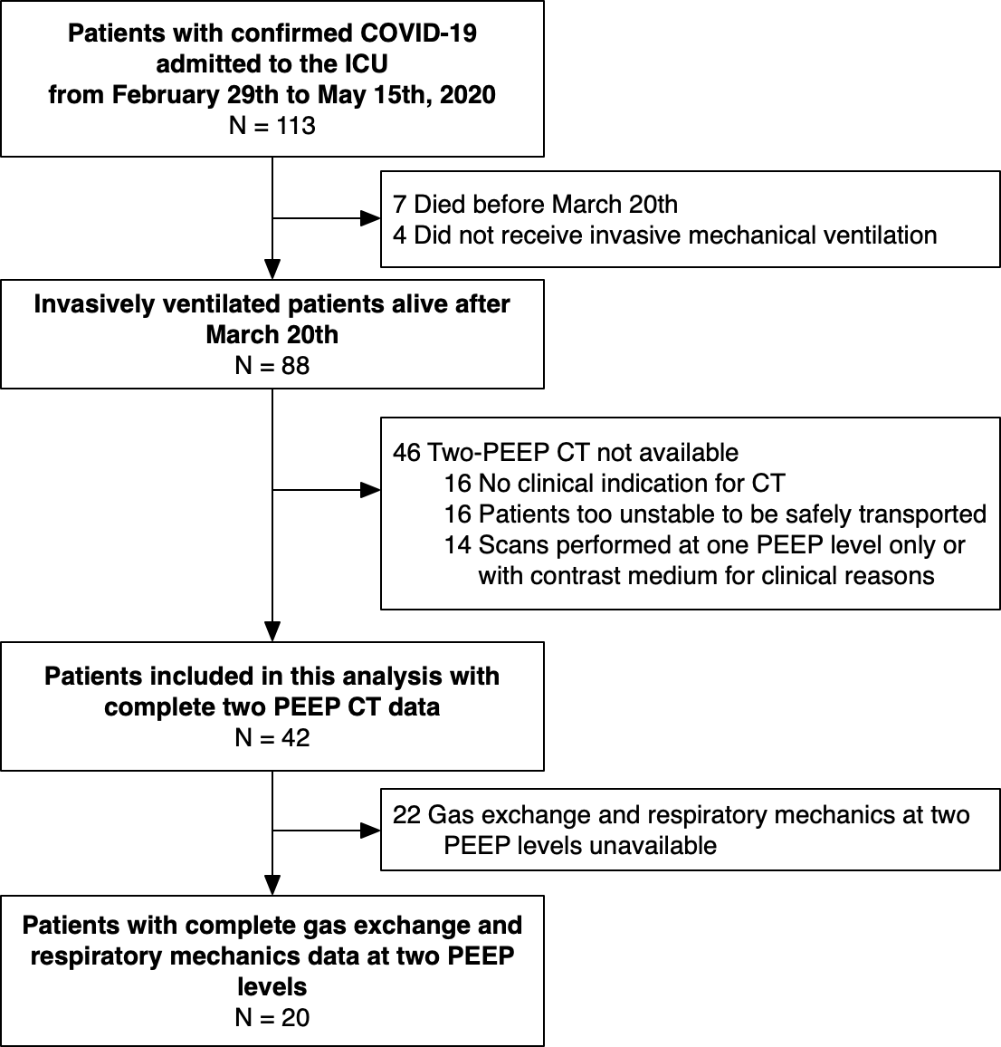
eFigure 1: Patient inclusion flow. PEEP: positive end-expiratory pressure; CT: computed tomography.

eTable 1. Characteristics of patients with and without gas exchange data on the day of CT scan.
Parameter | All (N=42) | With gas exchange data (N=20) | Without gas exchange data (N=22) | p
Age, median [IQR], years | 63 [58 - 67] | 65 [57 - 68] | 62 [58 - 66] | 0.495
Predicted body weight, median [IQR], kg | 70 [61 - 73] | 71 [66 - 75] | 68 [61 - 72] | 0.656
Body mass index, median [IQR], kg/m² | 28 [25 - 31] | 26 [24 - 29] | 28 [26 - 31] | 0.217
Male sex, N (%) | 33 (78.6) | 17 (77.3) | 16 (80.0) | >0.999
Time from symptoms onset, median [IQR], days | 23 [13 - 28] | 18 [13 - 26] | 25 [17 - 29] | 0.194
Time from first confirmed swab, median [IQR], days | 15 [10 - 23] | 11 [10 - 20] | 19 [10 - 25] | 0.246
Time from start of invasive ventilation, median [IQR], days | 9 [4 - 13] | 9 [4 - 12] | 9 [5 - 18] | 0.457
Comorbidities
Hypertension, N (%) | 24 (57.1) | 15 (68.2) | 9 (45.0) | 0.212
Cardiovascular disease, N (%) | 5 (11.9) | 5 (22.7) | 0 (0.0) | 0.049*
Smoker, N (%) | 1 (2.4) | 1 (4.5) | 0 (0.0) | >0.999
Former smoker, N (%) | 5 (11.9) | 3 (13.6) | 2 (10.0) | >0.999
Chronic kidney failure, N (%) | 1 (2.4) | 1 (4.5) | 0 (0.0) | >0.999
Diabetes, N (%) | 5 (11.9) | 3 (13.6) | 2 (10.0) | >0.999
Obesity, N (%) | 11 (26.2) | 7 (31.8) | 4 (20.0) | 0.491
Ventilator settings
Tidal volume, median [IQR], ml/kg PBW | 7.2 [6.3 - 7.9] | 7.4 [6.5 - 7.9] | 7.1 [6.2 - 7.9] | 0.457
Respiratory rate, median [IQR], 1/min | 19 [17 - 25] | 17 [16 - 23] | 21 [18 - 28] | 0.019*
PEEP, median [IQR], cmH₂O | 10 [8 - 12] | 10 [8 - 12] | 10 [9 - 12] | 0.768
Plateau pressure, median [IQR], cmH₂O | 24 [21 - 28] | 24 [21 - 28] | 24 [22 - 28] | 0.705
FiO₂, median [IQR] | 0.60 [0.50 - 0.70] | 0.55 [0.40 - 0.65] | 0.70 [0.60 - 0.70] | 0.003*
Respiratory system compliance, median [IQR], ml/cmH₂O | 36 [29 - 50] | 37 [30 - 48] | 35 [29 - 50] | 0.605
Blood gas analysis
pH, median [IQR] | 7.43 [7.36 - 7.48] | 7.44 [7.41 - 7.48] | 7.41 [7.35 - 7.46] | 0.173
PaO₂, median [IQR], mmHg | 73 [64 - 91] | 71 [62 - 81] | 75 [67 - 94] | 0.155
PaCO₂, median [IQR], mmHg | 48 [43 - 56] | 45 [42 - 56] | 51 [43 - 56] | 0.450
PaO₂/FiO₂, median [IQR], mmHg | 123 [100 - 160] | 135 [113 - 175] | 110 [96 - 159] | 0.174
Lactate, median [IQR], mmol/L | 1.1 [0.8 - 1.8] | 1.3 [0.8 - 2.1] | 1.1 [0.8 - 1.4] | 0.425
Ventilatory ratio | 1.8 [1.5 – 2.4] | 1.7 [1.3 – 2.2] | 1.9 [1.6 – 2.6] | 0.121
Blood analyses
D-dimer, median [IQR], ug/L | 1647 [1048 - 4426] | 2584 [1101 - 12074] | 1480 [835 - 1893] | 0.134
C reactive protein, median [IQR], mg/L | 42 [17 - 108] | 25 [10 - 66] | 52 [21 - 111] | 0.162
Procalcitonin, median [IQR], ug/L | 0.21 [0.09 - 0.97] | 0.17 [0.07 - 0.58] | 0.26 [0.10 - 1.22] | 0.420
Interleukin-6, median [IQR], ng/L | 127 [55 - 387] | 161 [93 - 452] | 84 [16 - 199] | 0.064
Creatinine, median [IQR], mg/dL | 0.9 [0.7 - 1.7] | 1.0 [0.7 - 1.4] | 0.8 [0.7 - 1.7] | 0.781
Hemodynamics
Heart rate, median [IQR], 1/min | 82 [70 - 100] | 79 [68 - 94] | 85 [71 - 111] | 0.212
Mean arterial pressure, median [IQR], mmHg | 82 [73 - 93] | 79 [72 - 98] | 83 [78 - 93] | 0.465
Ventilator-associated pneumonia, N (%) | 12 (28.6) | 8 (40.0) | 4 (18.2) | 0.315
PEEP: positive end-expiratory pressure; ICU: intensive care unit; PBW: predicted body weight.

eTable 2 – Associations with inflammatory and thrombophilia markers
 | Lung recruitment (%) | Excess lung weight (%)
D-dimer (ug/L) | ρ = -0.051, p = 0.750 | ρ = 0.049, p = 0.759
C reactive protein (mg/L) | ρ = 0.152, p = 0.335 | ρ = 0.072, p = 0.651
Procalcitonin (ug/L) | ρ = 0.190, p = 0.229 | ρ = -0.064, p = 0.689
Interleukin-6 (ng/L) | ρ = -0.142, p = 0.371 | ρ = 0.013, p = 0.933
Respiratory system compliance (ml/cmH₂O) | ρ = -0.068, p = 0.667 | ρ = -0.068, p = 0.668
PaO₂/FiO₂ | ρ = 0.035, p = 0.828 | ρ = -0.296, p = 0.057

eTable 3. Characteristics of patients in two respiratory system compliance groups.
Parameter | All (N=42) | Lower compliance (N=24) | Higher compliance (N=18) | p
Age, median [IQR], years | 63 [58 - 67] | 64 [58 - 67] | 62 [60 - 66] | 0.779
Predicted body weight, median [IQR], kg | 70 [61 - 73] | 70 [61 - 75] | 70 [61 - 71] | 0.990
Body mass index, median [IQR], kg/m² | 28 [25 - 31] | 28 [26 - 31] | 28 [25 - 31] | >0.99
Male sex, N (%) | 33 (78.6) | 18 (75.0) | 15 (83.3) | 0.708
Time from symptoms onset, median [IQR], days | 23 [13 - 28] | 26 [17 - 37] | 17 [13 - 25] | 0.065
Time from first confirmed swab, median [IQR], days | 15 [10 - 23] | 20 [11 - 30] | 10 [9 - 18] | 0.025*
Time from start of invasive ventilation, median [IQR], days | 9 [4 - 13] | 11 [4 - 13] | 7 [4 - 13] | 0.315
Comorbidities
Hypertension, N (%) | 24 (57.1) | 13 (54.2) | 11 (61.1) | 0.757
Cardiovascular disease, N (%) | 5 (11.9) | 3 (12.5) | 2 (11.1) | >0.99
Smoker, N (%) | 1 (2.4) | 1 (4.2) | 0 (0.0) | >0.99
Former smoker, N (%) | 5 (11.9) | 3 (12.5) | 2 (11.1) | >0.99
Chronic kidney failure, N (%) | 1 (2.4) | 1 (4.2) | 0 (0.0) | >0.99
Diabetes, N (%) | 5 (11.9) | 5 (20.8) | 0 (0.0) | 0.060
Obesity, N (%) | 11 (26.2) | 5 (20.8) | 6 (33.3) | 0.483
Ventilator settings
Tidal volume, median [IQR], ml/kg PBW | 7.2 [6.3 - 7.9] | 6.9 [6.1 - 7.6] | 7.7 [7.2 - 8.9] | 0.008*
Respiratory rate, median [IQR], 1/min | 19 [17 - 25] | 21 [16 - 26] | 18 [17 - 22] | 0.507
PEEP, median [IQR], cmH₂O | 10 [8 - 12] | 10 [8 - 12] | 10 [10 - 13] | 0.127
Plateau pressure, median [IQR], cmH₂O | 24 [21 - 28] | 27 [24 - 29] | 21 [19 - 25] | <0.001*
FiO₂, median [IQR] | 0.60 [0.50 - 0.70] | 0.60 [0.50 - 0.70] | 0.63 [0.50 - 0.70] | 0.907
Respiratory system compliance, median [IQR], ml/cmH₂O | 36 [29 - 50] | 30 [22 - 35] | 50 [44 - 63] | <0.001*
Blood gas analysis
pH, median [IQR] | 7.43 [7.36 - 7.48] | 7.43 [7.35 - 7.47] | 7.43 [7.37 - 7.48] | 0.532
PaO₂, median [IQR], mmHg | 73 [64 - 91] | 72 [66 - 88] | 75 [64 - 94] | 0.949
PaCO₂, median [IQR], mmHg | 48 [43 - 56] | 51 [41 - 62] | 47 [43 - 52] | 0.374
PaO₂/FiO₂, median [IQR], mmHg | 123 [100 - 160] | 122 [94 - 165] | 128 [107 - 160] | 0.684
Lactate, median [IQR], mmol/L | 1.1 [0.8 - 1.8] | 1.2 [1.0 - 1.8] | 1.0 [0.8 - 1.8] | 0.220
Ventilatory ratio | 1.8 [1.5 – 2.4] | 1.9 [1.2 – 2.6] | 1.8 [1.6 – 2.2] | 0.799
Blood analyses
D-dimer, median [IQR], ug/L | 1647 [1048 - 4426] | 1471 [831 - 3962] | 1684 [1050 - 6866] | 0.576
C reactive protein, median [IQR], mg/L | 42 [17 - 108] | 29 [17 - 66] | 62 [25 - 136] | 0.118
Procalcitonin, median [IQR], ug/L | 0.21 [0.09 - 0.97] | 0.37 [0.10 - 1.44] | 0.13 [0.09 - 0.46] | 0.186
Interleukin-6, median [IQR], ng/L | 127 [55 - 387] | 130 [49 - 373] | 127 [55 - 387] | 0.839
Creatinin, median [IQR], mg/dL | 0.9 [0.7 - 1.7] | 1.1 [0.6 - 1.7] | 0.9 [0.7 - 1.1] | 0.730
Hemodynamics
Heart rate, median [IQR], 1/min | 82 [70 - 100] | 94 [80 - 111] | 72 [66 - 81] | 0.002*
Mean arterial pressure, median [IQR], mmHg | 82 [73 - 93] | 80 [70 - 90] | 84 [78 - 103] | 0.088
Ventilator-associated pneumonia, N (%) | 12 (28.6) | 9 (37.5) | 3 (16.7) | 0.180
Patients’ characteristics on the day of CT scan according to their respiratory system compliance (cut-off value 40 ml/cmH₂O). IQR: interquartile range; PBW predicted body weight; PEEP: Positive End-Expiratory Pressure; ICU: intensive care unit.

eFigure 2 – Associations between lung excess mass and aeration at PEEP 8 cmH₂O.
eFigure 2: Associations between lung excess mass and aeration at PEEP 8cmH₂O.

eFigure 3 – Ventral-dorsal and apical-caudal ROIs
eFigure 3: Lung aeration compartments in three ventral-to-dorsal and three apical-to-caudal regions of equal mass at PEEP level of 8 cmH₂O and 16 cmH₂O.

eFigure 4 – Associations between lung recruitment and disease severity
eFigure 4: Associations between lung recruitment and disease severity.

eFigure 5 – Ventilatory ratio at two PEEP levels
eFigure 5: Ventilatory ratio at PEEP of 8 and 16 cmH₂O. Gray squares and lines represent individual patient data, red bars the median value. Dashed lines represent patients in the recruiters group, solid lines the non-recruiters group. PEEP: positive end-expiratory pressure.

eFigure 6 – Associations between recruitment and gas exchange
eFigure 6: Associations between recruitment and gas exchange. The venous admixture is estimated with FiO₂ of 1.0.

References
1. Fan E, Del Sorbo L, Goligher EC, Hodgson CL, Munshi L, Walkey AJ, Adhikari NKJ, Amato MBP, Branson R, Brower RG, Ferguson ND, Gajic O, Gattinoni L, Hess D, Mancebo J, Meade MO, McAuley DF, Pesenti A, Ranieri VM, Rubenfeld GD, Rubin E, Seckel M, Slutsky AS, Talmor D, Thompson BT, Wunsch H, Uleryk E, Brozek J, Brochard LJ, et al. An Official American Thoracic Society/European Society of Intensive Care Medicine/Society of Critical Care Medicine Clinical Practice Guideline: Mechanical Ventilation in Adult Patients with Acute Respiratory Distress Syndrome. Am J Respir Crit Care Med 2017;195:1253–1263.
2. Chiumello D, Marino A, Brioni M, Menga F, Cigada I, Lazzerini M, Andrisani MC, Biondetti P, Cesana B, Gattinoni L. Visual anatomical lung CT scan assessment of lung recruitability. Intensive Care Med 2013;39:66–73.
3. Protti A, Iapichino GE, Milesi M, Melis V, Pugni P, Comini B, Cressoni M, Gattinoni L. Validation of computed tomography for measuring lung weight. Intensive Care Med Exp 2014;2:31.
4. Gerard SE, Herrmann J, Kaczka DW, Musch G, Fernandez-Bustamante A, Reinhardt JM. Multi-resolution convolutional neural networks for fully automated segmentation of acutely injured lungs in multiple species. Med Image Anal 2020;60:101592.
5. Güldner A, Braune A, Ball L, Silva PL, Samary C, Insorsi A, Huhle R, Rentzsch I, Becker C, Oehme L, Andreeff M, Vidal Melo MF, Winkler T, Pelosi P, Rocco PRM, Kotzerke J, Gama de Abreu M. Comparative Effects of Volutrauma and Atelectrauma on Lung Inflammation in Experimental Acute Respiratory Distress Syndrome. Crit Care Med 2016;44:e854-865.
6. Ball L, Brusasco C, Corradi F, Paparo F, Garlaschi A, Herrmann P, Quintel M, Pelosi P. Lung hyperaeration assessment by computed tomography: correction of reconstruction-induced bias. BMC Anesthesiol 2016;16:67.

