Additional file 3: Added value of MDW to SIRS criteria for Sepsis2 diagnosis (pre-test =0.17) and to qSOFA for Sepsis-3 diagnosis (pre-test =0.09).

Abbreviations: MDW, monocyte distribution width; SIRS, systemic inflammatory response syndrome; qSOFA, quick Sequential Organ Failure Assessment

A. SIRS criteria and Sepsis-2

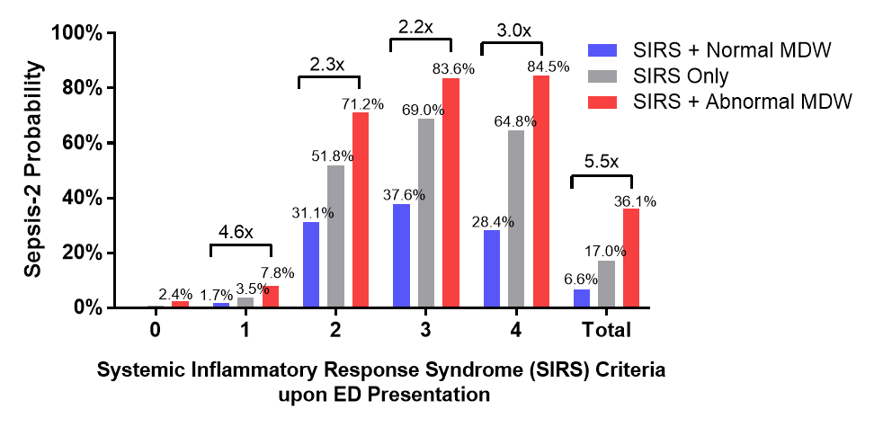
B. qSOFA score and Sepsis-3
