The time from physiological derangement to critical care admission associates with mortality
Supplementary Material
Stephen F Whebell, Emma J Prower, Joe Zhang, Megan Pontin, David Grant, Andrew T Jones, Guy W Glover

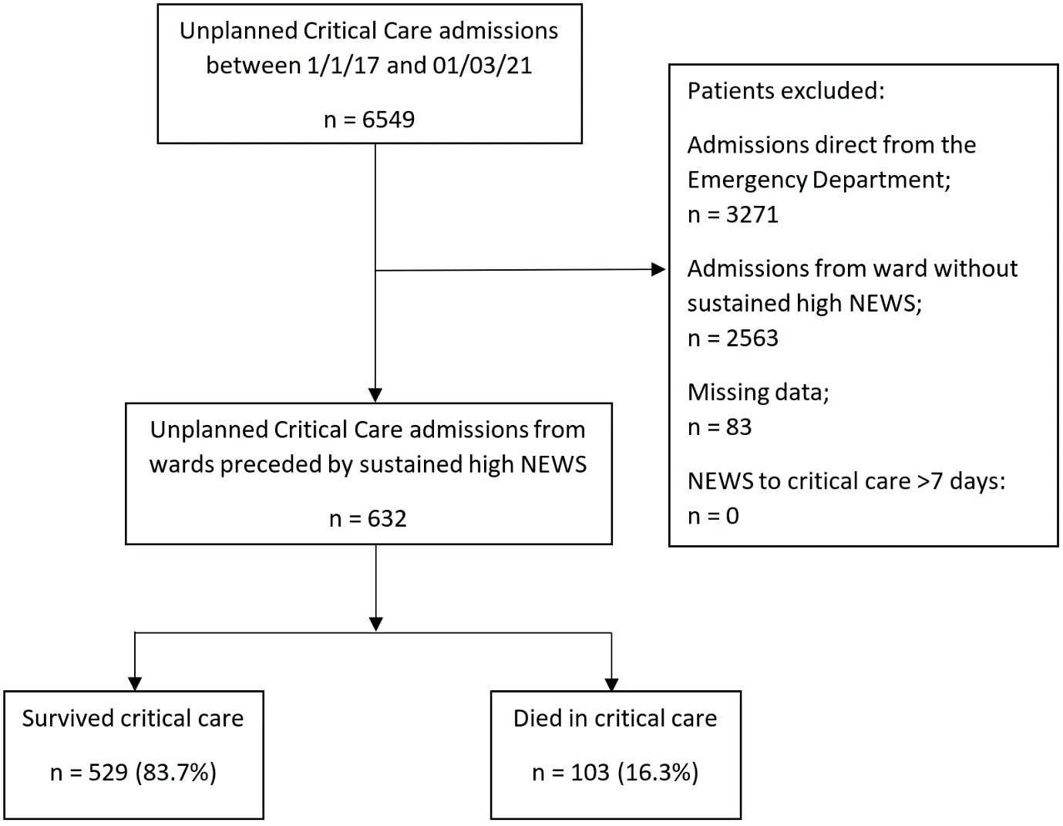
Supplementary Figure 1: Flow chart of patient inclusion and exclusion

 | Full dataset  (n=715) |  |  | Dataset analysed  (n=632)
 | Number of observations | Percent of total observations |  | Number of observations | Percent of total observations
Age | 661 |  | 92.44% | 632 | 100.0%
Male gender | 715 |  | 100.0% | 632 | 100.0%
Charlson-Deyo Comorbidity Index | 715 |  | 100.0% | 632 | 100.0%
Frailty Score | 715 |  | 100.0% | 632 | 100.0%
Primary diagnosis code | 715 |  | 100.0% | 632 | 100.0%
Admission type | 661 |  | 92.44% | 632 | 100.0%
Sepsis during admission | 715 |  | 100.0% | 632 | 100.0%
Hospital length of stay | 690 |  | 96.50% | 632 | 100.0%
Hospital mortality | 715 |  | 100.0% | 632 | 100.0%
Time from hospital admission to initial high NEWS | 715 |  | 100.0% | 632 | 100.0%
Initial high NEWS value | 715 |  | 100.0% | 632 | 100.0%
Time of initial high NEWS | 715 |  | 100.00% | 632 | 100.0%
Peri-arrest call prior to critical care admission | 715 |  | 100.0% | 632 | 100.0%
Initial high NEWS to critical care admission | 715 |  | 100.0% | 632 | 100.0%
Day 1 SOFA score | 632 |  | 88.39% | 632 | 100.0%
Invasive Mechanical Ventilation | 715 |  | 100.0% | 632 | 100.0%
Non-invasive Ventilation | 715 |  | 100.0% | 632 | 100.0%
Critical Care length of stay | 707 |  | 98.88% | 632 | 100.0%
Critical care mortality | 715 |  | 100.0% | 632 | 100.0%
Supplementary Table 1: Missing data in the full dataset and the dataset used for analysis.
NEWS, national early warning score; SOFA, sequential organ failure assessment; NIV, non-invasive ventilation; IMV, invasive mechanical ventilation.

Univariable logistic models for critical care mortality (Supplementary)
Variable | OR | Lower CI (0.025) | Upper CI (0.975) | p
Age* | 1.02 | 1.0 | 1.03 | 0.063
Male gender | 0.92 | 0.63 | 1.5 | 0.9
Frailty Score* | 0.89 | 0.8 | 0.99 | 0.033
Charlson-Deyo Score* | 0.98 | 0.96 | 1.0 | 0.105
Triggering high NEWS2 score | 1.06 | 0.94 | 1.2 | 0.322
Time to triggering high NEWS2 score* | 1.01 | 1.0 | 1.02 | 0.06
Triggering high NEWS2 score out of hours | 1.06 | 0.69 | 1.62 | 0.785
Peri-arrest call prior to critical care admission | 1.36 | 0.72 | 2.54 | 0.343
Score To Door time* | 1.02 | 1.0 | 1.03 | 0.06
SOFA Score* | 1.2 | 1.13 | 1.29 | <0.001
Sepsis flagged at critical care admission | 0.87 | 0.56 | 1.37 | 0.548
NIV or IMV* | 1.93 | 1.26 | 2.95 | 0.002
Elective admission | 0.84 | 0.5 | 1.4 | 0.5
Emergency admission | 1.24 | 0.76 | 2.0 | 0.384
Other admission | 0.79 | 0.3 | 2.1 | 0.637
Univariable logistic models for hospital mortality (Supplementary)
Variable | OR | Lower CI (0.025) | Upper CI (0.975) | p
Age* | 1.02 | 1.01 | 1.03 | 0.002
Male gender | 1.03 | 0.72 | 1.47 | 0.871
Frailty Score | 1.01 | 0.93 | 1.09 | 0.811
Charlson-Deyo Score | 0.99 | 0.98 | 1.01 | 0.397
Triggering high NEWS2 score* | 1.11 | 1.00 | 1.23 | 0.045
Time to triggering high NEWS2 score* | 1.01 | 1.00 | 1.02 | 0.027
Triggering high NEWS2 score out of hours | 1.01 | 0.71 | 1.44 | 0.945
Peri-arrest call prior to critical care admission | 1.27 | 0.74 | 2.19 | 0.374
Score To Door time* | 1.01 | 0.99 | 1.03 | 0.154
SOFA Score* | 1.17 | 1.11 | 1.24 | <0.001
Sepsis flagged at critical care admission | 1.16 | 0.81 | 1.67 | 0.411
NIV or IMV* | 1.85 | 1.30 | 2.64 | <0.001
Elective admission* | 0.73 | 0.47 | 1.13 | 0.15
Emergency admission | 1.26 | 0.85 | 1.87 | 0.252
Other admission | 1.13 | 0.55 | 2.34 | 0.741
Supplementary Table 2: Odds ratios, confidence intervals and p-values for each variable analysed in a univariate logistic regression. Confidence intervals presented are raw and not bootstrapped. Univariable model constants not reported.
OR, odds ratio; CI, confidence interval, NEWS, national early warning score; SOFA, sequential organ failure assessment; NIV, non-invasive ventilation; IMV, invasive mechanical ventilation. *used in final multivariate model.

Sensitivity analysis
Missing datapoints were imputed with the median of available data for each variable analysed. Three patients were subsequently excluded for having a time from initial high NEWS to critical care admission of >7 days. This resulted in 713 patients available for analysis.

Multivariable logistic model for critical care mortality
Variable | OR | Lower CI (0.025) | Upper CI (0.975) | p
Score To Door time | 1.02 | 1.0 | 1.03 | 0.01
Age | 1.02 | 1.0 | 1.03 | 0.022
Dr Foster Global Frailty Score | 0.86 | 0.7 | 1.05 | 0.134
Charlson Deyo Score | 0.99 | 0.97 | 1.01 | 0.264
SOFA Score | 1.21 | 1.12 | 1.31 | <0.001
NIV or IMV | 1.71 | 1.09 | 2.67 | 0.016
Time to triggering high NEWS | 1.02 | 1.0 | 1.03 | 0.011
Constant | 0.02 | 0.01 | 0.07 | <0.001
Multivariable logistic model for hospital mortality
Variable | OR | Lower CI (0.025) | Upper CI (0.975) | p
Score To Door time | 1.01 | 1.0 | 1.03 | 0.048
Age | 1.02 | 1.01 | 1.03 | 0.001
Triggering high NEWS value | 1.11 | 0.99 | 1.23 | 0.047
Time to triggering high NEWS | 1.01 | 1.0 | 1.02 | 0.023
SOFA score | 1.17 | 1.1 | 1.25 | <0.001
NIV or IMV | 1.62 | 1.11 | 2.3 | 0.009
Elective hospital admission | 0.64 | 0.4 | 1.03 | 0.056
Constant | 0.01 | 0.0 | 0.04 | <0.001
Multivariable log-linear model for critical care length of stay (survivors)
Variable | β | Lower CI (0.025) | Upper CI (0.975) | p
Score To Door time | 0.01 | 0.0 | 0.02 | 0.008
Age | 0.0 | -0.01 | 0.01 | 0.482
Dr Foster Global Frailty Score | 0.02 | -0.03 | 0.06 | 0.578
Charlson-Deyo Score | 0.0 | -0.01 | 0.01 | 0.506
SOFA Score | 0.02 | -0.05 | 0.03 | 0.316
Sepsis status during admission | 0.31 | 0.14 | 0.57 | 0.008
NIV or IMV | 0.7 | 0.44 | 0.88 | <0.001
Constant | 0.33 | -0.2 | 0.86 | 0.216
Multivariable log-linear model for Score to Door time
Variable | β | Lower CI (0.025) | Upper CI (0.975) | p
Age | 0.0 | -0.002 | 0.006 | 0.335
Dr Foster Global Frailty Score | 0.03 | -0.03 | 0.03 | 0.285
Charlson-Deyo Score | 0.0 | -0.005 | 0.007 | 0.559
Triggering high NEWS value | -0.08 | -0.11 | -0.04 | <0.001
Time to triggering high NEWS | 0.00 | -0.002 | 0.006 | 0.230
Triggering high NEWS out of hours | 0.01 | -0.09 | 0.14 | 0.929
Peri-/arrest call prior to critical care admission | -0.07 | -0.25 | 0.14 | 0.489
Constant | 2.41 | 2.0 | 2.83 | <0.001
Supplementary Table 3: Multivariable logistic and log-linear regression model results of imputed dataset (sensitivity analysis). Odds ratios presented for logistic models and coefficients presented for log-linear models.
OR, odds ratio; β, coefficient of variable in linear regression; CI, confidence interval; NIV, non-invasive ventilation; IMV, invasive mechanical ventilation; NEWS, national early warning score; SOFA, sequential organ failure assessment

