ADDITIONAL FILE 1

Impact of a restrictive antibiotic policy on the acquisition of extended-spectrum beta-lactamase-producing Enterobacteriaceae in an endemic region: a before-and-after, propensity-matched cohort study in a Caribbean intensive care unit

Christophe Le Terrier, MD^{1,2}* ; Marco Vinetti, MD,^{1,3}* ; Paul Bonjean, MD⁴ ; Régine Richard, RN¹ ; Bruno Jarrige, MD⁵ ; Bertrand Pons, MD¹ ; Benjamin Madeux, MD¹ ; Pascale Piednoir, MD¹ ; Fanny Ardisson, MD¹ ; Elain Elie, MD¹ ; Frédéric Martino, MD¹ ; Marc Valette, MD¹ ; Edouard Ollier, MD, PhD⁴ ; Sébastien Breurec, MD, PhD^{6,7,8,9} ; Michel Carles,MD, PhD^{1,7} ; Guillaume Thiéry, MD^{10,11}
* Contributed equally to this work
¹ Division of Intensive Care, University Hospital of Guadeloupe, Pointe-à-Pitre/Les Abymes, French West Indies, France
² Division of Intensive Care, Geneva University Hospitals, Geneva, Switzerland
³ Division of Intensive Care, Saint-Pierre Clinic, Ottignies, Belgium
⁴Division of Clinical Epidemiology, University Hospital of Saint-Etienne, Saint-Etienne, France
⁵ Division of Hospital Infection Control, University Hospital of Guadeloupe, Pointe-à-Pitre/Les Abymes, French West Indies, France
⁶ Laboratory of Clinical Microbiology, Faculty of Medecine Hyacinthe Bastaraud, University of Antilles, Pointe-à-Pitre, French West Indies, France
⁷ Faculty of Medecine Hyacinthe Bastaraud, University of Antilles, Pointe-à-Pitre, French West Indies, France
⁸ INSERM Center for Clinical Investigation 1424, Pointe-à-Pitre/Les Abymes, French West Indies, France
⁹ Transmission, Reservoir and Diversity of Pathogens Unit, Institut Pasteur de Guadeloupe, Pointe-à-Pitre, French West Indies, France
¹⁰ Division of Intensive Care, University Hospital of Saint-Etienne, Saint-Etienne, France
¹¹ University Jean Monnet, Saint-Etienne, France

Keywords: intensive care unit, Caribbean, extended-spectrum beta-lactamase (ESBL)–producing Enterobacteriaceae, antimicrobial resistance, antibiotic stewardship, Intestinal microbiota, ESBL-E colonization.
Running title: Antimicrobial stewardship and ESBL
Submitted to: Critical Care
Word count: Abstract: 332; manuscript 3439; 4 Tables; 2 Figures; 1 Additional File
Corresponding author:
Christophe Le Terrier, MD
Division of Intensive Care
Geneva University Hospitals
4 Rue Gabrielle-Perret-Gentil
1211 Geneva 14, Switzerland
Tel: +41 775 53 27 41
E-mail: leterrier.icu@gmail.com
ORCID: 0000-0002-5455-5576

Alternative corresponding author:
Guillaume Thiéry, MD
Division of Intensive Care
University Hospital of Saint-Etienne
Avenue Albert Raimond
42270 Saint-Priest-en-Jarez / France
Tel: +33 4 77 12 78 62
E-mail: guillaume.thiery@chu-st-etienne.fr

Contents
I/ Restrictive antibiotic treatment protocol from 1 January 2015 to 31 December 2015
Part 1. Initiation of antibiotic therapy 4
Part 2. Choice of the molecule 5
Part 3. Duration therapy 6
II/ Additional Tables and Figures
Table 1 a. Prevalence of resistant bacteria in the hospital and in the ICU, 2014-2015 7
b. Prevalence of resistant bacteria in the hospital according to the unit and the origin
of samples, 2014-2015 7
Table 2 Demographic characteristics, comorbidities, and diagnosis upon admission to the ICU of all included patients 8
Table 3 Sepsis category during the study period 9
Figure 1 a. Absolute main differences before and after weighted adjustment in the main analysis sample 10
b. Absolute main differences before and after weighted adjustment in the subgroup receiving antibiotherapy 10
c. Absolute main differences before and after weighted adjustment in the subgroup
in septic shock. 11

Figure 2 ROC curve of the propensity score in the main analysis 11

II/ Restrictive antibiotic treatment protocol from 1 January 2015 to 31 December 2015
Part 1. Initiation of antibiotic therapy
Stable patient (no septic shock, no severe acute respiratory distress syndrome [ARDS], no bacterial meningitis) with suspicion of clinical sepsis:
- Collection of a complete bacteriological chart (blood cultures, urine, sputum, puncture of any other suspect liquid);
- Abstention of antibiotic treatment until microbiological evidence of infection obtained.
Lung: 10⁵ CFU/ml in quantitative endotracheal suction specimen or 10³ CFU/ml in distal pulmonary samples.
Urinary tract: 10⁵ CFU/ml in urinary samples with significant leukocyturia (white cell count >10⁴/ml).
Abdominal: Any isolation in a sterile liquid (ascitis/peritoneal fluid).
Blood samples: Any isolation not considered contaminating (e.g., coagulase-negative staphylococci).
Any cavity/sterile space (pleura, joints, cerebrospinal fluid, etc.): Any isolation.

Unstable patient (in septic shock, severe ARDS or suspicion of bacterial meningitis):
- Collection of a complete bacteriological chart (blood cultures, urine, sputum, puncture of any suspicious liquid).
- After sampling, immediate initiation of a combination therapy with a dose of aminoglycoside (except for treatment of an abscess or anaerobic infection).

Part 2. Choice of the molecule

General rules

• No empirical use of carbapenem or piperacillin/tazobactam (to be used only in the case of documentation with an antibiogram leaving no other choice).
• As narrow a spectrum as possible.
• No empirical coverage of subdiaphragmatic anaerobes (unless clearly indicated in management, e.g., colonic perforation).
• No empirical coverage of Pseudomonas aeruginosa, unless clearly indicated in management, e.g., acute chronic obstructive pulmonary disease colonized with P. aeruginosa or late ventilator-associated pneumonia (VAP).
• Monotherapy in definitive antibiotic treatment, except endocarditis.
• Use of single-dose aminoglycoside for spectrum broadening and sparing of broad-spectrum beta-lactams while waiting for microbiological data.

Protocolized specific empirical treatments
- Cefuroxime (+ metronidazole if submesocolic location) for community peritonitis
- Cefuroxime for community biliary peritonitis
- Cefoxitin or temocillin +/- metronidazole for nosocomial (tertiary) peritonitis
- Cefotaxime + spyramycin for community-acquired pneumonia
- Cefazolin for dilapidated wounds with open fractures and for facial smashing
- Cefuroxime or ciprofloxacin for urinary tract infections
- Amoxicillin for suspicion of leptospirosis
- Cefuroxime for early VAP (<5 days)
- Ceftazidime plus cloxacillin for late VAP (> 5 days)

Part 3. Duration therapy

Short and fixed duration of all antibiotic therapies, other than those defined in the long-term antibiotic therapy group (see below).

• 5 days for community-acquired pneumonia;
• 4 days for secondary peritonitis (from the surgical intervention)
• 24 h for proximal digestive perforations operated within 24 hours
• <24 h for traumatic digestive perforations (any kind) operated within 12 hours
• 1-3 days for dilapidated wounds with open fractures
• 24 h for facial smears (with sinus fracture)
• 7 days for coagulase-negative staphylococci bacteremia
• 14 days for Staphylococcus aureus bacteremia
• 5 days for leptospirosis
• 7 days for pyelonephritis
• 7-21 days for bacterial meningitis
- 7 days if Neisseria meningitidis or Haemophilus influenzae
- 10 days if Streptococcus pneumonia
- 14-21 days for other etiologies, depending on the germ
• 7 days for VAP
• 7 days maximum for any other infection.

Long-term therapies (≥14 days), in collaboration with the infectiology team

• Osteitis and severe skin and soft tissue infections
• Endocarditis
• Spondylodiscitis
• Empyema and pulmonary abscess
• Deep abscess undrained and/or resistant to antibiotic therapy
• Complicated infected thrombophlebitis

II/ Additional Tables and Figures
Resistance rates within species in diagnostic samples * |  | Hospital |  | ICU
 |  | 2014 | 2015 | 2014 | 2015
ESBL-E (%) |  | 13 | 11.8 | 37.6 | 28.4
 | Klebsiella pneumoniae | 33.3 | 28.6 | 59.4 | 52.2
 | Escherichia coli | 3.5 | 3.4 | 3.8 | 9.1
 | Enterobacter cloacae | 22 | 21 | 42.9 | 31.8
 | Klebsiella aerogenes | 9 | 11 | NA | NA
 | Others | 1 | 1 | NA | NA
Carbapenemase-producing Enterobacteriaceaeª (%) |  | 0 | 0.03 | 0 | 0
MRSA (%) |  | 8.9 | 7 | 13.8 | 3.6
GRE (%) |  | 0 | 0 | 0 | 0
Resistant-ceftazidime Acinetobacter baumanii (%) |  | 2 | 2 | 8.3 | NA
Resistant-imipenem Acinetobacter baumanii (%) |  | 2 | 1 | 8.3 | NA
Resistant-ceftazidime Pseudomonas aeruginosa (%) |  | 6.2 | 10.9 | 10.4 | 7.9
Resistant-imipenem Pseudomonas aeruginosa (%) |  | 11.2 | 7.2 | 23.0 | 10.5
Table 1a. Prevalence of resistant bacteria in the hospital and in the ICU, 2014-2015

b. Prevalence of resistant bacteria in the hospital according to the unit and the origin of samples, 2014-2015.

Resistance rates within species in diagnostic samples * |  | Total |  | Urinary |  | Catheter |  | Blood |  | Pulmonary
 |  | 2014 | 2015 | 2014 | 2015 | 2014 | 2015 | 2014 | 2015 | 2014 | 2015
ESBL-E in the hospital (%) |  | 13 | 11.8 | 12.5 | 14 | 50 | 33 | 19.1 | 21.3 | 21.8 | 21.8
 | ICU | 33.3 | 28.6 | 33 | 30 | 56.3 | 38 | 45 | 40 | 24 | 17.5
 | Medicine unit | 19.7 | 20.9 | 18.9 | 18.9 | 36.8 | 36.8 | 19.1 | 27 | 29.4 | 16.6
 | Surgical unit | 10.8 | 12 | 14.6 | 21 | 20.7 | 25 | 25 | 16.2 | 0 | 28.5
ESBL-producing K. pneumoniae in the hospital (%) |  | 32 | 28.5 | 31 | 32 | 70 | 54 | 42.5 | 36 | 43.3 | 27
 | ICU | 59 | 52 | 59 | 60 | 73 | 58 | 71 | 61 | 43.7 | 30
 | Medicine unit | 38.5 | 38 | 39 | 44.9 | 60 | 37 | 32.5 | 35.4 | 66 | 14
 | Surgical unit | 23.9 | 31 | 26 | 37 | 50 | 50 | 62.8 | 33 | 0 | 50

*Rate of resistance strains within species in only samples for diagnostic purposes. Ecological sampling and duplicates were excluded.

ESBL-E: extended-spectrum beta-lactamase–producing Enterobacteriaceae; MRSA: methicillin-resistant Staphylococcus aureus; GRE: glycopeptide-resistant enterococci; NA: Missed data.

ª Two strains were detected in the hospital in carriage in 2014: one strain of NDM-producing K. pneumoniae and one strain OXA-48-producing E. coli; in 2015, one strain was detected in the hospital in carriage of KPC-2-producing K. pneumoniae.

Table 2. Demographic characteristics, comorbidities, and diagnosis upon admission to the ICU of all included patients
Patient characteristics |  | Conventional strategy period  2014  n=738 | Restrictive strategy period  2015  n=803 | p value
Age, years, median (IQR) |  | 59 (45-69) | 58 (42-70) | 0.53
Male (%) |  | 64.0 | 63.1 | 0.74
SAPS II, median (IQR) |  | 40 (26-55) | 37 (24-53) | <0.01
Comorbidities before ICU admission n (%)
 | Hypertension | 284 (38.5) | 349 (43.5) | 0.05
 | Diabetes | 220 (29.8) | 207 (25.8) | <0.01
 | Chronic renal insufficiency | 78 (10.6) | 102 (12.7) | 0.19
 | Cardiac disease | 73 (9.9) | 67 (8.3) | 0.29
 | Immunosuppression | 48 (6.5) | 89 (11.1) | <0.01
 | Malignancy | 67 (9.1) | 62 (7.7) | 0.34
 | Obesity ª | 52 (7.0) | 65 (8.1) | 0.44
 | Hospitalization in the last year | 144 (19.5) | 205 (25.5) | <0.01
 | Antibiotherapy in the last 3 months | 288 (39.0) | 304 (37.9) | 0.64
 | ESBL-E carrier at ICU admission | 34 (4.6) | 35 (4.4) | 0.09
Diagnosis on admission to the ICU^{b} n (%) |  |  |  | <0.01
 | Sepsis | 237 (32.1) | 211 (26.3)
 | Acute renal failure | 20 (2.7) | 30 (3.7)
 | Acute respiratory failure | 59 (8.0) | 52 (6.5)
 | Neurological failure | 115 (15.6) | 98 (12.2)
 | Polytrauma | 93 (12.6) | 137 (17.1)
 | Acute heart failure | 38 (5.1) | 78 (9.7)
 | Surgical emergency | 56 (7.6) | 46 (5.7)
 | Sickle cell disease | 11 (1.5) | 25 (3.1)
 | Suicide attempt | 22 (3.0) | 27 (3.4)
 | others | 87 (11.8) | 99 (12.3)

ª Obesity defined by a body mass index >30
^{b}Main diagnosis made at admission
# When not specified, results are n (%).
SAPS II: Simplified Acute Physiology Score II; ICU: intensive care unit; ESBL-E: extended-spectrum beta-lactamase–producing Enterobacteriaceae; SD: standard deviation; IQR: interquartile range.

Table 3 Sepsis category on ICU admission and ICU-acquired during the study period
Sepsis category |  | Conventional strategy period  2014  n=738 | Restrictive strategy period  2015  n=803 | p value
On ICU admissionª n (%) |  | n= 237 (32.1) | n= 211 (26.3) | <0.01
 | Leptospirosis | 10 (1.4) | 16 (2.0) | 0.33
 | Pulmonary infection | 111 (40.8) | 83 (34.9) | 0.17
 | Urinary infection | 34 (12.5) | 44 (18.5) | 0.06
 | Cutaneous infection | 8 (2.9) | 13 (5.5) | 0.15
 | Catheter-related bloodstream infection | 5 (1.8) | 9 (3.8) | 0.18
 | Intraabdominal infection | 58 (21.3) | 55 (23.1) | 0.63
 | Endocarditis | 7 (2.6) | 7 (2.9) | 0.80
 | Central nervous system infection | 23 (8.5) | 13 (5.5) | 0.19
 | Bone infection | 3 (1.1) | 3 (1.3) | 1
 | Ear, nose and throat infection | 3 (1.1) | 9 (3.8) | 0.05
 | Others | 28 (10.3) | 18 (7.6) | 0.28
Acquired during ICU length of stayª n (%) |  | n= 178 (24.4) | n= 135 (16.8) | <0.01
 | Pulmonary infection | 108 (61.0) | 61 (44.2) | <0.01
 | Urinary infection | 24 (13.6) | 22 (15.9) | 0.55
 | Cutaneous infection | 4 (2.3) | 6 (4.3) | 0.34
 | Catheter-related bloodstream infection | 24 (13.6) | 20 (14.5) | 0.81
 | Intraabdominal infection | 10 (5.6) | 32 (23.2) | <0.01
 | Endocarditis | 2 (1.1) | 2 (1.4) | 1
 | Central nervous system infection | 11 (6.2) | 3 (2.2) | 0.08
 | Bone infection | 0 (0) | 3 (2.2) | 0.08
 | Ear, nose and throat infection | 2 (1.1) | 2 (1.4) | 0.80
 | Others | 28 (15.8) | 16 (11.6) | 0.70

ª Multiple diagnoses were possible for the same patient.
# When not specified, results are n (%).

SAPS II: Simplified Acute Physiology Score II; ICU: intensive care unit; ESBL-E: extended-spectrum beta-lactamase–producing Enterobacteriaceae; SD: standard deviation

Figure 1a. Absolute main differences before and after weighted adjustment in the main analysis sample.
b. Absolute main differences before and after weighted adjustment in the subgroup receiving antibiotherapy. c. Absolute main differences before and after weighted adjustment in the subgroup in septic shock.

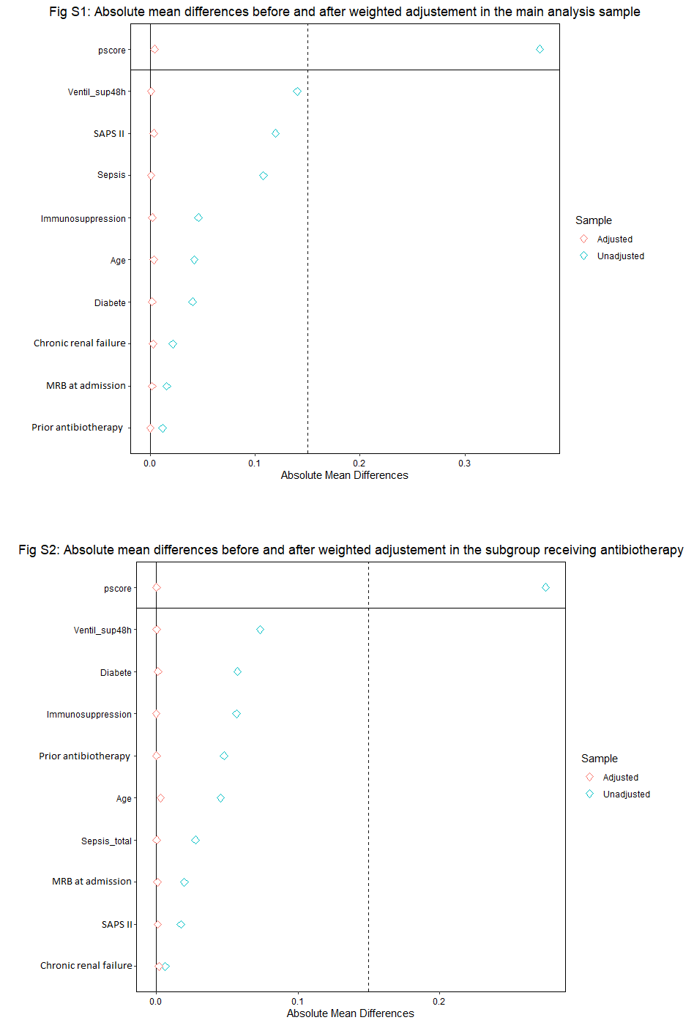
a
b
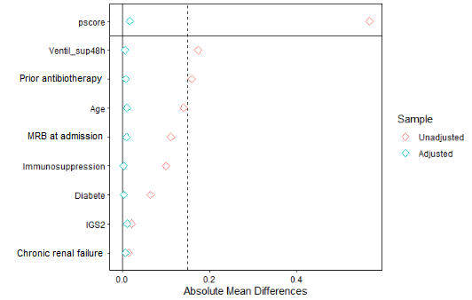
c

Figure 2 ROC curve of the propensity score in the main analysis.



