ADDITIONAL FILE 1
ONLINE SUPPLEMENTARY DATA

The EVOLUTION OF THE VENTILATORY RATIO IS A PROGNOSTIC FACTOR IN MECHANICALLY VENTILATED COVID-19 ARDS PATIENTS

Antoni Torres, et al.

FIGURE LEGEND

e-Figure 1. Missing data map of variables including in the multivariant analyses. Missing observations are displayed in white while observations with valid values are shown in golden. The assessed variables are on the x-axis and the observations are on the y-axis.

e-Figure 2. Smoothed scatter plots between each continuous predictor variables and outcomes in logit scale.

e-Figure 3. Heatmap of pairwise correlation between biomarkers, lung mechanics, and gas exchange at ICU admission (A) and at day 3 (B). The color key of the Pearson’s coefficient correlations is shown on the right. Statistically significant correlations are indicated with green surrounding squares (p-value≤0.05).
e-Table 1. List of participating centers

Site and Region
Hospital Virgen del Rocío, Andalucía
Hospital Virgen De Valme, Andalucía
Hospital San Juan de Dios, Andalucía
Hospital Virgen Macarena, Andalucía
Hospital Universitario de Jerez de la Frontera, Andalucía
Hospital Universitario Reina Sofía, Andalucía
Hospital Nuestra Señora de Gracia, Aragón
Hospital Universitario de Gran Canaria Doctor Negrín, Canarias
Hospital Universitario Marqués de Valdecilla, Cantabria
Hospital Universitario Río Hortega, Castilla y León
Hospital Clínico Universitario de Valladolid, Castilla y León
Hospital General Río Carrión, Castilla y León
Hospital Germans Trias i Pujol, Catalunya
Hospital Universitario Vall d'Hebron, Catalunya
Hospital Clinici Provinvial Barcelona, Catalunya
Hospital Universitari Bellvitge, Catalunya
Hospital Universitario del Mar, Catalunya
Hospital Universitari Mútua Terrassa, Catalunya
Hospital Universitari Arnau de Vilanova, Catalunya
Hospital Universitari Joan XXIII de Tarragona, Catalunya
Hospital Sagrat Cor, Catalunya
Hospital Parc Taulí, Catalunya
Clínica Sagrada Familia, Catalunya
Hospital de Tortosa Verge de la Cinta, Catalunya
Hospital de Mataró, Catalunya
Hospital de Santa Maria, Catalunya
Hospital General Universitario Gregorio Marañón, Comunidad de Madrid
HM Hospitales Madrid, Comunidad de Madrid
Hospital Universitario La Paz, Comunidad de Madrid
Hospital Universitario Ramón y Cajal, Comunidad de Madrid
Hospital Universitario de La Princesa, Comunidad de Madrid
Hospital Infanta Leonor de Madrid, Comunidad de Madrid
Hospital Universitario 12 de Octubre, Madrid
Hospital Universitario Sant Joan d’Alacant, Comunitat Valenciana
Hospital Universitario La Fe de Valencia, Comunitat Valenciana
Hospital Clínic Universitari de València, Comunitat Valenciana
Hospital Universitario de Cruces, Euskadi
Hospital San Pedro de Alcántara, Extremadura
Hospital Álvaro Cunqueiro, Galicia
Hospital Universitario Lucus Augusti, Galicia
Hospital Clínico Universitario de Santiago, Galicia
Hospital Universitari Son Espases, Illes Balears
Hospital Universitari Son Llàtzer, Illes Balears
Hospital Universitario Central de Asturias, Principado de Asturias

e-Table 2. Box- tidwell test for checking the linearity assumption of the positive variables. Samples with negative or zero value were replaced by 0.01.

Variables | p-value
(Intercept) | 0.75
PaO2/FiO2 | 0.71
Log (PaO2/FiO2) | 0.99
SOFA_hemo | 0.72
Log (SOFA_hemo) | 0.63
D-Dimer | 0.47
Log (D-Dimer) | 0.034
Platelets | 0.18
Log (Platelets) | 0.17
Creatinine | 0.23
Log (Creatinine) | 0.54
Age | 0.87
Log (Age) | 0.99
Lymphocytes | 0.45
Log (Lymphocytes) | 0.032
Ventilatory Ratio | 0.12
Log (Ventilatory Ratio) | 0.12
Total Bilirubin | 0.77
Log (Total Bilirubin) | 0.81
PaO2/FiO2:log (PaO2/FiO2) | 0.67
SOFA_hemo:log (SOFA_hemo) | 0.75
D-Dimer:log(D-Dimer) | 0.52
Platelets:log (Platelets) | 0.18
Creatinine:log (Creatinine) | 0.23
Age:log (Age) | 0.84
Lymphocytes:log (Lymphocytes) | 0.63
Ventilatory Ratio:log (Ventilatory Ratio) | 0.13
Total Bilirubin:log (Total Bilirubin) | 0.86

e-Table 3: Number of patients per center included in this subpopulation of 1,118 patients (COVID 19 ARDS patients intubated at day 1 of ICU admission that remained ventilated after 3 days).

Included patients | Sites  (N=44)
1 – 25 | 27 (61%)
25 – 50 | 6 (14%)
51 – 75 | 9 (21%)
76 – 100 | 1 (2%)
> 100 | 1 (2%)

e-Table 4. Demographic and clinical characteristics at ICU admission of patients that received invasive mechanical ventilation (MV) at any time of ICU stay.
 | No. | All patients (n=1645) | Survivors  (n=1016) | Non-survivors  (n=629) | p-value
Age, years | 1645 | 64.0 [56.0-71.0] | 61.0 [53.0-68.0] | 68.0 [61.0-73.0] | <0.001
Age, categories | 1645
<50 |  | 236 (14.4%) | 199 (19.6%) | 37 (5.9%) | <0.001
50–69 |  | 910 (55.3%) | 593 (58.4%) | 317 (50.4%) | 0.002
>70 |  | 434 (26.38%) | 191 (18.8%) | 243 (38.6%) | <0.001
Sex, female |  | 471 (28.63%) | 315/1016 (31.0%) | 156/629 (24.8%) | 0.007
BMI, kg/m² | 1487 | 28.3 [25.7-31.8] | 28.6 [25.7-32.0] | 28.0 [25.6-31.3] | 0.1
Comorbidities
Active smoker | 1069 | 84 (7.9%) | 44 (6.5%) | 40 (10.2%) | 0.034
Hypertension | 1644 | 820 (49.9%) | 457 (45.0%) | 363 (57.8%) | <0.001
Diabetes mellitus | 1644 | 375 (22.8%) | 209 (20.6%) | 166 (26.4%) | 0.006
Dyslipidemia | 1644 | 375 (22.8%) | 223 (22.0%) | 152 (24.2%) | 0.30
Chronic cardiac failure | 1643 | 195 (11.9%) | 91 (9.0%) | 104 (16.6%) | <0.001
Chronic kidney disease | 1644 | 94 (5.7%) | 40 (3.9%) | 54 (8.6%) | <0.001
Chronic respiratory disease | 1643 | 170 (10.4%) | 78 (7.7%) | 92 (14.7%) | <0.001
Days since first symptoms | 1611 | 7.0 [5.0-9.0] | 7.0 [5.0-9.0] | 7.0 [4.0-9.0] | 0.008
Days from hospital admission to ICU admission | 1633 | 2.0 [0.0-4.0] | 2.0 [0.0-4.0] | 2.0 [0.0-5.0] | 0.56
APACHE score | 907 | 12.0 [9.0-15.0] | 11.0 [8.0-14.5] | 13.0 [11.0-17.0] | <0.001
SOFA score | 1102 | 6.0 [4.0-8.0] | 6.0 [3.0-8.0] | 7.0 [4.0-8.0] | <0.001
SOFA hemodynamic component | 1516 | 3.0 [0.0-4.0] | 1.0 [0.0-4.0] | 3.0 [0.0-4.0] | 0.013
SOFA renal component | 1619 | 0.0 [0.0-0.0] | 0.0 [0.0-0.0] | 0.0 [0.0-1.0] | <0.001
Temperature, ºC | 1462 | 37.0 [36.1-37.9] | 37.0 [36.2-37.9] | 36.9 [36.0-37.7] | 0.01
Respiratory rate, bpm | 1376 | 25.0 [20.0-30.3 | 25.0 [20.0-31.3] | 25.0 [20.0-30.0] | 0.73
Respiratory support
High-flow oxygen | 1616 | 616 (38.1%) | 414 (41.3%) | 202 (32.9%) | 0.001
Noninvasive MV | 1629 | 177/1629 (10.9%) | 99 (9.8%) | 78 (12.5%) | 0.10
Invasive MV | 1637 | 1227 (75.0%) | 739 (73.2%) | 488 (78.1%) | 0.026
Arterial blood gases
PaO₂/FIO₂ ratio, mmHg | 1480 | 112.6 [78.2-168.1] | 115.7 [81.4-174.0] | 105.2 [72.3-156.4] | 0.001
PaO₂/F_{I}O₂ ratio categories | 1480
PaO₂/FIO₂ ratio <= 100 |  | 610 (41.2%) | 355 (38.2%) | 255 (46.4%) | 0.002
PaO₂/FIO₂ ratio 101-200 |  | 624 (42.2%) | 408 (43.9%) | 216 (39.3%) | 0.09
PaO₂/FIO₂ ratio 201-300 |  | 172 (11.6%) | 113 (12.2%) | 59 (10.7%) | 0.45
PaO₂/FIO₂ ratio > 301 |  | 62 (4.2%) | 45 (4.8%) | 17 (3.1%) | 0.11
pH | 1551 | 7.39 [7.31-7.45] | 7.4 [7.33-7.45] | 7.36 [7.29-7.43] | <0.001
PaCO₂, mmHg | 1541 | 41.4 [35.0-50.0] | 40.0 [34.6-48.0] | 43.0 [35.5-53.9] | <0.001
Lactate, mg/dL | 1081 | 12.9 [9.9-17.6] | 12.6 [9.4-16.2] | 14.4 [10.8-19.8] | <0.001
Laboratory findings
Lymphocyte count, 10^9/L | 1593 | 0.68 [0.46-0.94] | 0.7 [0.5-1.0] | 0.61 [0.4-0.9] | <0.001
Platelet count, 10^9/L | 1613 | 224.0 [169.0-294.0] | 234.0 [174.0-299.0] | 212.0 [160.0-281.3] | <0.001
D-dimers, mg/L | 1253 | 1.07 [0.57-3.17] | 0.96 [0.52-2.19] | 1.47 [0.67-5.37] | <0.001
Ferritin, ng/mL | 572 | 1359 [781-2260] | 1266 [689-2142] | 1465 [846-2376] | 0.07
IL6, pg/mL | 360 | 101.6 [46.3-177.2] | 93.8 [44.9-173.0] | 124.0 [59.4-193.3] | 0.15
CRP, mg/dL | 1457 | 16.9 [9.2-26.1] | 16.4 [9.1-25.5] | 17.7 [9.3-27.2] | 0.09
Bilirubin, mg/dL | 1454 | 0.63 [0.42-1.0] | 0.64 [0.43-1.0] | 0.6 [0.4-1.0] | 0.63
Serum creatinine, mg/dL | 1619 | 0.87 [0.68-1.15] | 0.82 [0.65-1.04] | 0.97 [0.74-1.31] | <0.001

e-Table 4 caption: Continuous variables are expressed as median (IQR) and categorical variables as number (percentages). CRP, C-reactive protein; FiO₂, fraction of inspired oxygen; MV, mechanical ventilation; PaCO₂, arterial partial pressure of carbon dioxide; PaO₂, partial pressure of arterial oxygen; SOFA: sequential organ failure assessment score.

e-Table 5. Delta differences between day 3 and ICU admission of laboratory findings and ventilation management variables of the early ventilated patients that remained ventilated after 2 days according to in-hospital mortality.

 | No. | All patients (n=1118) | Survivors  (n=685) | Non-survivors  (n=433) | p-value
Arterial blood gases
PaO₂/FIO₂ ratio, mmHg | 1006 | +46.7 [-9.2-108.3] | +52.5 [-3.9-114.4] | +38.4 [-15.3-96.7] | 0.07
pH | 1056 | +0.02 [-0.05-0.10] | +0.03 [-0.04-0.10] | +0.02 [-0.06-0.11] | 0.15
PaCO₂, mmHg | 1068 | +3.1 [-5.1-12.0] | +2.3 [-5.4-10.0] | +4.3 [-5.0-13.1] | 0.007
Lactate, mg/dL | 650 | +1.8 [-2.2-6.8] | +1.8 [-1.8-7.1] | +.7 [-3.0-6.3] | 0.93
Laboratory findings
Lymphocyte count, 10^9/L | 1081 | 0.00 [-0.20-0.26] | 0.00 [-0.20-0.30] | 0.00 [-0.20-0.20] | 0.041
Neutrophil count, 10^9/L | 472 | 0.00 [-3.3-2.37] | -0.02 [-3.05-2.27] | +0.02 [-3.58-2.65] | 0.95
Platelet count, 10^9/L | 1088 | +24.0 [-30.0-75.0] | +35.0 [-20.8-80.0] | +8.5 [-35.0-53.0] | 0.013
D-dimers, mg/L | 660 | +0.45 [-0.18-2.08] | +0.40 [-0.11-1.69] | +0.58 [-0.36-3.67] | 0.001
Ferritin, ng/mL | 217 | -51.0 [-368.0-303.0] | -38.5 [-336.8-273.5] | -79.0 [-370.0-314.5] | 0.66
IL6, pg/mL | 65 | -0.6 [-50.3-75.9] | -2.3 [-51.3-42.7] | +2.0 [-22.8-105.4] | 0.93
CRP, mg/dL | 859 | -4.6 [-14.04-3.4] | -4.8 [-14.8-3.7] | -4.16 [-13.2-2.5] | 1.00
Bilirubin, mg/dL | 906 | +0.04 [-0.16-0.43] | +0.04 [-0.16-0.40] | +0.05 [-0.16-0.56] | 0.023
Serum creatinine, mg/dL | 1094 | +0.02 [-0.13-0.32] | 0.0 [-0.14-0.22] | +0.12 [-0.11-0.54] | <0.001
Ventilatory setting and pulmonary mechanics
Tidal volume/PBW (ml/kg) | 445 | 0.0 [-0.52-0.63] | +0.02 [-0.36-0.67] | 0.0 [-0.67-0.54] | 0.74
Respiratory rate, rpm | 945 | 0.0 [-2.0-2.0] | 0.0 [-2.0-2.0] | 0.0 [-1.0-3.0] | 0.09
PEEP, cmH₂O | 1014 | 0.0 [-2.0-1.0] | 0.0 [-2.0-1.0] | 0.0 [-2.0-2.0] | 0.23
FiO₂, % | 1036 | -20.0 [-35.0--5.0] | -20.0 [-40.0--10.0] | -17.0 [-30.0-0.0] | 0.11
Peak inspiratory pressure, cmH₂O | 453 | 0.0 [-3.0-3.0] | 0.0 [-3.9-3.0] | 0.0 [-3.0-4.0] | 0.68
End-inspiratory plateau pressure, cmH₂O | 310 | -0.7 [-3.0-2.0] | -1.0 [-3.0-1.0] | 0.0 [-3.0-2.1] | 0.25
Driving pressure, cmH₂Oª | 296 | 0.0 [-3.0-2.0] | 0.0 [-3.0-2.0] | 0.0 [-2.0-3.0] | 0.39
Compliance, mL/cmH₂O^{b} | 274 | +0.69 [-6.28-8.79] | +1.3 [-6.28-9.39] | +0.11 [-6.19-7.17] | 0.18
Ventilatory ratio^{c} | 715 | +0.18 [-0.18-0.56] | +0.14 [-0.18-0.47] | +0.32 [-0.17-0.75] | <0.001

e-Table 5 caption: Delta was calculated as variable at day 3 minus variable at ICU admission. Continuous variables are expressed as median (IQR). CRP, C-reactive protein; FiO₂, fraction of inspired oxygen; PaCO₂, arterial partial pressure of carbon dioxide; PaO₂, partial pressure of arterial oxygen; PBW, predicted body weight. ª Defined as plateau pressure—PEEP. ^{b} Defined as tidal volume/(Plateau pressure − PEEP). ^{c} Defined as (minute ventilation × PaCO₂)/(PBW × 100 × 37.5)

e-Table 6. Correlations between ventilatory ratio and main biomarkers, lung mechanics or gas exchange data at ICU admission and day 3.

Variable 1 | Variable 2 | Correlation coefficient | p-value
Ventilatory ratio at ICU admission | PaO₂/ FiO₂ at ICU adm. | 0.01 | 0.68
Ventilatory ratio at ICU admission | Platelets at ICU adm. | -0.02 | 0.61
Ventilatory ratio at ICU admission | D-Dimer at ICU adm. | -0.004 | 0.90
Ventilatory ratio at ICU admission | PEEP at ICU adm. | -0.03 | 0.43
Ventilatory ratio at ICU admission | Driving pressure at ICU adm. | 0.02 | 0.68
Ventilatory ratio at ICU admission | Compliance at ICU adm. | -0.02 | 0.66
Ventilatory ratio at day 3 | PaO₂/ FiO₂ at day 3 | -0.19 | <0.001
Ventilatory ratio at day 3 | Platelets at day 3 | -0.06 | 0.07
Ventilatory ratio at day 3 | D-Dimer at day 3 | 0.02 | 0.6
Ventilatory ratio at day 3 | PEEP at day 3 | 0.11 | <0.001
Ventilatory ratio at day 3 | Driving pressure at day 3 | 0.14 | 0.004
Ventilatory ratio at day 3 | Compliance at day 3. | -0.05 | 0.324

e-Table 7. Main interventions and treatments in the subpopulation of 1,118 patients (COVID-19 ARDS patients intubated at day 1 of ICU admission that remained ventilated after 3 days) according to in-hospital mortality.
 |  | No. | All patients (n=1118) |  | Survivors  (n=685) |  | Non-survivors  (n=433) |  | p-value
COVID-19 therapies | 1110
Ribavirin |  |  | 2 (0.2%) |  | 1 (0.2%) |  | 1 (0.2%) |  | 1
Lopinavir/ritonavir |  |  | 892 (80.4%) |  | 555 (81.3%) |  | 337 (78.9%) |  | 0.35
Remdesivir |  |  | 84 (7.6%) |  | 54 (7.9%) |  | 30 (7.0%) |  | 0.67
Interferon alpha |  |  | 9 (0.8%) |  | 1 (0.2%) |  | 8 (1.9%) |  | 0.003
Interferon beta |  |  | 488 (44.0%) |  | 289 (42.3%) |  | 199 (46.6%) |  | 0.17
Chloroquine |  |  | 63 (5.7%) |  | 38 (5.6%) |  | 25 (5.8%) |  | 0.89
Hydroxychloroquine |  |  | 986 (88.8%) |  | 612 (89.3%) |  | 373 (86.1%) |  | 0.24
Tocilizumab |  |  | 499 (45.0%) |  | 324 (47.4%) |  | 175 (41.0%) |  | 0.05
Darunavir/cobicistat |  |  | 23 (2.1%) |  | 13 (1.9%) |  | 10 (2.3%) |  | 0.67
Pharmacological adjunctive
therapies
Continuous furosemide |  | 1002 | 701 (63.6%) |  | 412 (60.9%) |  | 289 (68.0%) |  | 0.017
Inmmunoglobulins |  | 1003 | 13 (1.2%) |  | 7 (1.0%) |  | 6 (1.4%) |  | 0.58
Subcutaneous heparin |  | 1009 | 1065 (96.0%) |  | 662 (97.1%) |  | 403 (94.4%) |  | 0.039
≤ 1 mg/kg/day |  | 1009 | 816 (73.6%) |  | 527 (77.3%) |  | 289 (67.7%) |  | <0.001
> 1 mg/kg/day |  | 1009 | 381 (34.4%) |  | 234 (34.3%) |  | 147 (34.4%) |  | 1.00
Convalescent plasma |  | 1105 | 6 (0.5%) |  | 5 (0.7%) |  | 1 (0.2%) |  | 0.47
Vasopressor treatment |  | 1110 | 1028 (92.6%) |  | 608 (89.3%) |  | 420 (97.9%) |  | <0.001
Continuous neuromuscular blockers |  |  | 950 (85.9%) |  | 561 (82.5%) |  | 389 (91.2%) |  | <0.001
Corticosteroid |  | 1092 | 831 (76.1%) |  | 504 (74.6%) |  | 327 (78.6%) |  | 0.14
Other adjunctive treatments
Tracheostomy |  | 1115 | 482 (43.2%) |  | 326 (47.7%) |  | 156 (36.1%) |  | <0.001
Recruitment maneuvers |  | 1057 | 653 (61.8%) |  | 371 (57.3%) |  | 282 (68.8%) |  | <0.001
Prone position |  | 1107 | 874 (79.0%) |  | 509 (74.7%) |  | 365 (85.7%) |  | <0.001
Prone length, hours |  | 812 | 48.0 [25.8-82.0] |  | 48.0 [24.0-72.0] |  | 60.0 [36.0-90.0] |  | <0.001
ECMO support |  | 1105 | 20 (1.8%) |  | 10 (1.5%) |  | 10 (2.4%) |  | 0.36
ECMO length, days |  | 20 | 10.5 [4.8-16.5] |  | 17.0 [11.0-24.5] |  | 6.5 [4.0-10.3] |  | 0.024
Renal replacement therapy |  | 1115 | 157 (14.1%) |  | 62 (9.1%) |  | 95 (22.0%) |  | <0.001

e-Table 8. Major complications in the subpopulation of 1,118 patients (COVID-19 ARDS patients intubated at day 1 of ICU admission that remained ventilated after 3 days) according to in-hospital mortality.
 | No. | All patients (n=1118) | Survivors  (n=685) | Non-survivors  (n=433) | p-value
Bacterial pneumonia ª | 1113 | 368 (33.1%) | 241 (35.2%) | 127 (29.6%) | 0.06
ARDS ^{b} | 1118
Mild |  | 76 (6.8%) | 65 (9.5%) | 11 (2.5%) | <0.001
Moderate |  | 467 (41.8%) | 341 (49.8%) | 126 (29.1%) | <0.001
Severe |  | 575 (51.4%) | 279 (40.7%) | 296 (68.4%) | <0.001
Pneumothorax | 1118 | 108 (9.7%) | 53 (7.7%) | 55 (12.7%) | 0.007
Pleural effusion | 1117 | 132 (11.8%) | 87 (12.7%) | 45 (10.4%) | 0.26
Organizing pneumonia | 1092 | 54 (5.0%) | 38 (5.7%) | 16 (3.8%) | 0.20
Tracheobronchitis | 1112 | 16 (1.4%) | 15 (2.2%) | 1 (0.2%) | 0.008
Pulmonary embolism | 1083 | 94 (8.7%) | 71 (10.6%) | 23 (5.6%) | 0.005
Myocardial infarction | 1117 | 132 (11.8%) | 87 (12.7%) | 45 (10.4%) | 0.26
Endocarditis | 1118 | 9 (0.8%) | 4 (0.6%) | 5 (1.2%) | 0.32
Myocarditis/pericarditis | 1116 | 3 (0.3%) | 1 (0.2%) | 2 (0.5%) | 0.56
Cardiomyopathy | 1118 | 24 (2.2%) | 12 (1.8%) | 12 (2.8%) | 0.29
Heart failure | 1117 | 27 (2.4%) | 19 (2.8%) | 8 (1.9%) | 0.43
Cardiac ischemia | 1118 | 43 (3.9%) | 23 (3.4%) | 20 (4.6%) | 0.34
Bacteremia | 1115 | 446 (40.0%) | 261 (38.2%) | 185 (42.9%) | 0.12
Stroke | 1116 | 35 (3.1%) | 22 (3.2%) | 13 (3.0%) | 1.00
Delirium | 1113 | 280 (25.2%) | 239 (34.9%) | 41 (9.6%) | <0.001
Coagulation disorder ^{c} | 1116 | 290 (26.0%) | 158 (23.1%) | 132 (30.6%) | 0.006
Disseminated intravascular coagulation ^{d} | 1102 | 69 (6.3%) | 34 (5.0%) | 35 (8.2%) | 0.041
Anemia ^{e} | 1118 | 800 (71.6%) | 496 (72.4%) | 304 (70.2%) | 0.45
Rhabdomyolysis | 1111 | 46 (4.1%) | 27 (4.0%) | 19 (4.4%) | 0.76
Acute renal failure ^{f} | 1118 | 493 (44.1%) | 238 (34.7%) | 255 (58.9%) | <0.001
Pancreatitis | 1118 | 14 (1.3%) | 8 (1.2%) | 6 (1.4%) | 0.79
Liver dysfunction | 1114 | 369 (33.1%) | 218 (31.8%) | 151 (35.2%) | 0.27
Hemorrhage | 1116 | 103 (9.2%) | 49 (7.2%) | 54 (12.5%) | 0.004

Definitions: ª Clinically or radiologically diagnosed bacterial pneumonia managed with antimicrobials. Bacteriological confirmation was not required. ^{b} Acute Respiratory Distress Syndrome (ARDS) was defined according to Berlin criteria. Mild ARDS, PaO2/FiO2 >200 mmHg and ≤300 mmHg, with PEEP≥5 cm H₂O.Moderate ARDS, PaO2/FiO2 >100 mmHg and ≤200 mmHg with PEEP ≥5 cm H₂O. Severe ARDS, PaO2/FiO2 ≤100 mmHg with PEEP ≥5 cm H₂O. ^{c} Abnormal coagulation was identified by abnormal prothrombin time or activated partial thromboplastin time. ^{d} Disseminated intravascular coagulation was defined by thrombocytopenia, prolonged prothrombin time, low fibrinogen, elevated D-dimer and thrombotic microangiopathy. ^{e} Hemoglobin consistently below 120 g/L for non-pregnant women and 130 g/L for men. ^{f} Acute renal injury was defined as an increase in serum creatinine by ≥0.3 mg/dL within 48 hours or an increase in serum creatinine to ≥1.5 times baseline.

e-Table 9. Main secondary outcomes in the subpopulation of 1,118 patients (COVID-19 ARDS patients intubated at day 1 of ICU admission that remained ventilated after 3 days) according to in-hospital mortality.
 | No. | All patients (n=1118) | Survivors  (n=685) | Non-survivors  (n=433) | p-value
Length of ICU stay, days | 1116 | 20.0 [11.0-32.0] | 22.0 [13.0-35.0] | 16.0 [9.0-26.0] | <0.001
Length of hospital stay, days | 1118 | 30.0 [19.0-48.0] | 38.0 [25.0-57.0] | 19.0 [11.0-30.0] | <0.001
NIMV length, days | 263 | 2.0 [1.0-5.0] | 3.0 [1.0-6.0] | 2.0 [1.0-4.0] | 0.15
IMV length, days | 1089 | 16.0 [10.0-27.0] | 16.0 [10.0-27.0] | 16.0 [9.0-25.0] | 0.16
ICU mortality | 1118 | 419 (37.5) |  | 419 (97.0%)
Ventilator free days | 567 |  | 12.0 [0.0-18.0]
ICU free days | 1116 | 0.0 [0.0-10.0] | 6.0 [0.0-15.0] | 0.0 [0.0-0.0] | <0.001
Cause of death | 429
Respiratory failure |  |  |  | 178 (41.5%)
Septic shock |  |  |  | 22 (5.1%)
Multiorgan failure |  |  |  | 179 (41.7%)
Cardiovascular accident |  |  |  | 6 (1.4%)
28-day mortality | 1118 | 357 (31.9%) |  | 357 (82.4%) | <0.001

e-Table 9 caption: ICU, intensive care unit; IMV, invasive mechanical ventilation; NIMV, non-invasive mechanical ventilation.

e-Table 10. Multivariable model assessing predictors of in-hospital mortality (N=662 patients)
Variable | Odds ratio (95% CI) | p-value
Age, years | 1.01 (1.01 to 1.02) | <0.001
Sex, male | 1.06 (0.98 to 1.14) | 0.16
Hypertension | 1.00 (0.93 to 1.08) | 0.96
Chronic respiratory disease | 1.09 (1.00 to 1.23) | 0.049
SOFA hemodynamic component | 1.00 (0.98 to 1.02) | 0.82
PaO₂/F_{I}O₂ ratio at ICU admission, mmHg | 1.00 (1.00 to 1.00) | 0.12
Serum creatinine at ICU admission, mg/dL | 1.09 (1.04 to 1.14) | <0.001
Lymphocyte count at ICU admission, x 10⁹/L | 1.00 (0.98 to 1.03) | 0.85
Platelet count at ICU admission, x 10⁹/L | 1.00 (1.00 to 1.00) | 0.10
Total bilirubin at ICU admission, mg/dL | 0.96 (0.91 to 1.02) | 0.22
D-dimers at ICU admission, μg/L | 1.00 (1.00 to 1.00) | 0.23
Ventilatory ratio at ICU admission | 1.08 (1.03 to 1.15) | 0.004

e-Table 10 caption: Mixed-effects model with centers as a random effect and considering a binomial distribution. AUC statistic (area under the curve) is 0.79 (95% CI 0.76 to 0.83) and Brier score is 0.18. CI, confidence interval; FiO₂, fraction of inspired oxygen; ICU, intensive care unit; PaO₂, partial pressure of arterial oxygen; SOFA, sequential organ failure assessment score.

e-Figure 1
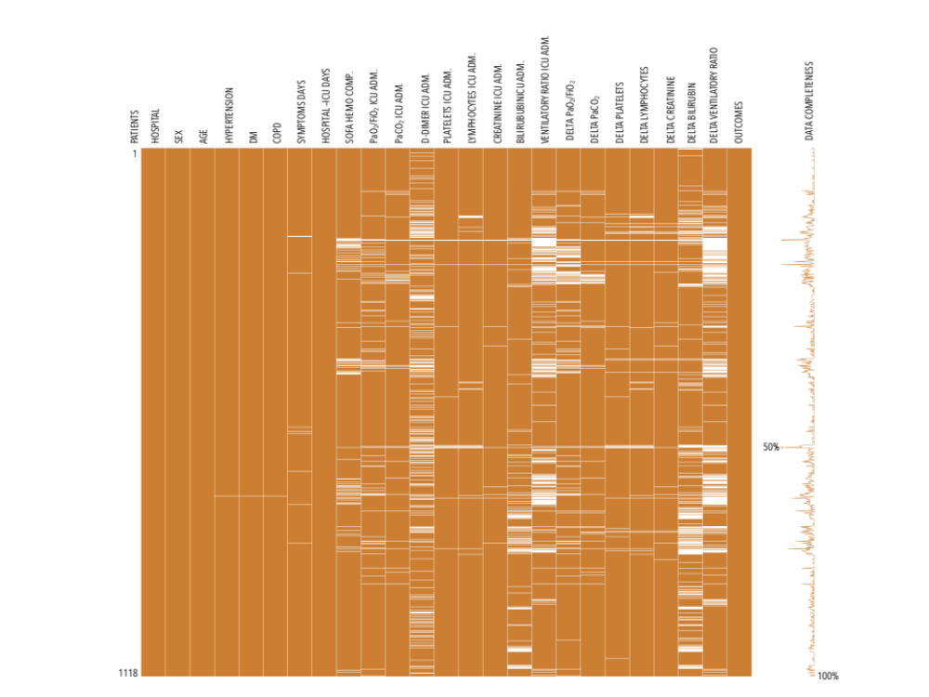

e-Figure 1 caption. Missing data map of variables including in the multivariant analyses. Missing observations are displayed in white while observations with valid values are shown in golden. The assessed variables are on the x-axis and the observations are on the y-axis.

e-Figure 2
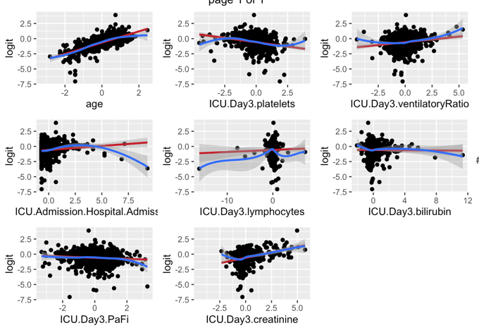
e-Figure 2 caption. Smoothed scatter plots between each continuous predictor variables and outcomes in logit scale.

e-Figure 3

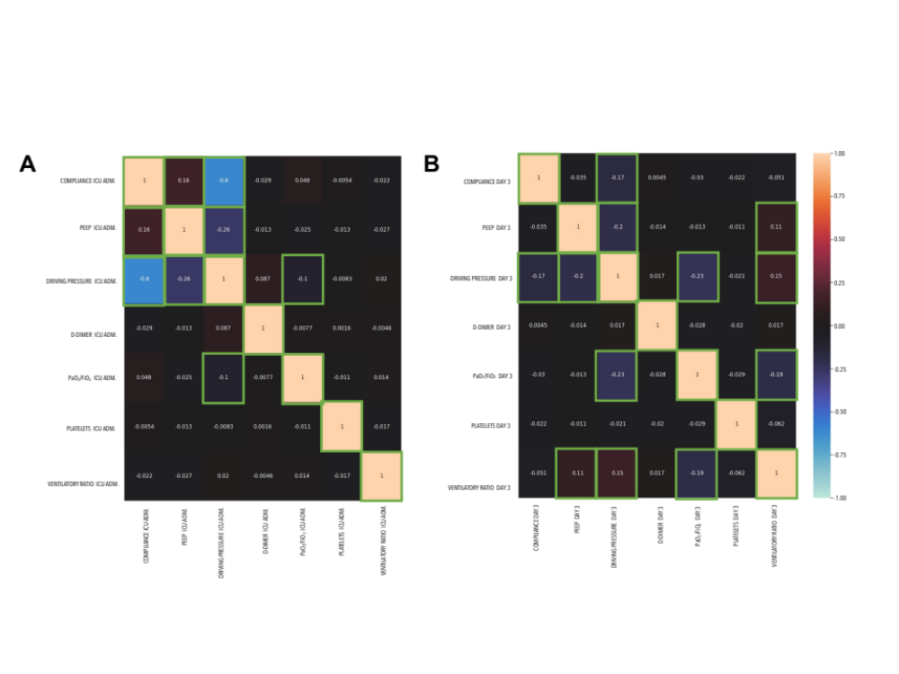
e-Figure 3 caption. Heatmap of pairwise correlation between biomarkers, lung mechanics, and gas exchange at ICU admission (A) and at day 3 (B). The color key of the Pearson’s coefficient correlations is shown on the right. Statistically significant correlations are indicated with green surrounding squares (p-value≤0.05).

