Additional file 1

Table S1 Distribution of continuous renal replacement therapy modalities, by coronavirus disease 2019 status and heparin use
Modality | All patients | COV− |  | COV+
Modality | All patients | ACD-A only | ACD-A+UH | ACD-A only | ACD-A+UH
Modality | (N=394)* | (n=194) | (n=9) | (n=66) | (n=125)
CVVHD, n (%) | 210 (53.3) | 42 (21.6) | 2 (22.2) | 57 (86.4) | 109 (87.2)
CVVHDF, n (%) | 30 (7.6) | 8 (4.1) | 0 (0) | 7 (10.6) | 15 (12.0)
CVVH, n (%) | 154 (39.1) | 144 (74.2) | 7 (77.8) | 2 (3.0) | 1 (0.8)
COV−, not diagnosed with coronavirus disease 2019; COV+, diagnosed with coronavirus disease 2019; ACD-A, anticoagulant citrate dextrose solution formula A; UH, unfractionated heparin; CVVHD, continuous venovenous hemodialysis; CVVHDF, continuous venovenous hemodiafiltration; CVVH, continuous venovenous hemofiltration.
*Ex post facto exclusions: no ACD-A (n=66), readmission (n=13), and renal replacement therapy connected to an extracorporeal membrane oxygenation circuit (n=1).

Table S2 Timing of collection of D-dimer level determination closest to the initiation of continuous renal replacement therapy, restricted to the patients diagnosed with coronavirus disease 2019 for whom D-dimer values were available (n=180)
 | COV+ ACD-A |  | COV+ ACD-A+UH
 | (n=63) |  | (n=117)
 | Pre-CRRT | Post-CRRT | Pre-CRRT | Post-CRRT
 | n=51 (81%) | n =12 (19%) | n=93 (79%) | n=24 (21%)
Time (h) between D-dimer determination and CRRT initiation, median (IQR) | 60.4 (18.2–214) | 20.6 (2.0–46.2) | 79.8 (23.4–219) | 13.8 (2.1–28.9)
COV+, diagnosed with coronavirus disease 2019; ACD-A, anticoagulant citrate dextrose solution formula A; UH, unfractionated heparin; CRRT, continuous renal replacement therapy; IQR, interquartile range.
Table S3 Electrolyte profiles during continuous renal replacement therapy
Variable | COV− | COV+ |  | p
Variable | ACD-A only | ACD-A only | ACD-A+UH | p
Variable | (n=50) | (n=64) | (n=124) | p
Sodium (mEq/L),* median (IQR) | 139 (136–143) | 138 (136–141) | 137 (134–140) | 0.061
Potassium (mEq/L),† median (IQR) | 4.38 (4.01–4.80) | 4.53 (4.25–5.02) | 4.53 (4.16–5.07) | 0.100
Phosphorus (mg/dL),‡ median (IQR) | 4.07 (3.00–5.01) | 4.25 (3.60–5.10) | 4.43 (3.48–5.52) | 0.241
pH,§ median (IQR) | 7.40 (7.36–7.42) | 7.30 (7.25–7.36) | 7.30 (7.22–7.36) | <0.001
Ionized calcium (mg/dL),║ median (IQR) | 4.62 (4.37–4.97) | 4.60 (4.39–4.91) | 4.54 (4.23–4.84) | 0.239
COV−, not diagnosed with coronavirus disease 2019; COV+, diagnosed with coronavirus disease 2019; ACD-A, anticoagulant citrate dextrose solution formula A; UH, unfractionated heparin; IQR, interquartile range.
*n=214; †n=217; ‡n=191; §n=214; ║n=218.

Table S4 Mean numbers of positive cultures within the first 28 days after the initiation of continuous renal replacement therapy
Positive culture | COV− | COV+ |  | p
Positive culture | ACD-A only | ACD-A only | ACD-A+UH | p
Positive culture | (n=50) | (n=64) | (n=124) | p
Blood,* mean ± SD | 0.52 ± 0.74 | 0.63 ± 0.90 | 0.40 ± 0.74 | 0.158
Tracheal,† mean ± SD | 0.13 ± 0.34 | 0.44 ± 0.59 | 0.31 ± 0.70 | 0.048
Urine,‡ mean ± SD | 0.32 ± 0.59 | 0.22 ± 0.58 | 0.22 ± 0.49 | 0.497
COV−, not diagnosed with coronavirus disease 2019; COV+, diagnosed with coronavirus disease 2019; ACD-A, anticoagulant citrate dextrose solution formula A; UH, unfractionated heparin; SD, standard deviation.
*n=237; †n=212; ‡n=237.

Table S5 Main reasons for a filter change*
Reason | COV− | COV+
Reason | ACD-A only | ACD-A only | ACD-A+UH
Reason | n=50 | n=64 | n=124
Clotting, % | 48.0 | 70.3 | 33.9
CRRT device problems, % | 0.0 | 0.0 | 0.8
Routine, % | 2.0 | 0.0 | 4.8
Hemodynamic instability/intolerance, % | 14.0 | 15.6 | 35.5
Physician decision to interrupt CRRT, % | 16.0 | 9.4 | 19.4
Patient transfer, % | 14.0 | 0.0 | 2.4
Vascular access problems, % | 6.0 | 4.7 | 3.2
*p < 0.05 overall.

Fig. S1 Kaplan–Meier estimate of filter clotting during the first filter use in continuous renal replacement therapy (CRRT) using anticoagulant citrate dextrose solution formula A (ACD-A), with and without unfractionated heparin, the former subdivided by the type of heparin use.

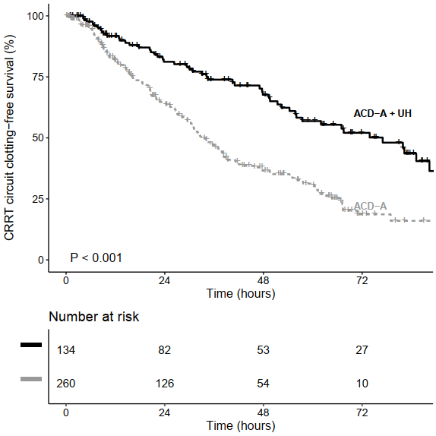
Fig. S2 Kaplan–Meier estimate of filter clotting during the first filter use in continuous renal replacement therapy (CRRT) using anticoagulant citrate dextrose solution formula A (ACD-A), with and without unfractionated heparin (UH) in the first filter use during continuous renal replacement therapy (CRRT), including the 154 patients who were excluded for undergoing continuous venovenous hemofiltration.

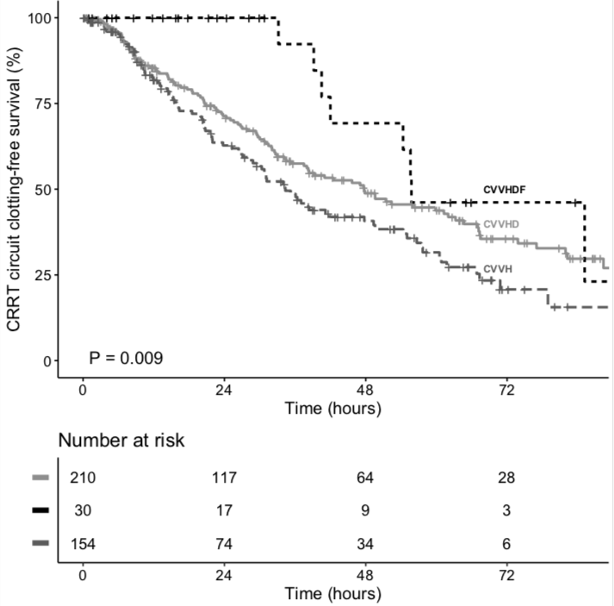
Fig. S3 Kaplan–Meier estimate of filter clotting during continuous renal replacement therapy (CRRT),* by modality, including the patients who were excluded for undergoing continuous venovenous hemofiltration (CVVH).
CVVHD, continuous venovenous hemodialysis; CVVHDF, continuous venovenous hemodiafiltration.
*Exclusions: no ACD-A (n=66), readmission (n=13), and renal replacement therapy connected to an extracorporeal membrane oxygenation circuit (n=1).

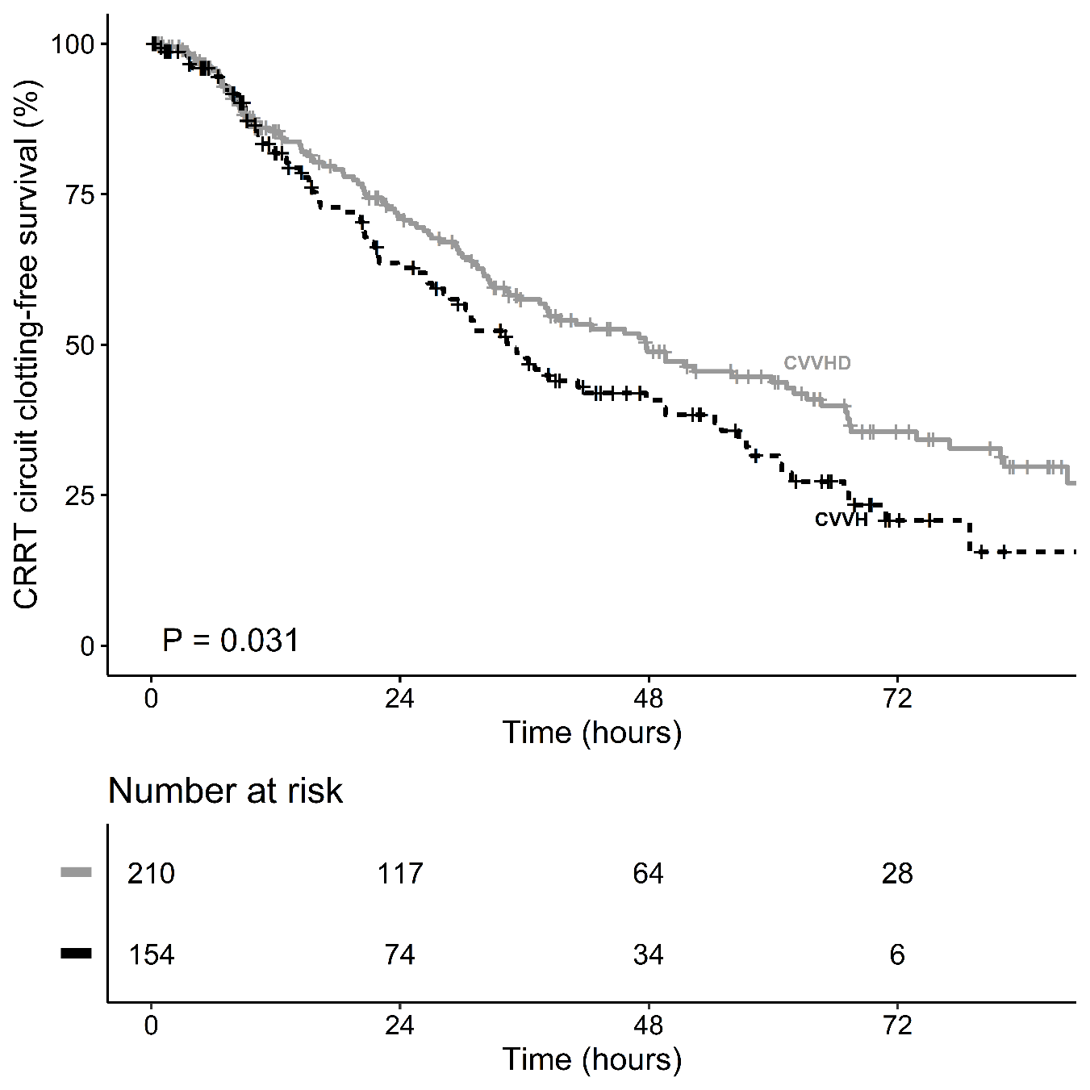
Fig. S4 Kaplan–Meier estimate of filter clotting during continuous renal replacement therapy (CRRT), comparing continuous venovenous hemodialysis (CVVHD) with continuous venovenous hemofiltration (CVVH).
*Exclusions: no ACD-A (n=66), readmission (n=13), renal replacement therapy connected to an extracorporeal membrane oxygenation circuit (n=1); and continuous venovenous hemodiafiltration (n=30).

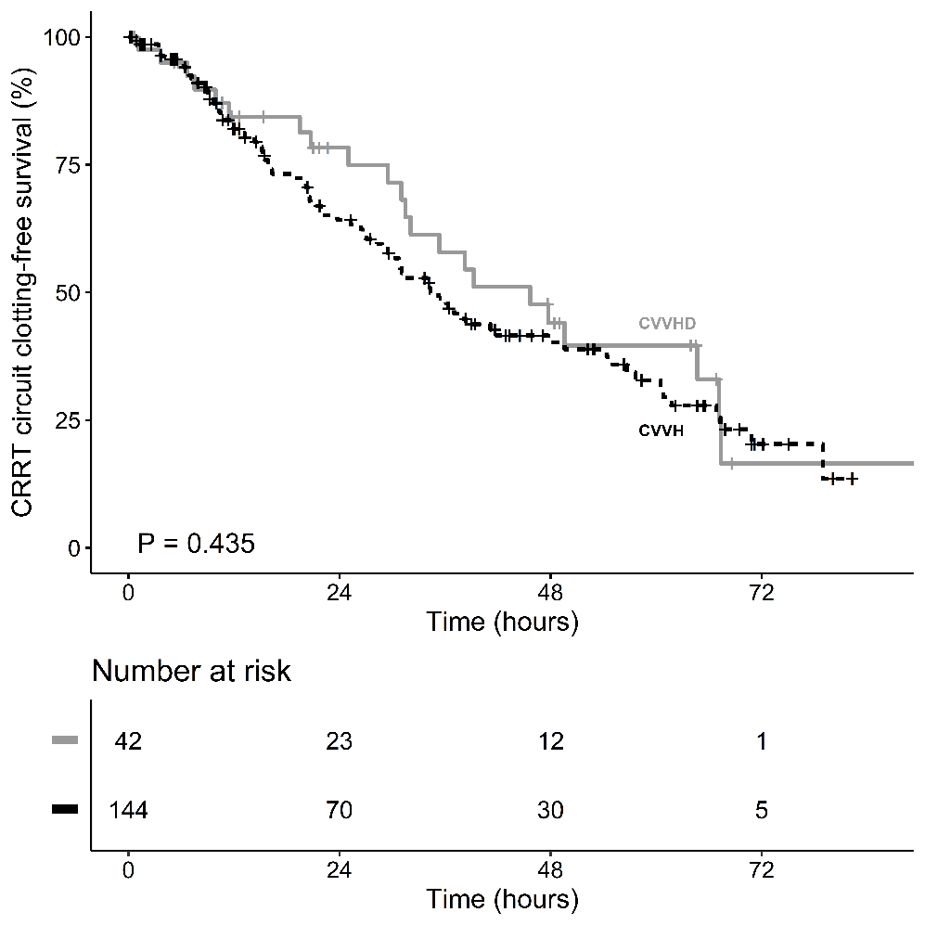
Fig. S5 Kaplan–Meier estimate of filter clotting during heparin-free continuous renal replacement therapy (CRRT) in patients without coronavirus disease 2019, comparing continuous venovenous hemodialysis (CVVHD) with continuous venovenous hemofiltration (CVVH).
*Exclusions: no ACD-A (n=66), readmission (n=13), renal replacement therapy connected to an extracorporeal membrane oxygenation circuit (n=1); continuous venovenous hemodiafiltration (n=30); and a diagnosis of coronavirus disease 2019 or heparin use in patients without coronavirus disease 2019 (n=178).

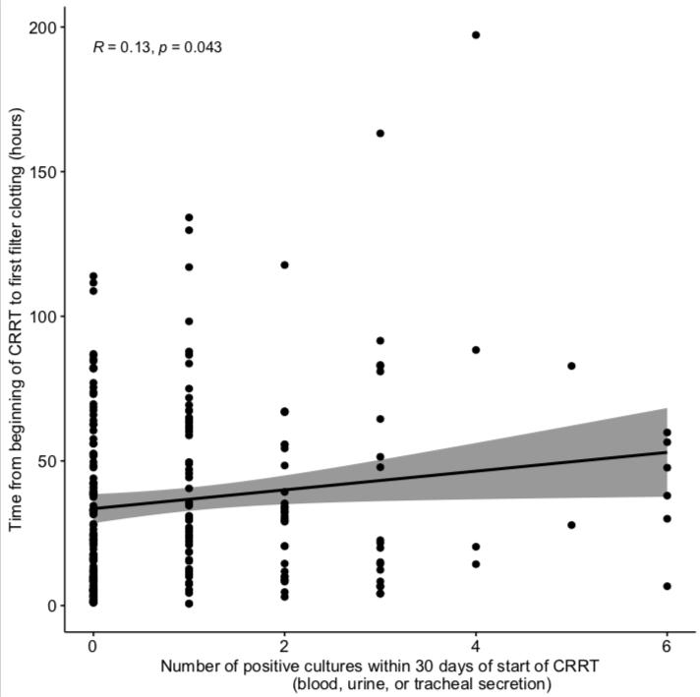
Fig. S6 Correlation between the time from the initiation of continuous renal replacement therapy (CRRT) to filter clotting and any of the infections studied.

