Head Helmets to deliver non-invasive ventilation: a review of technical and clinical aspects

Andrea Coppadoro¹ M.D., Elisabetta Zago^{1,2} M.D., Fabio Pavan^{1,2} M.D., Giuseppe Foti^{1,2} M.D., Giacomo Bellani^{1,2} M.D. Ph.D.

¹ASST Monza, San Gerardo Hospital, Monza, Italy
² Department of Medicine and Surgery, University of Milan-Bicocca, Monza, Italy

Additional File 2

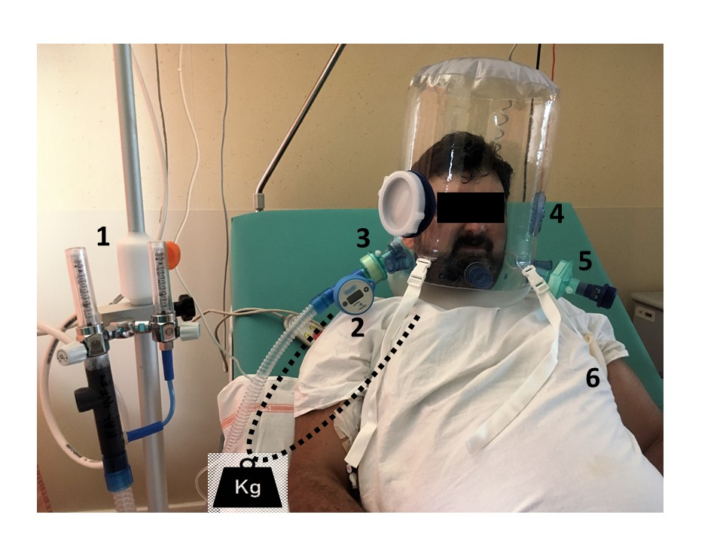
Figure e1. A typical patient undergoing helmet CPAP for COVID-19 acute respiratory failure treatment outside the ICU. A Venturi system (1) is used to generate a 60L/min flow with an FiO2 of 50%, as measured by the FiO2 meter (2). A HME filter (3) is set before helmet to reduce noise; the helmet is equipped with an anti-suffocation valve (4). An optional HEPA filter (5) is set before the PEEP valve to minimize environmental contamination. The helmet is secured by two armpit braces (6); for prolonged therapy, braces should be passed above the arms (dotted line) and connected to counterwheighs (black artwork).

