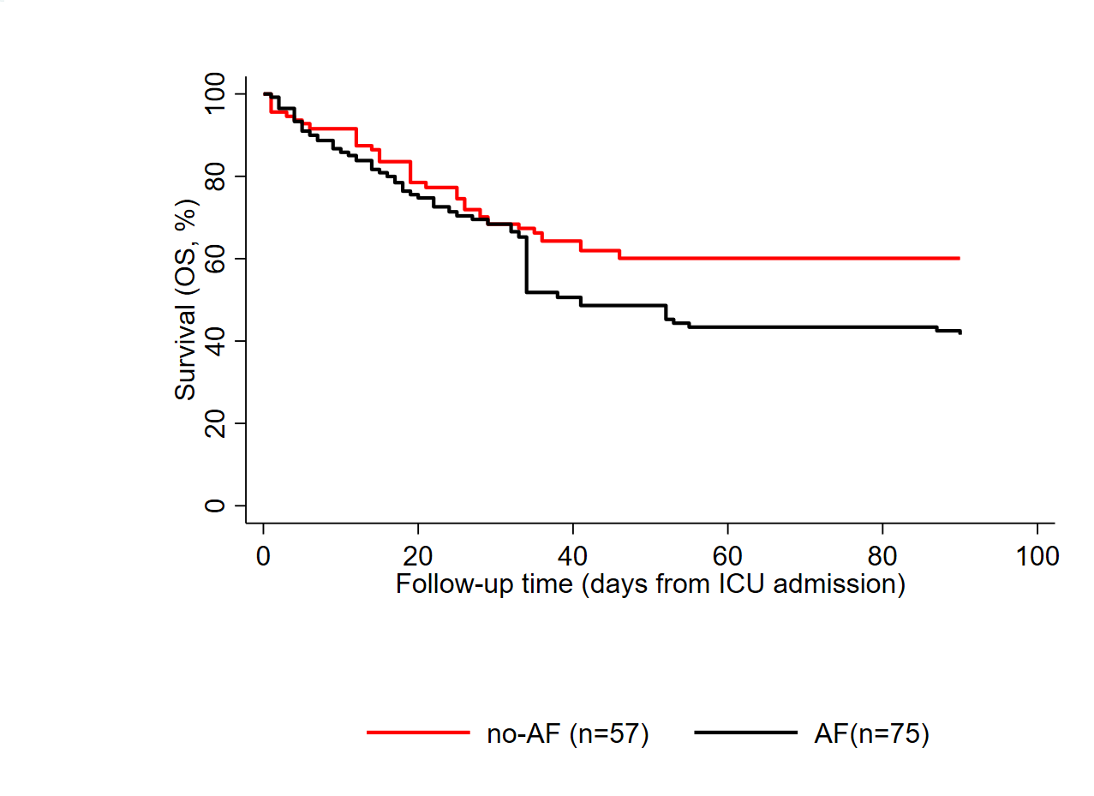
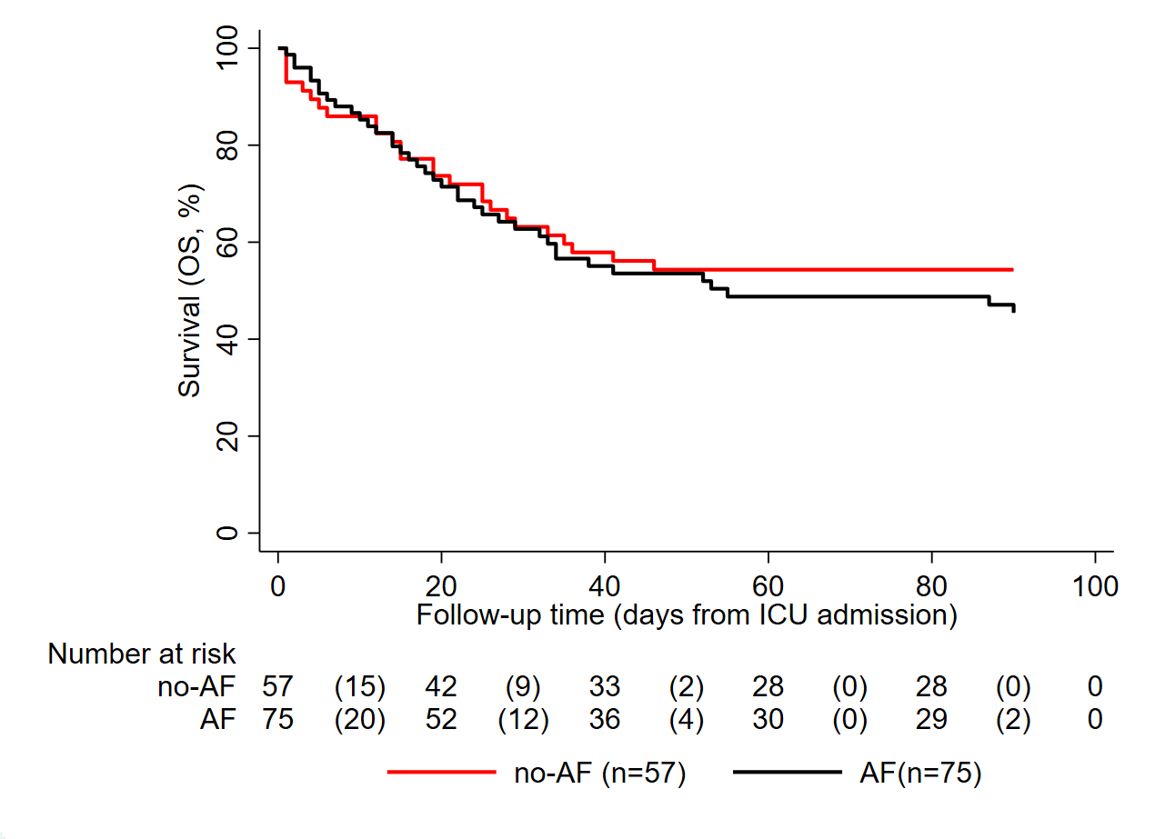
p=0.142
p=0.478
Unadjusted Analysis
Adjusted Analysis

Supplementary Figure 5: 90-day ICU survival according to antifungal prophylaxis (Long-term survival)
A) Unadjusted analysis B) IPTW adjusted analysis. p values are calculated using the log rank test. Risk table was only computed for the unadjusted analysis.
ICU survival was calculated by using Kaplan Maier estimators.
CAPA – coronavirus disease 19 associated pulmonary aspergillosis; AF – antifungal prophylaxis.

