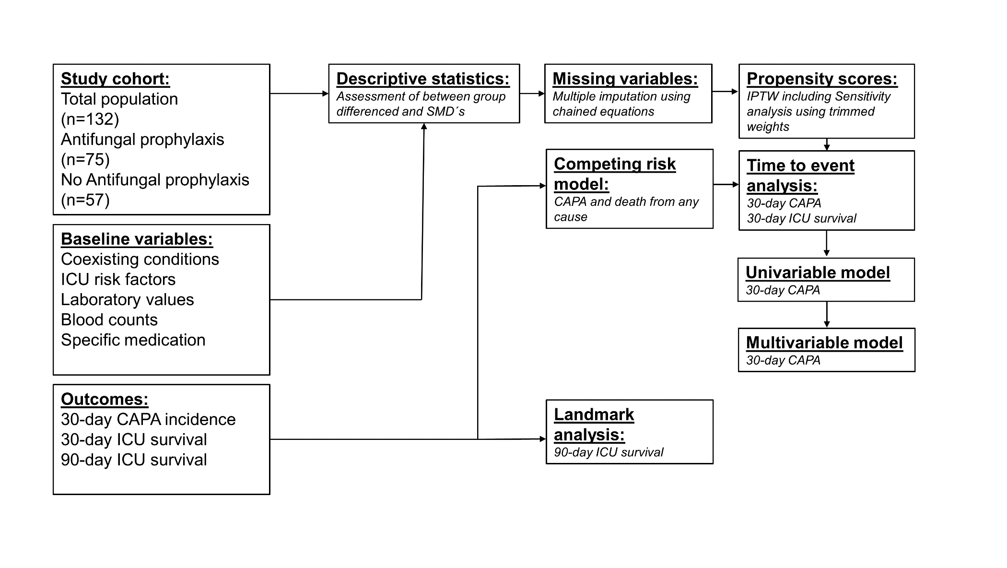

Supplementary Figure 1: Statistical analysis plan.
CAPA- COVID-19 associated pulmonary aspergillosis; ICU- intensive care unit; SMD – standardized mean difference; IPTW – invers probability of treatment weight; SW – stabilized weights;

