Prediction of extubation outcome in critically ill patients: a systematic review and meta-analysis.
Additional file

Flavia TORRINI, Ségolène GENDREAU, Johanna MOREL, Guillaume CARTEAUX, Arnaud W THILLE, Massimo ANTONELLI, Armand MEKONTSO DESSAP

Additional table S1: Variables excluded because of missing data.
Variable tested | Number (%) of studies
Arrhythmia | 1 (1%)
Aspiration | 1 (1%)
Atelectasis | 2 (3%)
Burns | 1 (1%)
Deep vein thrombosis | 1 (1%)
Delirium tremens | 1 (1%)
Difficult intubation | 0 (0%)
Hospital cost (NT$10,000) | 1 (1%)
Hospital mortality | 4 (6%)
Hospital stay (days) | 8 (12%)
Baseline IAP, mmH20 | 1 (1%)
IAP, mmH2O | 1 (1%)
ICU mortality | 2 (3%)
ICU stay (days) | 6 (9%)
ICU LOS prior to first SBT, days | 1 (1%)
ICU LOS/% burn | 1 (1%)
Modified Rankin scale | 1 (1%)
Mortality at 28 days | 3 (4%)
Mortality at 90 days | 1 (1%)
Multiple antibiotics (>3) | 1 (1%)
Myocardial infarction | 1 (1%)
Number of intubation | 1 (1%)
Pleural effusion | 1 (1%)
Pneumothorax | 1 (1%)
Postextubation hospital stay | 1 (1%)
Postextubation ICU stay | 2 (3%)
Pulmonary complications | 1 (1%)
Pulmonary embolism | 1 (1%)
Reoperation – n (%) | 1 (1%)
Rhabdomyolysis | 1 (1%)
Total duration of MV, days | 3 (4%)
Tracheostomy | 1 (1%)
Transferred to respiratory care center | 1 (1%)
Transferred to respiratory care ward | 1 (1%)
Ventilator-associated pneumonia | 2 (3%)
IAP: Intra-abdominal pressure; ICU: intensive-care unit; LOS: level of service; SBT: spontaneous breathing trial

Additional figure S1. Forest plots for variables statistically significantly associated with extubation failure.
- Acute Heart failure
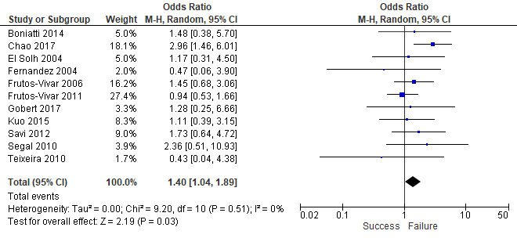

- Age
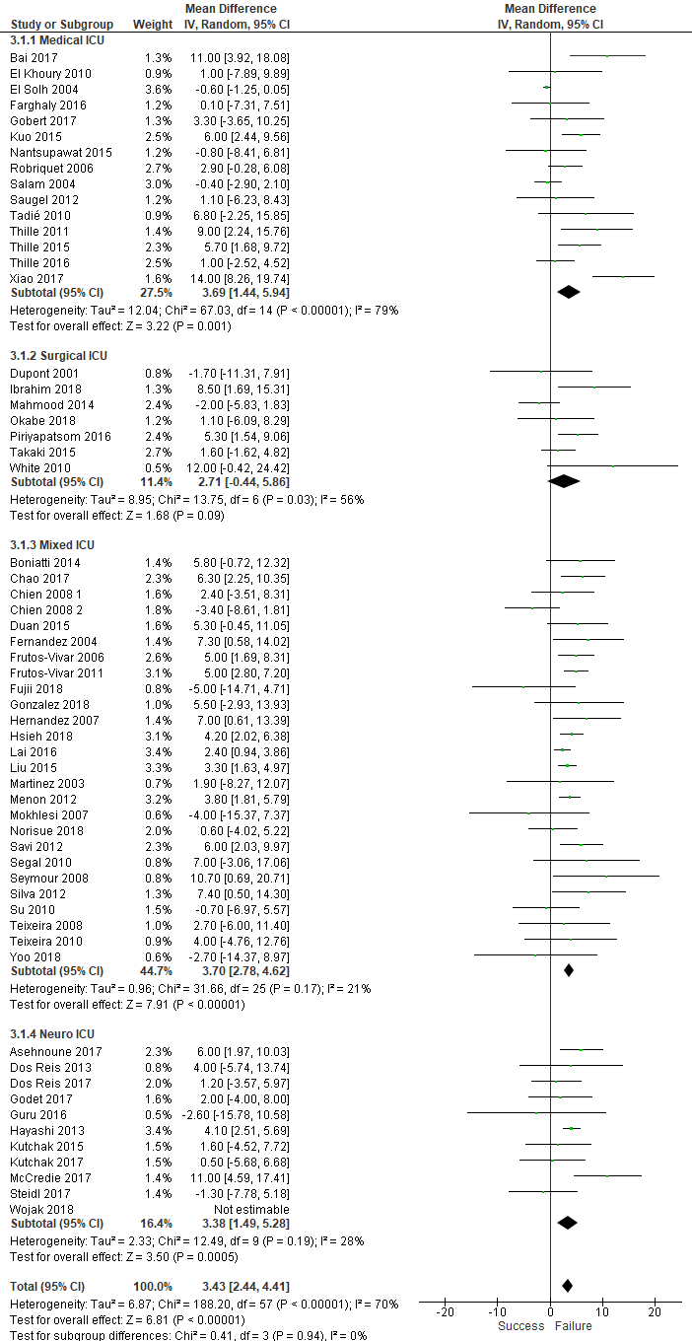
- APACHE II score
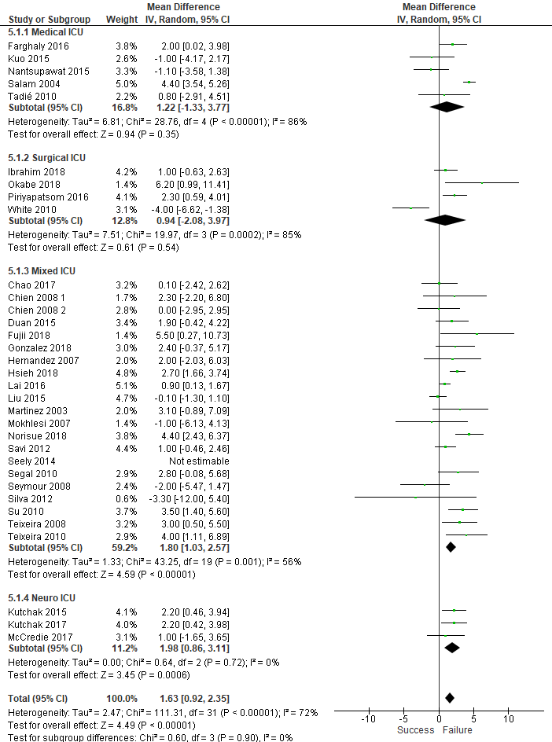

- BMI
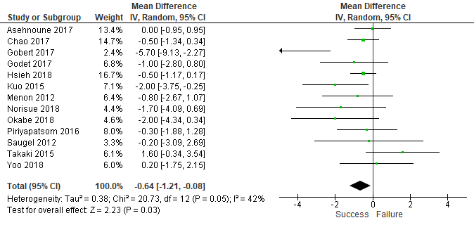

- COPD
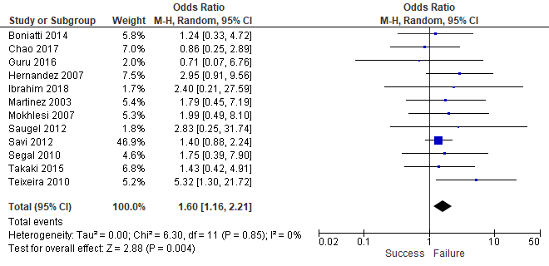

- COPD exacerbation
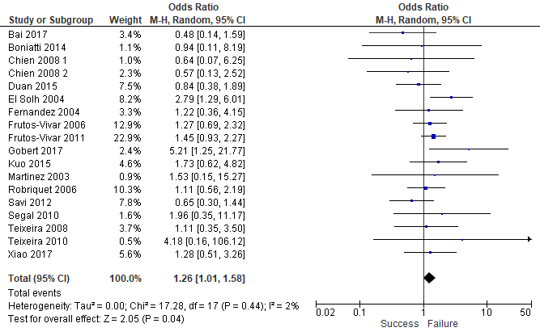

- Cough
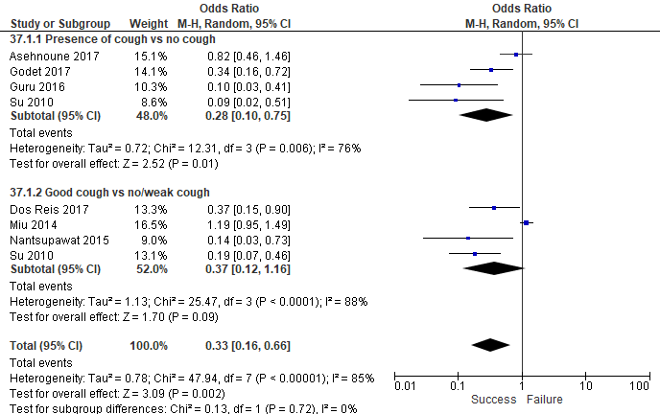

- Cough peak flow
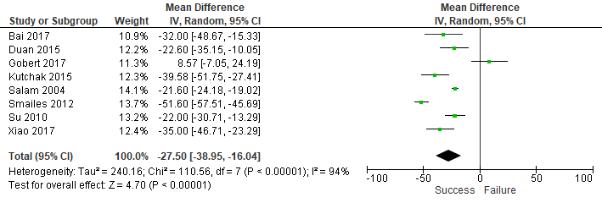

- Duration of mechanical ventilation before extubation
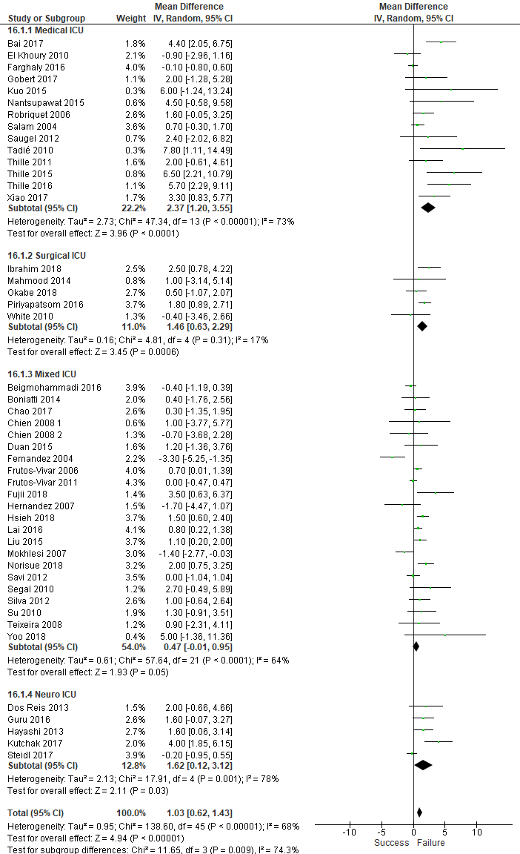
- GCS at extubation
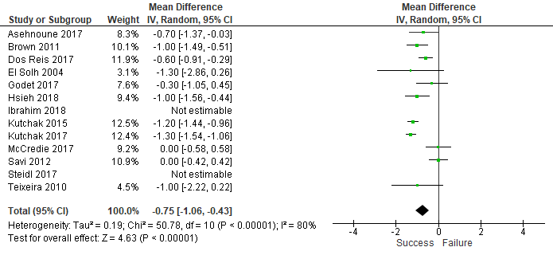

- Heart rate before extubation
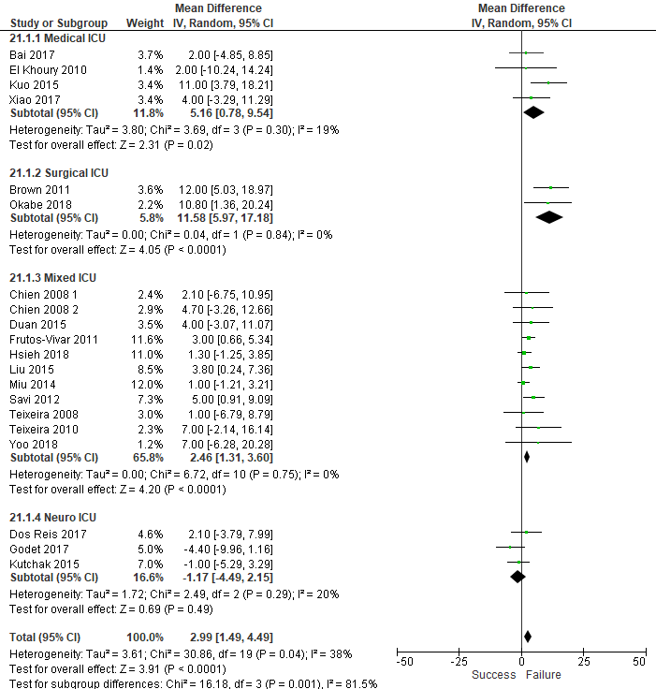
- Hemoglobin on the day of extubation
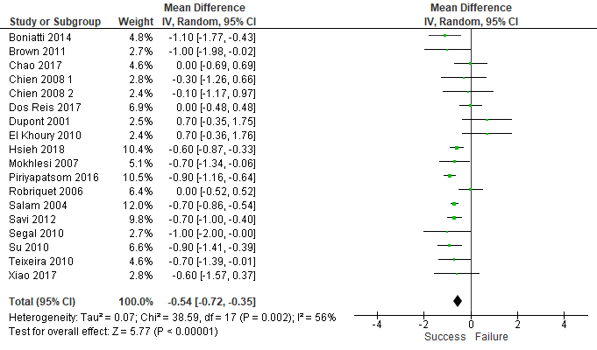

- History of cardiac disease
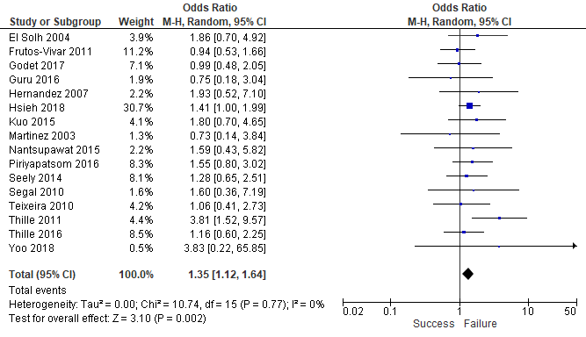

- History of respiratory disease
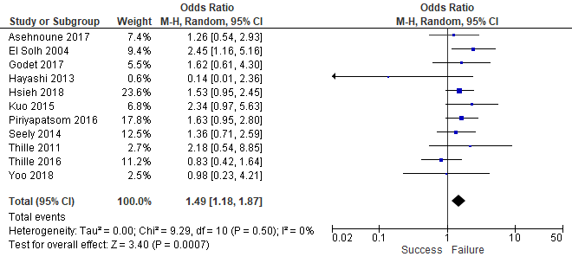

- Maximal expiratory pressure
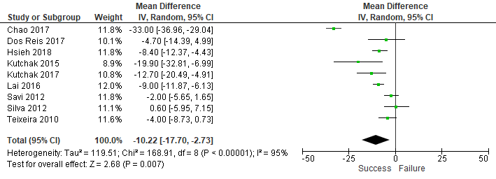

- Presence of moderate to abundant secretions
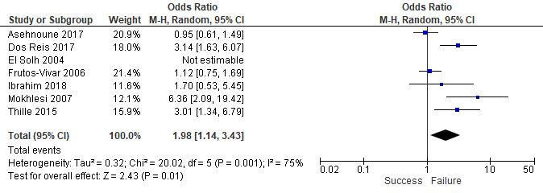

- Negative inspiratory force
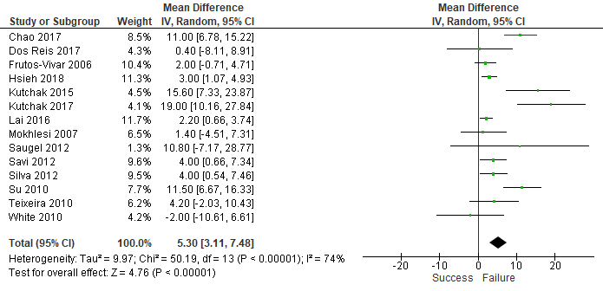

- PaO₂ before extubation
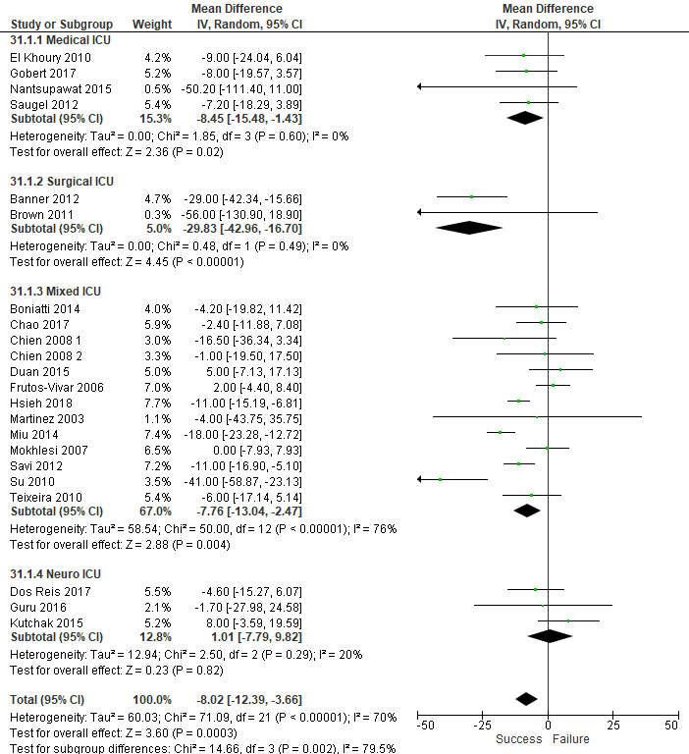

- PaO₂/FiO₂ before extubation
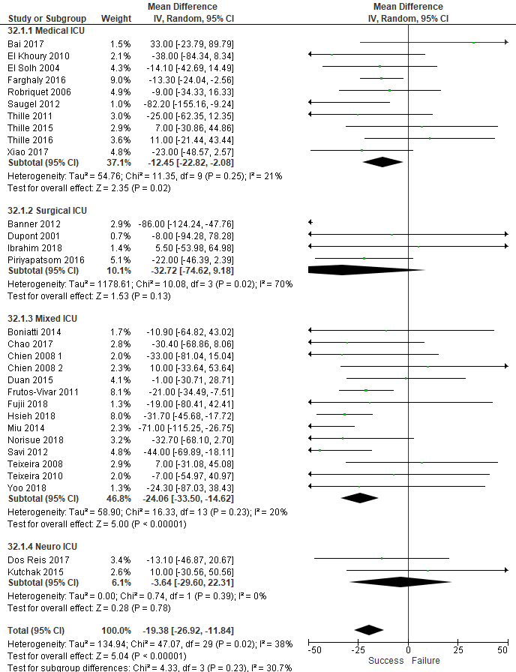

- Pneumonia
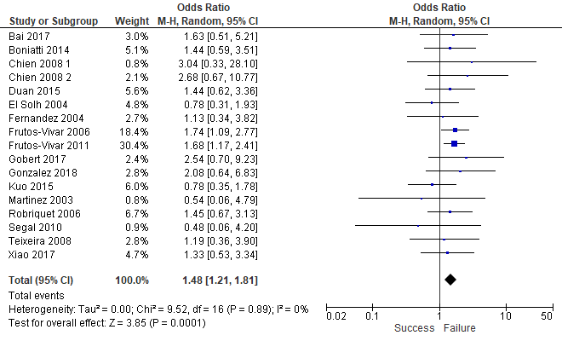

- Respiratory rate before extubation
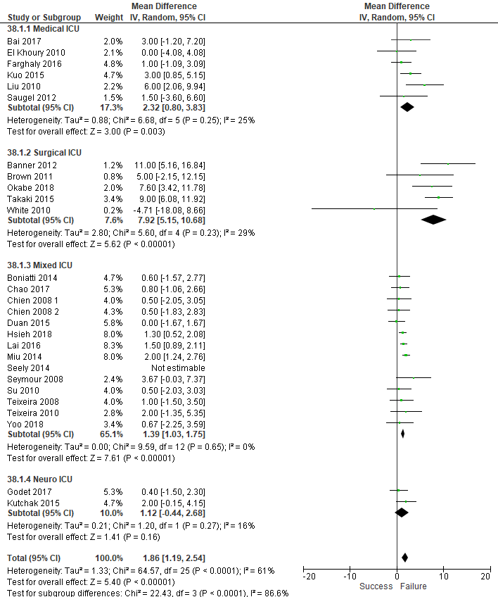

- RSBI
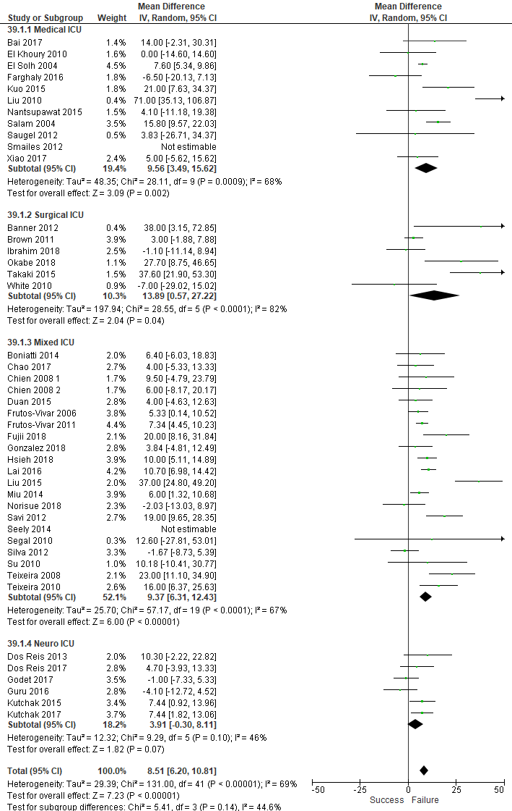
- RSBI after 1 minute of a spontaneous breathing trial
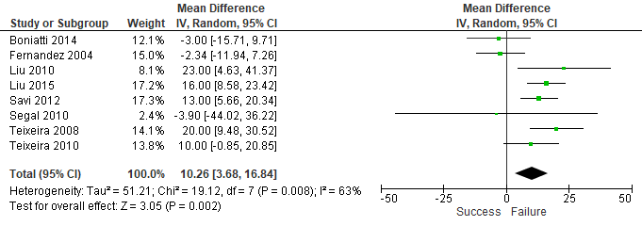

- SaO₂ before extubation
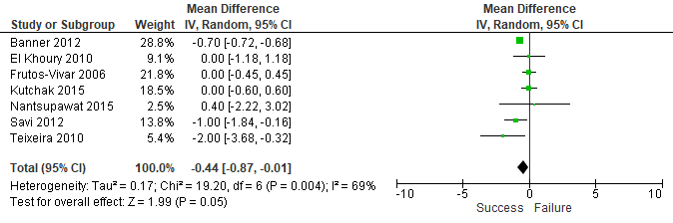

- SAPS II
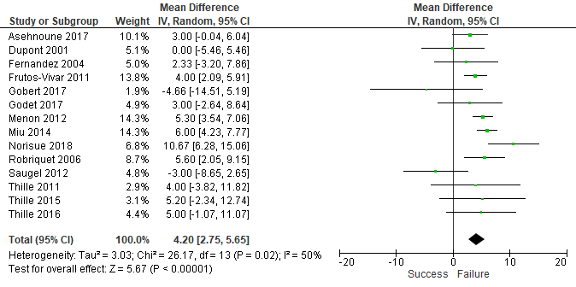

- Tidal volume before extubation
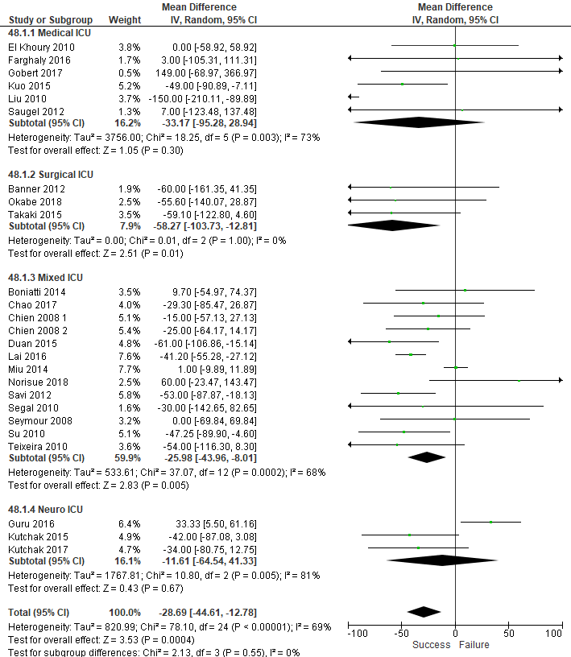

Additional table S2. Subgroup analyses by intensive care unit type.
Variable | N (%) |  | ICU type | n (%) |  | Effect estimate (95% IC), p value
Acute heart failure | 11 (16%) |  | Medical | 3 |  | 1.16 (0.56 to 2.43 ), p= 0.69
Acute heart failure |  |  | Mixed | 8 |  | 1.47 (0.98 to 2.19 ), p= 0.06
Acute respiratory failure | 7 (10%) |  | Mixed | 3 |  | 0.93 (0.5 to 1.73 ), p= 0.83
Acute respiratory failure |  |  | Surgical | 2 |  | 2.78 (1.28 to 6.05 ), p= 0.01
Acute respiratory failure |  |  | Medical | 2 |  | 1.51 (0.46 to 4.96 ), p= 0.49
Age | 59 (88%) |  | Medical | 15 |  | 3.69 (1.44 to 5.94 ), p= 0.001
Age |  |  | Surgical | 7 |  | 2.71 (-0.44 to 5.86 ), p= 0.09
Age |  |  | Mixed | 26 |  | 3.7 (2.78 to 4.62 ), p= <0.001
Age |  |  | Neurological | 11 |  | 3.38 (1.49 to 5.28 ), p= <0.001
Albumin | 9 (13%) |  | Mixed | 5 |  | -0.09 (-0.23 to 0.06 ), p= 0.24
Albumin |  |  | Surgical | 1 |  | -3 (-5.49 to -0.51 ), p= 0.02
Albumin |  |  | Medical | 1 |  | -0.3 (-0.99 to 0.39 ), p= 0.4
Albumin |  |  | Other | 2 |  | -2.56 (-3.9 to -1.22 ), p= <0.001
APACHE II score | 33 (49%) |  | Medical | 5 |  | 1.22 (-1.33 to 3.77 ), p= 0.35
APACHE II score |  |  | Surgical | 4 |  | 0.94 (-2.08 to 3.97 ), p= 0.54
APACHE II score |  |  | Mixed | 21 |  | 1.8 (1.03 to 2.57 ), p= <0.001
APACHE II score |  |  | Neurological | 3 |  | 1.98 (0.86 to 3.11 ), p= 0.001
ARDS | 9 (13%) |  | Mixed | 6 |  | 1.12 (0.7 to 1.77 ), p= 0.64
ARDS |  |  | Medical | 1 |  | 0.68 (0.14 to 3.4 ), p= 0.64
ARDS |  |  | Other | 2 |  | 1.3 (0.26 to 6.43 ), p= 0.75
BMI | 13 (19%) |  | Mixed | 5 |  | -0.53 (-1 to -0.05 ), p= 0.03
BMI |  |  | Medical | 3 |  | -2.44 (-5.05 to 0.17 ), p= 0.07
BMI |  |  | Surgical | 2 |  | -0.92 (-2.53 to 0.68 ), p= 0.26
BMI |  |  | Other | 1 |  | 1.6 (-0.34 to 3.54 ), p= 0.11
BMI |  |  | Neurological | 2 |  | -0.22 (-1.06 to 0.62 ), p= 0.61
History of cardiac disease | 16 (24%) |  | Mixed | 8 |  | 1.27 (0.99 to 1.63 ), p= 0.06
History of cardiac disease |  |  | Medical | 4 |  | 1.84 (1.1 to 3.07 ), p= 0.02
History of cardiac disease |  |  | Surgical | 1 |  | 1.55 (0.8 to 3.02 ), p= 0.2
History of cardiac disease |  |  | Other | 1 |  | 1.59 (0.43 to 5.82 ), p= 0.49
History of cardiac disease |  |  | Neurological | 2 |  | 0.94 (0.49 to 1.78 ), p= 0.84
History of respiratory disease | 11 (16%) |  | Mixed | 3 |  | 1.43 (0.99 to 2.07 ), p= 0.06
History of respiratory disease |  |  | Medical | 5 |  | 1.65 (1.03 to 2.65 ), p= 0.04
History of respiratory disease |  |  | Surgical | 1 |  | 1.63 (0.95 to 2.8 ), p= 0.08
History of respiratory disease |  |  | Neurological | 2 |  | 0.61 (0.07 to 5.36 ), p= 0.66
Coma | 8 (12%) |  | Mixed | 5 |  | 0.76 (0.55 to 1.05 ), p= 0.1
Coma |  |  | Medical | 2 |  | 0.71 (0.32 to 1.59 ), p= 0.4
Coma |  |  | Surgical | 1 |  | 1.08 (0.29 to 4.01 ), p= 0.9
COPD | 12 (18%) |  | Mixed | 8 |  | 1.62 (1.15 to 2.28 ), p= 0.01
COPD |  |  | Medical | 1 |  | 2.83 (0.25 to 31.74 ), p= 0.4
COPD |  |  | Surgical | 1 |  | 2.4 (0.21 to 27.59 ), p= 0.48
COPD |  |  | Other | 1 |  | 1.43 (0.42 to 4.91 ), p= 0.57
COPD |  |  | Neurological | 1 |  | 0.71 (0.07 to 6.76 ), p= 0.76
COPD exacerbation |  | 17 (25%) | Mixed |  | 12 | 1.14 (0.87 to 1.5 ), p= 0.3
 |  |  | Medical |  | 3 | 2.66 (1.51 to 4.68 ), p= 0.001
 |  |  | Other |  | 2 | 1.17 (0.67 to 2.02 ), p= 0.59
Cough versus No or weak cough |  | 7 (10%) | Mixed |  | 2 | 0.38 (0.03 to 4.59 ), p= 0.45
 |  |  | Neurological |  | 3 | 0.38 (0.18 to 0.79 ), p= 0.009
 |  |  | Other |  | 1 | 0.14 (0.03 to 0.73 ), p= 0.02
Creatinine |  | 9 (13%) | Mixed |  | 5 | 0.18 (-0.1 to 0.46 ), p= 0.2
 |  |  | Medical |  | 1 | -0.3 (-0.81 to 0.21 ), p= 0.24
 |  |  | Surgical |  | 2 | 0.24 (-0.25 to 0.73 ), p= 0.35
 |  |  | Other |  | 1 | 0 (-0.16 to 0.16 ), p= 1
Diastolic blood pressure pre extubation |  | 9 (13%) | Mixed |  | 4 | -1.89 (-4.63 to 0.84 ), p= 0.18
 |  |  | Medical |  | 1 | -1 (-8.15 to 6.15 ), p= 0.78
 |  |  | Neurological |  | 2 | 1.1 (-1.73 to 3.93 ), p= 0.45
 |  |  | Other |  | 2 | -2.15 (-5.66 to 1.36 ), p= 0.23
Diabetes |  | 14 (21%) | Mixed |  | 9 | 1.1 (0.75 to 1.63 ), p= 0.62
 |  |  | Surgical |  | 1 | 0.56 (0.1 to 3.23 ), p= 0.51
 |  |  | Neurological |  | 3 | 1.54 (0.91 to 2.61 ), p= 0.11
 |  |  | Other |  | 1 | 1.71 (0.47 to 6.28 ), p= 0.42
Duration of MV before extubation |  | 46 (69%) | Medical |  | 14 | 2.37 (1.2 to 3.55 ), p= <0.001
 |  |  | Surgical |  | 5 | 1.46 (0.63 to 2.29 ), p= 0.001
 |  |  | Mixed |  | 22 | 0.47 (-0.01 to 0.95 ), p= 0.05
 |  |  | Neuro |  | 5 | 1.62 (0.12 to 3.12 ), p= 0.03
GCS at extubation |  | 12 (18%) | Mixed |  | 3 | -0.59 (-1.38 to 0.2 ), p= 0.14
 |  |  | Medical |  | 1 | -1.3 (-2.86 to 0.26 ), p= 0.1
 |  |  | Surgical |  | 1 | -1 (-1.49 to -0.51 ), p= <0.001
 |  |  | Neurological |  | 7 | -0.75 (-1.14 to -0.37 ), p= <0.001
GCS upon admission |  | 12 (18%) | Mixed |  | 4 | -0.2 (-0.58 to 0.18 ), p= 0.3
 |  |  | Surgical |  | 1 | -0.5 (-1.33 to 0.33 ), p= 0.24
 |  |  | Neurological |  | 7 | -0.33 (-0.88 to 0.22 ), p= 0.24
Heart rate pre extubation |  | 20 (30%) | Medical |  | 4 | 5.16 (0.78 to 9.54 ), p= 0.02
 |  |  | Surgical |  | 2 | 11.58 (5.97 to 17.18 ), p= <0.001
 |  |  | Mixed |  | 11 | 2.46 (1.31 to 3.6 ), p= <0.001
 |  |  | Neurological |  | 3 | -1.17 (-4.49 to 2.15 ), p= 0.49
Hemoglobin |  | 18 (27%) | Mixed |  | 10 | -0.66 (-0.81 to -0.5 ), p= <0.001
 |  |  | Medical |  | 2 | -0.1 (-1.46 to 1.26 ), p= 0.88
 |  |  | Neurological |  | 1 | 0 (-0.48 to 0.48 ), p= 1
 |  |  | Other |  | 2 | -0.15 (-0.67 to 0.36 ), p= 0.56
 |  |  | Surgical |  | 3 | -0.48 (-1.39 to 0.42 ), p= 0.3
History of hypertension |  | 8 (12%) | Mixed |  | 5 | 1.05 (0.73 to 1.52 ), p= 0.79
 |  |  | Surgical |  | 1 | 0.96 (0.27 to 3.46 ), p= 0.96
 |  |  | Neurological |  | 1 | 1.15 (0.37 to 3.57 ), p= 0.81
 |  |  | Other |  | 1 | 3.44 (0.42 to 28.29 ), p= 0.25
Males |  | 52 (78%) | Medical |  | 12 | 0.95 (0.53 to 1.68 ), p= 0.85
 |  |  | Surgical |  | 5 | 1.16 (0.56 to 2.42 ), p= 0.69
 |  |  | Mixed |  | 25 | 0.94 (0.77 to 1.13 ), p= 0.49
 |  |  | Neuro |  | 10 | 0.7 (0.43 to 1.13 ), p= 0.14
Mean arterial pressure pre extubation |  | 7 (10%) | Mixed |  | 5 | -1 (-2.44 to 0.44 ), p= 0.18
 |  |  | Neurological |  | 1 | -0.2 (-6.69 to 6.29 ), p= 0.95
 |  |  | Other |  | 1 | -0.2 (-15.7 to 15.3 ), p= 0.98
Maximal Expiratory Pressure |  | 9 (13%) | Mixed |  | 6 | -9.39 (-18.81 to 0.03 ), p= 0.05
 |  |  | neurological |  | 3 | -11.7 (-19.36 to -4.04 ), p= 0.003
Minute ventilation pre extubation |  | 17 (25%) | Mixed |  | 12 | -0.08 (-0.49 to 0.34 ), p= 0.71
 |  |  | Medical |  | 3 | -0.1 (-0.77 to 0.56 ), p= 0.76
 |  |  | Surgical |  | 1 | 2.7 (0.86 to 4.54 ), p= 0.004
Neurologic diagnosis |  | 9 (13%) | Mixed |  | 6 | 1.01 (0.59 to 1.71 ), p= 0.98
 |  |  | Medical |  | 3 | 1.81 (0.78 to 4.19 ), p= 0.17
Negative inspiratory force |  | 14 (21%) | Mixed |  | 9 | 4.46 (2.49 to 6.43 ), p= < 0.001
 |  |  | Medical |  | 1 | 10.8 (-7.17 to 28.77 ), p= 0.24
 |  |  | Surgical |  | 1 | -2 (-10.61 to 6.61 ), p= 0.65
 |  |  | Neurological |  | 3 | 11.65 (0.49 to 22.8 ), p= 0.04
FiO₂ during SBT |  | 11 (16%) | Mixed |  | 5 | 0.01 (0.00, 0.01), p=0.001
 |  |  | Surgical |  | 3 | -0.01 (-0.04, 0.02), p= 0.6
 |  |  | Neurological |  | 3 | 0.00 (-0.00, 0.00), p=1
PaCO₂ pre extubation |  | 34 (51%) | Medical |  | 11 | 1.06 (-0.92 to 3.05 ), p= 0.29
 |  |  | Surgical |  | 3 | 0.65 (-3.39 to 4.69 ), p= 0.75
 |  |  | Mixed |  | 17 | 1.08 (-0.06 to 2.22 ), p= 0.06
 |  |  | Neurological |  | 3 | -0.51 (-1.71 to 0.68 ), p= 0.4
PaO₂ pre extubation |  | 22 (33%) | Medical |  | 4 | -8.45 (-15.48 to -1.43 ), p= 0.02
 |  |  | Surgical |  | 2 | -29.83 (-42.96 to -16.7 ), p= <0.001
 |  |  | Mixed |  | 13 | -7.76 (-13.04 to -2.47 ), p= 0.004
 |  |  | Neurological |  | 3 | 1.01 (-7.79 to 9.82 ), p= 0.82
PaO₂/FiO₂ pre extubation |  | 30 (45%) | Medical |  | 10 | -12.45 (-22.82 to -2.08 ), p= 0.02
 |  |  | Surgical |  | 4 | -32.72 (-74.62 to 9.18 ), p= 0.13
 |  |  | Mixed |  | 14 | -24.06 (-33.5 to -14.62 ), p= <0.001
 |  |  | Neurological |  | 2 | -3.64 (-29.6 to 22.31 ), p= 0.78
pH pre extubation |  | 27 (40%) | Medical |  | 10 | 0 (-0.01 to 0.01 ), p= 0.87
 |  |  | Surgical |  | 2 | -0.01 (-0.03 to 0.01 ), p= 0.42
 |  |  | Mixed |  | 13 | -0.01 (-0.01 to 0 ), p= 0.23
 |  |  | Neurological |  | 2 | -0.01 (-0.02 to 0 ), p= 0.14
PEEP during SBT |  | 11 (16%) | Mixed |  | 6 | 0.04 (-0.02 to 0.09 ), p= 0.19
 |  |  | Surgical |  | 2 | -0.19 (-0.91 to 0.53 ), p= 0.61
 |  |  | Neurological |  | 3 | 0.1 (-0.02 to 0.22 ), p= 0.1
Pneumonia |  | 17 (25%) | Mixed |  | 11 | 1.61 (1.27 to 2.04 ), p= <0.001
 |  |  | Medical |  | 3 | 1 (0.53 to 1.91 ), p= 1
 |  |  | Other |  | 3 | 1.44 (0.85 to 2.45 ), p= 0.17
Respiratory rate pre extubation |  | 27 (40%) | Medical |  | 6 | 2.32 (0.8 to 3.83 ), p= 0.003
 |  |  | Surgical |  | 5 | 7.92 (5.15 to 10.68 ), p= <0.001
 |  |  | Mixed |  | 14 | 1.39 (1.03 to 1.75 ), p= <0.001
 |  |  | Neurological |  | 2 | 1.12 (-0.44 to 2.68 ), p= 0.16
RSBI |  | 44 (66%) | Medical |  | 11 | 9.56 (3.49 to 15.62 ), p= 0.002
 |  |  | Surgical |  | 6 | 13.89 (0.57 to 27.22 ), p= 0.04
 |  |  | Mixed |  | 21 | 9.37 (6.31 to 12.43 ), p= <0.001
 |  |  | Neurological |  | 6 | 3.91 (-0.3 to 8.11 ), p= 0.07
RSBI, 1 min SBT |  | 8 (12%) | Mixed |  | 7 | 9.14 (2.28 to 15.99 ), p= 0.009
 |  |  | Medical |  | 1 | 23 (4.63 to 41.37 ), p= 0.01
SaO₂ pre extubation |  | 7 (10%) | Mixed |  | 3 | -0.78 (-1.81 to 0.25 ), p= 0.14
 |  |  | Medical |  | 1 | 0 (-1.18 to 1.18 ), p= 1
 |  |  | Surgical |  | 1 | -0.7 (-0.72 to -0.68 ), p= <0.001
 |  |  | Neurological |  | 1 | 0 (-0.6 to 0.6 ), p= 1
 |  |  | Other |  | 1 | 0.4 (-2.22 to 3.02 ), p= 0.76
SAPS II |  | 15 (22%) | Mixed |  | 6 | 5.51 (3.81 to 7.2 ), p= <0.001
 |  |  | Medical |  | 5 | 1.52 (-2.56 to 5.6 ), p= 0.47
 |  |  | Surgical |  | 1 | 0 (-5.46 to 5.46 ), p= 1
 |  |  | Neurological |  | 2 | 3 (0.32 to 5.68 ), p= 0.03
 |  |  | Other |  | 1 | 5.6 (2.05 to 9.15 ), p= 0.002
Presence of moderate to abundant secretions |  | 7 (10%) | Mixed |  | 2 | 2.47 (0.45 to 13.4 ), p= 0.3
 |  |  | Medical |  | 2 | 3.01 (1.34 to 6.79 ), p= 0.01
 |  |  | Surgical |  | 1 | 1.7 (0.53 to 5.45 ), p= 0.37
 |  |  | Neurological |  | 2 | 1.69 (0.52 to 5.43 ), p= 0.38
Tidal volume pre extubation |  | 25 (37%) | Medical |  | 6 | -33.17 (-95.28 to 28.94 ), p= 0.3
 |  |  | Surgical |  | 3 | -58.27 (-103.73 to -12.81 ), p= 0.01
 |  |  | Mixed |  | 12 | -25.98 (-43.96 to -8.01 ), p= 0.005
 |  |  | Neurological |  | 3 | -11.61 (-64.54 to 41.33 ), p= 0.67
Cough peak flow |  | 8 (12%) | Mixed |  | 2 | -22.19 (-29.35 to -15.04 ), p= <0.001
 |  |  | Medical |  | 2 | -7.54 (-37.04 to 21.96 ), p= 0.62
 |  |  | Other |  | 3 | -40.89 (-54.67 to -27.11 ), p= <0.001
 |  |  | Neurological |  | 1 | -39.58 (-51.75 to -27.41 ), p= <0.001
Postoperative respiratory failure |  | 7 (10%) | Mixed |  | 5 | 0.94 (0.66 to 1.32 ), p= 0.71
 |  |  | Surgical |  | 1 | 0.52 (0.14 to 1.92 ), p= 0.33
 |  |  | Medical |  | 1 | 2.25 (0.84 to 6.03 ), p= 0.11
Systolic blood pressure pre extubation |  | 12 (18%) | Mixed |  | 6 | -0.2 (-2.56 to 2.15 ), p= 0.87
 |  |  | Medical |  | 2 | 3.49 (-4.13 to 11.1 ), p= 0.37
 |  |  | Surgical |  | 1 | -2 (-10.8 to 6.8 ), p= 0.66
 |  |  | Other |  | 2 | -3.24 (-10.15 to 3.66 ), p= 0.36
 |  |  | Neurological |  | 1 | 2 (-4.52 to 8.52 ), p= 0.55
Sepsis |  | 7 (10%) | Mixed |  | 6 | 1.17 (0.92 to 1.49 ), p= 0.2
 |  |  | Medical |  | 1 | 1.01 (0.29 to 3.58 ), p= 0.99
Shock |  | 8 (12%) | Mixed |  | 4 | 0.72 (0.29 to 1.76 ), p= 0.47
 |  |  | Medical |  | 4 | 0.99 (0.41 to 2.39 ), p= 0.99
Steroids |  | 7 (10%) | Mixed |  | 3 | 0.96 (0.44 to 2.13 ), p= 0.93
 |  |  | Medical |  | 1 | 0.62 (0.13 to 2.93 ), p= 0.55
 |  |  | Surgical |  | 1 | 0.85 (0.46 to 1.58 ), p= 0.62
 |  |  | Neurological |  | 1 | 0.28 (0.08 to 0.93 ), p= 0.04
 |  |  | Other |  | 1 | 1.17 (0.59 to 2.29 ), p= 0.66
Trauma |  | 7 (10%) | Mixed |  | 6 | 0.83 (0.62 to 1.13 ), p= 0.23
 |  |  | Surgical |  | 1 | 0.55 (0.18 to 1.72 ), p= 0.3
N: Number of studies; n: Number of studies in ICU subgroup ; ARDS: acute respiratory distress syndrom; BMI: body mass index; COPD: chronic obstructive pulmonary disease; MV: mechanical ventilation; GCS: glasgow coma scale; SBT: spontaneous breathing trial; PEEP: positiv end expiratory pressure; RSBI: Rapid shallow breathing index; SAPS II: simplifed acute Physiology Score II.

Additional figure S2. Heatmap of natural log transformation of odd ratios (LnOR) for extubation failure, according to ICU type.
Natural log transformation of odd ratios (LnOR) derived from crude OR (for binary variables) and from standardized mean differences (for continuous variables), summarizing the effect of 30 variables significantly associated with extubation outcome in at least one intensive care unit (ICU) type. LnOR factors were scaled to adjust for extreme values. White boxes represent missing or nonsignificant values.
Additional table S3: Sensitivity analysis focusing on studies defining extubation failure as death or reintubation, whatever the delay.
Variables | Statistical significance  after sensitivity analysis
Acute heart failure | yes
Age | yes
APACHE II score | yes
BMI | no
COPD | yes
COPD exacerbation | no
Cough* | yes
Cough peak flow | yes
Duration of mechanical ventilation before extubation | yes
GCS at extubation | yes
Heart rate before extubation | yes
Hemoglobin on the day of extubation | yes
History of cardiac disease | yes
History of respiratory disease | yes
Maximal expiratory pressure | yes
Negative inspiratory force | yes
PaO₂ before extubation | yes
PaO₂/FiO₂ before extubation | yes
Pneumonia | yes
Presence of moderate to abundant secretions | yes
Respiratory rate before extubation | yes
RSBI before extubation | yes
RSBI after 1 minute of a spontaneous breathing trial | no
SaO₂ before extubation | yes
SAPS II | yes
Tidal volume before extubation | yes
BMI: body mass index; COPD: chronic obstructive pulmonary disease; GCS: glasgow coma scale; RSBI: Rapid shallow breathing index; SAPS II: simplifed acute Physiology Score II.

Additional table S4. Sensitivity analysis focusing on studies defining extubation failure at 48 hours.
Variables | Statistical significance  after sensitivity analysis
Acute heart failure | yes
Age | yes
APACHE II score | yes
BMI | no
COPD | yes
COPD exacerbation | no
Cough* | no
Cough peak flow | no
Duration of mechanical ventilation before extubation | no
GCS at extubation | yes
Heart rate before extubation | yes
Hemoglobin on the day of extubation | yes
History of cardiac disease | no
History of respiratory disease | no
Maximal expiratory pressure | yes
Negative inspiratory force | yes
PaO2 before extubation | yes
PaO2/FiO2 before extubation | yes
Pneumonia | yes
Presence of moderate to abundant secretions | no
Respiratory rate before extubation | yes
RSBI before extubation | yes
RSBI after 1 minute of a spontaneous breathing trial | no
SaO2 before extubation | no
SAPS II | no
Tidal volume before extubation | yes
*: cough was considered in only one study included in the sensitivity analysis.
BMI: body mass index; COPD: chronic obstructive pulmonary disease; GCS: glasgow coma scale; RSBI: Rapid shallow breathing index; SAPS II: simplifed acute Physiology Score II.

Additional figure S3. Forest plot for the 26 variables significantly associated with extubation failure, assessed by multivariate meta-analysis for multiple factors.
Effects are reported in natural log transformation of odd ratios (lnOR) derived from crude OR with 95% confidence interval margins (CI).

Additional figure S4. Individual risk of bias in the included studies.
