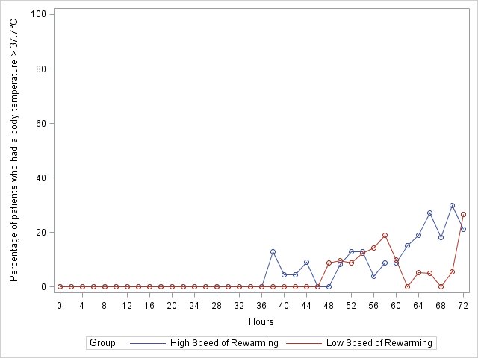

H0 was the time at ICU admission.

