Supplementary material

Table 1S: 10-fold cross-validation. Performance of the Flow Index and other parameters in detecting breaths with high inspiratory effort.

 | threshold | sensitivity | specificity | PPV | NPV | accuracy
FI | 4.53 (0.01) | 0.76 (0.15) | 0.84 (0.07) | 0.35 (0.15) | 0.97 (0.02) | 0.83 (0.07)
RR | 26 (1) | 0.38 (0.16) | 0.52 (0.08) | 0.08 (0.05) | 0.89 (0.02) | 0.51 (0.06)
RR/V_{T} | 41 (0) | 0.68 (0.20) | 0.64 (0.06) | 0.16 (0.08) | 0.95 (0.04) | 0.65 (0.05)
V_{T} IBW | 8.8 (0.0) | 0.68 (0.18) | 0.64 (0.04) | 0.17 (0.07) | 0.95 (0.04) | 0.65 (0.04)

Results of stratified 10-fold cross validation for the studied variable to internally validate the estimate of sensitivity, specificity, Positive Predictive Value (PPV) and Negative Predicted Value (NPV). The best threshold for detecting high inspiratory effort using variables studied as predictors was chosen by identifying the top-left corner value in the retrieving operating characteristic curve. Data are shown as mean (Standard Deviation).
Abbreviations: FI = Flow Index, RR = respiratory rate, V_{T} = tidal volume, IBW = ideal body weight, PPV = Positive Predictive Value, NPV = Negative Predictive Value, AUC = Area Under the retrieving operative characteristic Curve
Table 2S: 10-fold cross-validation. Performance of the Flow Index and other parameters in detecting breaths with low inspiratory effort.

 | threshold | sensitivity | specificity | PPV | NPV | accuracy
FI | 2.65 (0.00) | 0.77 (0.08) | 0.74 (0.07) | 0.83 (0.04) | 0.67 (0.08) | 0.76 (0.06)
RR | 24 (1.00) | 0.49 (0.08) | 0.61 (0.11) | 0.68 (0.09) | 0.42 (0.07) | 0.54 (0.07)
RR/V_{T} | 53 (0) | 0.589 (0.05) | 0.56 (0.12) | 0.69 (0.10) | 0.44 (0.05) | 0.57 (0.06)
V_{T} IBW | 8.09 (0.00) | 0.50 (0.07) | 0.42 (0.09) | 0.59 (0.07) | 0.33 (0.08) | 0.47 (0.06)

Results of stratified 10-fold cross validation for the studied variable to internally validate the estimate of sensitivity, specificity, Positive Predictive Value (PPV) and Negative Predicted Value (NPV). The best threshold for detecting low inspiratory effort using variables studied as predictors was chosen by identifying the top-left corner value in the retrieving operating characteristic curve. Data are shown as mean (Standard Deviation).
Abbreviations: FI = Flow Index, RR = respiratory rate, V_{T} = tidal volume, IBW = ideal body weight, PPV = Positive Predictive Value, NPV = Negative Predictive Value, AUC = Area Under the retrieving operative characteristic Curve

Sensitivity analysis with Pressure Time Product from the beginning of inspiratory flow (PTP) as a grouping variable. Low inspiratory effort was defined as PTP < 50 cmH₂O ‧ sec⁻¹ ‧ min⁻¹, high inspiratory effort as PTP > 200 cmH₂O ‧ sec⁻¹ ‧ min⁻¹, intermediate inspiratory effort as 50>PTP< 200 cmH₂O ‧ sec⁻¹ ‧ min⁻¹.

Table 3S: Ventilatory parameters in breaths with low, intermediate and high inspiratory effort
 | Low inspiratory effort | Intermediate inspiratory effort | High inspiratory effort | p
P_{0.1} (cmH₂O) | 0.6 (0.3 to 1.0) | 1.2 (0.9 to 1.6) | 1.8 (1.4 to 2.3) | <0.001
P_{musc} (cmH₂O) | 1.6 (0.7 to 2.1) | 6.4 (5.6 to 8.6) | 16.6 (15.2 to 18.6) | <0.001
Flow Index | 1.6 (1.2 to 2.5) | 3.4 (2.6 to 5.5) | 10.6 (7.7 to 10.8) | <0.001
RR (breaths⋅min⁻¹) | 22 (16 to 29) | 27 (20 to 33) | 24 (24 to 27) | 0.142
RR/V_{T} (breaths⋅L⁻¹⋅min⁻¹) | 48 (26 to 73) | 52 (33 to 80) | 39 (35 to 50) | 0.659
V̇E (L⋅min⁻¹) | 9.4 (7.3 to 13.1) | 12.7 (10.3 to 15.9) | 13.2 (12.7 to 14.0) | 0.059
V_{T}/IBW (ml⋅Kg⁻¹) | 8.2 (6.3 to 10.6) | 7.9 (6.9 to 9.7) | 9.6 (8.7 to 9.8) | 0.800
PTP (cmH₂O⋅sec⋅min⁻¹) | 11.4 (3.1 to 20.2) | 85.8 (73.5 to 130.3) | 209.6 (205.3 to 254.4) | <0.001
PS (cmH₂O) | 13 (10 to 17) | 4 (2 to 6) | 3 (2 to 5) | <0.001

P values are obtained with Kruskal Wallis test for non-parametric distribution. Abbreviations: P_{0.1}= airway occlusion pressure, P_{musc}= pressure generated by respiratory muscles, RR = respiratory rate, V_{T} = tidal volume, IBW = ideal body weight, V̇E= minute ventilation, PTP= Pressure Time Product from the beginning of inspiratory flow, PS = pressure support

Table 4S: Performance of the Flow Index and other routinely used parameters in detecting breaths with high inspiratory effort defined as PTP> 200 cmH₂O‧sec⁻¹‧min⁻¹)

 | threshold | specificity | sensitivity | PPV | NPV | AUC | P value
Flow index | 4.5  (2.7-5.7) | 0.82 (0.61-0.89) | 0.80 (0.68-0.96) | 0.14 (0.08-0.22) | 0.99 (0.99-1) | 0.86 (0.80-0.92) | -
RR  breaths⋅min⁻¹ | 30  (23-30) | 0.70 (0.40-0.73) | 0.60 (0.44-0.84) | 0.06 (0.04-0.09) | 0.98 (0.97-0.99) | 0.61 (0.50-0.71) | <0.001
RR/V_{T}  breaths⋅L⁻¹⋅min⁻¹ | 59  (31-59) | 0.58 (0.32-0.62) | 0.56 (0.40-0.80) | 0.05 (0.03-0.06) | 0.97 (0.96-0.99) | 0.52 (0.41-0.62) | <0.001
V_{T}/IBW  ml⋅Kg⁻¹ | 7.7  (7.7-10.4) | 0.53 (0.25-0.57) | 0.56 (0.44-1) | 0.04 (0.03-0.06) | 0.97 (0.96-1) | 0.55 (0.48-0.62) | <0.001
P_{0.1}  cmH₂O | 1.6  (1.4-1.7) | 0.83  (0.70-0.87) | 0.76  (0.60-0.88) | 0.14  (0.08-0.18) | 0.99  (0.98-0.99) | 0.77  (0.67-0.87) | 0.129

High inspiratory effort was defined as PTP> 200 cmH₂O‧sec⁻¹‧min⁻¹. Estimates of sensitivity, specificity, positive predictive value (PPV), and negative predictive value (NPV) for the best threshold (chosen by identifying the top-left corner value in the retrieving operating characteristic curve) for detecting high inspiratory effort using variables studied as predictors. 95% confidence intervals (95% CI) were obtained by 2000 bootstrapped samples. P values were computed by evaluating bootstrapping tests for the AUC of every variable versus the AUC of the Flow Index.
Abbreviations: RR = respiratory rate, V_{T} = tidal Volume, IBW = ideal body weight, P_{0.1}= airway occlusion pressure, PPV = Positive Predictive Value, NPV = Negative Predictive Value, AUC = Area Under the retrieving operative characteristic Curve

Figure 1S. Areas under the receiver operating curve for detecting high inspiratory effort (PTP > 200 cmH₂O‧sec⁻¹‧min⁻¹)
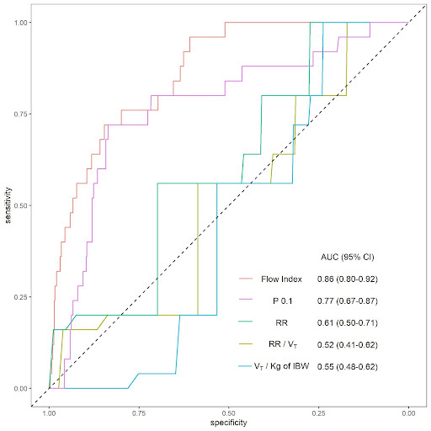
Abbreviations: P_{0.1}= airway occlusion pressure, RR = respiratory rate, V_{T} = tidal volume, IBW = ideal body weight

Table 5S: Performance of the FI and other parameters in detecting breaths with low inspiratory effort (defined as PTP<50 cmH₂O‧sec⁻¹‧min⁻¹)

 | threshold | specificity | sensitivity | PPV | NPV | AUC | P value
Flow index | 2.5  (2.0-2.8) | 0.70 (0.63-0.79) | 0.73 (0.63-0.80) | 0.76 (0.73-0.81) | 0.66 (0.61-0.71) | 0.75 (0.71-0.78) | -
RR  breaths⋅min⁻¹ | 25  (23-25) | 0.63 (0.57-0.71) | 0.59 (0.52-0.66) | 0.68 (0.64-0.72) | 0.54 (0.50-0.58) | 0.65 (0.61-0.69) | <0.001
RR/V_{T}  breaths⋅L⁻¹⋅min⁻¹ | 53  (33-53) | 0.56 (0.52-0.77) | 0.60 (0.44-0.66) | 0.65 (0.62-0.72) | 0.52 (0.48-0.56) | 0.59 (0.55-0.63) | <0.001
V_{T}/IBW  ml⋅Kg⁻¹ | 8.1  (8.1-8.1) | 0.63 (0.58-0.69) | 0.54 (0.50-0.60) | 0.66 (0.62-0.70) | 0.51 (0.48-0.55) | 0.54 (0.50-0.59) | <0.001
P_{0.1}  cmH₂O | 1.0  (0.9-1.1) | 0.67  (0.61-0.74) | 0.70  (0.63-0.76) | 0.74  (0.71-0.77) | 0.63  (0.58-0.67) | 0.73  (0.69-0.77) | 0.504

Low inspiratory effort was defined as PTP< 50 cmH₂O‧sec⁻¹‧min⁻¹. Estimates of sensitivity, specificity, Positive Predictive Value (PPV), and Negative Predicted Value (NPV) for the best threshold (chosen with by top-left corner in the retrieving operative characteristic curve) for detecting low inspiratory effort using variables studied as predictors. 95% confidence intervals (95% CI) were obtained by 2000 bootstrapped samples. P values were computed by evaluating bootstrapping tests for the AUC of every variable versus the AUC of the Flow Index.
Abbreviations: RR = respiratory rate, V_{T} = tidal Volume, IBW = ideal body weight, P_{0.1}= airway occlusion pressure, PPV = Positive Predictive Value, NPV = Negative Predictive Value, AUC = Area Under the retrieving operative characteristic Curve

Figure 2S. Areas under the receiver operating curve for detecting low inspiratory effort (PTP< 50 cmH₂O‧sec⁻¹‧min⁻¹)

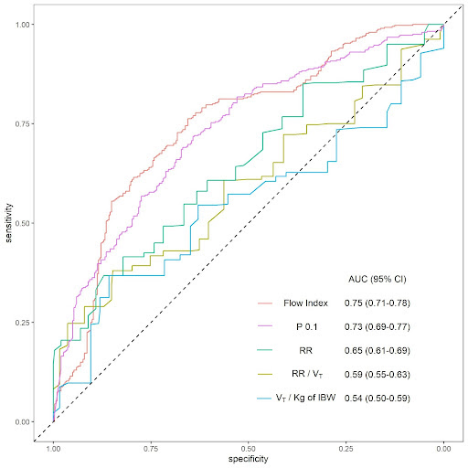
Abbreviations: P_{0.1}= airway occlusion pressure, RR = respiratory rate, V_{T} = tidal volume, IBW = ideal body weight
Sensitivity analysis with Pressure Time Product from beginning of inspiratory effort (PTP_{tot}) as a grouping variable. Low inspiratory effort was defined as PTP_{tot} < 50 cmH₂O ‧ sec⁻¹ ‧ min⁻¹, high inspiratory effort as PTP_{tot} > 200 cmH₂O ‧ sec⁻¹ ‧ min⁻¹, intermediate inspiratory effort as 50>PTP_{tot}< 200 cmH₂O ‧ sec⁻¹ ‧ min⁻¹.

Table 6S: Ventilatory parameters in breaths with low, intermediate and high inspiratory effort
 | Low inspiratory effort | Intermediate inspiratory effort | High inspiratory effort | p
P_{0.1} (cmH₂O) | 0.3 (0.2 to 0.7) | 0.9 (0.7 to 1.2) | 1.6 (1.3 to 2.0) | <0.001
P_{musc} (cmH₂O) | 1.8 (1.1 to 2.3) | 4.8 (3.1 to 7.4) | 10.7 (6.6 to 13.3) | <0.001
Flow Index | 1.5 (1.2 to 1.9) | 2.5 (1.6 to 3.7) | 5.2 (3.3 to 8.0) | <0.001
RR (breaths⋅min⁻¹) | 22 (15 to 27) | 24 (18 to 33) | 27 (23 to 30) | 0.057
RR/V_{T} (breaths⋅L⁻¹⋅min⁻¹) | 48 (30 to 66) | 50 (25 to 81) | 44 (32 to 90) | 0.841
V̇E (L⋅min⁻¹) | 8.7 (6.9 to 11.9) | 11.89 (9.5 to 14.3) | 14.2 (11.7 to 16.3) | 0.001
V_{T}/IBW (ml⋅Kg⁻¹) | 8.2 (6.8 to 10.3) | 8.0 (6.2 to 9.9) | 9.6 (7.0 to 10.0) | 0.727
PTP_{tot} (cmH₂O⋅sec⋅min⁻¹) | 21.0 (4.9 to 30.4) | 112.5 (76.9 to 156.2) | 256.8 (228.7 to 351.9) | <0.001
PS (cmH₂O) | 21 (18 to 27) | 16 (11 to 20) | 12 (9 to 17) | <0.001

P values are obtained with Kruskal Wallis test for non-parametric distribution. Abbreviations: P_{0.1}= airway occlusion pressure, P_{musc}= pressure generated by respiratory muscles, RR = respiratory rate, V_{T} = tidal volume, IBW = ideal body weight, V̇E= minute ventilation, PTP_{tot}= Pressure Time Product from beginning of inspiratory effort, PS = pressure support

Table 7S: Performance of the Flow Index and other routinely used parameters in detecting breaths with high inspiratory effort (defined as PTP_{tot}> 200 cmH₂O‧sec⁻¹‧min⁻¹)

 | threshold | specificity | sensitivity | PPV | NPV | AUC | P value
Flow index | 2.9  (2.6-3.3) | 0.71 (0.66-0.76) | 0.78 (0.71-0.84) | 0.41 (0.37-0.46) | 0.92 (0.9-0.95) | 0.78 (0.73-0.82) | -
RR  breaths⋅min⁻¹ | 25  (23-30) | 0.54 (0.45-0.72) | 0.62 (0.47-0.73) | 0.27 (0.24-0.32) | 0.85 (0.82-0.88) | 0.63 (0.58-0.68) | <0.001
RR/V_{T}  breaths⋅L⁻¹⋅min⁻¹ | 44  (44-46) | 0.61 (0.57-0.66) | 0.51 (0.43-0.6) | 0.26 (0.22-0.29) | 0.83 (0.8-0.85) | 0.55  (0.50-0.60) | <0.001
V_{T}/IBW  ml⋅Kg⁻¹ | 8.8  (8.8-7.7) | 0.64 (0.5-0.68) | 0.51 (0.43-0.62) | 0.27 (0.23-0.31) | 0.83 (0.81-0.86) | 0.54 (0.49-0.59) | <0.001
P_{0.1}  cmH₂O | 1.3  (1.3-1.3) | 0.78 (0.74-0.82) | 0.82 (0.76-0.88) | 0.50 (0.45-0.55) | 0.94 (0.93-0.96) | 0.85 (0.81-0.88) | 0.016

High inspiratory effort was defined as PTP_{tot}> 200 cmH₂O‧sec⁻¹‧min⁻¹. Estimates of sensitivity, specificity, positive predictive value (PPV), and negative predictive value (NPV) for the best threshold (chosen by identifying the top-left corner value in the retrieving operating characteristic curve) for detecting high inspiratory effort using variables studied as predictors. 95% confidence intervals (95% CI) were obtained by 2000 bootstrapped samples. P values were computed by evaluating bootstrapping tests for the AUC of every variable versus the AUC of the Flow Index.
Abbreviations: RR = respiratory rate, V_{T} = tidal Volume, IBW = ideal body weight, P_{0.1}= airway occlusion pressure, PPV = Positive Predictive Value, NPV = Negative Predictive Value, AUC = Area Under the retrieving operative characteristic Curve
Figure 3S. Areas under the receiver operating curve for detecting high inspiratory effort (PTP_{tot} >200 cmH₂O‧sec⁻¹‧min⁻¹)

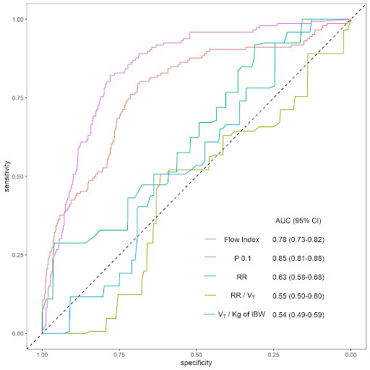
Abbreviations: P_{0.1}= airway occlusion pressure, RR = respiratory rate, V_{T} = tidal volume, IBW = ideal body weight

Table 8S: Performance of the FI and other parameters in detecting breaths with low inspiratory effort (defined as PTP_{tot}<50 cmH₂O‧sec⁻¹‧min⁻¹)

 | threshold | specificity | sensitivity | PPV | NPV | AUC | P value
Flow index | 2.0  (1.8-2.3) | 0.68 (0.6-0.73) | 0.73 (0.67-0.82) | 0.5 (0.46-0.54) | 0.85 (0.83-0.89) | 0.71 (0.67-0.75) | -
RR  breaths⋅min⁻¹ | 25  (25-27) | 0.57 (0.5-0.62) | 0.75 (0.67-0.83) | 0.43 (0.40-0.46) | 0.84 (0.80-0.88) | 0.69 (0.65-0.73) | 0.543
RR/V_{T}  breaths⋅L⁻¹⋅min⁻¹ | 50  (37-70) | 0.53 (0.4-0.68) | 0.67 (0.51-0.88) | 0.38 (0.35-0.42) | 0.79 (0.75-0.89) | 0.62 (0.58-0.66) | <0.001
V_{T}/IBW  ml⋅Kg⁻¹ | 8.2  (7.8-8.4) | 0.62 (0.55-0.68) | 0.58 (0.50-0.65) | 0.4 (0.36-0.45) | 0.77 (0.74-0.8) | 0.58 (0.53-0.62) | <0.001
P_{0.1}  cmH₂O | 0.8  (0.6-0.9) | 0.71 (0.65-0.80) | 0.73 (0.65-0.80) | 0.52 (0.48-0.60) | 0.86 (0.83-0.89) | 0.79 (0.75-0.83) | <0.001

Low inspiratory effort was defined as PTP_{tot}< 50 cmH₂O‧sec⁻¹‧min⁻¹. Estimates of sensitivity, specificity, Positive Predictive Value (PPV), and Negative Predicted Value (NPV) for the best threshold (chosen with by top-left corner in the retrieving operative characteristic curve) for detecting low inspiratory effort using variables studied as predictors. 95% confidence intervals (95% CI) were obtained by 2000 bootstrapped samples. P values were computed by evaluating bootstrapping tests for the AUC of every variable versus the AUC of the Flow Index.
Abbreviations: RR = respiratory rate, V_{T} = tidal Volume, IBW = ideal body weight, P_{0.1}= airway occlusion pressure, PPV = Positive Predictive Value, NPV = Negative Predictive Value, AUC = Area Under the retrieving operative characteristic Curve

Figure 4S. Areas under the receiver operating curve for detecting low inspiratory effort (PTP_{tot}< 50 cmH₂O‧sec⁻¹‧min⁻¹)

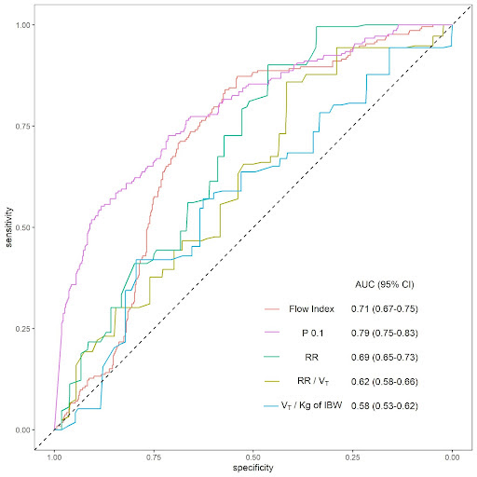
Abbreviations: P_{0.1}= airway occlusion pressure, RR = respiratory rate, V_{T} = tidal volume, IBW = ideal body weight

