Additional File

Table 1. Overview of machine learning studies that investigate extubation readiness

Authors | Year | Model | Outcome | Patients | Predictors
Kuo et al. | 2015 | ANN | Reintubation <48 hours | 121 | 8
Hsieh et al. | 2018 | ANN | Reintubation <72 hours | 3602 | 37
Hsieh et al. | 2019 | ANN | Simple, difficult, prolonged weaning | 3602 | 57
Fabregat et al. | 2020 | LDA, GBM, SVM | Reintubation <48 hours | 1570 | 19
Lin et al. | 2021 | XGBoost, RF, LR | Reintubation <120 hours | 963 | 300
Otaguro et al. | 2021 | RF, XGBoost, LightGBM | Reintubation <72 hours | 117 | 58
Jia et al. | 2021 | CNN | Reintubation <48 hours | 2299 | 24
Zhao et al. | 2021 | CatBoost | Reintubation <48 hours | 16189 | 78

ANN: Artificial neural network, LDA: Logistic discriminant analysis, GBM: Gradient boosting method, SVM: Support vector machines, RF: Random Forest, CNN: Convolutional neural network, LR: Logistic regression.
Search strategy:

Machine learning | "Artificial Intelligence"[Mesh] OR machine learning[ti] OR prediction algorithm*[ti] OR prediction model*[ti] OR neural network*[ti] OR deep learning[ti] OR artificial intelligence[ti] OR AI[ti] OR decision tree*[ti] OR computational intelligence[ti] OR machine intelligence[ti] OR big data[ti] OR bayesian[ti] OR naïve bayes[ti] OR k-nearest neighbour[ti] OR random forest[ti] OR support vector machine[ti] OR SVM[ti] OR Xgboost[ti] OR adaboost[ti] OR gradient boosting machine*[ti] OR regression tree*[ti] OR least squares[ti] OR stepwise regression[ti]
Extubation | "Airway Extubation"[Mesh] OR "Ventilator Weaning"[Mesh] OR extubation[ti] OR weaning[ti]
Adults | NOT (("Adolescent"[Mesh] OR "Child"[Mesh] OR "Infant"[Mesh] OR adolescen*[tiab] OR child*[tiab] OR schoolchild*[tiab] OR infant*[tiab] OR girl*[tiab] OR boy*[tiab] OR teen[tiab] OR teens[tiab] OR teenager*[tiab] OR youth*[tiab] OR pediatr*[tiab] OR paediatr*[tiab] OR puber*[tiab]) NOT ("Adult"[Mesh] OR adult*[tiab] OR man[tiab] OR men[tiab] OR woman[tiab] OR women[tiab])) NOT (animals[mh] NOT humans[mh])

The search was performed in Pubmed and is up to date until 16-09-2021
Table 2. Model performance

Model | ROC-AUC | Brier score
Unsuccesful extubation - 7 days
- Decision Tree | 0.59 ± 0.043 | 0.17 ± 0.007
- Logistic Regression | 0.67 ± 0.032 | 0.16 ± 0.004
- XGBoost | 0.70 ± 0.028 | 0.15 ± 0.007
Unsuccesful extubation - 48 hours
- Decision Tree | 0.54 ± 0.059 | 0.13 ± 0.004
- Logistic Regression | 0.66 ± 0.038 | 0.12 ± 0.007
- XGBoost | 0.67 ± 0.006 | 0.12 ± 0.003

Model performance for each of the models, for unsuccessful extubation within 7 days and 48 hours

Figure 1. PD-plot for BMI
Body mass index
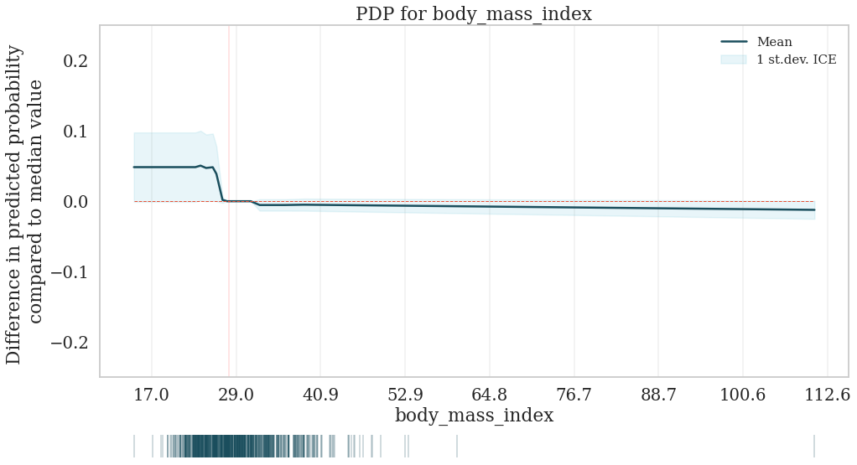
Body mass index (kg/m²)

