Additional file – Method E1
Esophageal pressure measurement.
An esophageal balloon-catheter (Nutriven®, Sidam, Modena, Italy) was inserted and filled with 3 mL of air to evaluate esophageal pressure (P_{oe}), as a surrogate marker of pleural pressure. We used a chest X-ray and a positive pressure occlusion test to check that the balloon was well placed, as described previously (E1). We measured the end-expiratory transpulmonary pressure (PL_{EE}, the difference between PEEP and end-expiratory P_{oe}) and the end-inspiratory transpulmonary pressure (PL_{EI}, the product of the plateau pressure and the ratio of lung and respiratory system elastances) (E2).

E1. Chiumello D, Consonni D, Coppola S, Froio S, Crimella F, Colombo A. The occlusion tests and end-expiratory esophageal pressure: measurements and comparison in controlled and assisted ventilation. Ann Intensive Care. déc 2016;6(1):13.
E2. Yoshida T, Amato MBP, Grieco DL, Chen L, Lima CAS, Roldan R, et al. Esophageal Manometry and Regional Transpulmonary Pressure in Lung Injury. Am J Respir Crit Care Med. 15 avr 2018;197(8):1018‑26.
Additional file – Method E2
Ventilatory ratio calculation.
The ventilatory ratio (VR) is an indication of overall efficiency of ventilation and lung perfusion (E1). The VR is well correlated with the dead space fraction calculated by the Bohr equation (E2), and has the advantage of not requiring the measurement of expired carbon dioxide (CO₂):
VR = (V_{E} x P_{a}CO₂) / (predicted V_{E} x ideal P_{a}CO₂)
Where V_{E} is the measured minute ventilation (in mL/min); P_{a}CO₂ is the arterial CO₂ pressure (in mmHg); and predicted V_{E} is the predicted minute ventilation (in mL/min), corresponding to predicted body weight (kg) multiplied by 100. Lastly, the ideal P_{a}CO₂ is fixed at 37.5 mmHg (E2).

E1. Diehl J-L, Peron N, Chocron R, et al. Respiratory mechanics and gas exchanges in the early course of COVID-19 ARDS: a hypothesis-generating study. Ann Intensive Care 2020;10(1):95.
E2. Sinha P, Calfee CS, Beitler JR, et al. Physiologic Analysis and Clinical Performance of the Ventilatory Ratio in Acute Respiratory Distress Syndrome. Am J Respir Crit Care Med 2019;199(3):333–341.

Additional file - Table E1
The LRM and titration of the optimal PEEP.
Characteristics | n (%)  median [IQR]
Maximum LRM, number of events (%)
Completed (PEEP = 40 cmH₂O) | 20 (67)
Interrupted at PEEP = 35 cmH₂O | 5 (17)
Interrupted at PEEP = 30 cmH₂O | 4 (13)
Interrupted at PEEP = 25 cmH₂O | 1 (3)
Reason for interrupting LRM, number of events (%)
Decrease in heart rate >20% | 3 (10)
Decrease in mean arterial pressure >20% | 9 (30)
Peripheral oxygen saturation <88% | 1 (3)
Optimal PEEP level, median [interquartile range], cmH₂O | 12 [10-14]
LRM: lung recruitment maneuver, PEEP: positive end-expiratory pressure.
Additional file - Table E2
Effects of LRM according to lung recruitability, in patients with positive end-expiratory transpulmonary pressure.
Parameters | R/I <0.62  n=11 | R/I ≥0.62  n=11 | p value
P_{a}O₂/F_{i}O₂ ratio, mmHg
P_{a}O₂/F_{i}O₂ pre-LRM | 116 [101-134] | 99 [71-131] | 0.566
P_{a}O₂/F_{i}O₂ post-LRM | 187 [129-192] | 139 [98-171] | 0.713
Δ P_{a}O₂/F_{i}O₂ (post-pre LRM) | 46 [10-91] | 41 [3-79] | 0.842
p value | 0.027 | 0.045
C_{rs}, mL/cmH₂O
C_{rs} pre-LRM | 32 [22-41] | 42 [28-46] | 0.173
C_{rs} post-LRM | 35 [23-43] | 44 [36-60] | 0.024
Δ C_{rs} (post-pre LRM) | 4 [-1-6] | 8 [4-17] | 0.032
p value | 0.240 | 0.018
C_{rs}: respiratory system compliance, LRM: lung recruitment maneuver, P_{a}O₂/F_{i}O₂: partial pressure of oxygen to inspired oxygen fraction.
Additional file - Table E3
Hemodynamic changes in LRM according to lung recruitability.
Parameters | All patients  n=30 | R/I <0.62  n=15 | R/I ≥0.62  n=15 | p value
Systolic blood pressure, mmHg
SBP pre-LRM | 123 [105-139] | 124 [115-142] | 115 [103-136] | 0.547
SBP post-LRM | 114 [103-131] | 114 |104-119] | 113 [104-134] | 0.868
ΔSBP (post-pre LRM) | -6 [-24-3] | -8 [-22--2] | -5 [-24-6] | 0.350
p value | 0.014 | 0.017 | 0.270
Diastolic blood pressure, mmHg
DBP pre-LRM | 57 [51-69] | 54 [51-63] | 61 [55-71] | 0.135
DBP post-LRM | 55 [51-61] | 54 [51-58] | 60 [51-64] | 0.299
ΔDBP (post-pre LRM) | 0 [-7-3] | 0 [-4-4] | 0 [-8-1] | 0.560
p value | 0.341 | 0.952 | 0.178
DBP: diastolic blood pressure, LRM: lung recruitment maneuver, SBP: systolic blood pressure.
Additional file - Figure E1
Protocol for the LRM in patient #12.
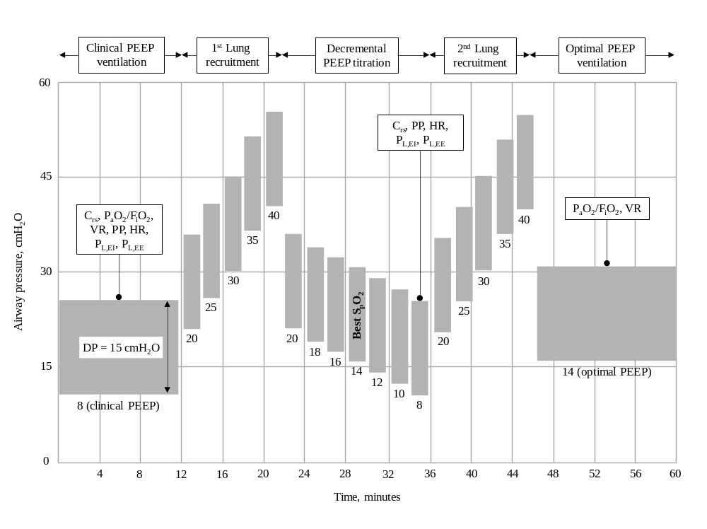
Additional file - Figure E2
Study flow chart.
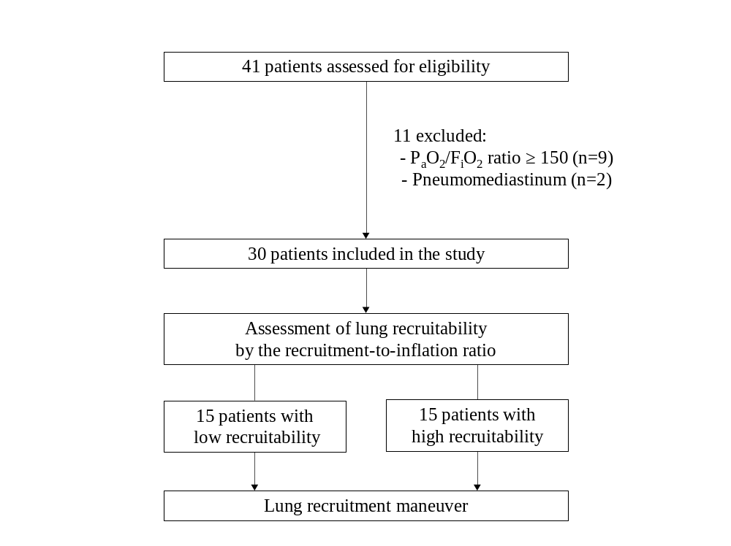
Additional file - Figure E3
The receiver operating characteristic curve for the prediction of lung recruitment after the LRM based on the R/I ratio.

