Electronic Supplementary Material

Prone Positioning during venovenous Extracorporeal Membrane Oxygenation for Acute Respiratory Distress Syndrome: a Pooled Individual Patient Data Analysis

Marco Giani, Emanuele Rezoagli, Christophe Guervilly, Jonathan Rilinger, Thibault Duburcq, Matthieu Petit, Laura Textoris, Bruno Garcia, Tobias Wengenmayer, Antonio Pesenti, Giacomo Grasselli, Alain Combes, Giuseppe Foti and Matthieu Schmidt for the EuroPronECMO Investigators

- Corresponding Author
Dr. Marco Giani, MD
University of Milano-Bicocca, Rianimazione generale, ASST Monza, Italy
marco.giani@unimib.it

Supplemental Methods
Ethics approval
All studies have been independently reviewed and approved by the local Institutional Review Boards. Here we provide the approval number / ID for each study.

- Giani et al. ref. 3105
- Petit et al. no. 2217028v0
- Guervilly et al. CIL/APHM 2018-44
- Rilinger et al. EK-Freiburg 151/14
- Garcia et al. ID-CRB 2020-A00763-36

Comorbidities definitions
Chronic respiratory disease includes either COPD or asthma; Malignancy includes either solid or hematological proliferative disorder; Vascular disease includes coronary or systemic vascular disease; immunodeficiency includes primary immunodeficiency, autoimmune disorder, and immunosuppressive therapy. Pulmonary ARDS includes pneumonia and trauma. Extrapulmonary ARDS includes sepsis/septic shock.

Propensity score
Patients were matched using the nearest neighbor approach (1:1 matching with no replacement) using a caliper of 0.2 standard deviation of the logit of the propensity score.
The similarity of the matched groups was assessed by the standardized differences of each independent variable used in the propensity score estimation. The balance in measured variable among the 2 groups (i.e. prone versus supine group) was investigated by standardized difference. A threshold of 0.10 of standardized difference was used as a cut-off for negligible balance
Statistical significance in the difference between the groups on continuous (i.e. ICU length of stay and the time to successful ECMO weaning within 60 days from ECMO start) and categorical outcome variables (i.e. ICU and hospital mortality, and disconnection from ECMO) were ascertained by Wilcoxon rank-sum test and Chi-square test, respectively.

Supplemental Results

Figure E1
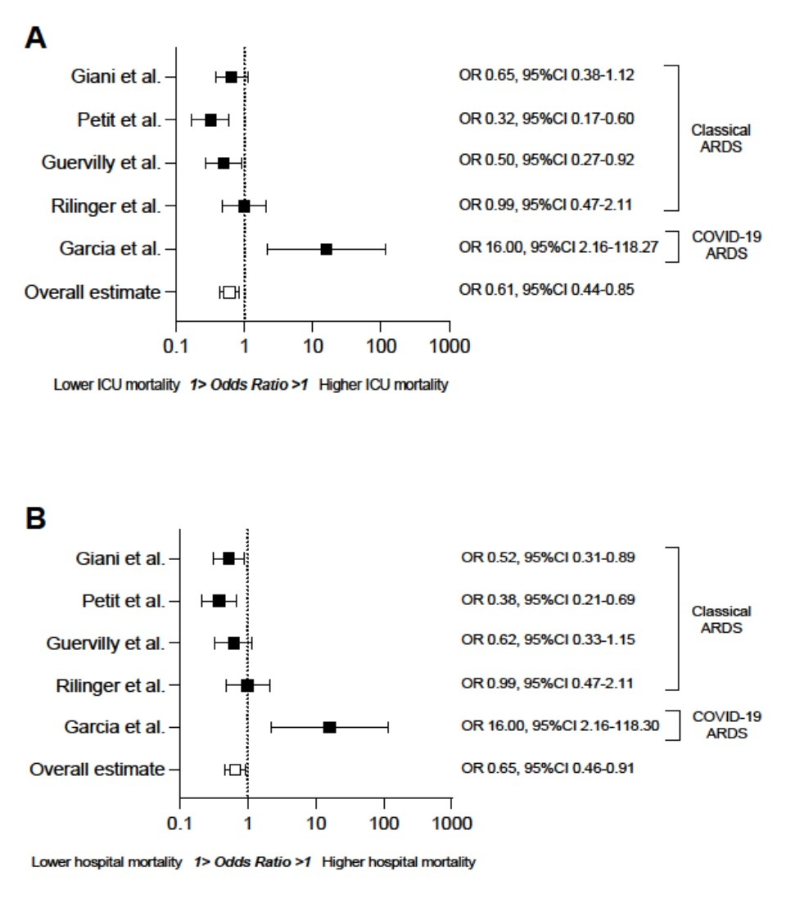
Odds ratio with 95% CI of ICU (panel A) and hospital (panel B) mortality in ECMO patients who underwent prone positioning (vs supine patients) in the 5 included studies. The overall data represents the Odds ratio with 95% CI of mortality by merging all data from the 5 studies and 95% CI was adjusted using the type of study as cluster variable by robust clustering.

Figure E2.
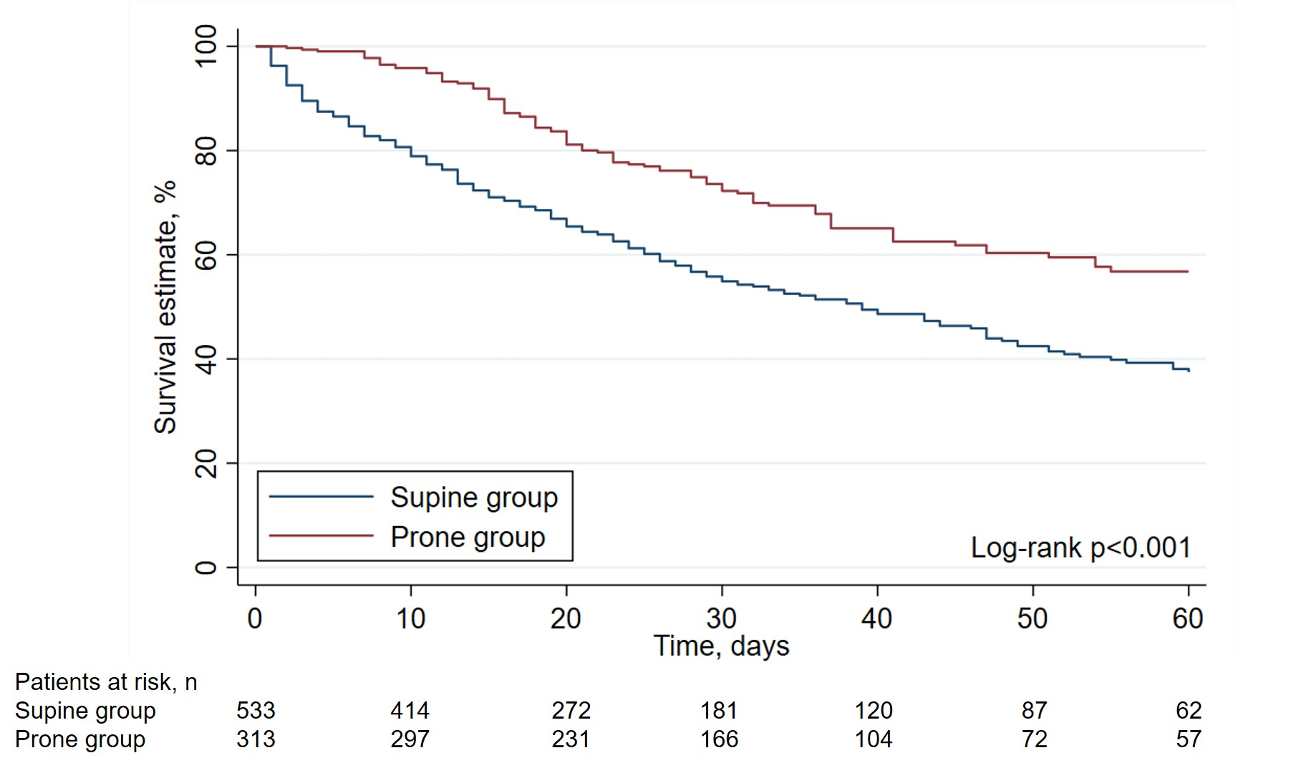
Survival estimation over 60-day follow up stratified by prone positioning during ECMO.

Table E1
Variable | HR | 95% CI | p
Age, years | 1.01 | 1.00-1.02 | 0.117
Sex, male | 0.97 | 0.84-1.11 | 0.632
Obesity (BMI≥30) | 0.94 | 0.77-1.16 | 0.576
Chronic respiratory disease | 1.38 | 0.87-2.18 | 0.168
Chronic heart failure | 0.91 | 0.65-1.27 | 0.589
Chronic liver disease | 2.24 | 1.55-3.25 | <0.001
Malignancy | 2.22 | 1.89-2.61 | <0.001
Immunodeficiency | 1.03 | 0.89-1.20 | 0.676
SOFA | 1.11 | 1.06-1.15 | <0.001
PaO₂/FiO₂ before ECMO, mmHg | 1.00 | 1.00-1.01 | 0.622
Days of mechanical ventilation before ECMO | 1.00 | 0.99-1.01 | 0.882
Use of prone positioning before ECMO | 0.87 | 0.67-1.12 | 0.281
Mobile ECMO transfer | 0.53 | 0.40-0.70 | <0.001
Use of prone positioning during ECMO | 0.67 | 0.42-1.06 | 0.090
Predictors of ICU mortality at 60-day follow-up. 95% CI of the HR was adjusted by robust clustering taking into account the 5 original cohorts of ECMO patients (i.e. clusters).

Table E2.
Variable | OR | 95% CI | p
Age, years | 1.02 | 1.01-1.03 | 0.001
Sex, males | 1.04 | 0.81-1.33 | 0.777
Obesity (BMI≥30) | 0.66 | 0.41-1.05 | 0.079
Chronic respiratory disease | 1.43 | 0.83-2.44 | 0.196
Chronic heart failure | 0.63 | 0.42-0.95 | 0.026
Chronic liver disease | 3.37 | 1.83-6.19 | <0.001
Malignancy | 3.17 | 2.27-4.41 | <0.001
Immunodeficiency | 1.40 | 1.18-1.66 | <0.001
SOFA | 1.08 | 1.03-1.14 | 0.002
Baseline PaO₂/FiO₂, mmHg | 1.00 | 1.00-1.01 | 0.477
Days of mechanical ventilation before ECMO | 1.02 | 1.00-1.03 | 0.052
Use of prone positioning before ECMO | 1.21 | 0.85-1.71 | 0.285
Mobile ECMO transfer | 0.65 | 0.50-0.86 | 0.002
Use of prone positioning during ECMO | 0.79 | 0.46-1.35 | 0.385
Predictors of hospital mortality. 95% CI of the OR was adjusted by robust clustering taking into account the 5 original cohorts of ECMO patients (i.e. clusters).

