Additional File 5 of the study by Grimaldi et al.

Ischemic injury of the upper digestive tract after out-of-hospital cardiac arrest: a prospective, multicentre study

Evolution of SOFA score according to upper gastrointestinal ischemic lesions severity

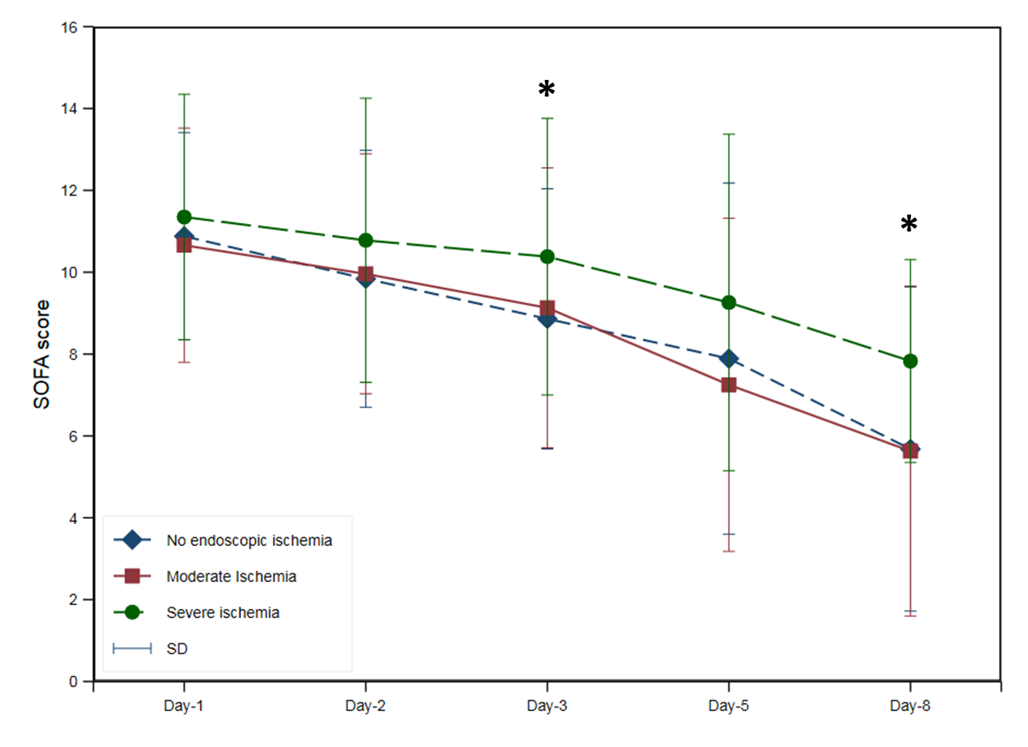
* indicate that SOFA score of patients with severe ischemic lesions is higher than patients without ischemic lesions (reference). Analyses of the change in SOFA score over time were based on mixed linear regression models with random intercepts for repeated measurements

