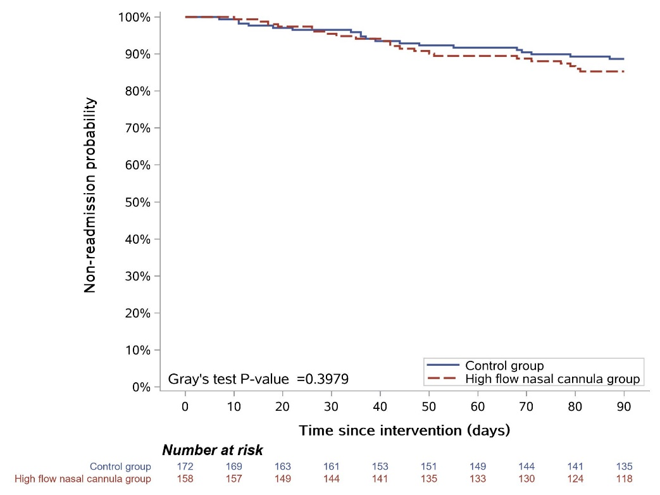

Figure E1 Kaplan-Meier analysis of time since intervention to readmission during 90 days follow-up period. The cumulative incidence function and Gray’s test were used to consider deaths as competing events to evaluate the difference of time to readmission for acute exacerbation between two groups.

