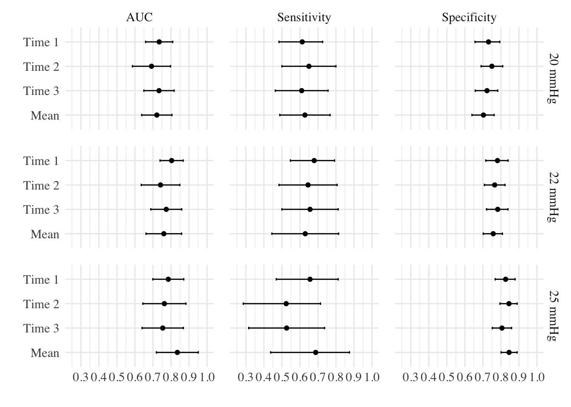
Figure S2. Forest plot indicating the areas under a curve (AUC), sensitivity and specificity for each time frame (T₁, T₂, T₃).

