a.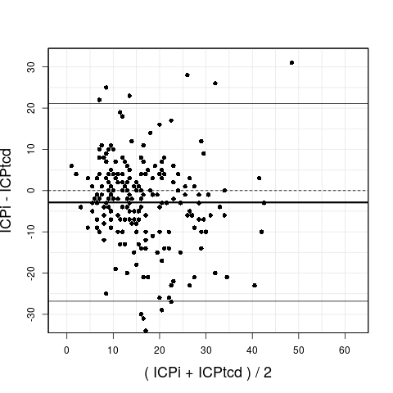b.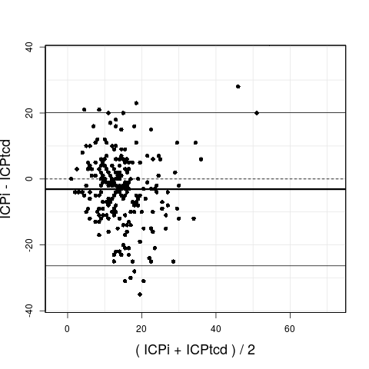

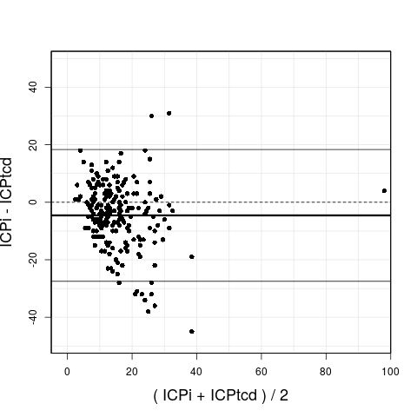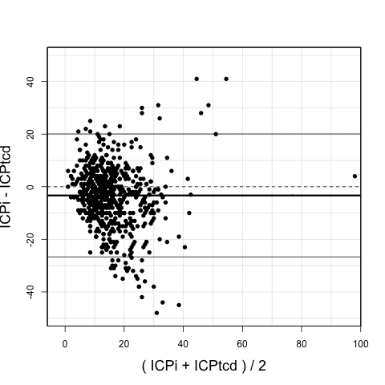
c. d.

Figure S3. Bland-Altman analysis for each time frame.

a. = T¹, b. = T², c.= T³, d.= average of all three time frames which yielded a mean bias (ICPtcd - ICPi) of -3.3 mmHg with an agreement range comprised between – 26.1 and + 19.5.

