Patients included in analysis
N=1,728
Missing outcome at 6 months
N=278
<18 years old
N=132
N=2,006
Patients in ICU stratum
N=2,138
Patients enrolled in CENTER-TBI core study
N=4,509
Patients in ER or Admission stratum
N=2,371

Supplementary Fig 1: Flowchart of patient selection for the analysis. ER, Emergency room; ICU, Intensive care unit.

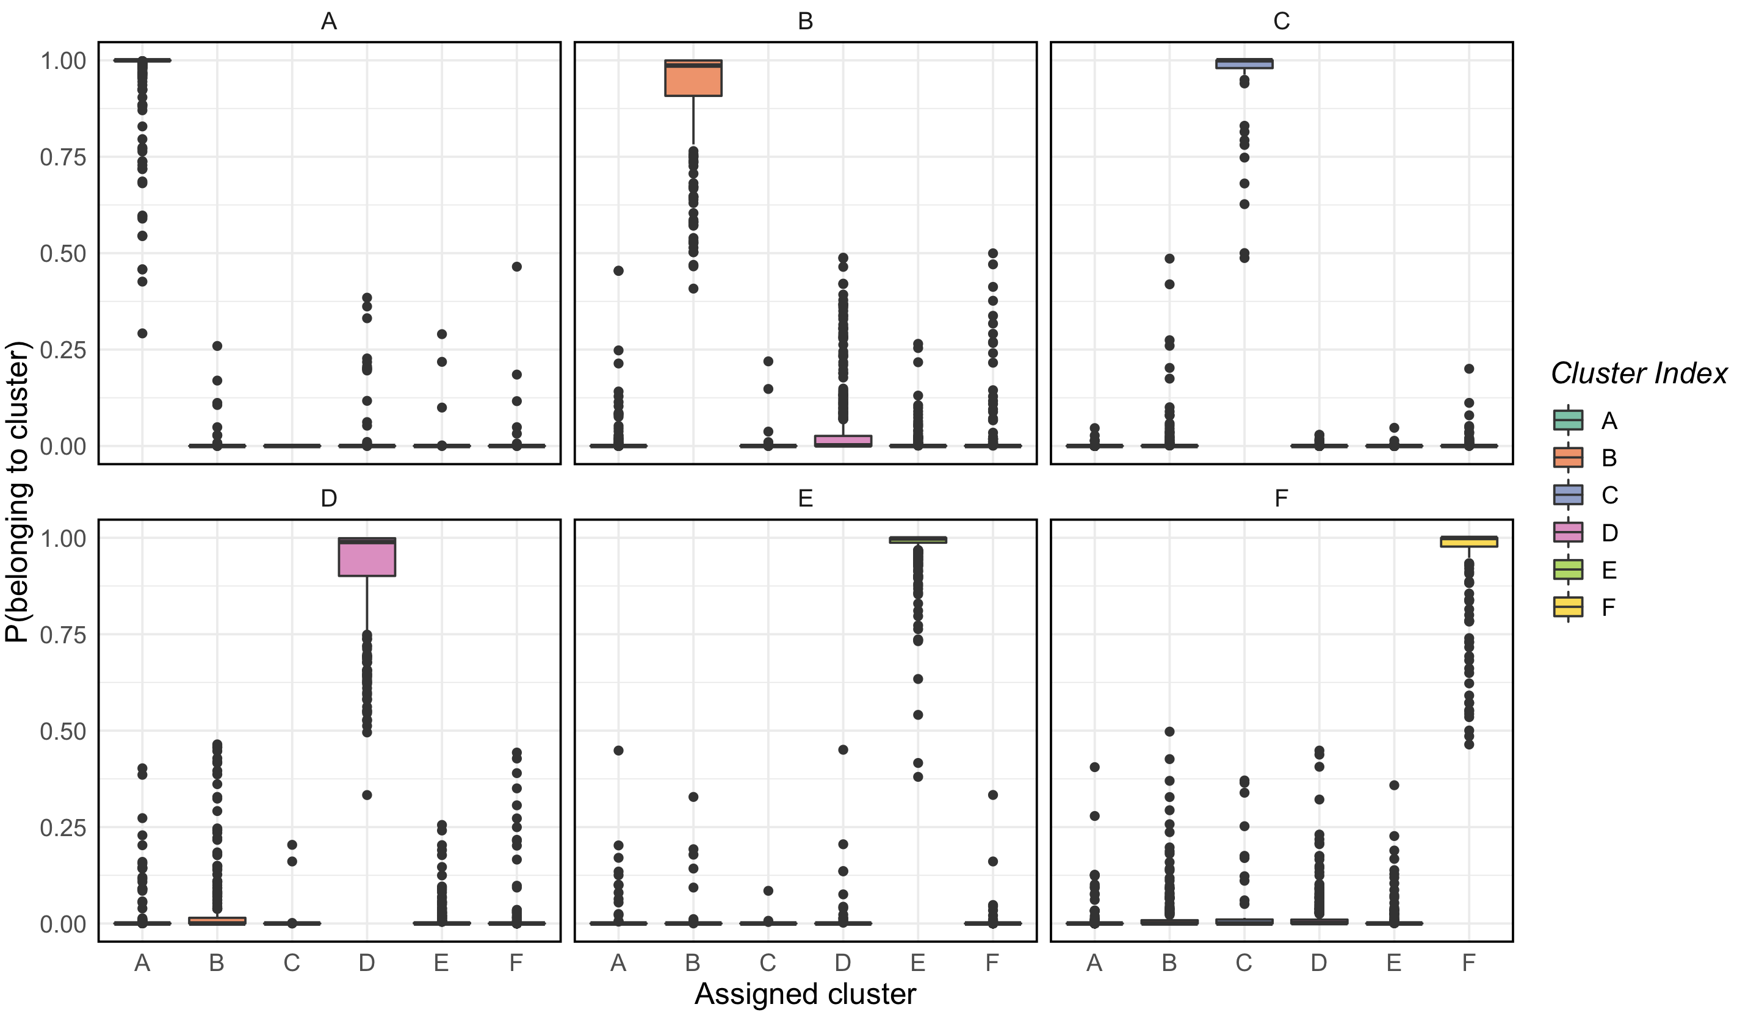

Supplementary Fig 2: Cluster assignment stability. Each subplot represents the probability of belonging to that cluster, stratified by the assigned cluster. Most patients had a very high probability of belonging to the assigned cluster, while the probability of belonging to another cluster was low.

