 | TAPSE |  | P value
 | <17mm | $≥$17mm | P value
P/F ratio | 256 ± 130 | 268 ± 142 | 0.71
PaC02 (mmHg) | 44.1 ± 14.3 | 38.5 ± 11.6 | 0.07
pH | 7.32 ± 0.07 | 7.36 ± 0.09 | 0.04
Lactate (mmol/l) | 1.9 (2.0) | 1.6 (2.3) | 0.68

Supplementary material 4 – Admission arterial blood gas results in those with RVD defined by TAPSE < 17mm. Those with TAPSE <17mm had a significantly lower admission pH. There was a trend towards a higher C02 in those with TAPSE <17mm that was not statistically significant. Data presented as mean ± standard deviation or median (interquartile range).

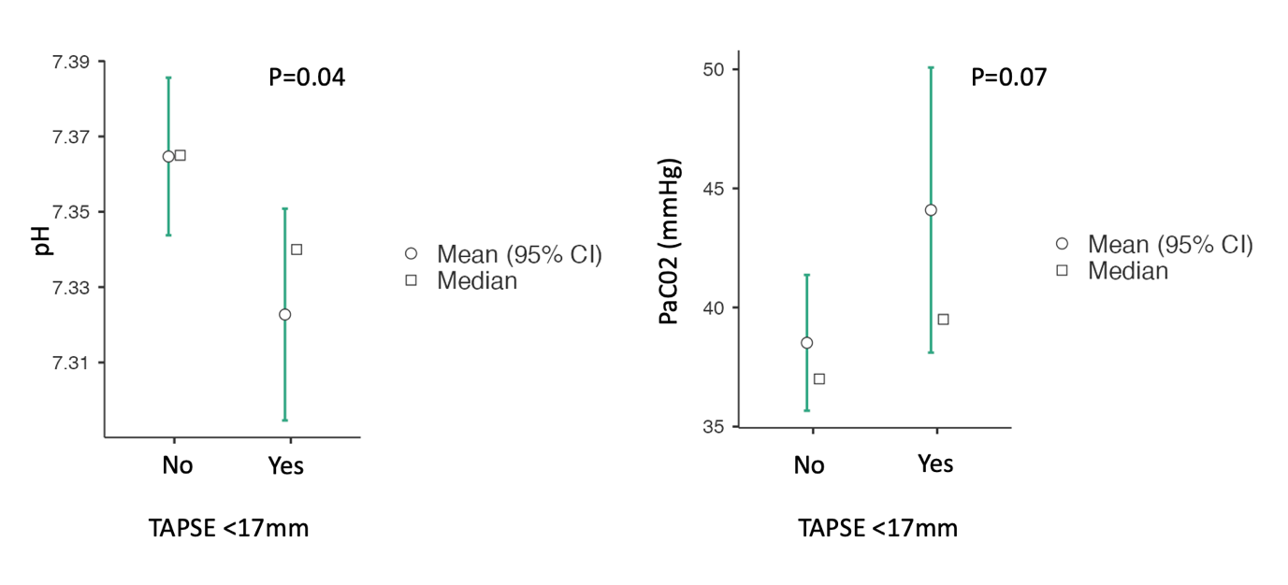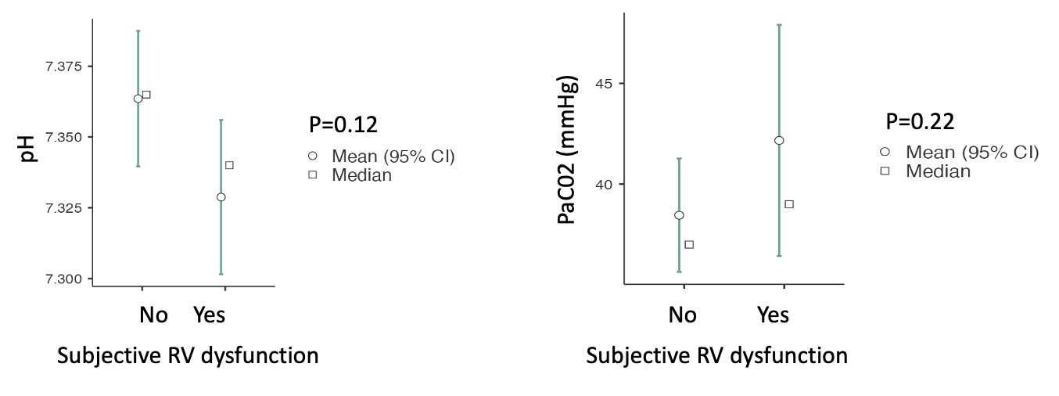
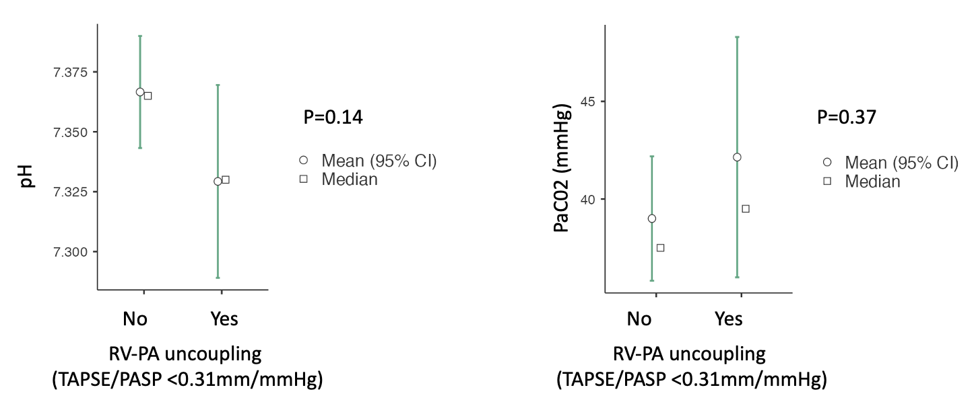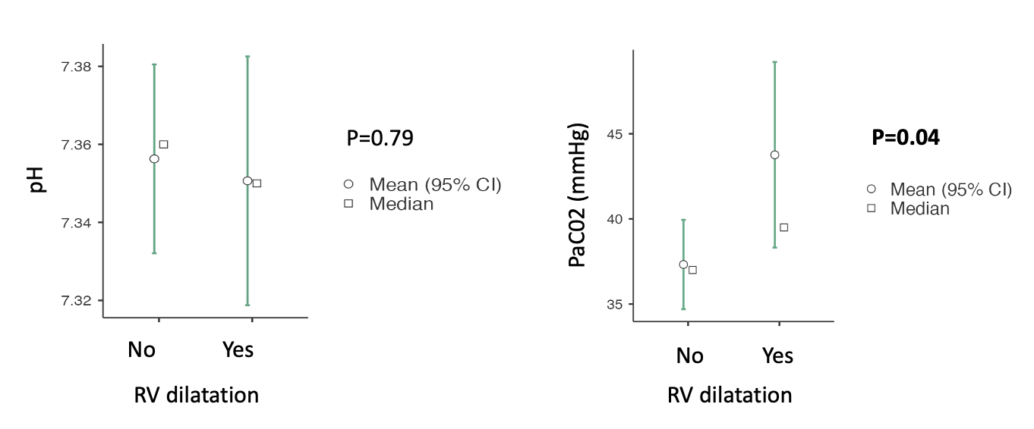
Supplementary material 4 – Bar plots of RVD by TAPSE, subjective, RV-PA uncoupling and RV dilation against admission pH and PaC02. Those with reduced TAPSE had significantly lower admission pH 7.32 ± 0.07 vs. 7.36 ± 0.09, p=0.04. Those with RV dilation had a higher PaC02 on admission (39.5mmHg (11.8) vs. 37mmHg (18.8), p=0.04.

