Supplementary Data
Antigen | PNP | Cryoprecipitate | Fibrinogen concentrate
Fibrinogen (mg/ml) | 4.2 ± 0.6 | 7.4 ± 0.7 | 21.6 ± 0.1
α2AP (µg/ml) | 69.6 ± 27.2 | 59.2 ± 3.3 | 0
FXIII (µg/ml) | 39 ± 19.5 | 57.7 ± 28.8 | 0.4 ± 0.02
PAI-1 (ng/ml) | 9.6 ± 8.3 | 8.2 ± 0.2 | 1 ± 0.1
TAFI (µg/ml) | 8.1 ± 2.0 | 15.0 ± 6.4 | 0.3 ± 0.3
TM (ng/ml) | 7.3 ± 1.7 | 10.7 ± 2.2 | 1.0 ± 0.9
Syndecan-1 (ng/ml) | 40.1 ± | 66.8 ± 26 | 0
tPA (ng/ml) | 1.1 ± 0.5 | 3.4 ± 0.3 | 0.3 ± 0.2
uPA (ng/ml) | 1.3 ± 0.01 | 0.6 ± 0.1 | 0
Table S1. Concentrations of fibrinolytic proteins in cryoprecipitate and fibrinogen concentrate. Plasma antigen levels for a panel of fibrinolytic proteins were measured in pooled normal plasma (PNP), cryoprecipitate and Fg-C. Data expressed at mean ± SD.

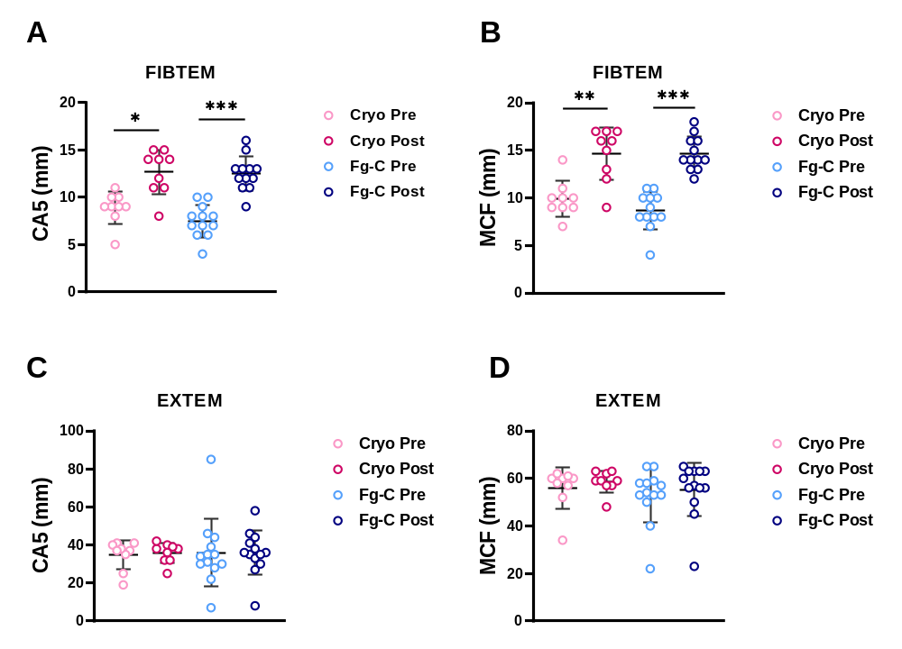
Figure S1. FIBTEM, but not EXTEM, measures of clot firmness are increased post-fibrinogen transfusion. ROTEM was performed on whole blood samples from FEISTY trauma patients pre- and post- transfusion with cryoprecipitate (cryo) or fibrinogen concentrate (Fg-C). The (A) clot amplitude at 5 minutes (CA5) and (B) maximum clot firmness (MCF) for FIBTEM; which measures the contribution of fibrinogen to the clot. The (C) CA5 and (D) MCF were also obtained for EXTEM; which determines the contribution of the extrinsic pathway. * p < 0.05, ** p < 0.01, *** p < 0.001.

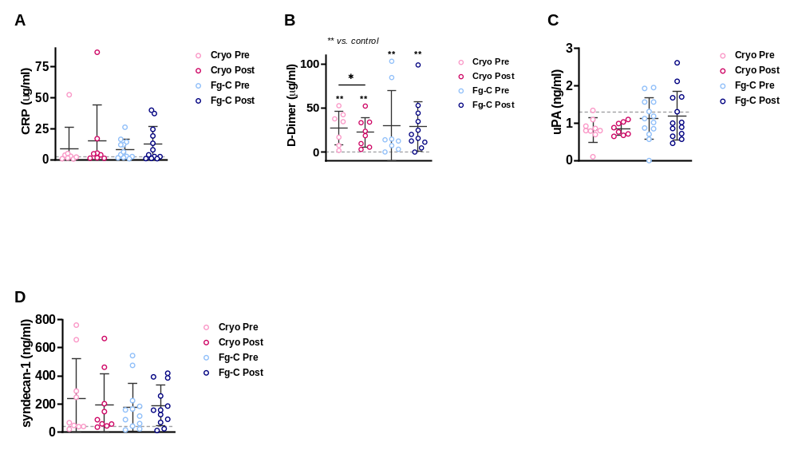
Figure S2. Inflammatory and endothelial markers are elevated in trauma patients. (A) CRP, (B) D-Dimer, (C) uPA and (D) Syndecan-1 antigen concentration were measured in plasma samples pre- and post- cryoprecipitate (cryo) and fibrinogen concentrate (Fg-C) transfusion. Grey dotted lines indicate the normal range from 16 healthy volunteers. * p < 0.05. ** p < 0.01 vs. healthy controls.

