Additional file 1. Additional results.

Table S1. Exclusion criteria.
- Body mass index (BMI) <18 or >30 kg/m²
- Acute severe neurological disorder and any other condition interfering with RASS assessment
- Systolic blood pressure less than 90 mm Hg after appropriate intravenous volume replacement and continuous infusions of 2 vasopressors
- Heart rate less than 50 beats/min or second- or third-degree heart block in the absence of a pacemaker
- Unstable angina or acute myocardial infarction
- Left ventricular ejection fraction less than 30%
- Contraindicate or allergic to study drugs
- Moribund state
- Acute hepatitis or serious hepatic dysfunction (Child-Pugh class C)
- Chronic kidney disease with glomerular filtration rate (GFR) < 60 ml/min/1.73m²
- Alcohol abuse
- Myasthenia gravis
- Pregnancy or lactation

Table S2. Outcomes.
 | Remimazolam  (n=30) | Propofol  (n=30) | P value
Primary Outcome
Percentage of time with a RASS score between -3 to 0, % | 73.2 (41.5 - 97.3) | 82.8 (65.6 - 100) | 0.269
Secondary Outcomes
Ventilator-free days at 7 days, h | 0.0 (0.0, 80.3) | 62.0 (0.0, 122.0) | 0.054
ICU length of stay, d | 14.0 (5.5 - 28.0) | 6.5 (3.0 - 15.8) | 0.143
28-day mortality | 6 (20.0%) | 3 (10.0%) | 0.472
Safety Outcomesª
Bradycardia | 0 (0.0%) | 2 (6.7%) | 0.492
Bradycardia with intervention | 0 (0.0%) | 0 (0.0%) | -
Tachycardia | 15 (50.0%) | 9 (30.0%) | 0.114
Tachycardia with intervention | 6 (20.0%) | 5 (16.7%) | 0.739
Hypotension | 22 (73.3%) | 23 (76.7%) | 0.766
Hypotension with intervention | 18 (60.0%) | 18 (60.0%) | 1.000
Hypertension | 8 (26.7%) | 7 (23.3%) | 0.766
Hypertension with intervention | 5 (16.7%) | 3 (10.0%) | 0.706
Data are count (%) or median (interquartile range).
Abbreviations: ICU: intensive care unit; RASS: Richmond Agitation and Sedation Scale.
ª The reporting of these events is the number of patients having at least one of these events.

Figure S1. The mean (SD) RASS scores over the study period.
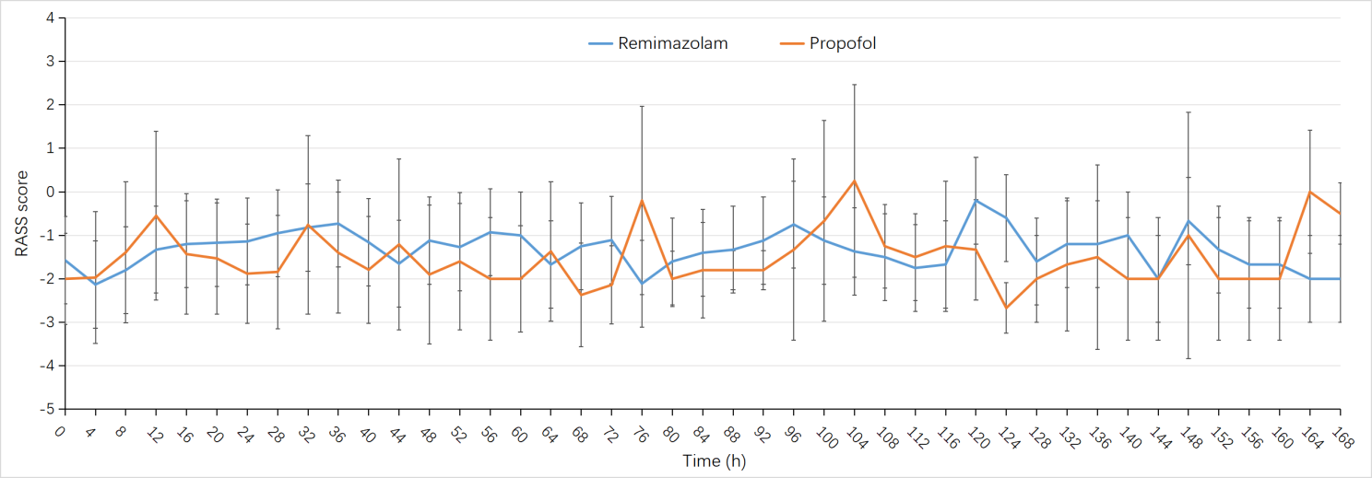

Figure S2. Kaplan-Meier plot of length of stay in the intensive care unit and number of patients at risk from start of study drug to 28 days (Log-rank P=0.22).
