Additional File 1 Figures and Tables
Association between in-ICU red blood cells transfusion and one-year mortality in ICU survivors
Table of contents
1. Supplemental Figures 3
Figure S1: Summary of the statistical analysis performed. MICE: multiple imputations by chained equations RF-MIA: random forest-missingness incorporated in attributes, AIPTW-AIPCW: augmented inverse probability of treatment weighting - augmented inverse probability of censoring weighting, IPTW: inverse probability of treatment weighting. 3
Figure S2: Absolute number of missing values in patients discharged alive in the FROG ICU cohort (n=1551). A: admission, CRP: C reactive protein, CV: cardiovascular, D: discharge, DBP: diastolic blood pressure, eGFR: glomerular filtration rate, I: inclusion, IL6: interleukin 6, LFABP: liver fatty acid binding protein (log), NGAL: neutrophil gelatinase associated lipocalin, p: plasma, PT: prothrombin time, RBC: red blood cells, RRT: renal replacement therapy, SBP: systolic blood pressure. 4
Figure S3: Directed acyclic diagram for variables associated with both the transfusion and the one-year mortality (red) and variables only associated with the outcome (blue). A, admission; I, Inclusion, A-I, Admission – Inclusion. DBP: diastolic blood pressure, eGFR: estimated glomerular filtration rate, RRT: renal replacement therapy, SAPS2: simplified acute physiology score II, SBP: systolic blood pressure, SOFA: sequential organ failure assessment 5
Variables are listed in the below table 5
Figure S4: Flow chart. 7
Figure S5: Timing of the first RBC transfusion from inclusion in the FROG-ICU cohort. Patients in whom the first transfusion was administered after day 25 are not represented on the Figure (n= 4 patients) 8
Figure S6: Time-course of lowest hemoglobin values from admission to discharge in the FROG-ICU cohort according to transfusion status. Data were collected at admission, day 1 to 3, and then twice a week until discharge. The p value represents the interaction between time points and transfusion status on hemoglobin values. The dashed line represents the recommended threshold of transfusion. 9
Figure S7: Probability to receive transfusion in the transfusion group and in the non-transfusion group in the FROG-ICU cohort. Panel A: The probability has been estimated according to a logistic regression with the baseline confounding variables excluding those impacting only the outcome (blue covariates of Figure E2). Panel B: The estimation of the probability has been done using random forests with all the confounding variables excluding those impacting only the outcome (blue covariates of Figure E2). 10
Figure S8: Standardized mean difference of confounding variables for the unweighted population and the weighted population given the inverse probability weighting score in the FROG-ICU cohort. Confounding variables included variables at baseline associated to both transfusion prescription and outcome. I: inclusion; neuro: neurological failure; ARF: acute respiratory failure, PO: post-operative scheduled and unscheduled; CS: cardiogenic shock and cardiac arrest; SS: severe sepsis or septic shock; HS: hemorrhagic shock including trauma; others: acute liver failure, acute kidney failure, hypovolemic shock, anaphylactic shock, multiple organ failure, acute pancreatitis, metabolic; F: female; cv: cardiovascular, C-V: cardio-vascular, eGFR: glomerular filtration rate; PT: prothrombine time. 11
Figure S9: Sensitivity analysis for clinical variables according to parameters at discharge in the unweighted FROG-ICU cohort. Reference is no transfusion* continuous variables were dichotomized according to median. 13
Figure S10: Sensitivity analysis for biomarkers variables according to parameters at discharge in the unweighted FROG-ICU cohort. Reference is no transfusion* continuous variables were dichotomized according to median. 14
Figure S11: Haptoglobin level normalized by IL-6 level in the unweighted FROG-ICU cohort. panel A: in RBC transfusion vs RBC no transfusion, panel B: according to eGFR ranges (parametric imputation with MICE). 15
Figure S12: Hazard ratio of death according to the number of packed RBC administered during ICU stay in the unweighted FROG-ICU cohort. 16
Supplemental Tables 17
Table S1: Exploratory analyses in the unweighted FROG-ICU cohort: Renal biomarkers (log transformed) according to RBC transfusion during ICU stay. eGFR: glomerular filtration rate, NGAL: neutrophil gelatinase associated lipocalin, p: plasma, u: urinary. 17
Table S2: Exploratory analyses in the unweighted FROG-ICU cohort: Cardiac biomarkers (log transformed) according to RBC transfusion during ICU stay. 18

Supplemental Figures

Figure S1: Summary of the statistical analysis performed. MICE: multiple imputations by chained equations RF-MIA: random forest-missingness incorporated in attributes, AIPTW-AIPCW: augmented inverse probability of treatment weighting - augmented inverse probability of censoring weighting, IPTW: inverse probability of treatment weighting.

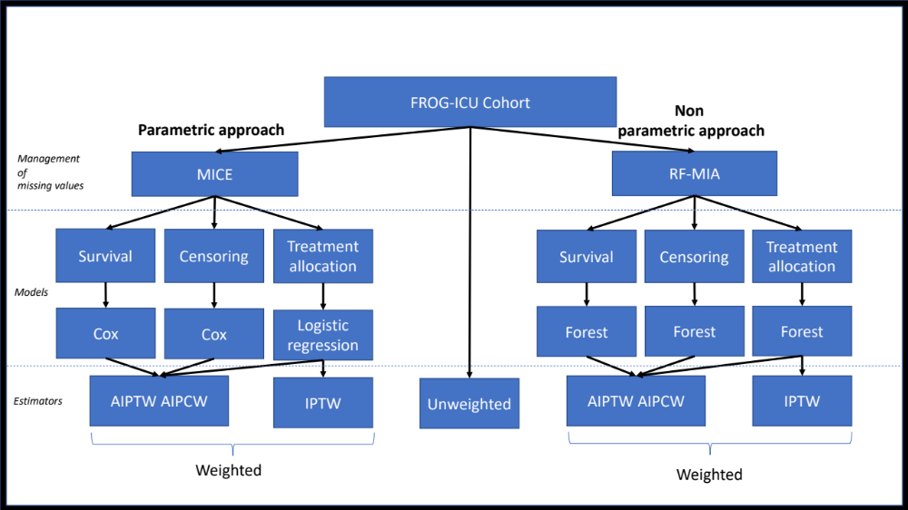

Figure S2: Absolute number of missing values in patients discharged alive in the FROG ICU cohort (n=1551). A: admission, CRP: C reactive protein, CV: cardiovascular, D: discharge, DBP: diastolic blood pressure, eGFR: glomerular filtration rate, I: inclusion, IL6: interleukin 6, LFABP: liver fatty acid binding protein (log), NGAL: neutrophil gelatinase associated lipocalin, p: plasma, PT: prothrombin time, RBC: red blood cells, RRT: renal replacement therapy, SBP: systolic blood pressure.

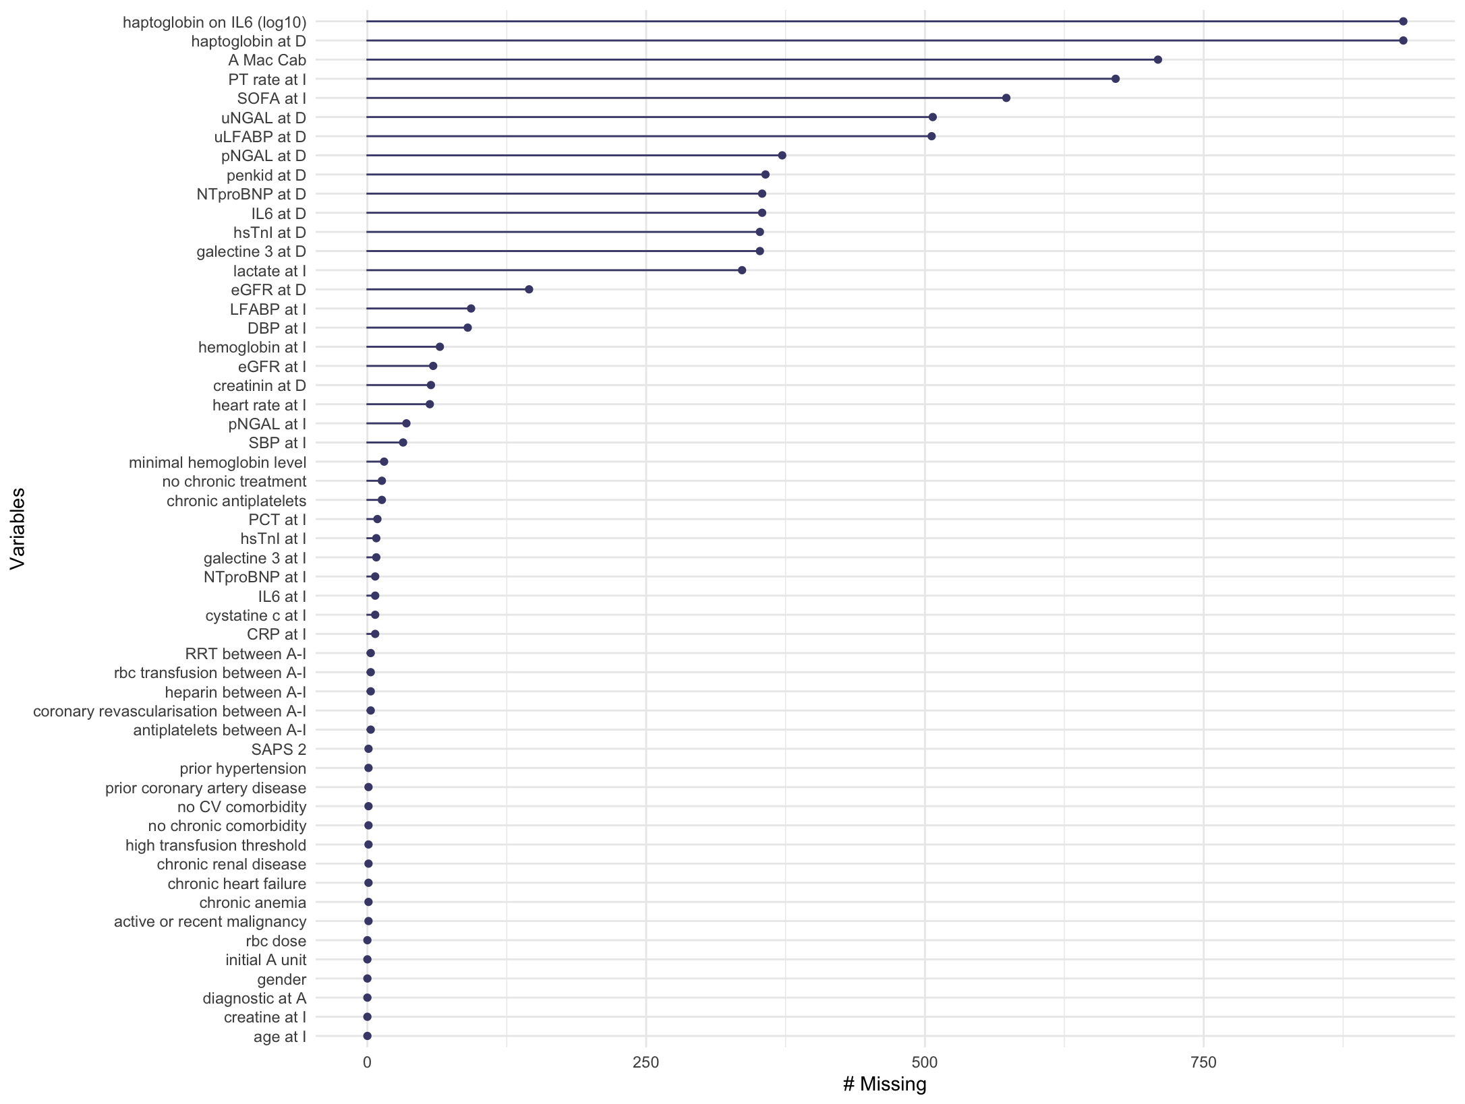

Figure S3: Directed acyclic diagram for variables associated with both the transfusion and the one-year mortality (red) and variables only associated with the outcome (blue). A, admission; I, Inclusion, A-I, Admission – Inclusion. DBP: diastolic blood pressure, eGFR: estimated glomerular filtration rate, RRT: renal replacement therapy, SAPS2: simplified acute physiology score II, SBP: systolic blood pressure, SOFA: sequential organ failure assessment

Variables are listed in the below table
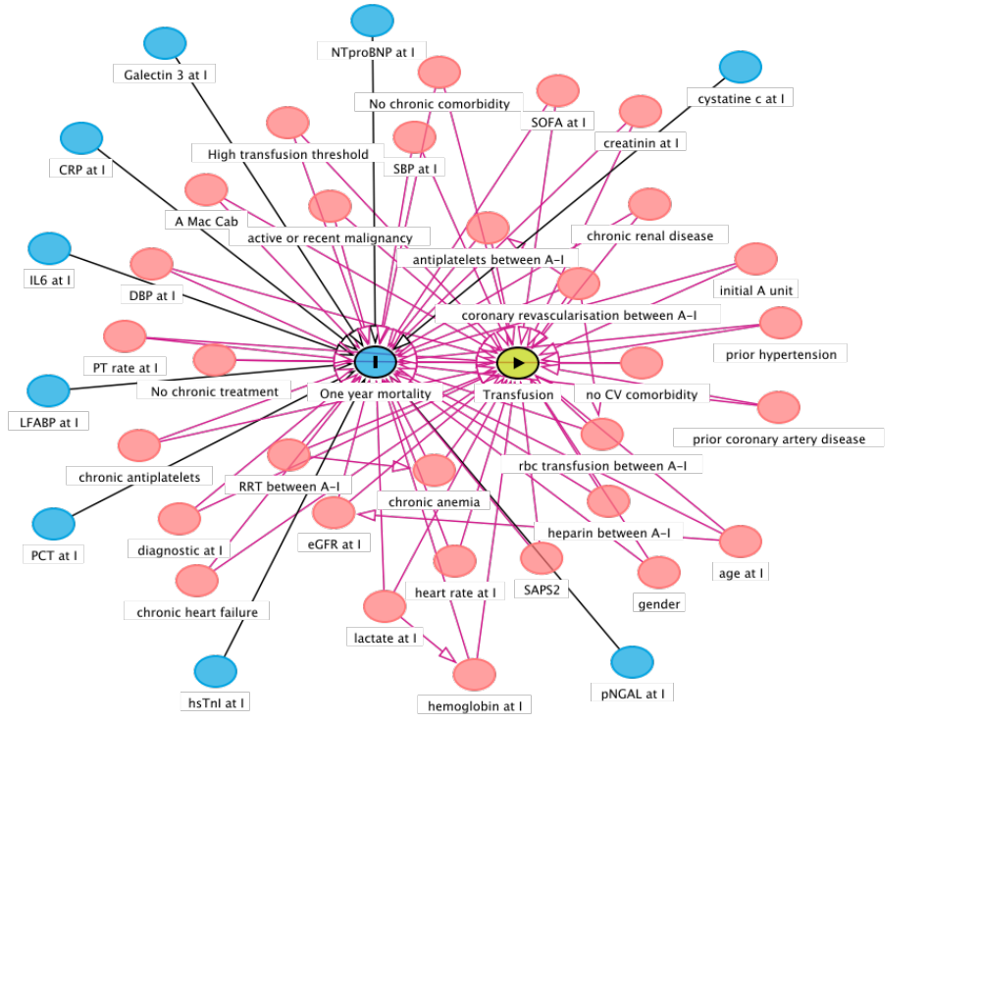

Variables associated to both transfusion decision and outcome | Variables associated to the outcome alone
Demographic | Biomarkers
Gender | CRP at I
Age at A | Galectine 3 at I
Medical history | PCT at I
Mac Cabe Score | hsTnI at A
Chronic heart failure | LFABP at I
Prior hypertension | cystatine c at I
Prior coronary artery disease | pNGAL at I
No cardiovascular comorbidity | IL6 at I
Chronic renal disease | NTproBNP at I
Chronic anemia
Active or recent malignancy
No chronic comorbidity
Chronic treatments
Chronic antiplatelets
No chronic treatment
Management between A and I
RBC transfusion between A-I
RRT between A-I
Coronary revascularisation between A-I
Heparin between A-I
Antiplatelets between A-I
Initial A unit
Clinical presentation at I
Diagnostic at I
High transfusion threshold
SAPS2
SOFA at I
Hemoglobin at I
SBP at I
DBP at I
Heart rate at I
eGFR at I
Lactate at I
Creatinin at I
PT rate at I

Figure S4: Flow chart.

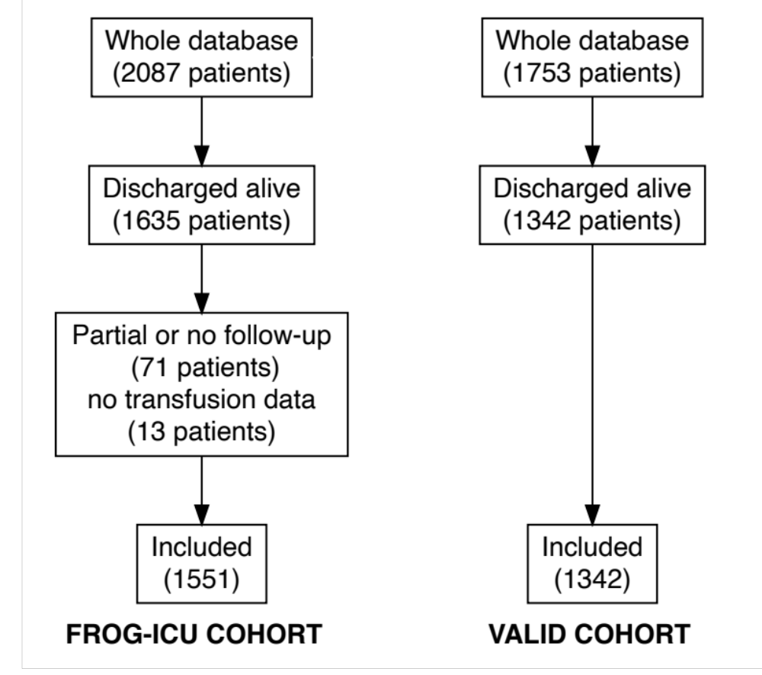

Figure S5: Timing of the first RBC transfusion from inclusion in the FROG-ICU cohort. Patients in whom the first transfusion was administered after day 25 are not represented on the Figure (n= 4 patients)

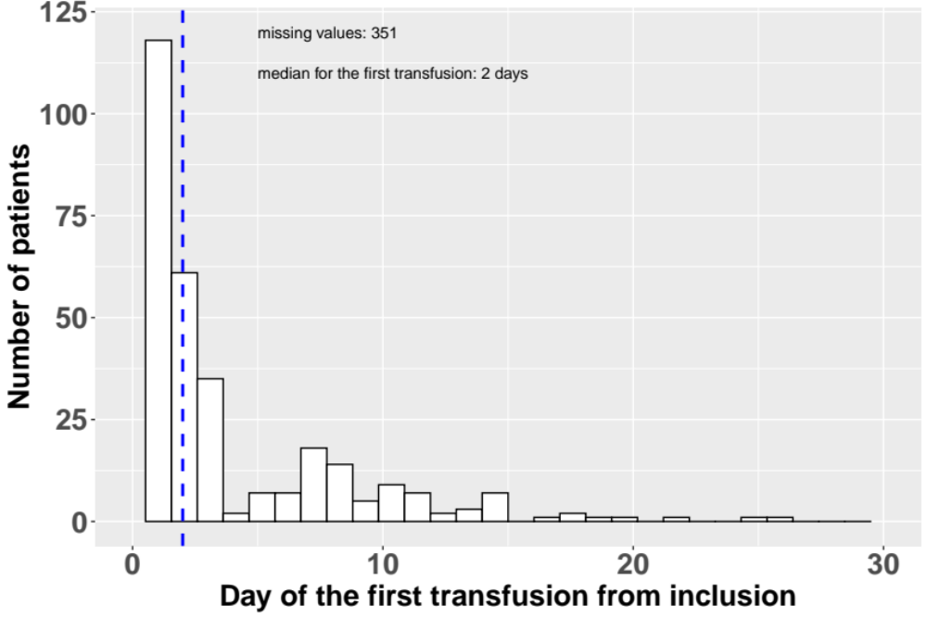

Figure S6: Time-course of lowest hemoglobin values from admission to discharge in the FROG-ICU cohort according to transfusion status. Data were collected at admission, day 1 to 3, and then twice a week until discharge. The p value represents the interaction between time points and transfusion status on hemoglobin values. The dashed line represents the recommended threshold of transfusion.

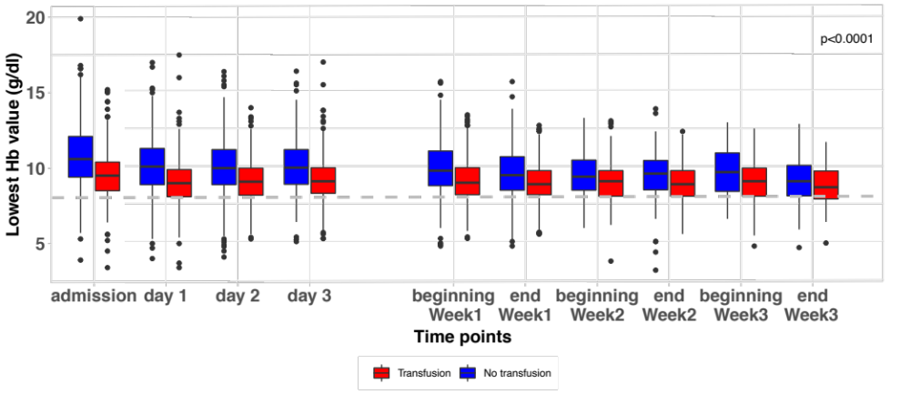

Figure S7: Probability to receive transfusion in the transfusion group and in the non-transfusion group in the FROG-ICU cohort. Panel A: The probability has been estimated according to a logistic regression with the baseline confounding variables excluding those impacting only the outcome (blue covariates of Figure E2). Panel B: The estimation of the probability has been done using random forests with all the confounding variables excluding those impacting only the outcome (blue covariates of Figure E2).

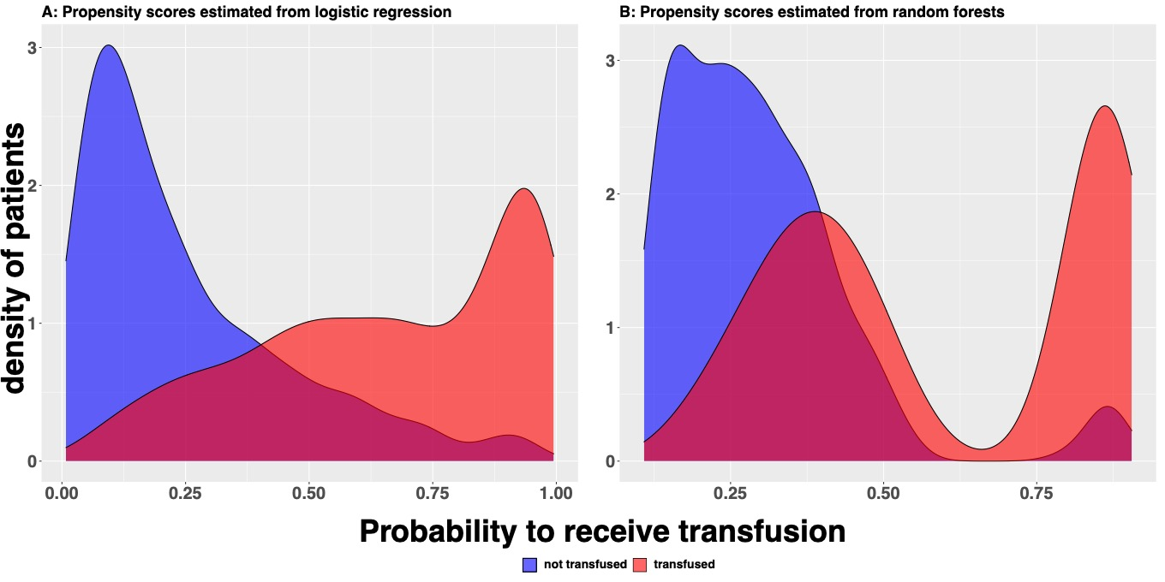

Figure S8: Standardized mean difference of confounding variables for the unweighted population and the weighted population given the inverse probability weighting score in the FROG-ICU cohort. Confounding variables included variables at baseline associated to both transfusion prescription and outcome. I: inclusion; neuro: neurological failure; ARF: acute respiratory failure, PO: post-operative scheduled and unscheduled; CS: cardiogenic shock and cardiac arrest; SS: severe sepsis or septic shock; HS: hemorrhagic shock including trauma; others: acute liver failure, acute kidney failure, hypovolemic shock, anaphylactic shock, multiple organ failure, acute pancreatitis, metabolic; F: female; cv: cardiovascular, C-V: cardio-vascular, eGFR: glomerular filtration rate; PT: prothrombine time.
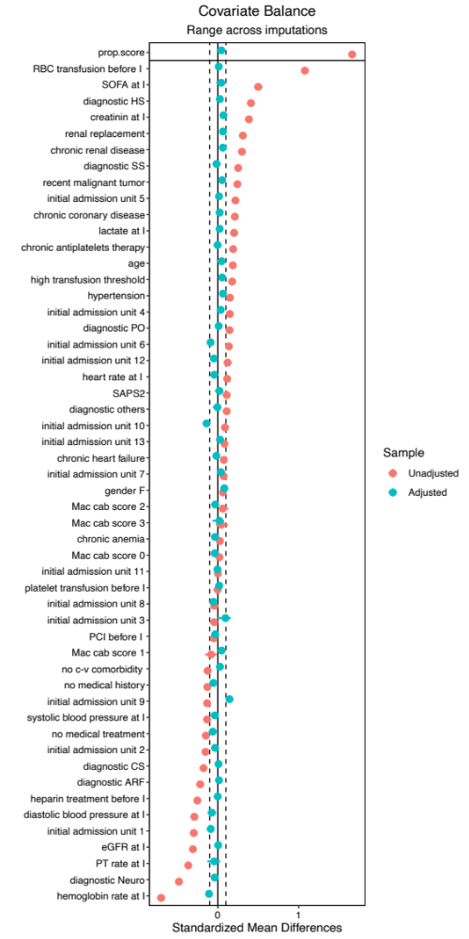

Figure S9: Sensitivity analysis for clinical variables according to parameters at discharge in the unweighted FROG-ICU cohort. Reference is no transfusion* continuous variables were dichotomized according to median.

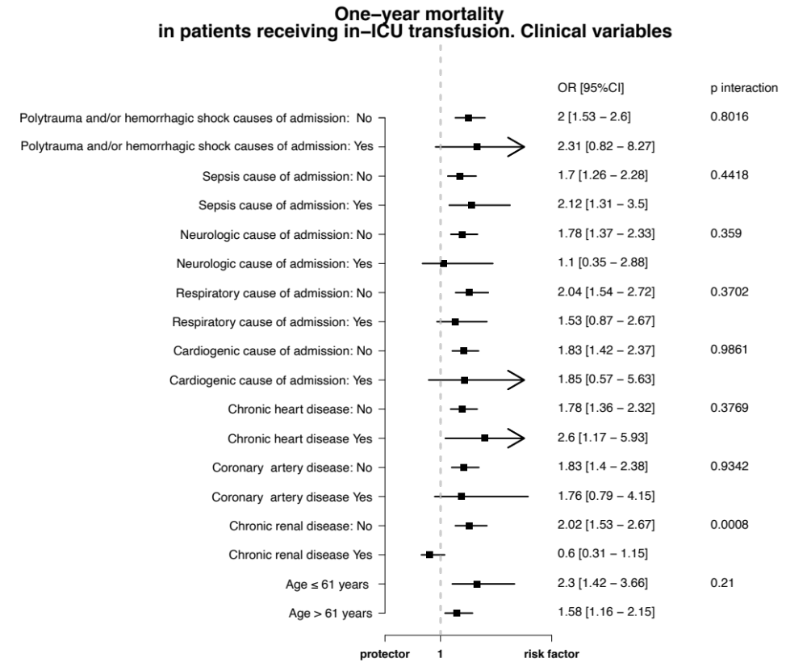

Figure S10: Sensitivity analysis for biomarkers variables according to parameters at discharge in the unweighted FROG-ICU cohort. Reference is no transfusion* continuous variables were dichotomized according to median.
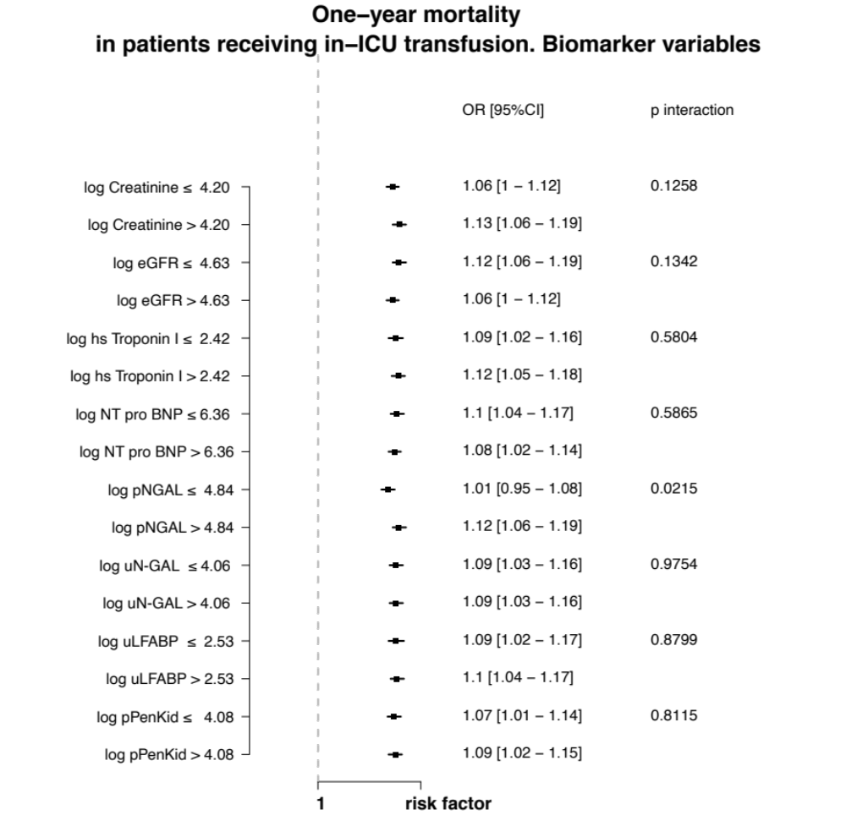

Figure S11: Haptoglobin level normalized by IL-6 level in the unweighted FROG-ICU cohort. panel A: in RBC transfusion vs RBC no transfusion, panel B: according to eGFR ranges (parametric imputation with MICE).

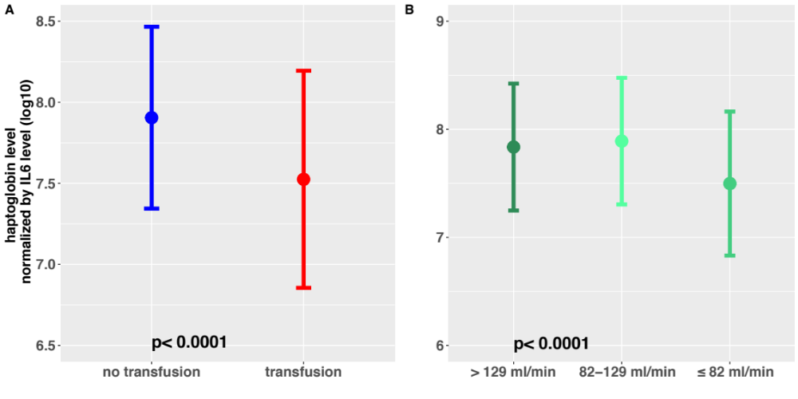

Figure S12: Hazard ratio of death according to the number of packed RBC administered during ICU stay in the unweighted FROG-ICU cohort.

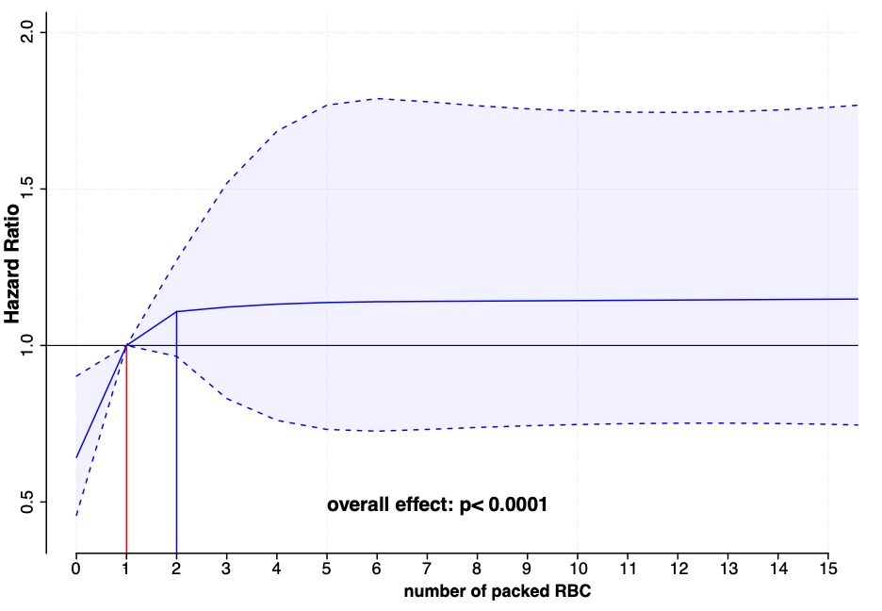

Supplemental Tables

Table S1: Exploratory analyses in the unweighted FROG-ICU cohort: Renal biomarkers (log transformed) according to RBC transfusion during ICU stay. eGFR: glomerular filtration rate, NGAL: neutrophil gelatinase associated lipocalin, p: plasma, u: urinary.

Variables at discharge | Global  mean±SD* | No transfusion  mean±SD* | Transfusion  mean±SD* | p-value
eGFR (log) | 4.47 ± 0.75 | 4.56 ± 0.65 | 4.36 ± 0.84 | <0.0001
Creatinine (log) | 4.33 ± 0.66 | 4.26 ± 0.59 | 4.43 ± 0.73 | <0.0001
p NGAL (log) | 4.75 ± 1.28 | 4.55 ± 1.27 | 5.03 ± 1.25 | <0.0001
u NGAL (log) | 4.23 ± 1.52 | 3.99 ± 1.42 | 4.56 ± 1.59 | <0.0001
u liver fatty acid binding protein (log) | 4.24 ± 0.73 | 4.1 ± 0.63 | 4.43 ± 0.82 | <0.0001
p PenKid (log) | 2.67 ± 1.39 | 2.41 ± 1.3 | 3.03 ± 1.42 | <0.0001
*imputed dataset was used.

Table S2: Exploratory analyses in the unweighted FROG-ICU cohort: Cardiac biomarkers (log transformed) according to RBC transfusion during ICU stay.

Variables at discharge | Global  mean±SD* | No transfusion  mean±SD* | Transfusion  mean±SD* | p value
Galectin 3 (log) | 3.02 ± 0.53 | 2.91 ± 0.48 | 3.16 ± 0.56 | <0.0001
NT pro-BNP (log) | 6.36 ± 1.92 | 6.09 ± 1.92 | 6.73 ± 1.86 | <0.0001
hs Troponin I (log) | 2.75 ± 1.85 | 2.69 ± 1.91 | 2.83 ± 1.77 | 0.168
*imputed dataset was used

